Software Construction & Development (SCD)
Lab 7 Report
Student Course Management System with GitHub Actions
Student Name
Roll / Registration No.
Date | 9 October 2026
Repository | https://github.com/Taha9876/SCD-LAB-7

1. Starting the Server
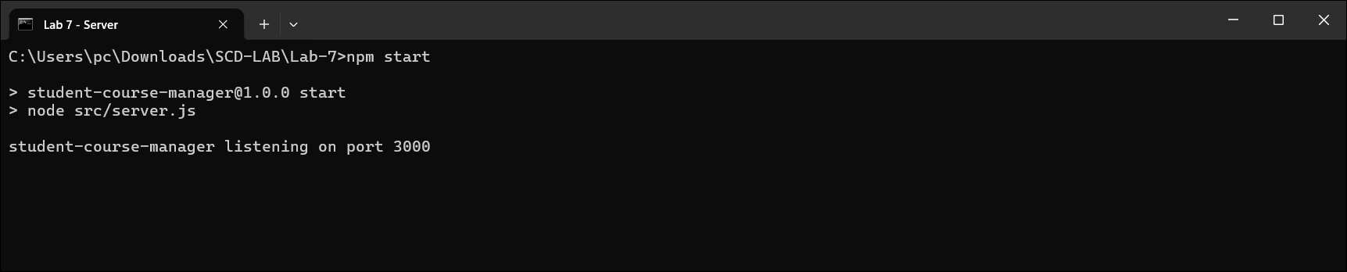

2. User Authentication: Register a Student
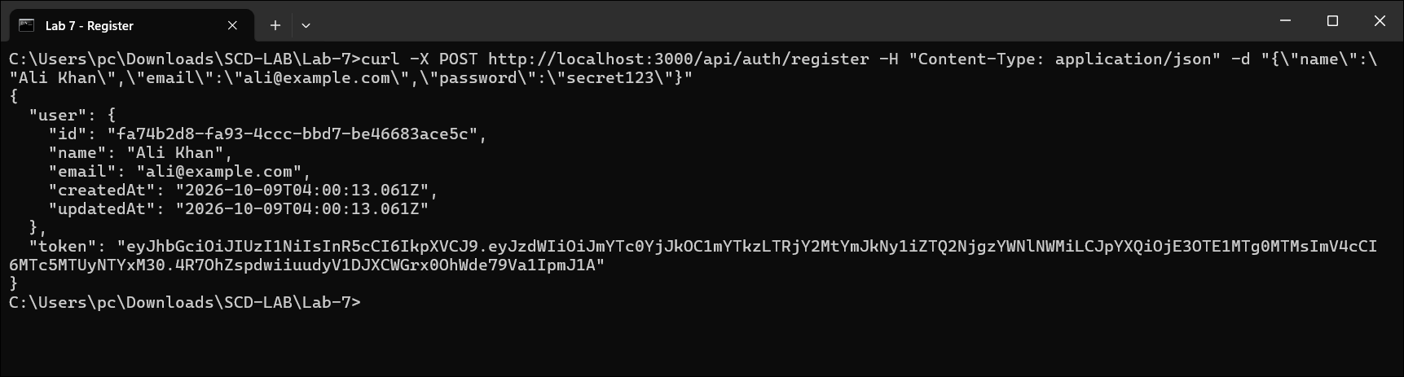

3. User Authentication: Login
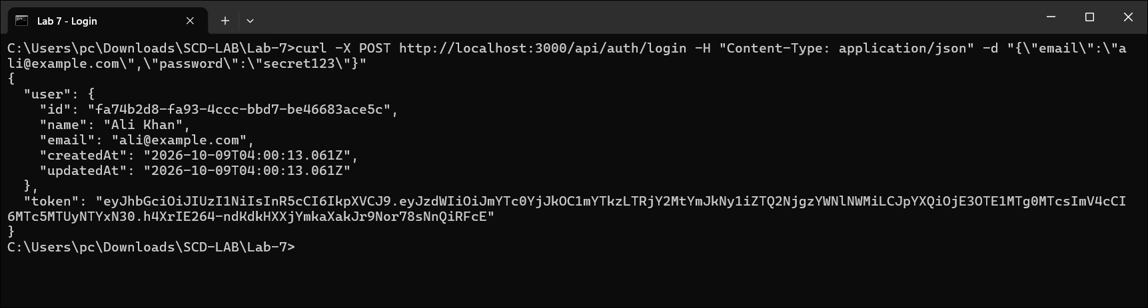

4. Course Management: Add a Course
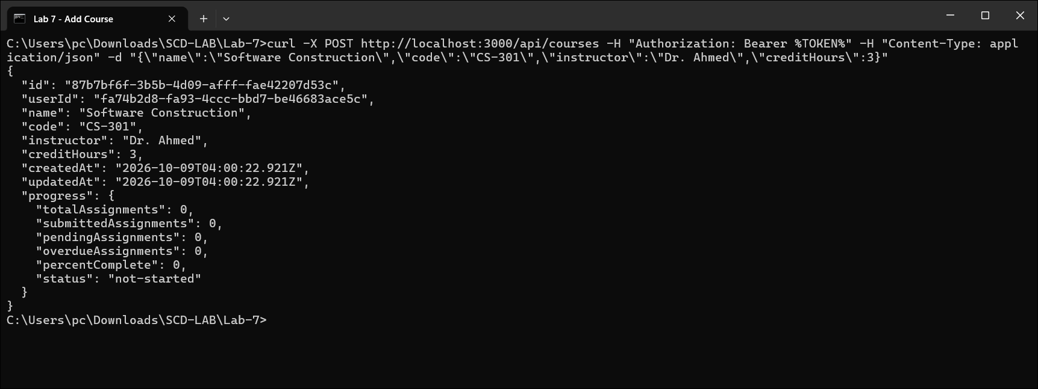

5. Course Management: View All Courses
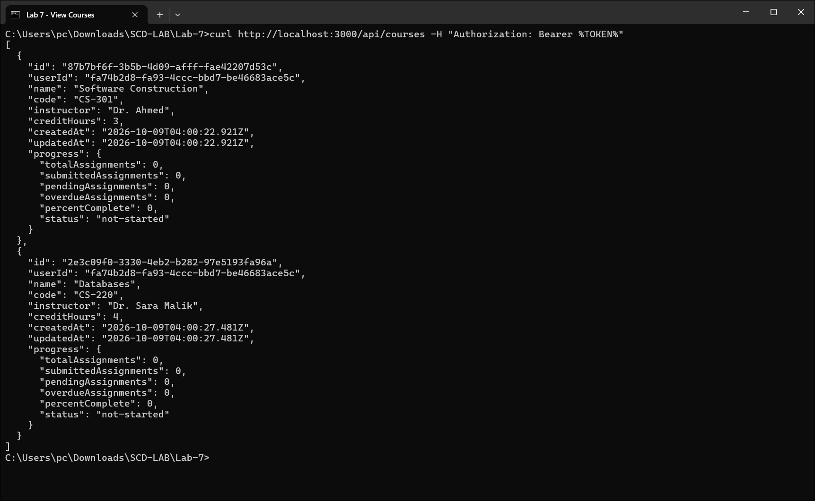

6. Course Management: Update a Course
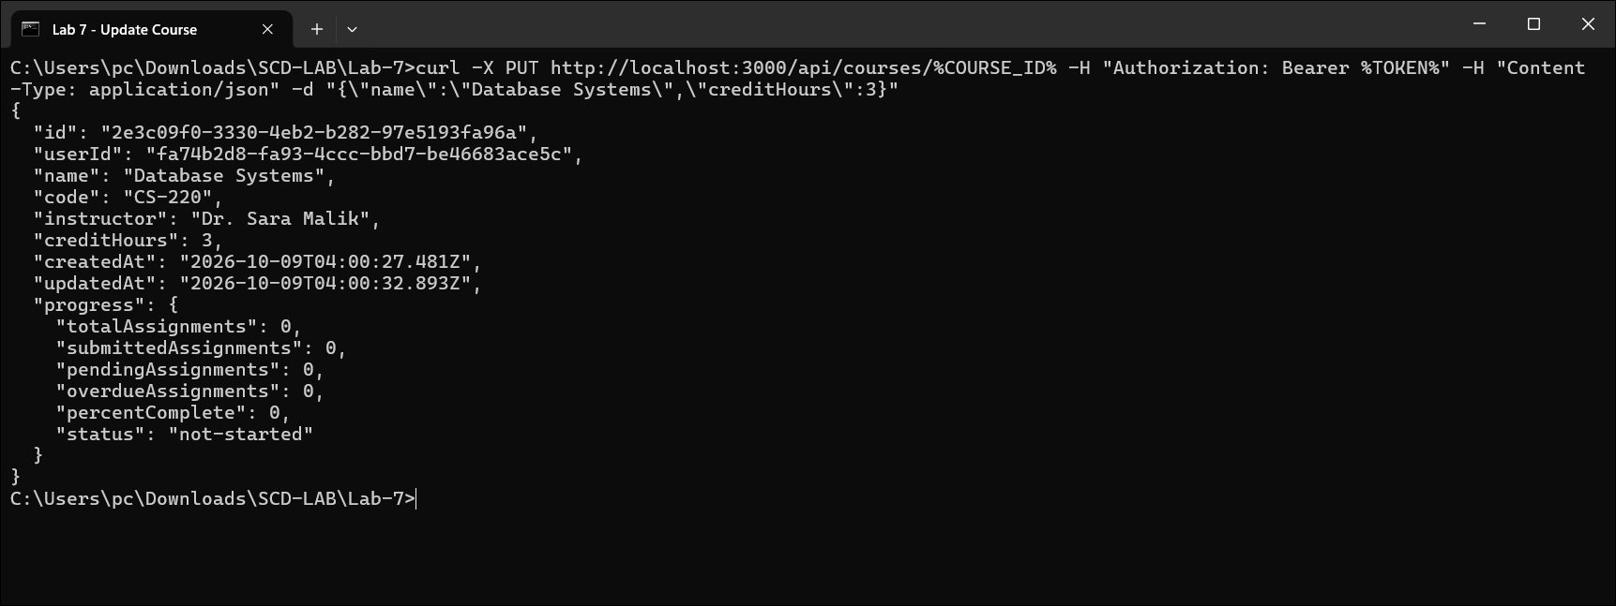

7. Course Management: Delete a Course
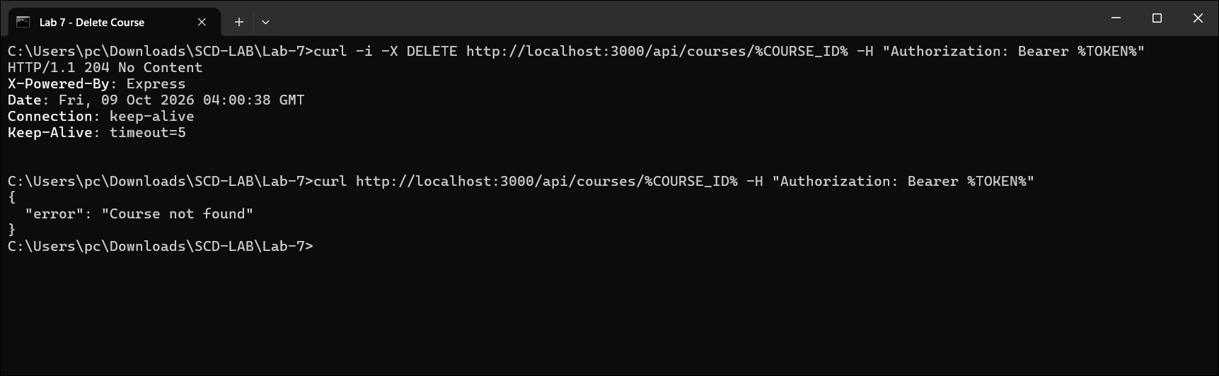

8. Assignment Management: Create an Assignment
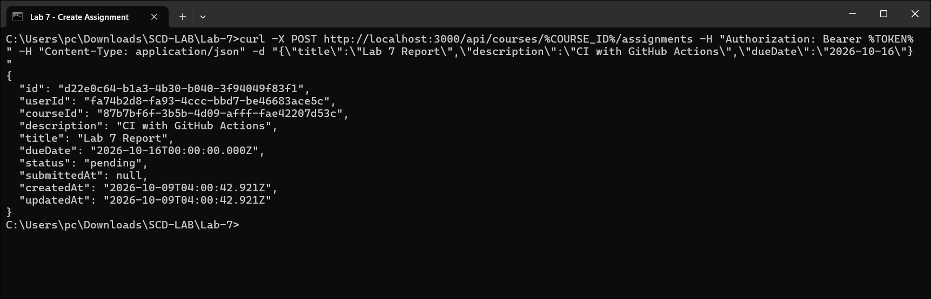

9. Assignment Management: View Course Assignments
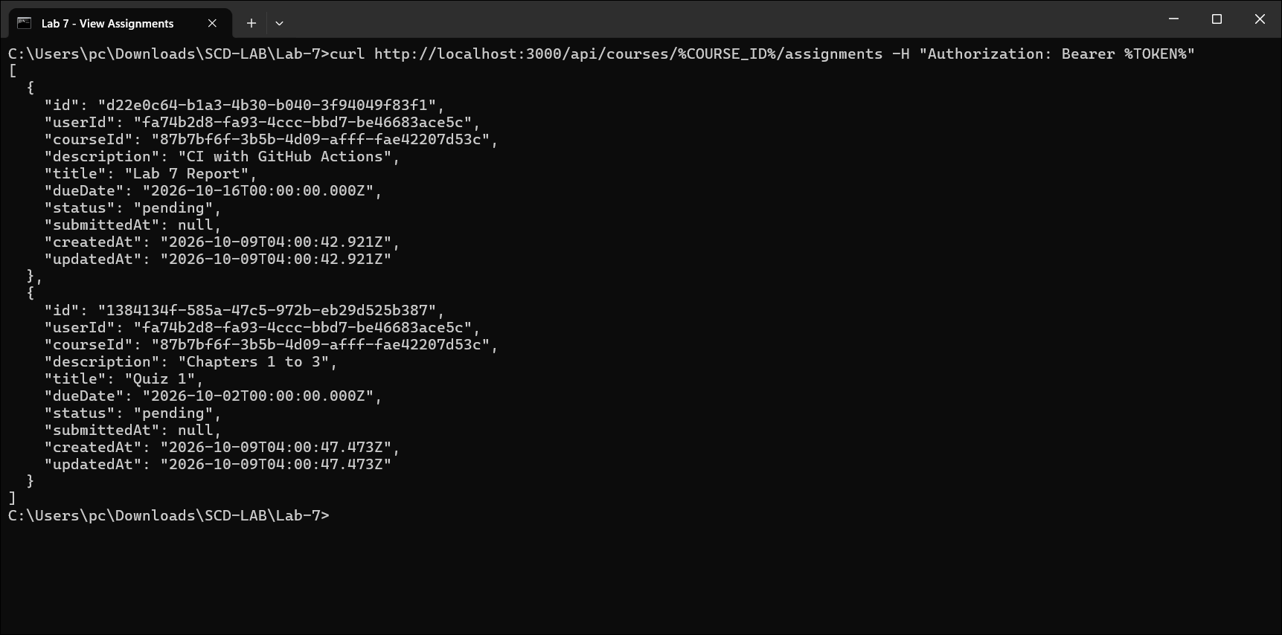

10. Assignment Management: Mark an Assignment as Submitted
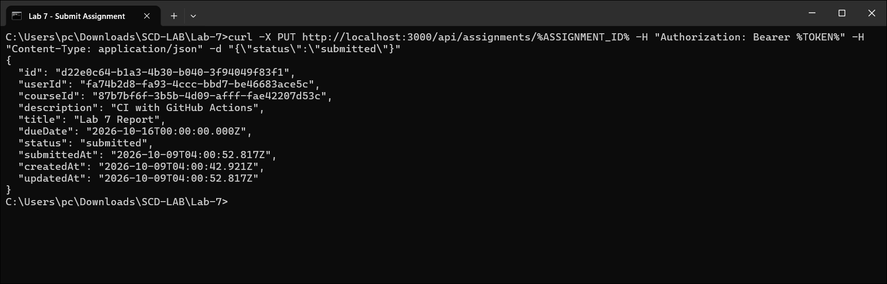

11. Progress Tracking: Course Progress
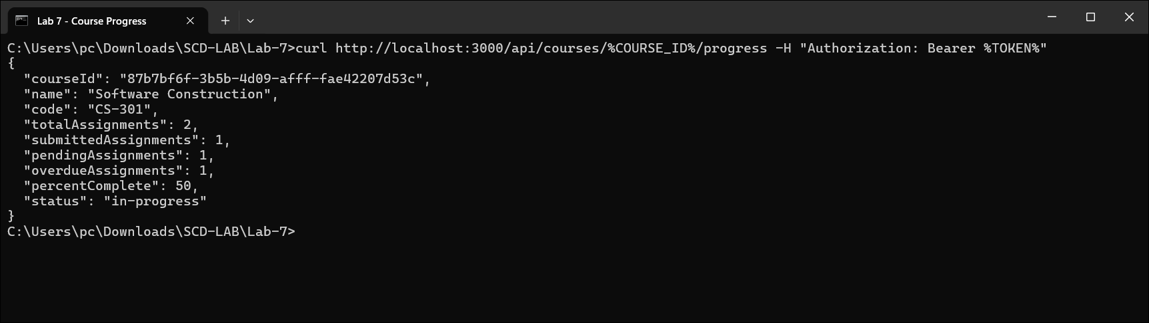

12. Progress Tracking: Overall Progress
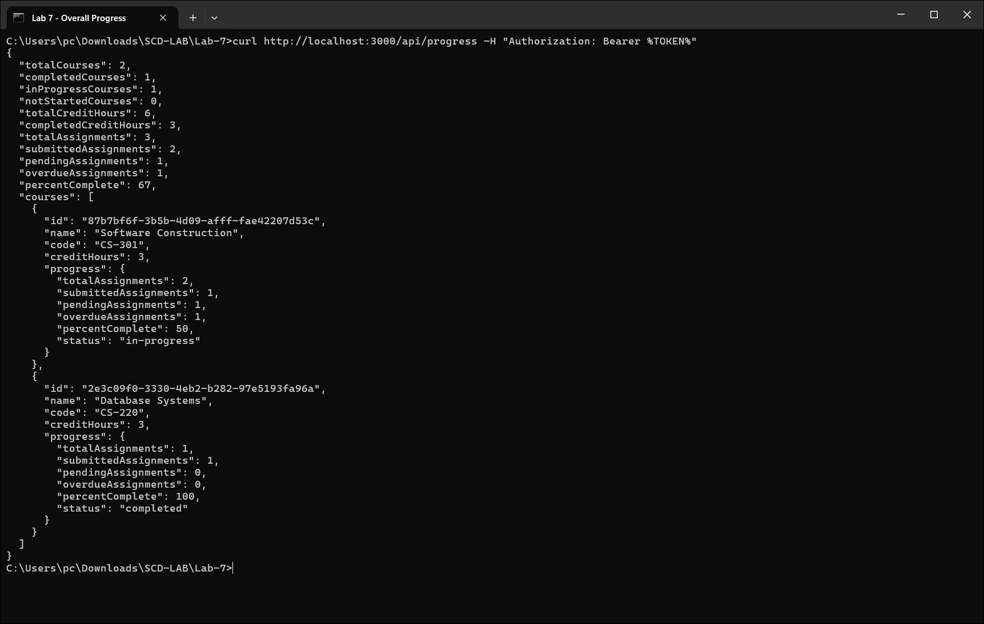

13. Course Filtering: By Course Code
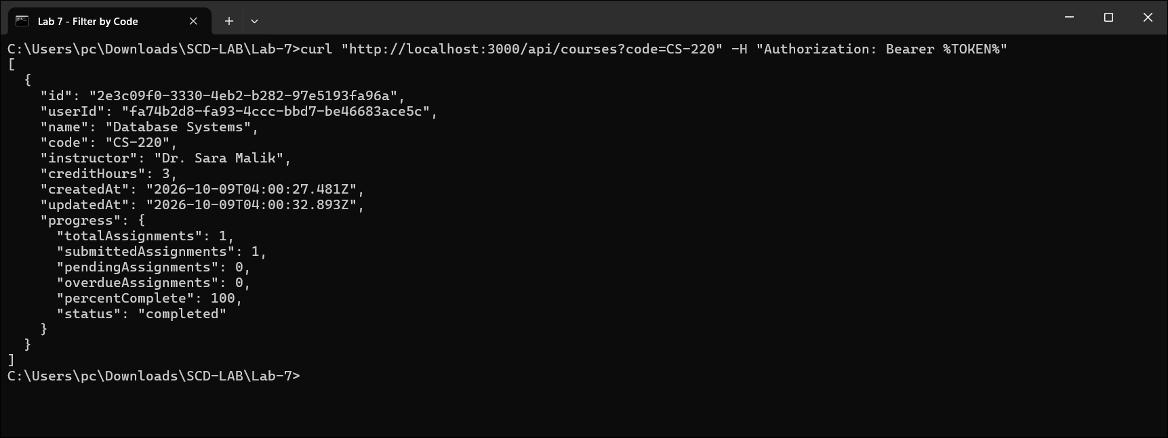

14. Course Filtering: By Instructor
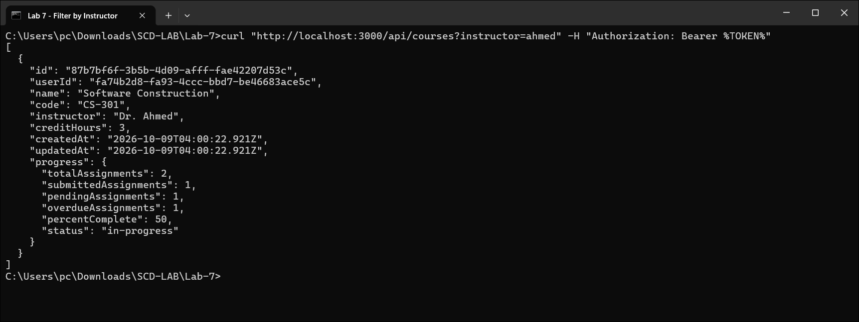

15. Course Filtering: By Completion Status
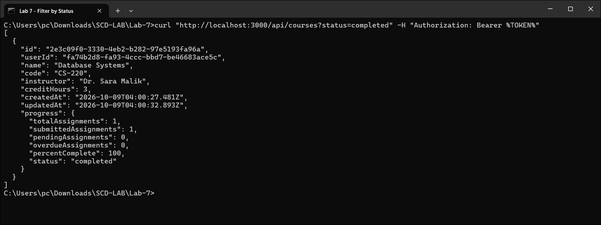

16. User Authentication: Protected Routes and Separate Data per Student
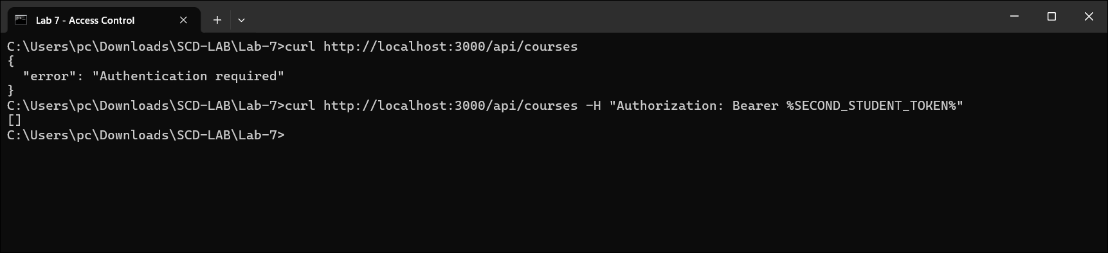

17. Automated Testing: Running the Test Suite
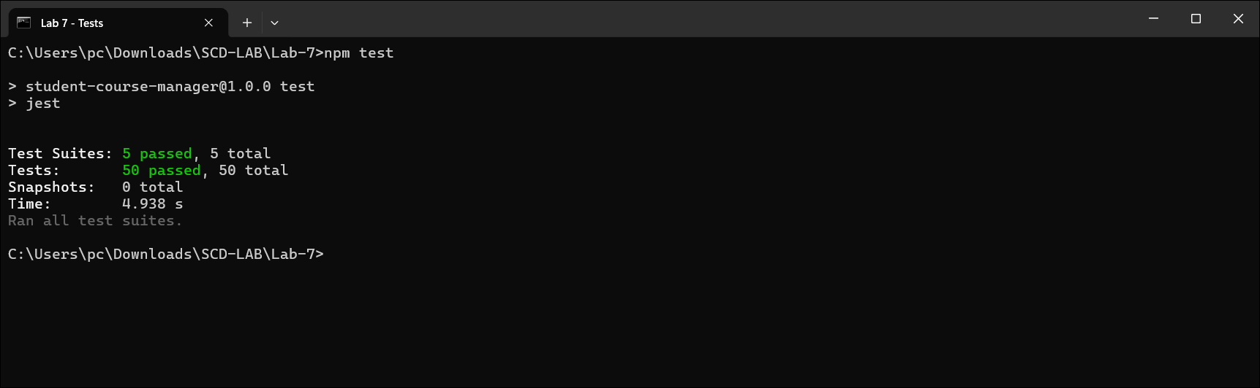

18. GitHub Actions: Workflow File
