SRE - Assignment 1
Technical Debt Inventory and Analysis
of the Python-Markdown code base
Group Report
# | Group member | Roll number | Individual files (Appendix A)
1 | Taha Yasir | i222429 | extensions/def_list.py, extensions/meta.py
2 | Khizar | i222595 | extensions/admonition.py, extensions/wikilinks.py
3 | Hadeed Abbas | i228780 | postprocessors.py, extensions/legacy_attrs.py

Report, analysis scripts and raw tool outputs: https://github.com/Taha9876/SRE-A1

Contents
1. Project Overview 3
1.1 Repository and version analysed 3
1.2 System description and purpose 3
1.3 Size and module count 3
2. Inventory Analysis 3
2.1 Project assets 3
2.2 Classification of assets 4
2.3 Quality metrics per module 4
2.4 Dependency mapping 5
3. Tool-Based Metrics 6
3.1 Cyclomatic complexity 6
3.2 Cognitive complexity 7
3.3 Code duplication 7
3.4 Test coverage 7
3.5 Bugs, vulnerabilities and code smells 8
3.6 Maintainability index 8
4. Debt Identification 8
4.1 Example of code debt: a deeply nested method (TD-01) 9
4.2 Example of design debt: one fix, two copies (TD-03) 9
4.3 Example of test debt: tests tied to one library release (TD-04) 9
4.4 Example of documentation debt (TD-05) 9
4.5 Example of infrastructure debt (TD-06) 10
5. Remediation Cost and Debt Ratio 10
5.1 Method 10
5.2 Tool outputs and cost per item 10
5.3 Technical Debt Ratio 10
6. Prioritization Strategy 11
6.1 Technique 1: hotspot analysis 11
6.2 Technique 2: weighted scoring model 12
6.3 Prioritised order and justification 12
7. Reflection 12
Appendix A. Individual Component: Manual Calculations 14
A.1 Member 1: Taha Yasir (i222429) 14
A.2 Member 2: Khizar (i222595) 18
A.3 Member 3: Hadeed Abbas (i228780) 22
Appendix B. Reproducing the Measurements 26

1. Project Overview

1.1 Repository and version analysed
Item | Value
Project | Python-Markdown (PyPI package Markdown)
Repository URL | https://github.com/Python-Markdown/markdown
Commit hash | 0bf535bc406c95dad66050f07c8402af03fe07d5
Commit position | 9 October 2026, branch master, 7 commits after release 3.11.0
Language / licence | Python (requires-python >= 3.11), BSD 3-Clause
History | Since March 2006; 1,672 commits, 191 contributors, 44 commits in the last 12 months
Our analysis repository | https://github.com/Taha9876/SRE-A1

1.2 System description and purpose
Python-Markdown converts Markdown text to HTML. It is used as a library, as the markdown_py command, and as the rendering engine of documentation tools such as MkDocs.
It is a five-stage pipeline run by the Markdown class: preprocessors clean the lines, the block parser builds an element tree, tree processors apply the inline patterns, a serializer writes HTML, and postprocessors restore stashed fragments. An extension API lets plug-ins add processors to any stage; 18 extensions ship with the package.

1.3 Size and module count
Business logic is the installable package markdown/. Tests, documentation and build files are not counted.
Measure (radon raw) | Core (14 modules) | Extensions (19 modules) | Package total
Physical lines of code (LOC) | 4,651 | 3,958 | 8,609
Source lines (SLOC: no blanks, comments, docstrings) | 2,279 | 2,172 | 4,451
Functions and methods | 207 | 190 | 397
Classes | 63 | 48 | 111

Selection criterion | Requirement | Python-Markdown | Met
Size | 5,000 - 12,000 LOC | 8,609 LOC (4,451 SLOC) | Yes
Structure | At least 10 classes / modules | 33 modules, 111 classes | Yes
Complexity | Non-trivial decision logic | 23 functions with cyclomatic complexity above 10; maximum 33 | Yes
Language | Java, Python, C#, C++ or React | Python 3 | Yes

2. Inventory Analysis

2.1 Project assets
Asset type | Location | Size | Content
Code - core | markdown/*.py | 14 modules, 4,651 LOC | Pipeline engine, HTML parser, serializers, util, CLI
Code - extensions | markdown/extensions/ | 19 modules, 3,958 LOC | Extension base class and 18 plug-ins
Tests | tests/ | 37 files, 14,667 LOC, 1,123 test cases | unittest suites plus 300 fixture files
Libraries - runtime | pyproject.toml | 0 mandatory, 2 optional | Standard library only; optional Pygments and PyYAML
Libraries - development | pyproject.toml, tox.ini | 3 test, 8 documentation | coverage, pyyaml, pytidylib; pinned docs tool chain
Configuration / build | repository root | 11 files | pyproject.toml, tox.ini, makefile, .coveragerc, mkdocs.yml, uv.lock and others
CI / process | .github/ | 6 workflows | Test matrix, changelog checks, docs deploy
Documentation | docs/, root *.md | 68 Markdown pages | User guide, extension reference, API guide, changelog
UI | markdown/__main__.py | 1 CLI module, 154 LOC | No graphical UI; command line markdown_py only

2.2 Classification of assets
Asset | Class | Evidence
core.py, __init__.py, __meta__.py, __main__.py | Active | Entry points and orchestrator
blockparser.py, blockprocessors.py, inlinepatterns.py, treeprocessors.py, preprocessors.py, htmlparser.py | Active | Default conversion path; touched by 31 of the 71 commits of the last three years
postprocessors.py | Active (part deprecated) | UnescapePostprocessor is marked @deprecated
util.py | Reusable | Generic Registry and helpers; imported by 16 modules
extensions/__init__.py | Reusable | Extension base class; imported by 20 modules
serializers.py | Reusable | Generic ElementTree-to-HTML writer with no internal dependency
test_tools.py | Reusable | TestCase helpers published for third-party extension authors
16 extensions (abbr, admonition, attr_list, codehilite, def_list, extra, fenced_code, footnotes, md_in_html, meta, nl2br, sane_lists, smarty, tables, toc, wikilinks) | Active | Registered entry points; documented and tested
extensions/legacy_attrs.py, extensions/legacy_em.py | Deprecated (legacy) | Kept only for documents written before version 3.0
AbbrPreprocessor, AbbrInlineProcessor, toc.get_name, toc.stashedHTML2text, attr_list.get_attrs, Markdown.docType | Deprecated | @deprecated decorator or a TODO marking it unused
tests/test_legacy.py and its 300 fixture files | Deprecated (legacy) | Older file-comparison tests
Other tests, documentation, CI, build configuration | Active | Maintained with each release

2.3 Quality metrics per module
CC = cyclomatic (radon); Cog = cognitive (complexipy); MI = maintainability index; Dup = duplicated lines (jscpd); Churn = commits in the last three years.
Module | LOC | SLOC | Fn | CC sum | CC max | Cog max | MI | Stmt % | Branch % | Dup | Churn
__init__.py | 48 | 5 | 0 | 0 | 0 | 0 | 100.0 | 100.0 | 100.0 | 0 | 0
__main__.py | 154 | 103 | 2 | 8 | 5 | 6 | 70.6 | 100.0 | 100.0 | 0 | 2
__meta__.py | 51 | 14 | 1 | 6 | 6 | 3 | 75.9 | 100.0 | 100.0 | 0 | 13
blockparser.py | 160 | 34 | 7 | 12 | 5 | 10 | 50.2 | 100.0 | 90.0 | 0 | 1
blockprocessors.py | 642 | 346 | 34 | 113 | 11 | 18 | 34.6 | 97.7 | 94.4 | 50 | 5
core.py | 531 | 197 | 12 | 41 | 10 | 14 | 48.9 | 100.0 | 94.7 | 32 | 5
extensions/__init__.py | 145 | 34 | 7 | 14 | 3 | 2 | 53.3 | 100.0 | 90.0 | 0 | 2
extensions/abbr.py | 199 | 115 | 15 | 37 | 10 | 18 | 59.5 | 93.3 | 91.2 | 16 | 11
extensions/admonition.py | 192 | 98 | 7 | 29 | 13 | 19 | 62.4 | 100.0 | 100.0 | 23 | 4
extensions/attr_list.py | 213 | 116 | 12 | 51 | 32 | 102 | 58.5 | 100.0 | 93.5 | 9 | 6
extensions/codehilite.py | 355 | 178 | 9 | 40 | 14 | 28 | 58.9 | 99.1 | 92.9 | 7 | 4
extensions/def_list.py | 128 | 63 | 5 | 21 | 17 | 19 | 69.9 | 96.6 | 100.0 | 12 | 3
extensions/extra.py | 66 | 18 | 3 | 3 | 1 | 0 | 100.0 | 100.0 | 100.0 | 0 | 0
extensions/fenced_code.py | 201 | 133 | 7 | 35 | 24 | 65 | 60.0 | 99.0 | 95.2 | 7 | 4
extensions/footnotes.py | 494 | 312 | 33 | 80 | 7 | 19 | 40.3 | 97.3 | 84.8 | 22 | 6
extensions/legacy_attrs.py | 78 | 27 | 5 | 11 | 7 | 9 | 79.3 | 100.0 | 100.0 | 12 | 2
extensions/legacy_em.py | 59 | 20 | 2 | 2 | 1 | 0 | 89.2 | 100.0 | 100.0 | 34 | 1
extensions/md_in_html.py | 458 | 291 | 22 | 123 | 25 | 94 | 32.9 | 98.0 | 92.0 | 38 | 9
extensions/meta.py | 93 | 47 | 4 | 13 | 10 | 17 | 78.4 | 100.0 | 90.0 | 7 | 4
extensions/nl2br.py | 49 | 10 | 2 | 2 | 1 | 0 | 100.0 | 100.0 | 100.0 | 7 | 2
extensions/sane_lists.py | 77 | 26 | 4 | 4 | 1 | 0 | 83.2 | 100.0 | 100.0 | 7 | 3
extensions/smarty.py | 295 | 151 | 10 | 17 | 5 | 4 | 65.8 | 100.0 | 78.6 | 8 | 6
extensions/tables.py | 255 | 155 | 10 | 53 | 14 | 26 | 51.6 | 100.0 | 98.6 | 28 | 4
extensions/toc.py | 496 | 323 | 26 | 98 | 14 | 25 | 37.0 | 94.5 | 91.7 | 11 | 5
extensions/wikilinks.py | 105 | 55 | 7 | 13 | 5 | 7 | 78.7 | 100.0 | 100.0 | 11 | 3
htmlparser.py | 460 | 290 | 28 | 101 | 14 | 19 | 36.5 | 99.0 | 90.0 | 9 | 15
inlinepatterns.py | 1052 | 524 | 48 | 142 | 33 | 58 | 25.9 | 99.5 | 94.9 | 36 | 11
postprocessors.py | 131 | 58 | 9 | 16 | 5 | 10 | 76.0 | 96.0 | 100.0 | 0 | 3
preprocessors.py | 91 | 30 | 4 | 4 | 1 | 0 | 82.4 | 100.0 | 100.0 | 0 | 1
serializers.py | 214 | 124 | 8 | 47 | 24 | 75 | 59.2 | 99.1 | 97.0 | 24 | 2
test_tools.py | 224 | 93 | 9 | 21 | 7 | 28 | 68.4 | 91.5 | 94.4 | 0 | 0
treeprocessors.py | 483 | 282 | 19 | 101 | 17 | 73 | 40.1 | 97.8 | 93.7 | 0 | 6
util.py | 410 | 179 | 26 | 51 | 9 | 9 | 52.2 | 96.0 | 97.4 | 0 | 5
Package total / worst | 8,609 | 4,451 | 397 | 1,309 | 33 | 102 | 25.9 | 98.1 | 93.4 | 205 | 71

2.4 Dependency mapping
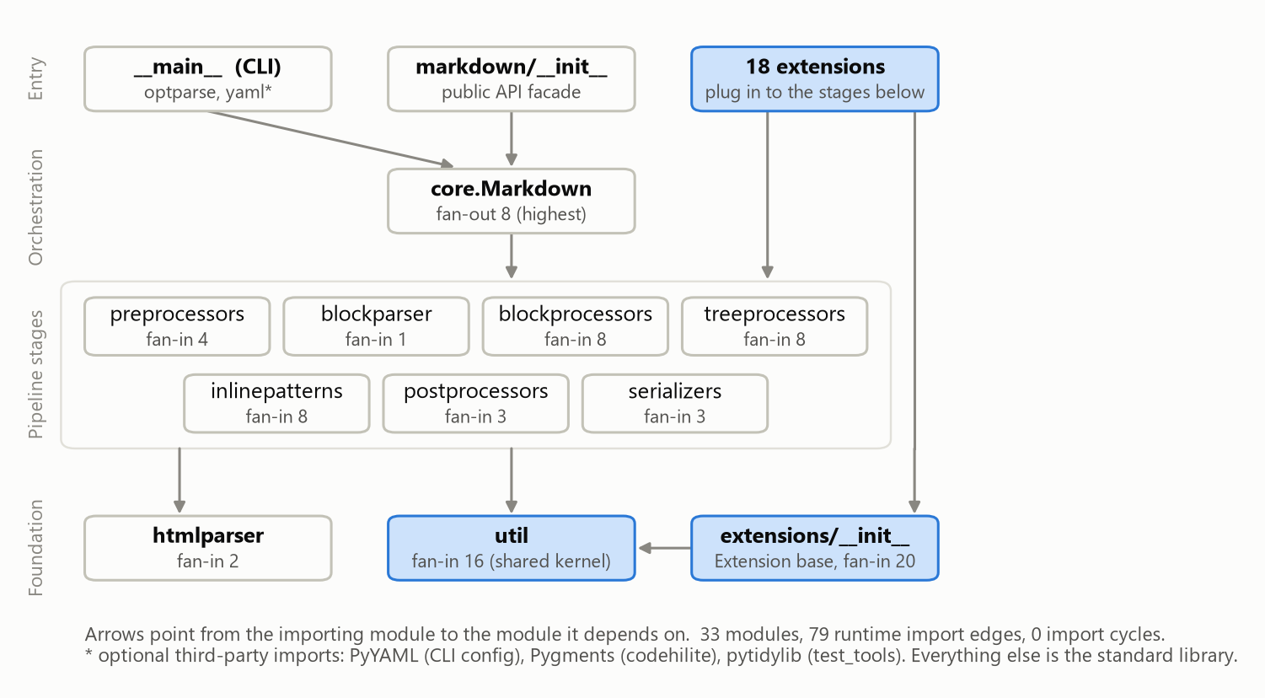
Figure 1. Layered view of the internal dependencies
Module | Fan-in (Ca) | Fan-out (Ce) | Instability Ce / (Ca + Ce) | Depends on
extensions | 20 | 1 | 0.05 | util
util | 16 | 0 | 0.00 | (nothing internal)
blockprocessors | 8 | 2 | 0.20 | blockparser, util
inlinepatterns | 8 | 1 | 0.11 | util
treeprocessors | 8 | 2 | 0.20 | inlinepatterns, util
core | 1 | 8 | 0.89 | blockprocessors, extensions, inlinepatterns, postprocessors, preprocessors, serializers, treeprocessors, util
extensions.fenced_code | 0 | 6 | 1.00 | extensions, extensions.attr_list, extensions.codehilite, preprocessors, serializers, util

- No cycles: 33 modules, 79 import edges, 0 import cycles.
- Healthy direction: stable modules (util 0.00, Extension base 0.05) are depended on; every extension (1.00) depends on them.
- Concentration risk: util has fan-in 16, so a change there reaches half of the code.
- Hidden coupling: wikilinks reads Markdown.Meta, an attribute only the meta extension creates.
- External: standard library only at run time; Pygments, PyYAML and pytidylib are optional.

3. Tool-Based Metrics
We could not keep a SonarQube server running on the analysis laptop, so we used the open-source tools below, as the assignment permits. Section 5 applies SonarQube's SQALE formula for the debt ratio.
Metric | Tool (version) | Result
Cyclomatic complexity | radon cc (6.0.1) | total 1,309; mean 3.30; maximum 33; 23 functions above 10
Cognitive complexity | complexipy (8.0.1) | total 1,743; mean 4.56; maximum 102; 26 functions above 15
Code duplication | jscpd (5.4.0) | 2.38 % of lines (205 lines, 26 clone pairs)
Test coverage - statement | coverage.py (7.16.2) | 98.07 % (3,514 of 3,583)
Test coverage - branch | coverage.py (7.16.2) | 93.44 % (1,211 of 1,296)
Bugs | pylint (4.1.2) | 0 errors; 20 reliability warnings
Vulnerabilities | bandit (1.9.4) | 0 high, 0 medium, 25 low
Code smells | pylint, flake8 (7.4.1), vulture (2.16) | 761 pylint messages; score 8.03 / 10
Maintainability index | radon mi (6.0.1) | mean 63.0; lowest 25.9; all modules rank A

3.1 Cyclomatic complexity
Most functions are simple: 336 of 397 (85 %) are rank A and the median is 2. The debt is in the tail: 23 functions exceed 10 and 9 exceed 15.
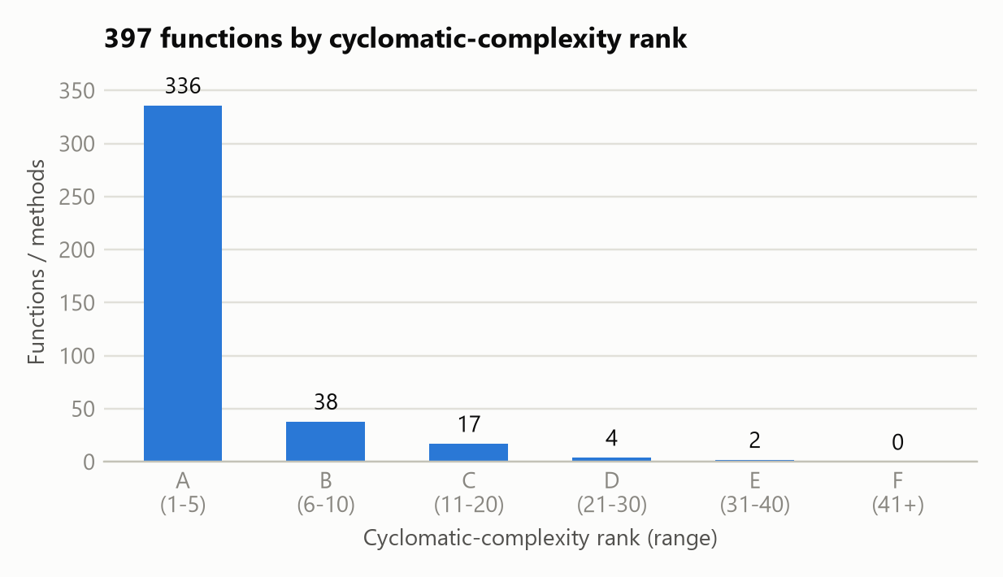
Figure 2. Distribution of cyclomatic complexity (radon ranks)

3.2 Cognitive complexity
26 functions exceed SonarQube's limit of 15 and 14 exceed 25. The ten worst:
Function | Module | Lines | Cyclomatic | Cognitive
AttrListTreeprocessor.run | extensions/attr_list.py | 103-161 | 32 | 102
HTMLExtractorExtra.handle_endtag | extensions/md_in_html.py | 160-246 | 25 | 94
_serialize_html | serializers.py | 119-192 | 24 | 75
InlineProcessor.__processPlaceholders | treeprocessors.py | 172-251 | 12 | 73
FencedBlockPreprocessor.run | extensions/fenced_code.py | 91-171 | 24 | 65
LinkInlineProcessor.getLink | inlinepatterns.py | 772-886 | 33 | 58
HTMLExtractorExtra.handle_starttag | extensions/md_in_html.py | 110-158 | 23 | 41
MarkdownInHtmlProcessor.parse_element_content | extensions/md_in_html.py | 328-399 | 14 | 37
InlineProcessor.__applyPattern | treeprocessors.py | 253-335 | 17 | 36
InlineProcessor.run | treeprocessors.py | 348-419 | 16 | 35

AttrListTreeprocessor.run and getLink have nearly equal cyclomatic complexity (32 and 33), but the first is nested six levels deep, so its cognitive complexity is almost double.

3.3 Code duplication
2.38 % of lines are duplicated (205 lines in 26 clone pairs), below SonarQube's 3 % gate. The clones that matter:
Clone | Location A | Location B
HTML escaping of &, <, > | serializers.py 70-78, 85-92 | extensions/toc.py 120-127; util.py 158-168
Workaround for CPython bug gh-77057 | htmlparser.py 372-380 | extensions/md_in_html.py 292-302
Split a block around a match | blockprocessors.py 594-606 | extensions/abbr.py 167-179; extensions/footnotes.py 286-300
Attribute escaping | serializers.py 83-94 | serializers.py 102-113

3.4 Test coverage
Statement coverage is 98.07 % (69 of 3,583 statements missed) and branch coverage is 93.44 % (85 of 1,296 missed), from the project's 1,123 tests.
This needed two combined runs. The code-highlighting tests skip unless Pygments is exactly 2.7.1; in a normal environment 111 tests are skipped and codehilite.py drops to 11 % (overall 94 %).
Module (lowest branch coverage) | Statement % | Branch % | Missed statements | Missed branches
extensions/smarty.py | 100.0 | 78.6 | 0 | 3
extensions/footnotes.py | 97.3 | 84.8 | 7 | 14
blockparser.py | 100.0 | 90.0 | 0 | 1
extensions/__init__.py | 100.0 | 90.0 | 0 | 1
extensions/meta.py | 100.0 | 90.0 | 0 | 1

3.5 Bugs, vulnerabilities and code smells
Category | Tool and rule | Count | Assessment
Bugs (confirmed) | pylint error / fatal | 0 | None provable statically
Bugs (potential) | super-init-not-called | 8 | Base initialiser skipped
 | arguments-differ, arguments-renamed | 6 | Override changes the base signature
 | inconsistent-return-statements | 5 | Value on some paths, None on others
 | deprecated-method | 1 | logger.warn() at blockprocessors.py:490
Vulnerabilities | bandit B405 (xml.etree import) | 20 | False positives: no XML input is parsed
 | bandit B101 (assert) | 5 | Low: removed under python -O
Code smells | pylint convention | 554 | line-too-long 196, invalid-name 152, missing docstrings 62
 | pylint refactor | 93 | no-else-return 24, too-many-branches 12
 | pylint warning (remaining) | 98 | attribute-defined-outside-init 36, redefined-builtin 29
 | flake8 | 4 | But 17 modules switch flake8 off file-wide (Section 4.4)
 | vulture (dead code) | 1 | One unused variable

3.6 Maintainability index
All 33 modules are rank A (above 19) with a mean of 63.0, but the spread is wide: seven modules holding 47 % of the lines score below 41.
Module (lowest MI) | MI | LOC | Functions | CC sum
inlinepatterns.py | 25.9 | 1052 | 48 | 142
extensions/md_in_html.py | 32.9 | 458 | 22 | 123
blockprocessors.py | 34.6 | 642 | 34 | 113
htmlparser.py | 36.5 | 460 | 28 | 101
extensions/toc.py | 37.0 | 496 | 26 | 98

4. Debt Identification
ID | Debt type | Weakness | Evidence
TD-01 | Code debt | Over-complex functions | 26 functions above cognitive 15; worst AttrListTreeprocessor.run (CC 32, cognitive 102)
TD-02 | Design debt | Oversized module | inlinepatterns.py: 1,052 lines, 24 classes, lowest MI (25.9)
TD-03 | Design debt | Duplicated logic | 26 clone pairs; escaping helper exists three times
TD-04 | Test debt | Pinned tests, branch gaps | 111 tests skip unless Pygments is 2.7.1; 85 uncovered branches; 88 pragma: no cover
TD-05 | Documentation debt | Undocumented or misleading code | 62 missing docstrings (17 in htmlparser.py); stale TODOs
TD-06 | Infrastructure debt | Stale version workarounds | Workaround "until we drop Python < 3.13" in two files; CLI on optparse
TD-07 | Design debt (obsolescence) | Deprecated and dead code | 10 items still shipped
TD-08 | Code debt | Inconsistent naming | 152 invalid-name: camelCase beside snake_case
TD-09 | Code debt | Lint findings, suppressed checks | 281 other pylint findings; 17 modules exempt from flake8
TD-10 | Security debt | Assertions as run-time checks | 5 assert statements in production paths

4.1 Example of code debt: a deeply nested method (TD-01)
AttrListTreeprocessor.run (extensions/attr_list.py, lines 103-161) repeats the same block three times at nesting depth five:
119 if pos is None and elem[-1].tail:
121 m = RE.search(elem[-1].tail)
122 if m:
123 if not self.assign_attrs(elem, m.group(1), strict=True):
124 elem[-1].tail = elem[-1].tail[:m.start()]
125 elif pos is not None and pos > 0 and elem[pos-1].tail:
127 m = RE.search(elem[pos-1].tail)
128 if m:
129 if not self.assign_attrs(elem, m.group(1), strict=True):
130 elem[pos-1].tail = elem[pos-1].tail[:m.start()]
131 elif elem.text: ... # the same block a third time

Result: cyclomatic 32, cognitive 102 (almost seven times the limit), four branches untested.

4.2 Example of design debt: one fix, two copies (TD-03)
The same workaround is in htmlparser.py (line 372) and extensions/md_in_html.py (line 292):
if self.rawdata[i:i+3] == '<![' and not self.rawdata[i:i+9] == '<![CDATA[':
# We have encountered the bug in #1534 (Python bug `gh-77057`).
# Provide an override until we drop support for Python < 3.13.
result = self.parse_bogus_comment(i)

Both are among the five most-changed files, and 11 of the 15 commits to htmlparser.py were bug fixes, so every parser fix has to be made twice.

4.3 Example of test debt: tests tied to one library release (TD-04)
# tests/test_syntax/extensions/test_code_hilite.py
def setUp(self):
if has_pygments and pygments.__version__ != required_pygments_version:
self.skipTest(f'Pygments=={required_pygments_version} is required')

The expected HTML was captured from Pygments 2.7.1 (2020). With any other version the suite still passes while 111 tests are silently skipped, so a regression from a newer Pygments goes unnoticed.

4.4 Example of documentation debt (TD-05)
- htmlparser.py, the most-changed file: 18 of its 28 functions have no docstring.
- core.py:119: # TODO: Maybe delete this. It does not appear to be used anymore. on a public attribute.
- 17 modules contain # flake8: noqa: E501 116-119. It reads as an exemption for four lines, but we tested it and flake8 then reports nothing for the whole file.

4.5 Example of infrastructure debt (TD-06)
htmlparser.py:169 still says "TODO: remove this when the bug is fixed in all supported Python versions", and the override in 4.2 waits for Python 3.13. Nothing links these workarounds to the supported-version setting, so they outlive their purpose.

5. Remediation Cost and Debt Ratio

5.1 Method
We applied the SQALE method used by SonarQube. The effort per finding is our own calibration; overlapping findings are costed once.
Remediation cost = SUM over findings ( effort to fix the finding )
Development cost = SLOC x 30 minutes (SonarQube default: 30 min per line of code)
Technical Debt Ratio = Remediation cost / Development cost x 100 %

5.2 Tool outputs and cost per item
# | Finding (tool output) | Debt type | Count | Effort rule | Minutes
R1 | Functions with cognitive complexity above 15 | Code debt | 26 functions | 5 min + 1 min per point above 15 | 703
R2 | Duplicated blocks | Design debt | 26 clone pairs | 20 min per clone pair | 520
R3 | Uncovered statements | Test debt | 69 lines | 2 min per line | 138
R4 | Uncovered branches | Test debt | 85 branches | 5 min per branch | 425
R5 | Tests pinned to Pygments 2.7.1 | Test debt | 1 test design issue | fixed estimate, 4 h | 240
R6 | Missing docstrings | Documentation debt | 62 definitions | 5 min each | 310
R7 | Non-PEP 8 names in the public API | Code debt | 85 names | 15 min each (alias + shim) | 1,275
R8 | Non-PEP 8 local names | Code debt | 67 names | 2 min each | 134
R9 | Other pylint findings | Code debt | 281 findings | 1-20 min each, by rule | 988
R10 | Lines over 119 columns | Code debt | 62 lines | 1 min each | 62
R11 | Security findings | Security debt | 25 findings | 10 min per assert, 2 min per review | 90
R12 | Oversized inlinepatterns.py | Design debt | 1 module | fixed estimate, 8 h | 480
R13 | Deprecated or dead code | Design debt | 10 items | 15 min each | 150
R14 | Stale Python-version workarounds | Infrastructure debt | 3 workarounds | 30 min each | 90
 | Total remediation cost |  |  | 93.4 h = 11.7 person-days | 5,605

Example (R1): handle_endtag has cognitive complexity 94, so 5 + (94 - 15) = 84 minutes.
Debt type | Minutes | Hours | Share
Code debt | 3,162 | 52.7 | 56 %
Design debt | 1,150 | 19.2 | 21 %
Test debt | 803 | 13.4 | 14 %
Documentation debt | 310 | 5.2 | 6 %
Security debt | 90 | 1.5 | 2 %
Infrastructure debt | 90 | 1.5 | 2 %

5.3 Technical Debt Ratio
Remediation cost = 5,605 min (93.4 hours)
Development cost = 4,451 SLOC x 30 min = 133,530 min (2,225.5 hours)
TDR = 5,605 / 133,530 x 100 = 4.20 %

SQALE maintainability rating | A | B | C | D | E
Technical Debt Ratio | up to 5 % | 6 - 10 % | 11 - 20 % | 21 - 50 % | above 50 %
Python-Markdown | 4.2 %

Justification. 4.2 % is rating A, consistent with 97 % coverage, 2.4 % duplication and no import cycles. Three qualifications:
- Size base: we used SLOC as SonarQube does; with all 8,609 physical lines the ratio would be 2.2 %.
- Concentration: five of the 33 modules hold 61 % of the over-threshold cognitive complexity.
- Not all should be repaid: R7 (23 % of the total) means renaming public methods, which would break third-party extensions.

6. Prioritization Strategy

6.1 Technique 1: hotspot analysis
A hotspot is code that is both complex and often changed. Score = commits touching the module in the last three years (git log, 71 commits) x its cognitive complexity.
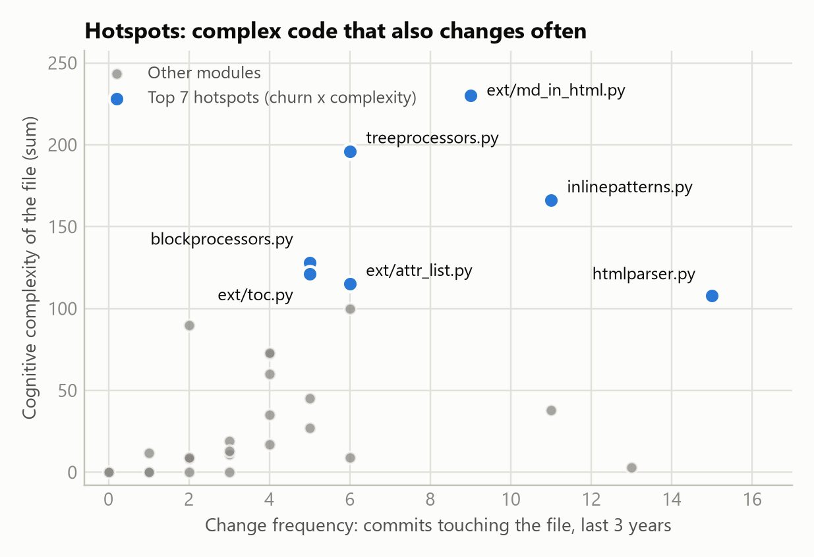
Figure 3. Change frequency against cognitive complexity per module
Rank | Module | Commits | Fixes | Cognitive | Score | Worst function (cognitive)
1 | extensions/md_in_html.py | 9 | 2 | 230 | 2,070 | HTMLExtractorExtra.handle_endtag (94)
2 | inlinepatterns.py | 11 | 3 | 166 | 1,826 | LinkInlineProcessor.getLink (58)
3 | htmlparser.py | 15 | 11 | 108 | 1,620 | HTMLExtractor.parse_starttag (19)
4 | treeprocessors.py | 6 | 4 | 196 | 1,176 | InlineProcessor.__processPlaceholders (73)
5 | extensions/attr_list.py | 6 | 1 | 115 | 690 | AttrListTreeprocessor.run (102)
6 | blockprocessors.py | 5 | 2 | 128 | 640 | ParagraphProcessor.run (18)

The top four modules hold 40 % of the cognitive complexity and were touched by 32 of the 71 commits. In htmlparser.py, 11 of 15 commits were fixes. _serialize_html is the third most complex function but its file changed only twice, so it is not a priority.

6.2 Technique 2: weighted scoring model
Each debt item is scored 1 to 5 on four criteria: Impact on users (weight 0.30), Risk of defects (0.25), Change frequency of the affected code (0.25) and Ease of repayment (0.20).
Rank | Item | Debt | Impact | Risk | Change | Ease | Score | Evidence
1 | TD-01 | Over-complex functions | 5 | 5 | 5 | 2 | 4.40 | Worst functions are in the four hotspots
2 | TD-03 | Duplicated logic | 3 | 4 | 4 | 4 | 3.70 | Parser fix duplicated in two hotspot files
3 | TD-04 | Pinned tests and branch gaps | 4 | 4 | 3 | 3 | 3.55 | 111 skipped tests hide regressions
4 | TD-02 | Oversized inlinepatterns.py | 3 | 3 | 5 | 2 | 3.30 | 11 commits in 3 years, MI 25.9
5 | TD-06 | Stale version workarounds | 2 | 3 | 5 | 3 | 3.20 | In htmlparser.py; partly blocked until 3.13
6 | TD-05 | Missing documentation | 2 | 2 | 4 | 5 | 3.10 | 18 undocumented functions in htmlparser.py
7 | TD-10 | Assertions as run-time checks | 3 | 2 | 2 | 5 | 2.90 | 5 statements, 50 minutes
8 | TD-07 | Deprecated and dead code | 2 | 2 | 2 | 5 | 2.60 | 150 minutes
9 | TD-09 | Lint findings | 1 | 2 | 3 | 4 | 2.35 | Mostly automatic fixes
10 | TD-08 | Naming inconsistency | 2 | 1 | 2 | 1 | 1.55 | Renaming breaks third-party extensions

6.3 Prioritised order and justification
Both techniques put the same thing first: the top-scoring item (TD-01) lies in the top-ranked hotspot modules.
Order | Action | Items | Effort | Why now
1 | Refactor the ten over-threshold functions in the four hotspot modules | TD-01 (part) | 6 h | Top of both rankings
2 | Merge the duplicated parser workaround and escaping helpers | TD-03 (part) | 2 h | Cheap; prevents half-applied fixes
3 | Unpin the Pygments tests; cover smarty and footnotes branches | TD-04 | 13 h | Safety net before step 5
4 | Replace asserts, delete dead code, document htmlparser.py | TD-10, TD-07, TD-05 | 9 h | Quick wins
5 | Split inlinepatterns.py; refactor the remaining complex functions | TD-02, TD-01 (rest) | 14 h | Valuable but risky
6 | Remove version workarounds when Python 3.13 is the minimum | TD-06 | 1.5 h | Blocked until then
7 | Fix lint findings when a file is edited anyway | TD-09 | 17 h | No user impact
- | Do not rename the camelCase public API | TD-08 | (21 h avoided) | Breaks third-party extensions

Steps 1 to 4 take about 30 hours, one third of the total remediation cost.

7. Reflection

Lessons learned
- Averages hide debt. Mean complexity 3.3 and 97 % coverage look healthy; the debt sits in 6 % of the functions and four files.
- One metric is not enough. Two functions with equal cyclomatic complexity differed twofold in cognitive complexity; coverage was 94 % or 97 % depending on one environment variable.
- History is a metric. Change frequency turned a list of complex functions into a ranking.

Trade-offs considered
- Compatibility against cleanliness. camelCase names and legacy extensions exist because third-party extensions depend on them, so we costed that debt but advise against repaying it.
- Risk against benefit. The parser needs refactoring most and is the most fix-prone, so test debt is ranked ahead of the large structural change.
- Precision. Our effort constants are estimates, so we rely on the ranking more than on the 4.2 % figure.

Implications for maintenance and evolution
- Manage debt where change happens: a CI rule against raising complexity in hotspot files costs almost nothing.
- Workarounds need an expiry: tie each to the minimum supported Python version in the release checklist.
- Suppressions (noqa, pragma: no cover) are debt too and should be reviewed like code.

Appendix A. Individual Component: Manual Calculations
Each member calculated the three metrics by hand for two files. The scanned handwritten sheets follow each member's summary. Rules used:
- Cyclomatic complexity: decision points + 1 per function (if, elif, for, while, except, each and / or, comprehension for / if, conditional expression).
- Cognitive complexity (SonarSource): +1 per if, elif, else, loop, except, conditional expression and boolean-operator sequence, plus +1 per nesting level for if, loops, except and conditional expressions.
- Comment density (SonarQube): comment lines / (comment lines + code lines) x 100; docstrings count as comments, blank lines are excluded.

A.1 Member 1: Taha Yasir (i222429)
File | Lines | Blank | # comment | Docstring | Code | Comment density
extensions/def_list.py | 128 | 29 | 18 | 18 | 63 | 36 / (36 + 63) = 36.4 %
extensions/meta.py | 93 | 22 | 11 | 13 | 47 | 24 / (24 + 47) = 33.8 %

File | Function | Cyclomatic | Cognitive
extensions/def_list.py | DefListProcessor.run | 17 | 17
 | 4 other functions with no decision point | 4 x 1 | 0
 | File total (hand) | tool cross-check | 21 | 21 | 17 | 19
extensions/meta.py | MetaPreprocessor.run | 10 | 17
 | 3 other functions with no decision point | 3 x 1 | 0
 | File total (hand) | tool cross-check | 13 | 13 | 17 | 17

Interpretation: extensions/def_list.py
Risks. One method holds the complexity: DefListProcessor.run has cyclomatic 17 (rank C); the other four functions have 1. It is driven by compound conditions (six and operators) and a state variable set in three places, and it returns False on one path and nothing on the others.
Debt and maintenance. Code debt with a documentation side: density is 36.4 %, but 15 of the 36 comment lines are licence header and a registration table, and run has no docstring. The file changed three times in three years, so interest is low; two extracted helpers would bring run under 10. The tool reports cognitive 19 against 17 by hand because it also counts the list comprehension on lines 43-44.

Interpretation: extensions/meta.py
Risks. MetaPreprocessor.run is a hand-written line parser: a while loop with two break statements, try / except KeyError used as normal control flow, and three levels of nesting. Cognitive complexity (17) is well above cyclomatic (10), so nesting is the problem. Branch coverage is 90 %: a document that ends inside the metadata block is untested.
Debt and maintenance. Design debt: MetaExtension.reset creates Markdown.Meta on an object it does not own, and wikilinks.py reads it with hasattr. Two extensions are coupled through an attribute no class declares, so a change to the metadata format can break a reader the maintainer cannot find.

Handwritten calculations: Taha Yasir, sheet 1 of 3
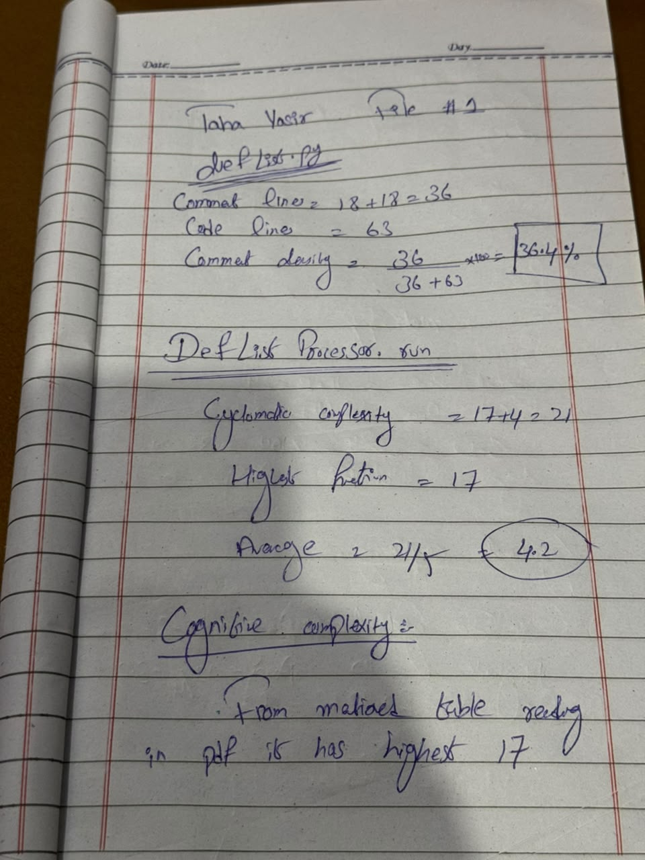
def_list.py: comment density, cyclomatic and cognitive complexity

Handwritten calculations: Taha Yasir, sheet 2 of 3
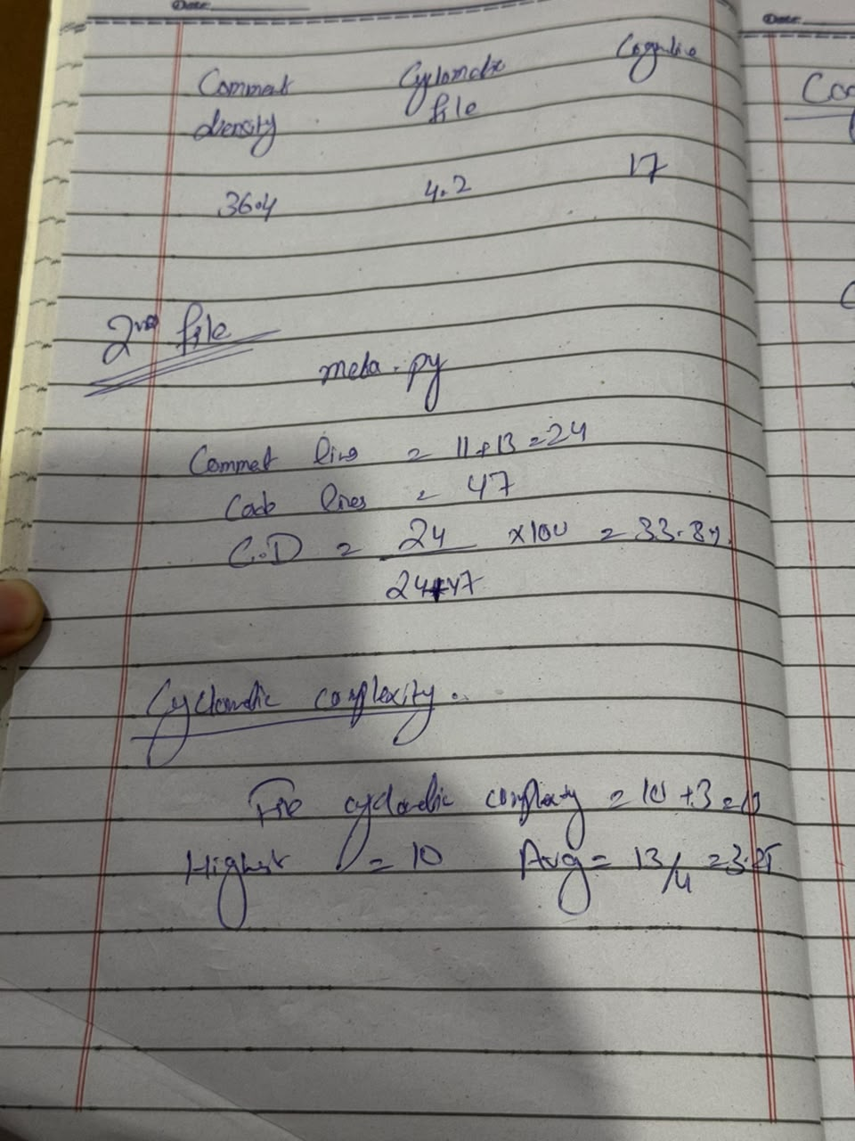
def_list.py summary; meta.py: comment density and cyclomatic complexity

Handwritten calculations: Taha Yasir, sheet 3 of 3
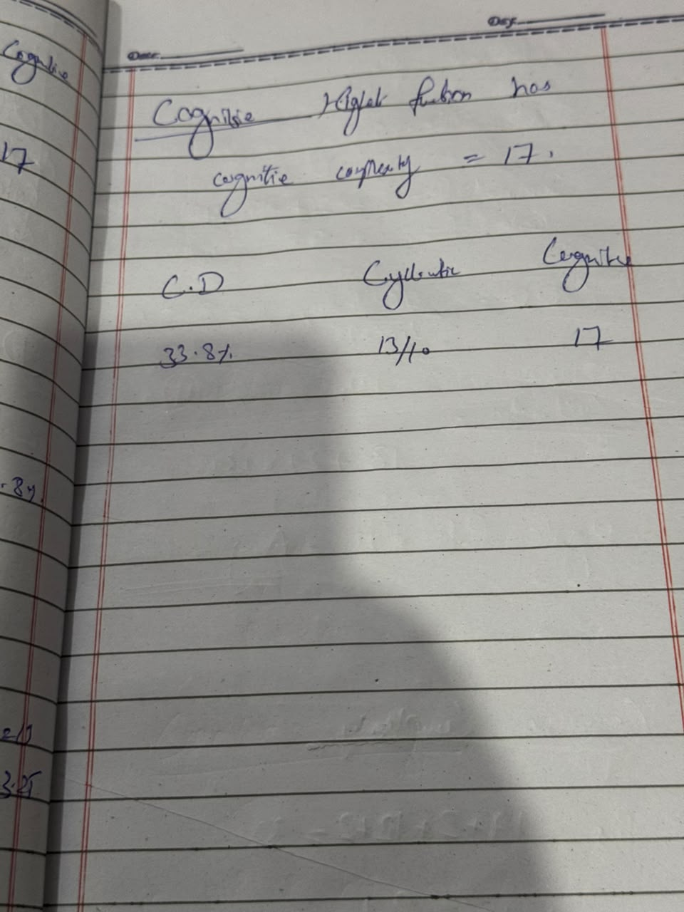
meta.py: cognitive complexity and summary

A.2 Member 2: Khizar (i222595)
File | Lines | Blank | # comment | Docstring | Code | Comment density
extensions/admonition.py | 192 | 48 | 27 | 19 | 98 | 46 / (46 + 98) = 31.9 %
extensions/wikilinks.py | 105 | 25 | 10 | 15 | 55 | 25 / (25 + 55) = 31.2 %

File | Function | Cyclomatic | Cognitive
extensions/admonition.py | AdmonitionProcessor.parse_content | 13 | 19
 | AdmonitionProcessor.test | 2 | 2
 | AdmonitionProcessor.run | 8 | 12
 | AdmonitionProcessor.get_class_and_title | 3 | 2
 | 3 other functions with no decision point | 3 x 1 | 0
 | File total (hand) | tool cross-check | 29 | 29 | 35 | 35
extensions/wikilinks.py | WikiLinksInlineProcessor.handleMatch | 3 | 4
 | WikiLinksInlineProcessor._getMeta | 5 | 7
 | 5 other functions with no decision point | 5 x 1 | 0
 | File total (hand) | tool cross-check | 13 | 13 | 11 | 11

Interpretation: extensions/admonition.py
Risks. parse_content (cyclomatic 13, cognitive 19) nests a four-part and and a conditional expression inside a while loop; the conditional expression alone costs four points at nesting level 3. test() stores current_sibling and content_indent for run(), so the two methods are only correct when called in that order.
Debt and maintenance. Code debt plus design debt (a hidden calling protocol). The class and three methods have no docstring and the comment on line 159 is garbled, so the 31.9 % density overstates the documentation. Statement and branch coverage are both 100 %, which makes refactoring safe.

Interpretation: extensions/wikilinks.py
Risks. Low: every function is rank A and the highest cyclomatic value is 5. _getMeta repeats the same if 'wiki_...' in self.md.Meta block three times, and handleMatch returns an Element on one path and an empty string on the other.
Debt and maintenance. Mild design debt: the file depends on the meta extension through the undeclared Markdown.Meta attribute. Fixing everything would take about half an hour and the file changed three times in three years, so it is low priority and a baseline for a low-debt extension.

Handwritten calculations: Khizar, sheet 1 of 3
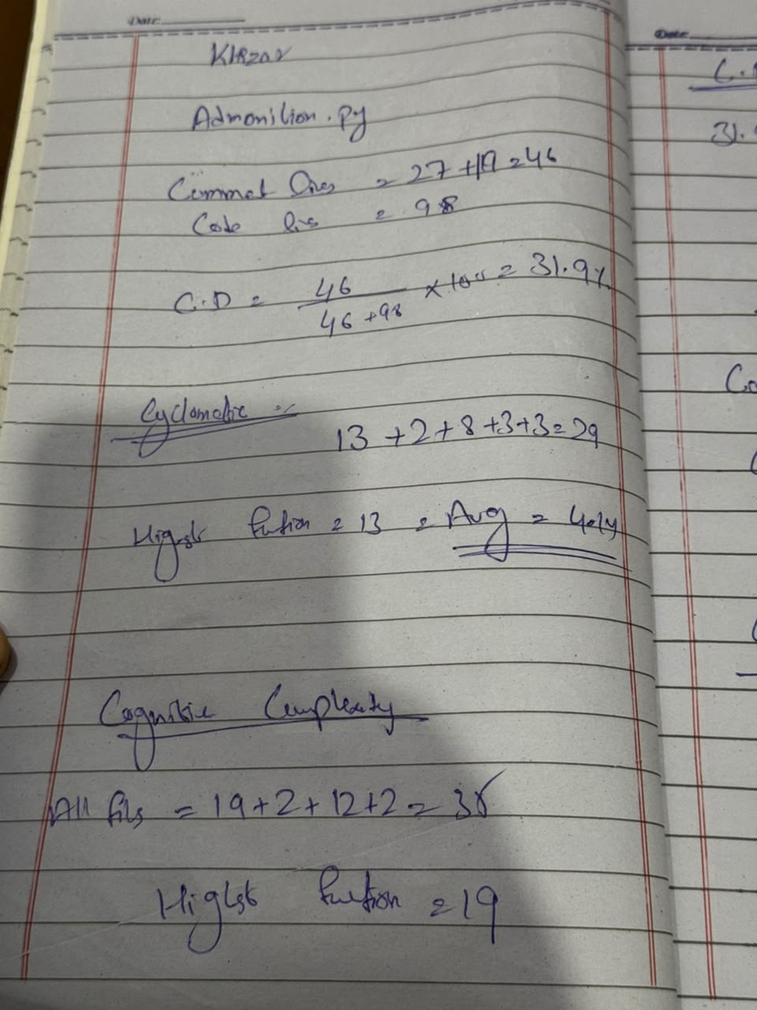
admonition.py: comment density, cyclomatic and cognitive complexity

Handwritten calculations: Khizar, sheet 2 of 3
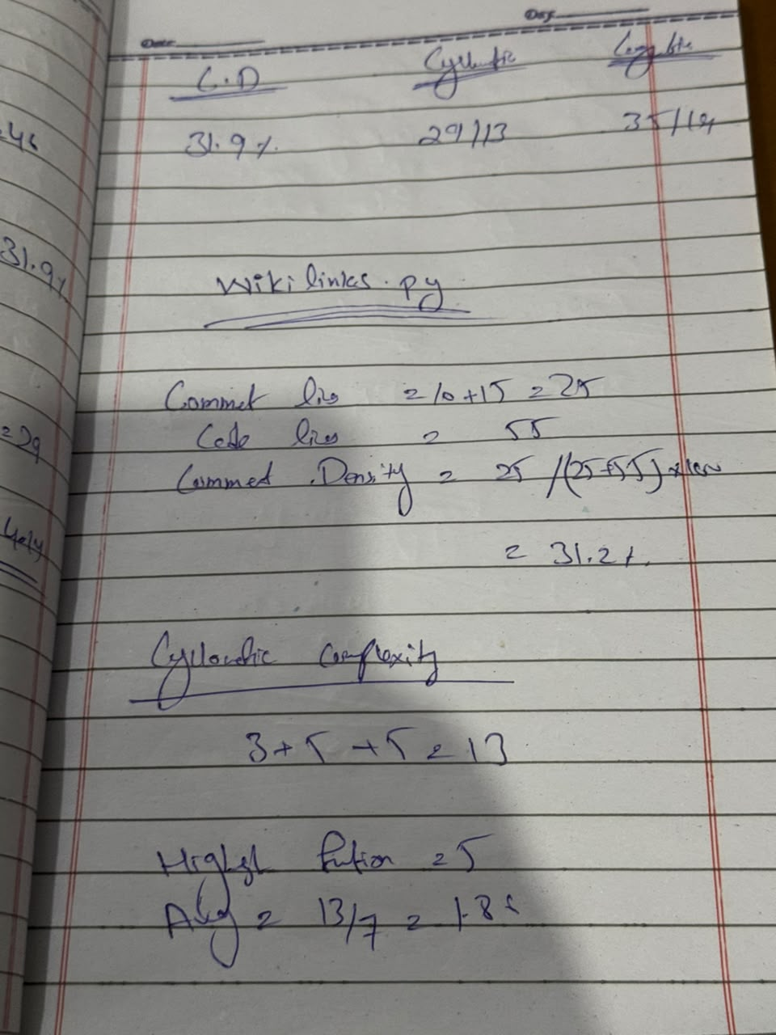
admonition.py summary; wikilinks.py: comment density and cyclomatic complexity

Handwritten calculations: Khizar, sheet 3 of 3
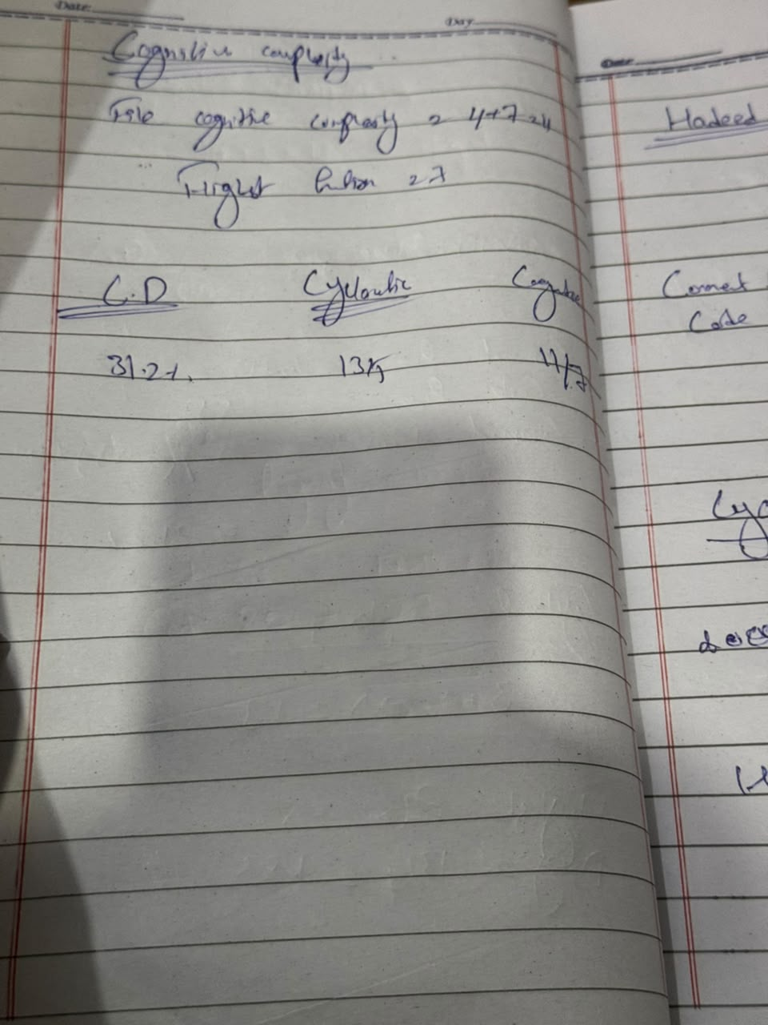
wikilinks.py: cognitive complexity and summary

A.3 Member 3: Hadeed Abbas (i228780)
File | Lines | Blank | # comment | Docstring | Code | Comment density
postprocessors.py | 131 | 35 | 14 | 24 | 58 | 38 / (38 + 58) = 39.6 %
extensions/legacy_attrs.py | 78 | 21 | 14 | 16 | 27 | 30 / (30 + 27) = 52.6 %

File | Function | Cyclomatic | Cognitive
postprocessors.py | RawHtmlPostprocessor.run | 2 | 10
 | RawHtmlPostprocessor.run > substitute_match | 5 | (in parent)
 | RawHtmlPostprocessor.isblocklevel | 3 | 3
 | 6 other functions with no decision point | 6 x 1 | 0
 | File total (hand) | tool cross-check | 16 | 16 | 13 | 13
extensions/legacy_attrs.py | LegacyAttrs.run | 7 | 9
 | 4 other functions with no decision point | 4 x 1 | 0
 | File total (hand) | tool cross-check | 11 | 11 | 9 | 9

Interpretation: postprocessors.py
Risks. RawHtmlPostprocessor.run hides its logic in a nested function that calls itself through pattern.sub(substitute_match, html), so recursion depth depends on the input. Per-function tools understate it: radon reports 2 for run and 5 for the closure, while cognitive complexity charges the closure to its parent and gives 10.
Debt and maintenance. Obsolescence debt: UnescapePostprocessor is @deprecated but still shipped, and its two methods are the file's only uncovered lines. Documentation debt: three docstrings contain errors (lines 22, 49, 96) and the base Postprocessor.run is a bare pass, so a subclass that forgets to override it silently returns None.

Interpretation: extensions/legacy_attrs.py
Risks. Only 27 code lines. LegacyAttrs.run reaches cyclomatic 7 from three if statements, two with an and, inside one loop. The callback in handleAttributes changes the element as a side effect and returns nothing, relying on re.sub treating None as an empty replacement.
Debt and maintenance. The module is deliberate debt, kept so that pre-3.0 documents still render. Its 52.6 % comment density is the highest measured, but 13 of the 30 comment lines are licence header and neither class has a docstring. The cost is small but permanent: it must pass on every new Python version until a major release removes it.

Handwritten calculations: Hadeed Abbas, sheet 1 of 3
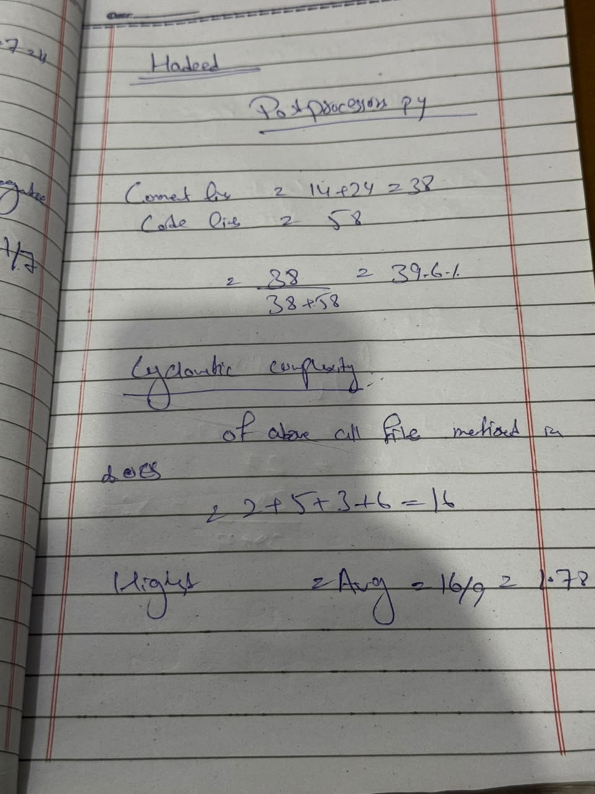
postprocessors.py: comment density and cyclomatic complexity

Handwritten calculations: Hadeed Abbas, sheet 2 of 3
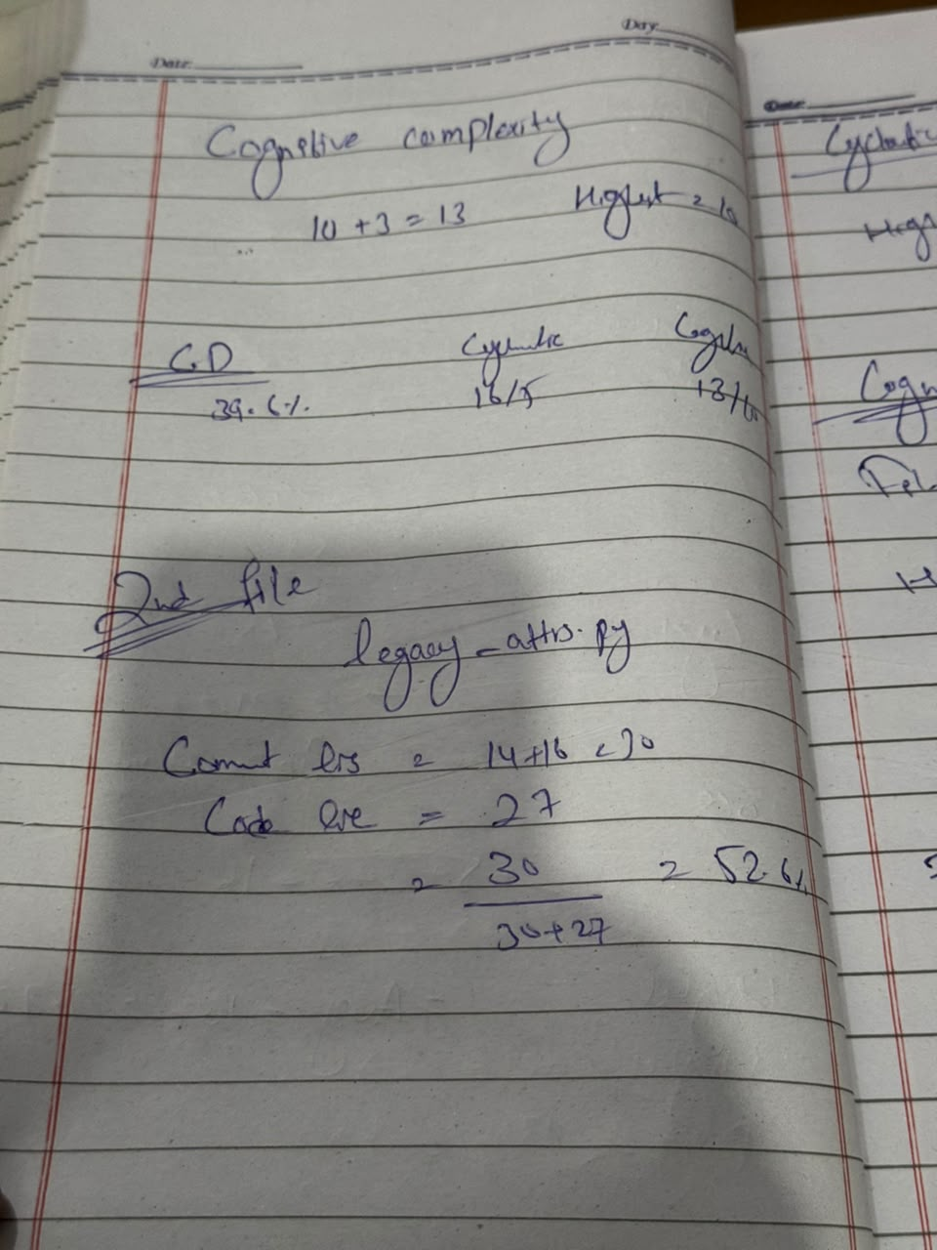
postprocessors.py cognitive complexity and summary; legacy_attrs.py: comment density

Handwritten calculations: Hadeed Abbas, sheet 3 of 3
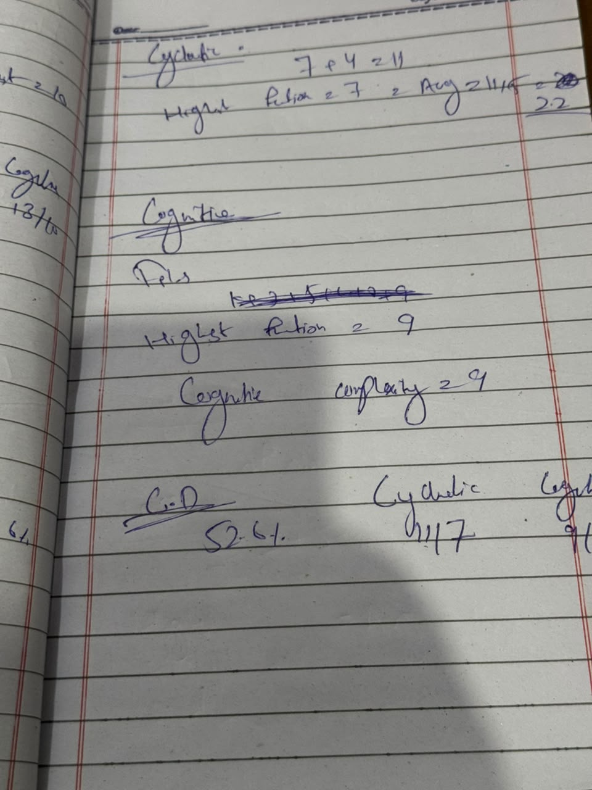
legacy_attrs.py: cyclomatic and cognitive complexity, summary

Appendix B. Reproducing the Measurements
Scripts and raw tool outputs: https://github.com/Taha9876/SRE-A1
git clone https://github.com/Python-Markdown/markdown.git && cd markdown
git checkout 0bf535bc406c95dad66050f07c8402af03fe07d5

radon raw markdown -j # size, comment lines
radon cc markdown -s -a -j # cyclomatic complexity
radon mi markdown -s -j # maintainability index
complexipy markdown --output-format json # cognitive complexity
npx jscpd markdown --min-lines 5 --min-tokens 50 # duplication
pylint markdown --output-format=json2 --exit-zero # bugs / code smells
bandit -r markdown -f json # vulnerabilities
flake8 markdown --max-line-length=119 ; vulture markdown --min-confidence 80

# coverage: two runs, combined; .coveragerc set aside so test_tools.py is measured too
coverage run -p --branch --source=markdown -m unittest discover tests # without Pygments
pip install pygments==2.7.1 && set PYGMENTS_VERSION=2.7.1
coverage run -p --branch --source=markdown -m unittest discover tests # with pinned Pygments
coverage combine && coverage report

git log --since="3 years ago" --name-only --format=@%H^|%s -- markdown # change frequency

References
- T. J. McCabe, "A Complexity Measure", IEEE Transactions on Software Engineering, 1976.
- G. A. Campbell, "Cognitive Complexity", SonarSource, 2018.
- J.-L. Letouzey, "The SQALE Method for Managing Technical Debt", 2016.
- A. Tornhill, "Your Code as a Crime Scene", Pragmatic Bookshelf, 2015.

