APPENDIX A (Circuit Diagrams)

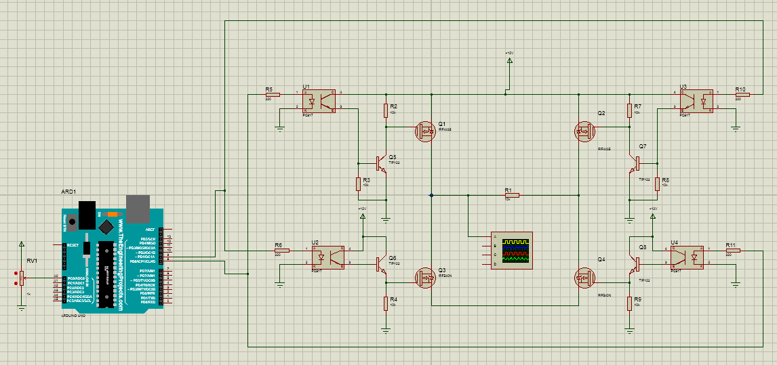

Fig.5: Circuit for Technique 1

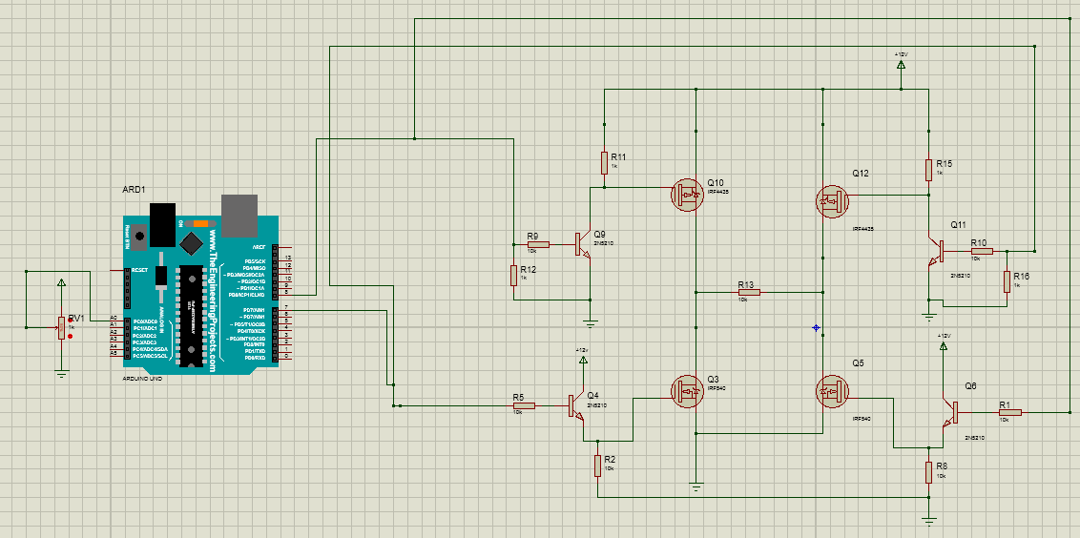

Fig.6: Circuit for Technique 2

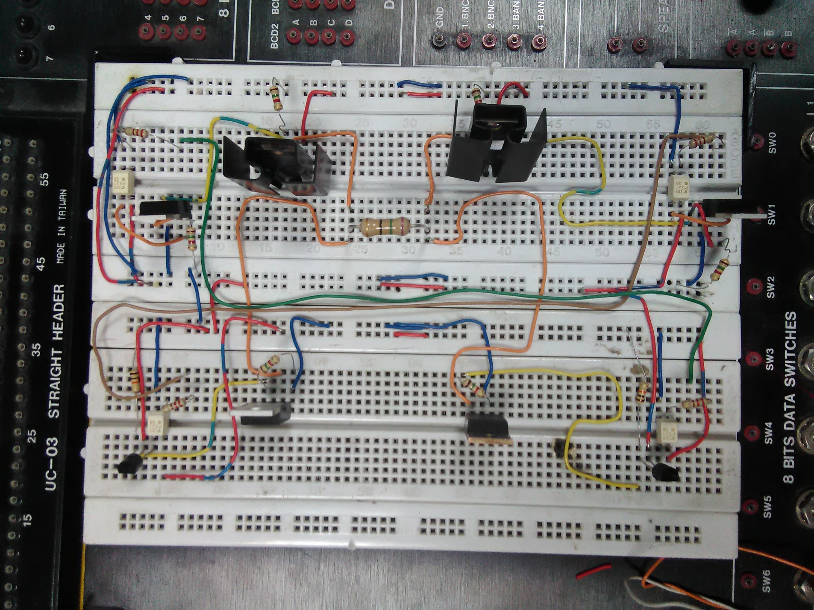

Fig.7: Circuit for Technique 1

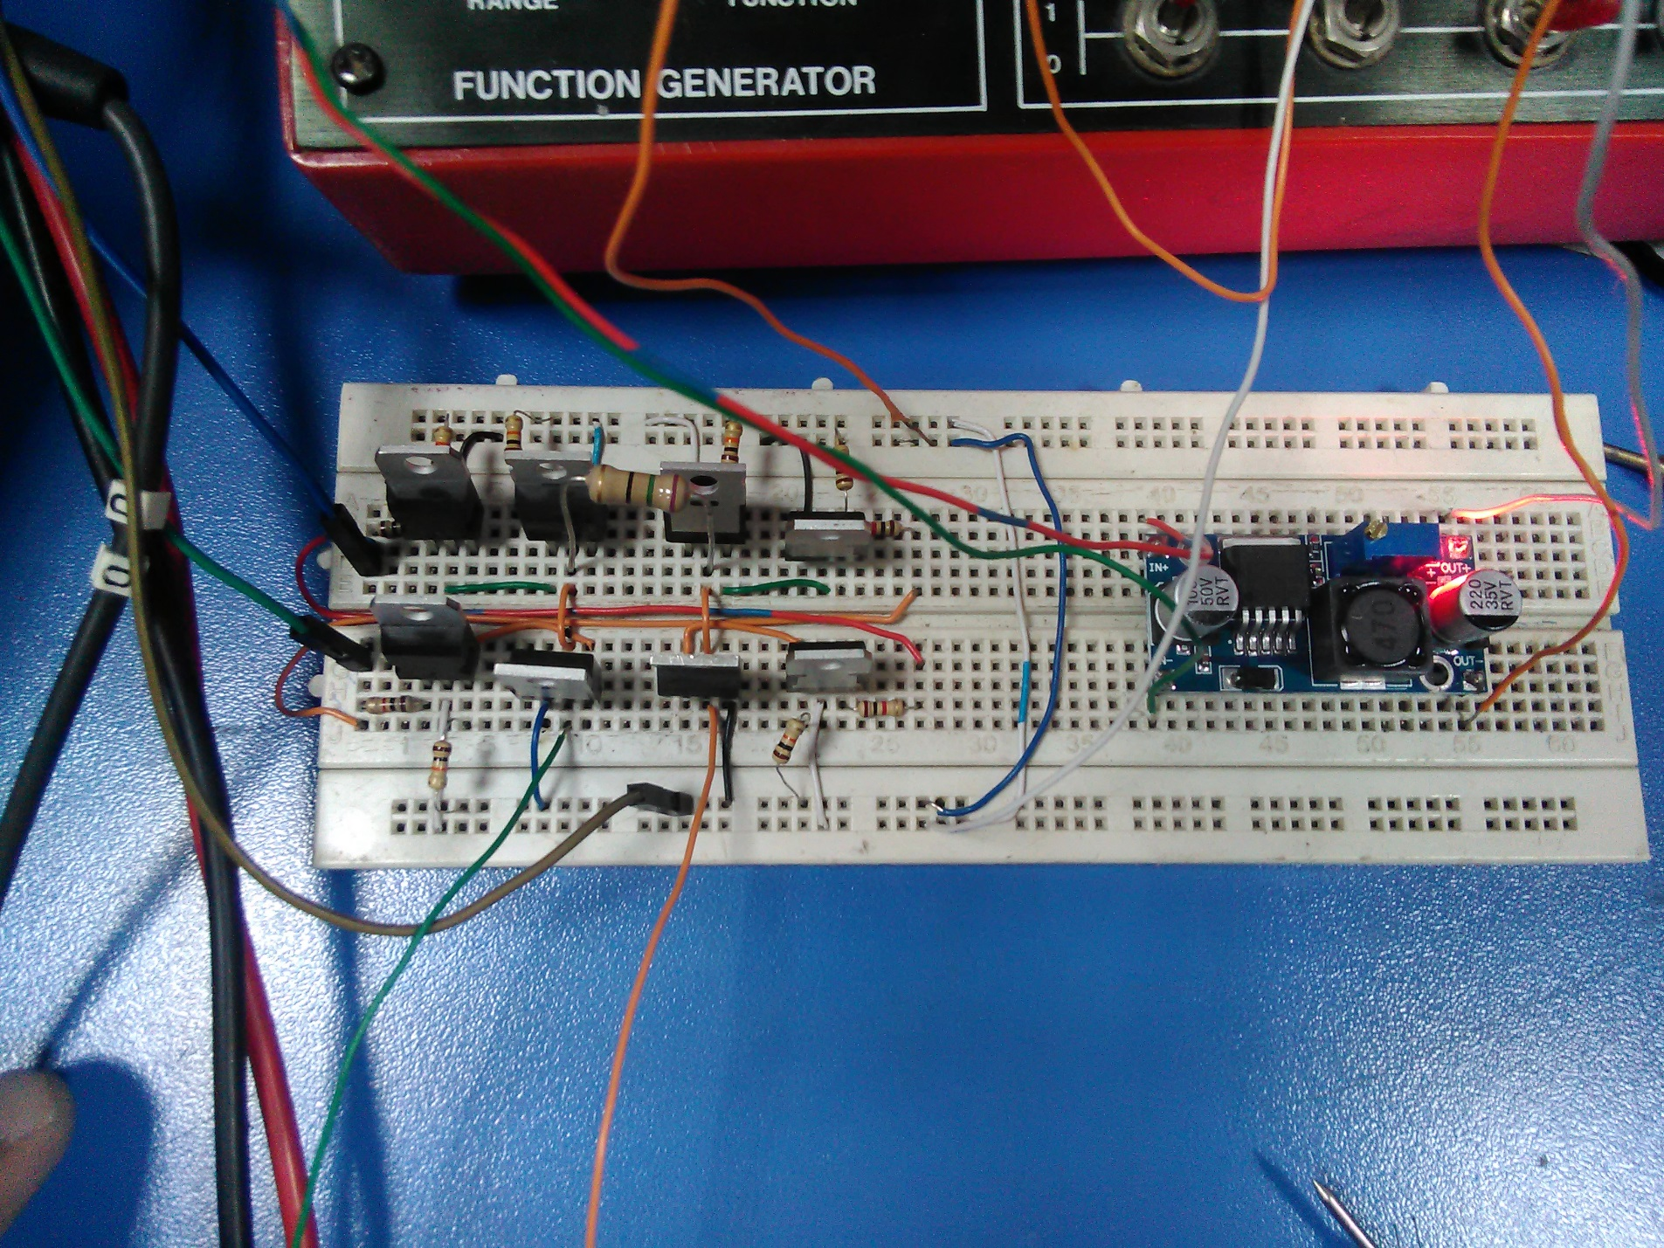

Fig.8: Circuit for Technique 2