**DOCKER’S NOTES**

**CONTAINER:**

A way to package application with all necessary Dependencies and Configuration.

Portable artifact, easily share and move this package to any environment

PROCESS OF CONTAINER

Simple sa scn ye hai k 2 dev agar kaam kar rhe hai different machine me tu onko koi dependencies issue na ae or wo apna code apas me merge kar k dev environment me push karde or QA me bhi

**DOCKERS**

Dockers enables you to separate your application from your infrastructure so you can work independently regardless of machine

Inshort docker is an open platform which help us to create these kinds of container

A dockerize Container is a combination of layes of docker images.

**DOCKER IMAGE:**

A docker image is part of a application like:

If working on linux one layer of dependencies of it created

Application using mongodb one layer of dependencies of it created

FOR EXAMPLE

**SIMPLE PROCESS OF DOCKERIZATION**

First all application parts stored in a container like docker image in a layer, when all layers saved in a container we called it Docker Image.

When we run this docker image it creates an environment and try to run application in this environment

**DOCKER VS VIRTUAL MACHINE**

Isko samjhne k liye hume ek operating system visualize karna hai like   
 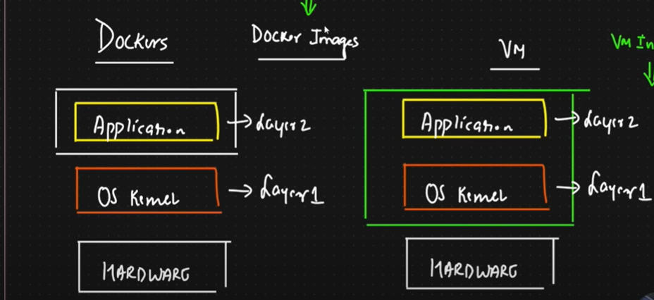

Ab os me 3 basic layers hoti hai application , os kernal, hardware

Application : wo software jo apne banaya ho

Os kernal: jo os ki dependencies se communicate karta ho

Hardware: apka apna pc

Tu **docker** ye karta hai k srf application wale part ko virtualize karta hai iska mtlb jis bhi pc me jai ga oska os kernal os se communicate karsake ga , isliye docker images choti bhi hoti hai q k wo os ko virtualize nhi karti. They are faster in execution. The draw back of docker image if application is written in linux the os kernal of windows can not interact with it .

**VM machines** OS and application dono ko virtualize kardeta hai , isliye heavy hota hai , VM is like a sub system in a system. VM are not faster in executions