Online Retail (Gift Products) Documentation

1. Documentation Overview:-
This document provides comprehensive documentation for the dataset prepared to power a Power BI / Tableau sales dashboard as part of the graduation project. It describes the dataset's origin, structure, cleaning steps applied, and all engineered features.
1.1 Source & Scope
The dataset is derived from a retail transaction system capturing customer purchase and return activity. It contains transactional records at the invoice line level — meaning each row represents one product purchased (or returned) within a single invoice. The dataset spans multiple countries, customer segments, and seasonal periods.

1.2 Key Facts

Attribute | Value
Date Range | 2009 – 2010
Original Columns | 6 raw fields (Invoice, StockCode, Description, Quantity, Price, InvoiceDate, Customer ID, Country)
Geographic Coverage | Multi-country (primarily United Kingdom and Europe)
Transaction Types | Sales and Returns

2. Problem Statement:
The following problems were identified within the dataset. These are the core reasons why this dataset was chosen. Each problem was directly addressed.

2.1 Business Problems to be Solved
→Problem 1. No Customer Value Metric:
The dataset has Customer IDs but no information about how valuable each customer is, making it impossible to tell who the best customers are or how to prioritize them.
- No record of how much each customer has spent in total
- No count of how many orders each customer has performed
- No grouping or classification exists (VIP or not)

→Problem 2. Time Data Does Not Show Important Patterns:
The Date column stores date and time as a single raw timestamp, making time-based analysis completely impossible without additional processing.
- No separated month or season to detect seasonal trends
- No time slot classification (Morning, Afternoon, Evening)

→Problem 3. No Customer Spending Comparison
The data provides no way to compare customer spending behavior, making it impossible to prioritize, segment, or reward high-value customers appropriately.
- No way to classify loyal customers from new buyers
- A customer who placed a single £10 order appears identical to one who spent over £16,000
- No metric exists to measure or rank customers by their spending level

2.2 Key Questions the Dashboard Will Answer
Sales & Revenue:
- What is the total revenue generated across 2009–2010?
- Which month and quarter recorded the highest sales?
- Which season (Winter, Spring, Summer, Autumn) generates the most revenue?
Time & Behavior:
- At what time of day (Morning, Afternoon, Evening) do most transactions occur?
- Which hours are the busiest for placing orders?
Customer Analysis:
- Who are the top customers by total revenue?
- What is the average order value per customer segment (VIP vs Medium)?
- How many orders does each customer segment perform on average?
Product Performance:
- What are the top 10 best-selling products by quantity?
- Which products generate the highest net sales?
Geography:
- Which countries contribute the most orders and revenue?
- How does the UK compare to other countries in total sales?

2.3 Expected Outcomes
By the end of this project, a fully interactive dashboard will allow business stakeholders to:
- Monitor sales performance across months, quarters, and seasons.
- Identify high-value customers to target for loyalty and retention programs
- Detect seasonal demand patterns to optimize inventory and marketing campaigns
- Compare product performance to make smarter stocking and pricing decisions
- Understand geographic market contribution beyond the UK
- Track year over year performance to measure business growth and compare results across different time periods
The ultimate goal is to turn raw transactional data into actionable business intelligence that supports data-driven decisions.

3.Tools:

Excel: For Data Cleaning & Preparation

Python: For Data Exploration

Tableau: For Data Visualization

4. Column Dictionary

4.1 Original Columns

Column Name | Data Type | Description
Invoice | Integer | Unique identifier for each invoice/transaction. Multiple rows can share the same Invoice number (one per product line).
StockCode | String | Product/item code identifying the specific product sold.
Description | String | Human-readable name and description of the product.
Quantity | Integer | Number of units sold. Negative values indicate returned items.
Price | Float | Unit selling price of the product in the local currency.
InvoiceDate | DateTime | Full timestamp of the transaction including date and time (e.g., 2009-12-01 07:45:00).
Customer ID | Integer | Unique identifier for the customer who made the purchase. Null rows were removed during cleaning.
Country | String | Country where the customer is located and the transaction originated.

4.2 Calculated Columns

Column Name | Data Type | Description | Derivation Logic
Net Sales | Float | Price × Quantity. Represents the revenue generated by a single invoice line. Negative values indicate return transactions. | Price * Quantity
Total Revenue per Customer | Float | Sum of all Net Sales values across every invoice line belonging to a given Customer ID. Represents the customer's lifetime spend in the dataset. | SUM(Net Sales) GROUP BY Customer ID
Total Orders | Integer | Count of distinct Invoice numbers associated with a given Customer ID. Represents how many separate purchase transactions the customer made. | COUNT(DISTINCT Invoice) GROUP BY Customer ID
Average Order Value | Float | Total Revenue per Customer divided by Total Orders. Represents the average monetary value of each order placed by the customer. | Total Revenue per Customer / Total Orders

5. Dashboard Use Cases

Column / Feature | Analytical Purpose | Suggested Visual Type
Net Sales | Transaction-level revenue calculation | KPI card, table, matrix
Total Revenue per Customer | Customer lifetime value; identify top spenders | Bar chart (Top 10 Customers), scatter
Total Orders | Purchase frequency analysis per customer | Histogram, bar chart, KPI
Average Order Value | Basket size / spending behavior analysis | KPI card, trend line, scatter
Month Name + Month Number | Monthly revenue trends with correct sorting | Line chart, column chart (x-axis)
Year + Quarter | Year-over-year and quarterly comparisons | Matrix, clustered bar, slicer
Month-Year | Continuous time-series trend axis | Line chart (x-axis label)
Hour + Time Slot | Peak purchase hour identification | Heatmap, bar chart by time slot
Season | Seasonal sales performance comparison | Stacked column, donut chart
Transaction Type | Sales vs. returns volume and value | Donut chart, KPI, filter slicer
Customer Segment | Customer value tiers — Regular / Medium / VIP | Donut chart, bar chart, slicer
Country | Geographic distribution of revenue | Map visual, bar chart

6. Data Preprocessing
The following screenshots document the main Excel Power Query cleaning and transformation steps used to prepare the final retail dataset for analysis and dashboard development.
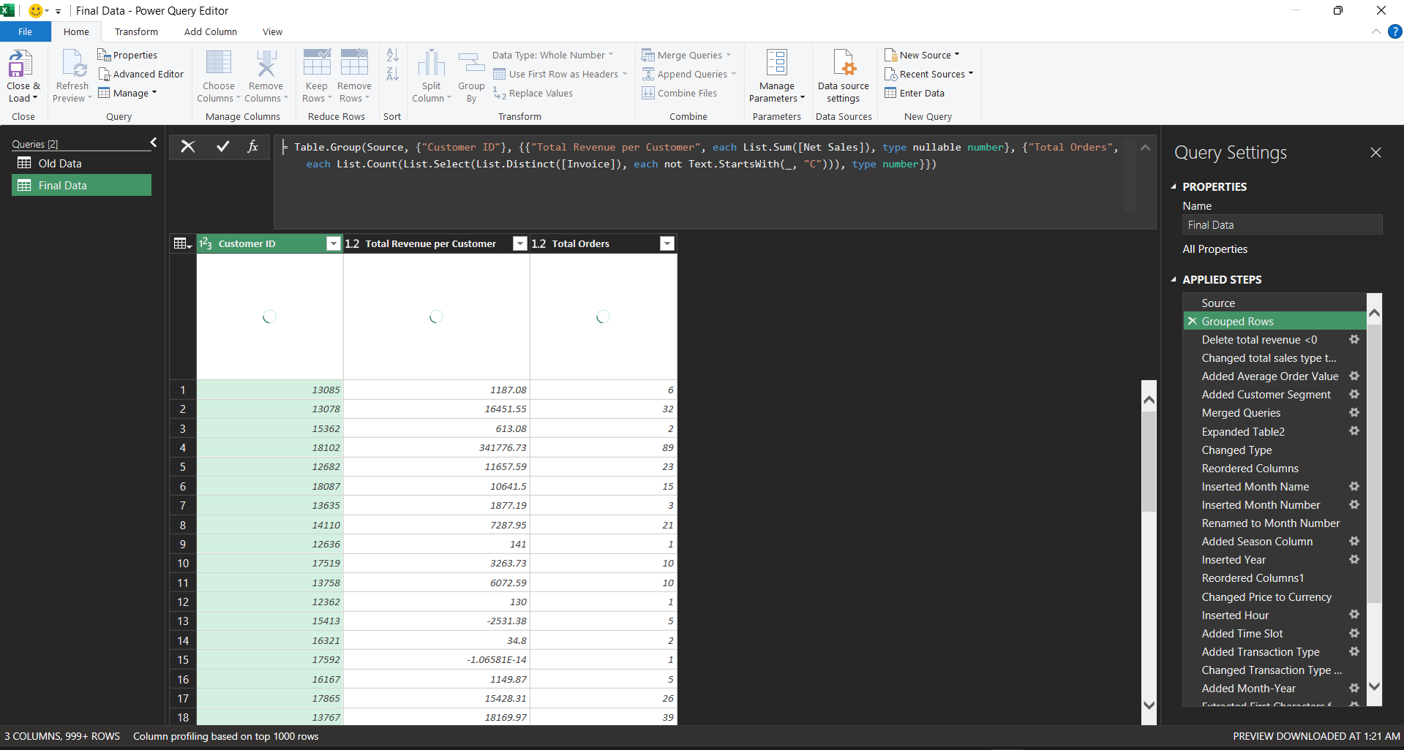
Screenshot 1: Customer-level aggregation. In Power Query, the data was grouped by Customer ID. This step calculated Total Revenue per Customer using the sum of Net Sales and calculated Total Orders by counting unique valid invoice numbers, excluding cancellation invoices that start with C. This created the customer value base needed for segmentation.
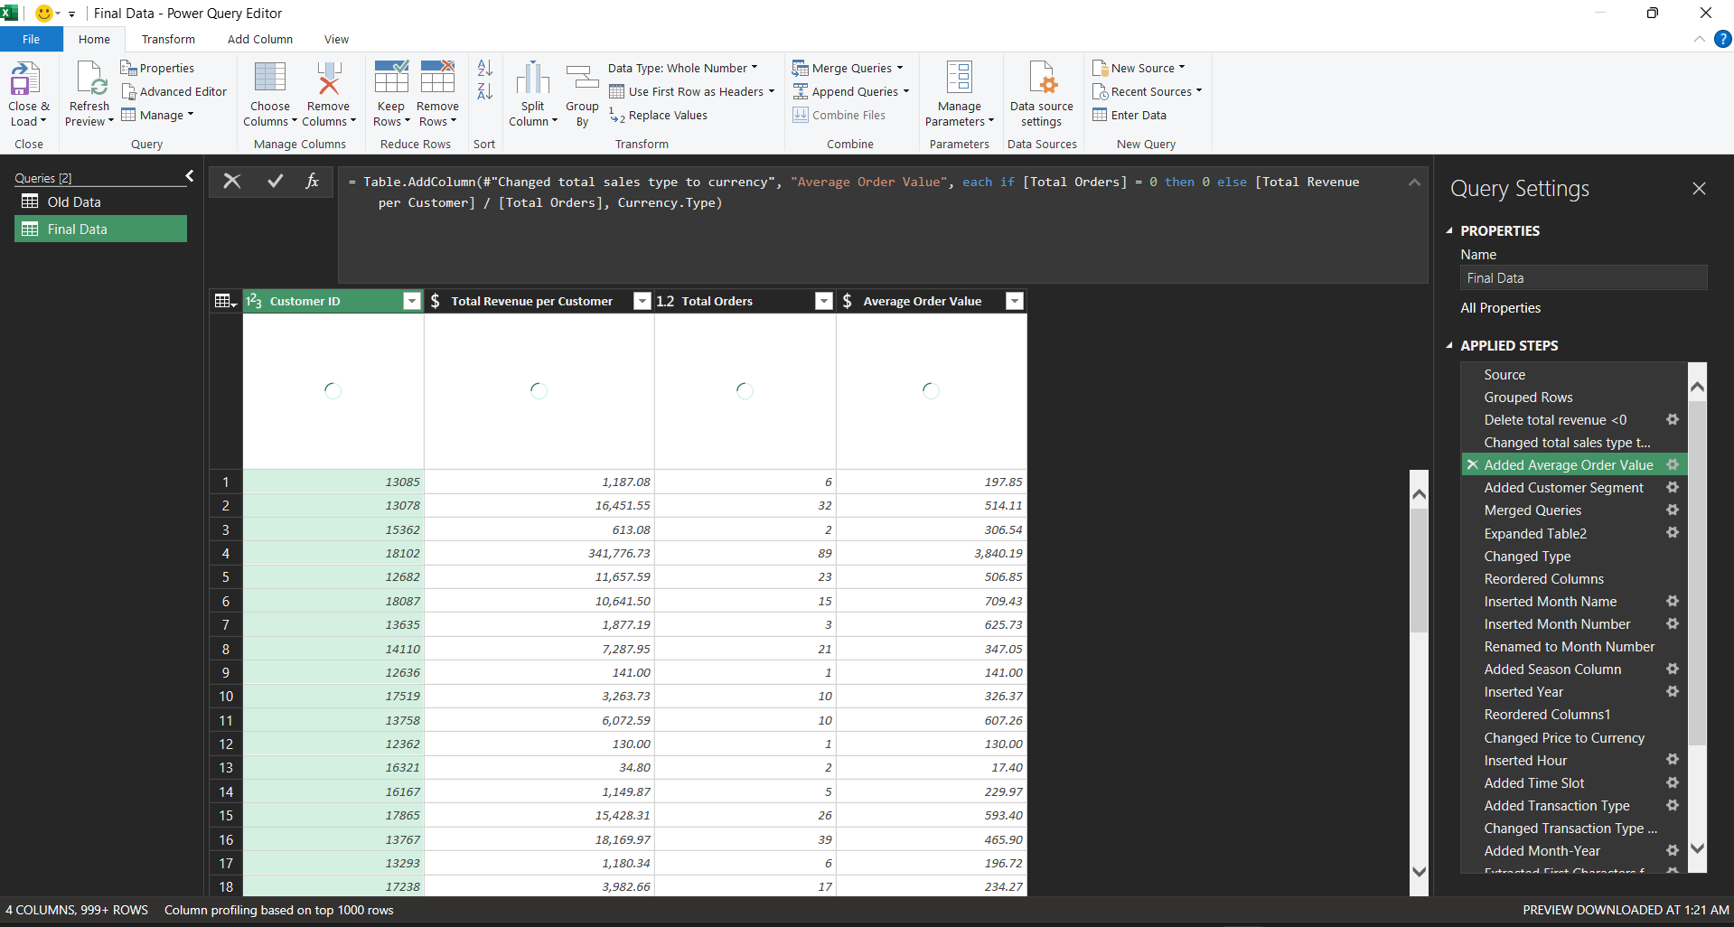
Screenshot 2: Average Order Value calculation. A new calculated column was added to divide Total Revenue per Customer by Total Orders. This created the Average Order Value metric, which helps compare how much customers spend per order rather than only comparing total lifetime revenue.
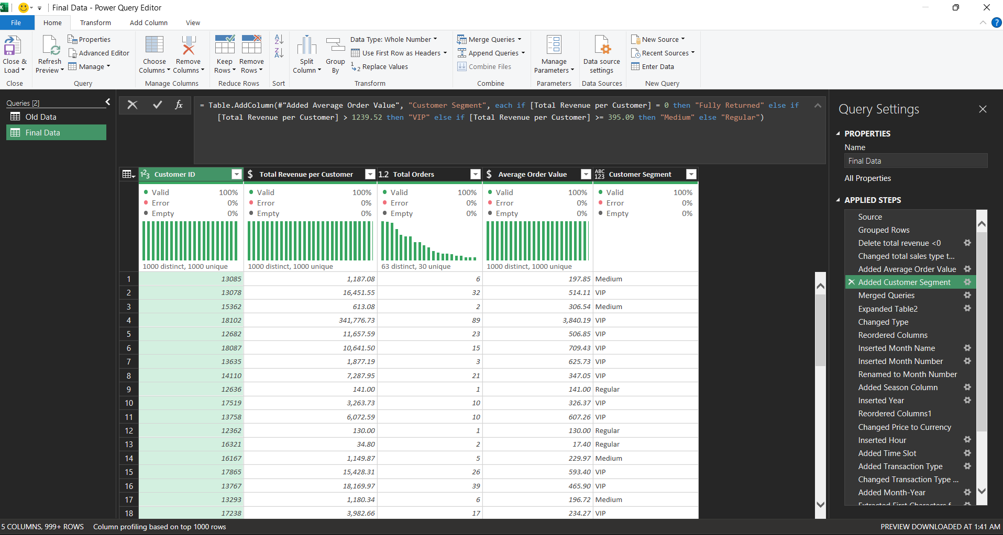
Screenshot 3: Customer Segment creation. A conditional column was created to classify customers based on Total Revenue per Customer. Customers were assigned into value groups such as VIP, Medium, Regular, or Fully Returned, making it easier to analyze customer behavior by spending level.
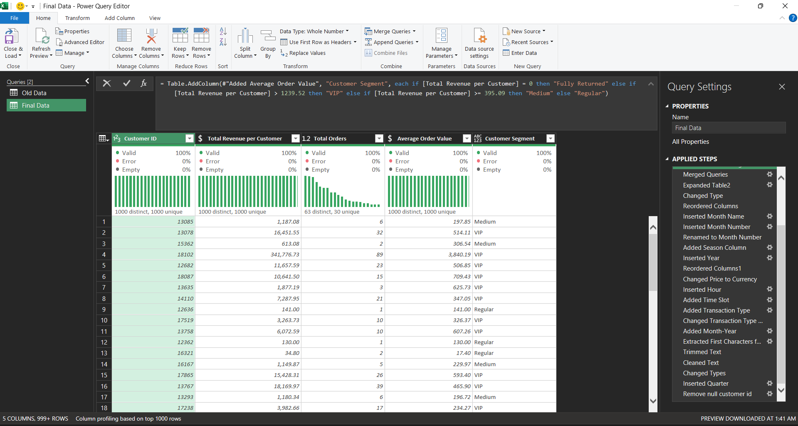
Screenshot 4: Final enrichment and validation of customer metrics. The customer-level calculations were available in the final query and checked through Power Query column profiling. The enriched fields, including Total Revenue per Customer, Total Orders, Average Order Value, and Customer Segment, prepare the dataset for dashboard filtering, comparison, and visual analysis.

