Table of Contents
Contents
Table of Contents 1
1. Problem and proposed solution 1
1.1 Problem 1
1.2 Proposed solution 2
2. System design 3
2.1 Modular design 3
2.2 Algorithm design 5
3. Tools used 7
3.1 Streaming and Messaging (Kafka) 7
3.2 Computer Vision Pipeline 7
3.3 Backend Service 8
3.4 Database 8
4. Final System 9
5. Deploying notes 10
6. Future work 10

Problem and proposed solution

1.1 Problem
The objective of this task is to monitor and detect rule violations in a pizza shop environment using computer vision and real-time data processing.
The system focuses on identifying unsafe or non-compliant handling of ingredients, with the following specific challenges:
- Detecting cases where a worker uses ingredients without a scooper.
- Correctly handling scenarios where multiple workers (e.g., two workers) are present simultaneously.
- Distinguishing between actual ingredient handling and cases where a hand enters the ingredient area only for cleaning purposes, which should not be considered a violation.

1.2 Proposed solution
To address the problem, the solution is based on object detection and object tracking applied to live camera streams.
- The system detects relevant objects such as hands, ingredients, and scoopers.
- When a hand enters the ingredient region, the system tracks that specific hand over time to analyze subsequent actions.
Further technical details are provided in the System Design section below.

2. System design

2.1 Modular design
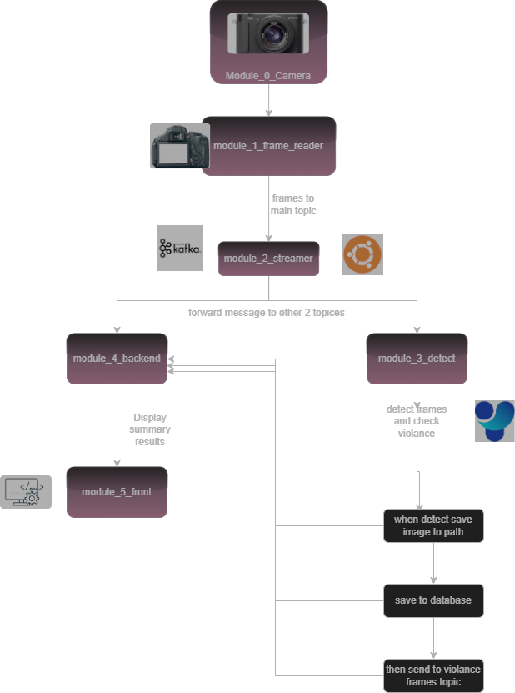

2.2 Algorithm design

1. Define ROI (Region of Interest)
- Mark the area where interaction with objects (like pizza) needs to be monitored.
2. Detect objects in each frame
- Use YOLO to detect relevant objects (e.g., hand, pizza, scooper).
3. Track objects across frames
- Use DeepSORT to maintain identity of detected objects over time.
4. For each frame:
- Check if a hand is inside the ROI:
  - If yes, mark the frame as a “warning frame” and start tracking that hand.
- Monitor the next frames (up to 10 seconds):
  - If the tracked hand touches pizza, flag this as an additional condition for a warning.
  - If the tracked hand does not touch the scooper, consider this a violation.
  - Log violations accordingly.
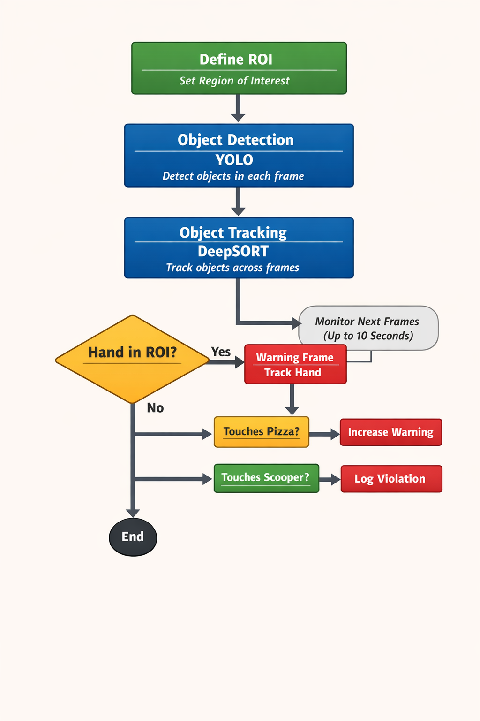

3. Tools used

3.1 Streaming and Messaging (Kafka)
A streaming layer is required to receive frames from cameras and distribute them for processing.
- A lightweight protocol such as MQTT was considered, but it was found to be unsuitable due to:
  - Low throughput
  - The high data rate required for image frames sent multiple times per second
- Apache Kafka was selected due to its:
  - High throughput and scalability
  - Reliability and strong guarantees against message loss
Deployment options considered:
- Managed Kafka (e.g., Azure Kafka)
  - Easier maintenance
  - Higher operational cost
- Self-hosted Kafka
  - More control and lower cost
  - Requires more setup and maintenance
For this task, Kafka was deployed locally on WSL, which was sufficient for development and testing.

3.2 Computer Vision Pipeline
- Object Detection
  - A standard YOLO model was used, as specified in the task requirements.
- Object Tracking
  - Ultralytics built-in tracking was initially tested:
    - Simple to integrate
    - However, it showed ID switches and instability in crowded scenes
  - DeepSORT was then used:
    - Provided more stable tracking
    - Reduced ID confusion, although occasional ID switches still occur
Overall, YOLO + DeepSORT achieved better performance for this task.

3.3 Backend Service
- FastAPI was used as the backend framework due to:
  - Its simplicity and high performance
  - Ease of integration with computer vision pipelines
- FastAPI also acts as a camera streaming host:
  - Converts video streams into an IP camera–like interface
  - RTSP cameras can be used in production, but FastAPI was chosen here for simplicity and time constraints

3.4 Database
- MySQL is used for data persistence
- Hosted locally using XAMPP
- Stores events such as:
  - Detected violations
  - Timestamps

3.5 Frontend
- The frontend is implemented using:
  - HTML
  - CSS
  - JavaScript
- It provides:
  - Live monitoring
  - Visualization of detected violations

4. Final System
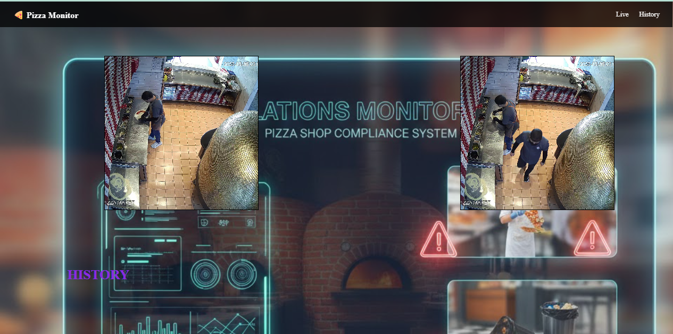
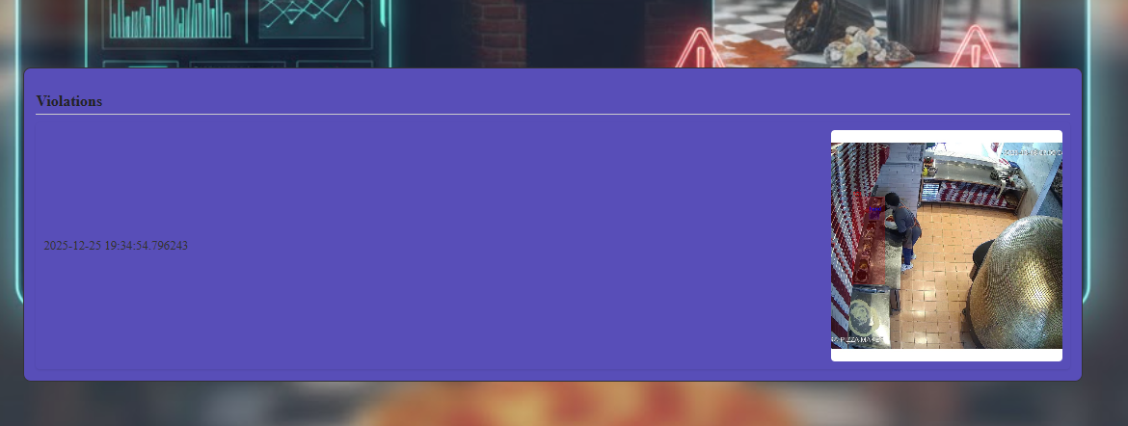
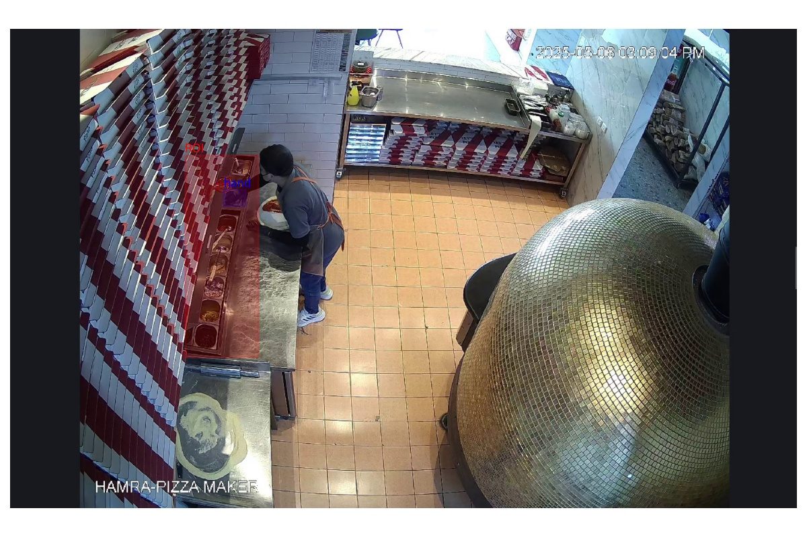

5. Deploying notes
- Kafka demonstrated high throughput and reliability, successfully handling continuous image streams without losing frames.
Frame integrity was verified by checking sequential frame IDs, confirming that no messages were dropped.
- However, the use of multiple internal Kafka topics introduced noticeable overhead, which negatively impacted overall video processing performance. This indicates a trade-off between modular topic design and real-time throughput.
- The computer vision model occasionally introduced processing latency.
To mitigate this, a queuing mechanism was implemented:
  - The system initially waits for the queue to reach a stable size.
  - Frames are then processed in a controlled flow, reducing jitter and improving temporal consistency.
- Multithreading was applied where concurrency was required, particularly for frame ingestion, inference, and post-processing, resulting in better resource utilization and smoother pipeline execution.

6. Future work
- Conduct systematic testing and validation of the model, with special focus on rare and challenging edge cases.
- Improve the accuracy and stability of the tracking component, particularly to further reduce ID switches.
- Optimize the data pipeline to reduce performance overhead caused by distributing frames across multiple Kafka topics, potentially by redesigning the topic structure or batching frames more efficiently.
- Using Docker and Terraform and SE tools as needed.

