Our Project is about Food Recipe graph

**Dataset**

https://www.kaggle.com/datasets/saldenisov/recipenlg

The dataset have each recipe ,and it’s ingredients

We focus on title ,NER column (individual ingredient)

**Then we construct Graph**

**Node** : individual ingredient

**Edge :** recipe using the 2 ingredient (undirected ,weighted)

**Sampling**:

The dataset is very large (large recipe ,large NER) ,so we worked on sample

-working on whole dataset using big data techniques is future work

**Graph**:

We tried to plot graph on many way to understand it:

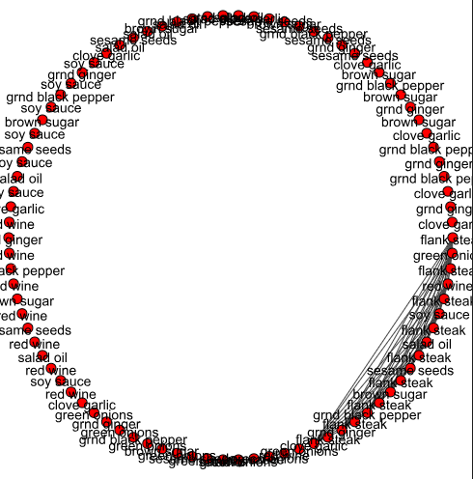

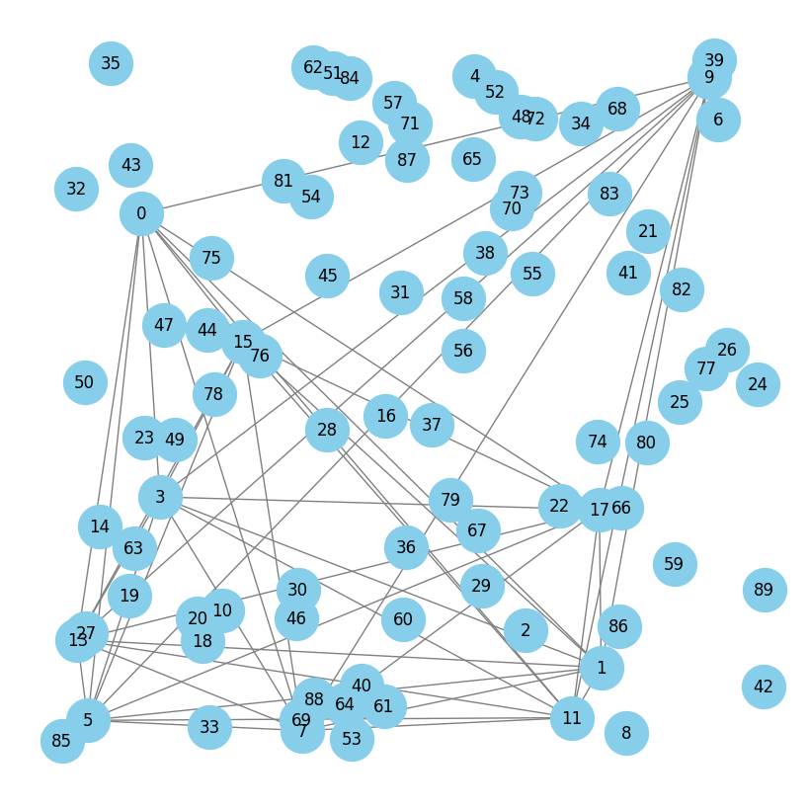

We **used Igraph , networkx**

**Then Degree ,avg degree**

meanly each individual NER used in one reciepe

Then

Edge list ,adj list

Adj matrix:

**3- get if special graph**

This result no ,we tried to check if near : still no ,but with visualize :

-part complete ,other isolated: This mean that some ingredients are complete (mostly used themselve in any reciepe) ,other like isolated ,may on one or two reciepes

**4-Centrality:**

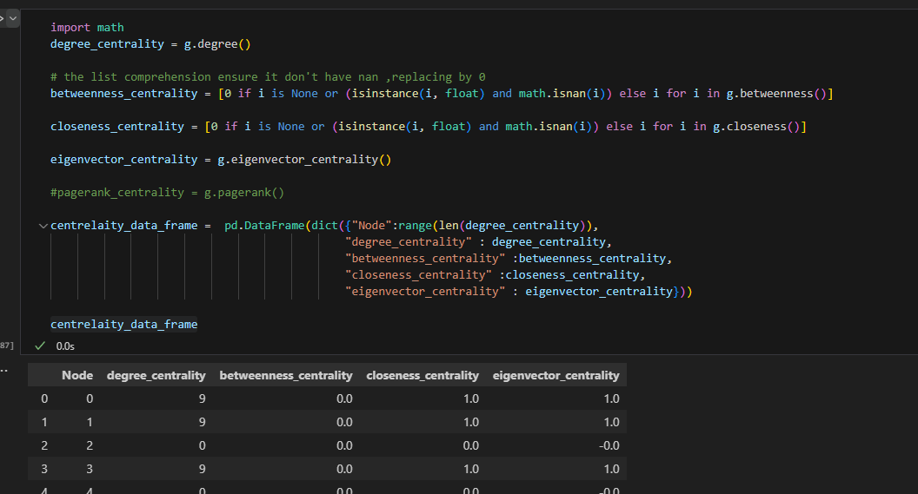

**For our project** : The most important relating of centrality of our dataset is Degree centrality (what is main important ingredients i should have in restaurant as appera in many reciepes can be many so no need eignvalue)  :

Plotting it: (with size represent deg)

Then getting most degree:

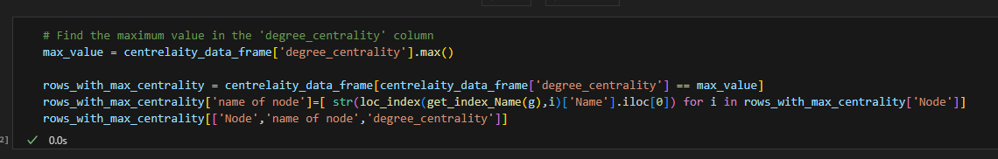

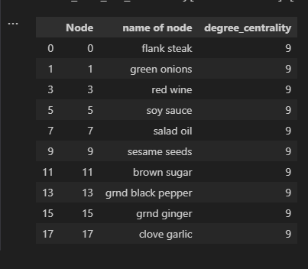

And those must be found in restaurant