# **Part 1**

## Problem 1:

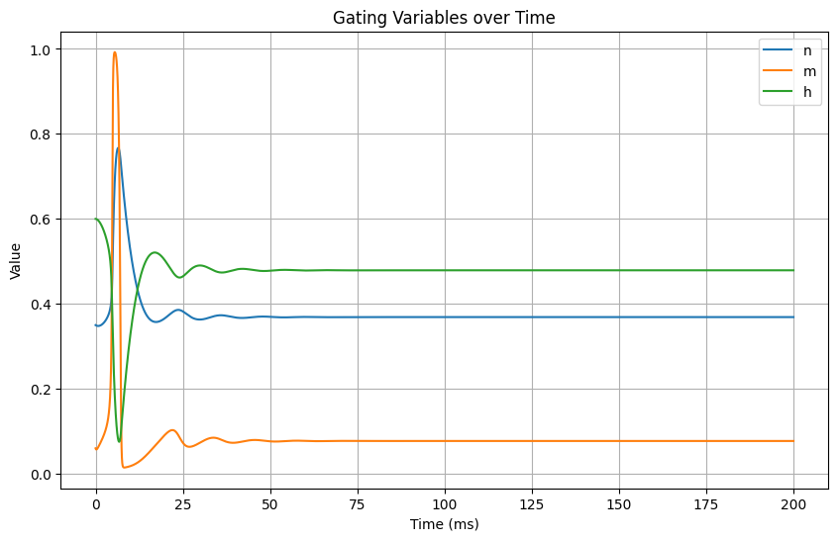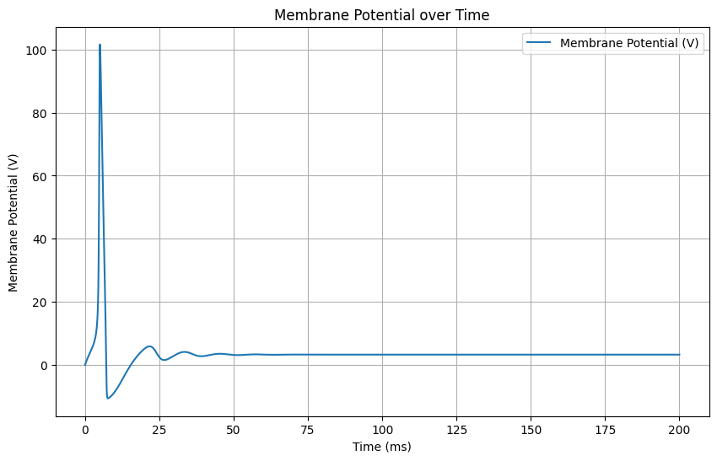

* As membrane potential **V** rises, both **m** and **n** increase.
* At extreme membrane potentials, **m** and **n** tend towards 1, indicating a high probability of channel opening.
* At more positive membrane potentials,**h** decreases, indicating a decreasing probability of the sodium channels being inactivated.
* When **h** is high, the sodium channels are inactivated, meaning they cannot be opened again until **h** decreases
* Also **m** and **h** are usually faster than **n**
* After repolarization it goes to refractory period

## Problem 2:

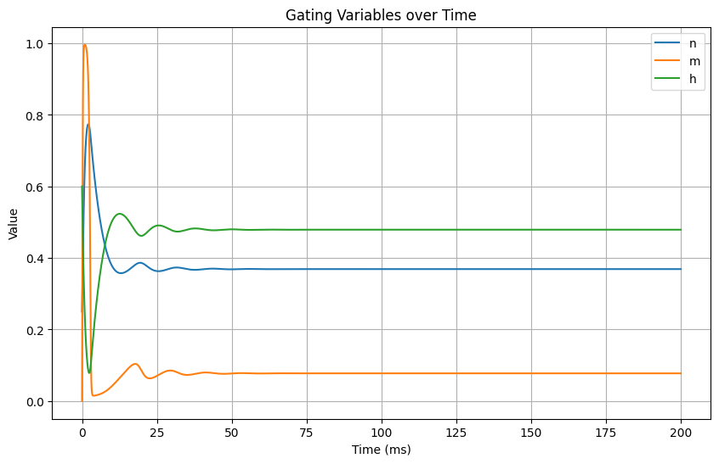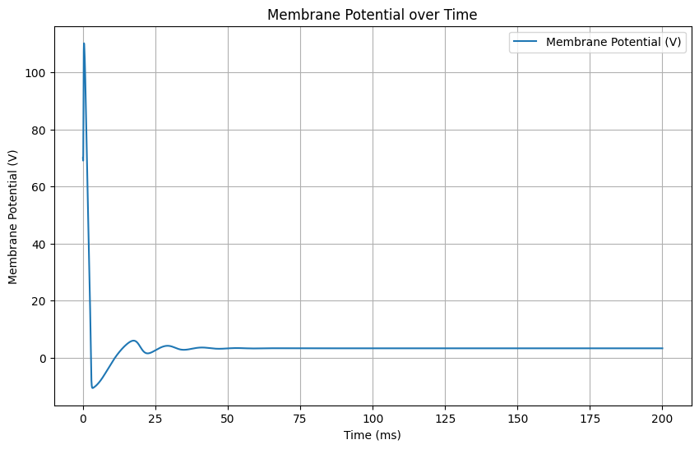

## Problem 3:

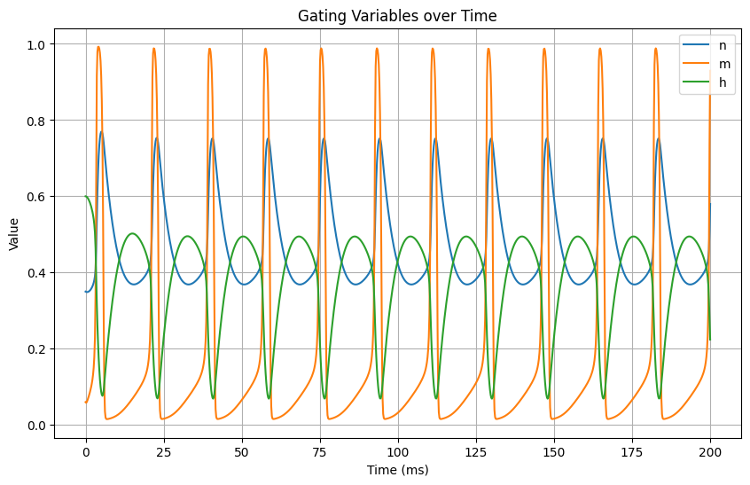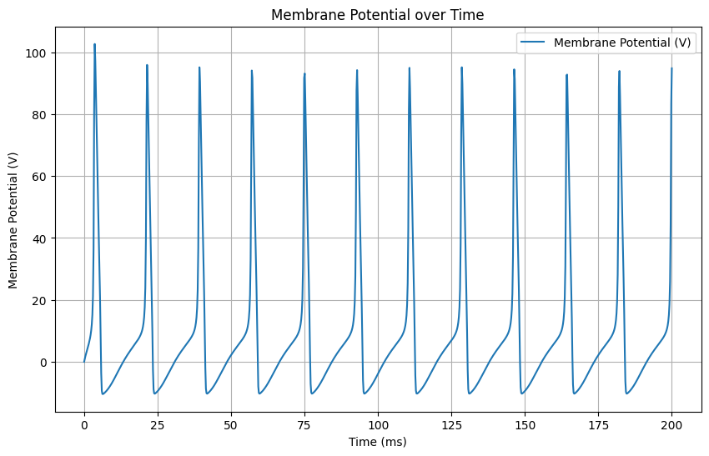

# Problem 4

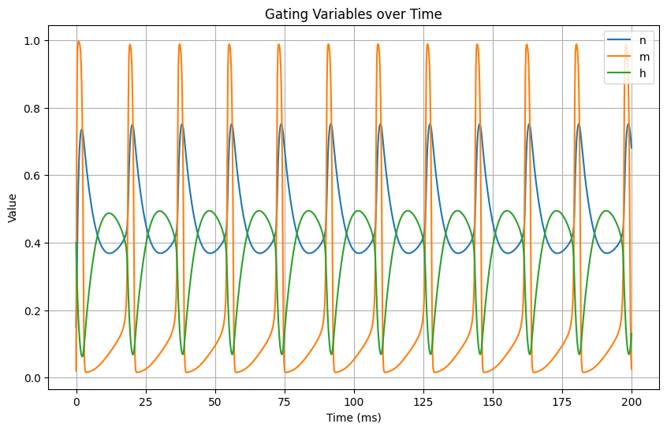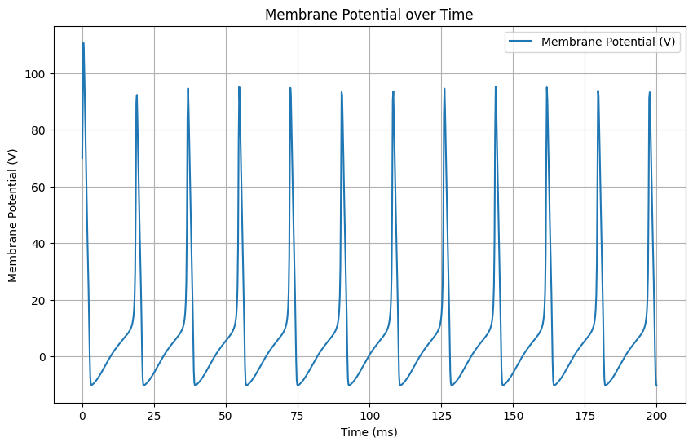

# **Part 2**

## Problem 1:

* ε1>>ε2
* ε1>>ε2
* ε1≈ε2

## Problem 2:

* ε1<<ε2
* ε1≈ε2
* ε1>>ε2