**Visualization**

* 1. 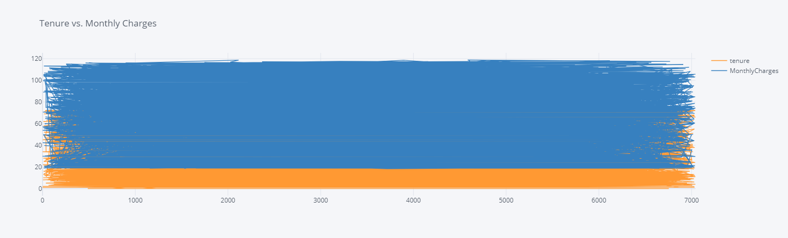**Line Plot**
* Tenure: This column represents the length of time (in months) that a customer has been with the telecom company. It indicates the duration of the customer's subscription or contract.
* Monthly Charges: This column represents the amount charged to the customer monthly for the telecom services they subscribe to. It includes charges for services such as internet, phone, and TV packages.
* By increasing the number of mouths for customers (Tenure), increase monthly charges.
* A company might offer a basic plan for new customers and more comprehensive plans with higher charges for long-term customers who need more features.
* If a customer with a long tenure suddenly starts paying lower charges (perhaps due to downgrading their plan), it could be a sign that they're considering switching to a competitor.
  1. 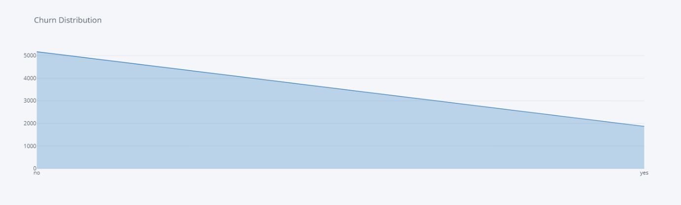**Area Plot**
* Churn: This column likely represents whether a customer churned (cancelled their service) or not.
  1. 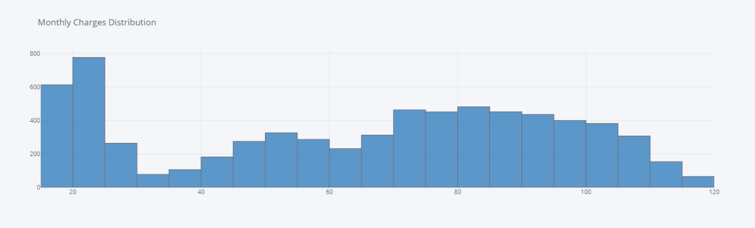**Histogram**
* Monthly Charges: This column represents the amount charged to the customer monthly for the telecom services they subscribe to. It includes charges for services such as internet, phone, and TV packages.
* As the charges increase, the frequency generally decreases, indicating fewer customers are in the higher charge brackets. This could suggest that most customers opt for more affordable or basic service plans.
  1. 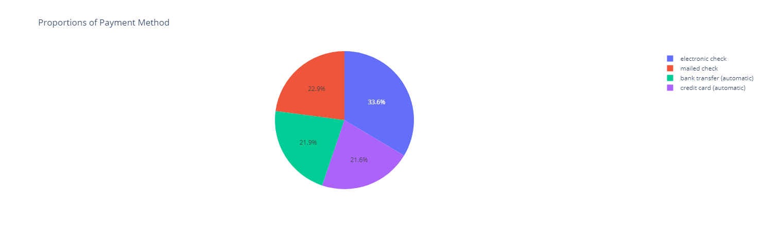**Pie Chart**
* Payment Method contains information about the method a customer uses to pay their monthly bill. electronic check, mailed check, bank transfer (automatic), credit card (automatic).
* It shows that electronic and mailed checks are the preferred methods, while automated payments via bank transfer and credit card are less common. This information could be valuable for a business in understanding customer payment preferences and potentially streamlining payment options.
  1. 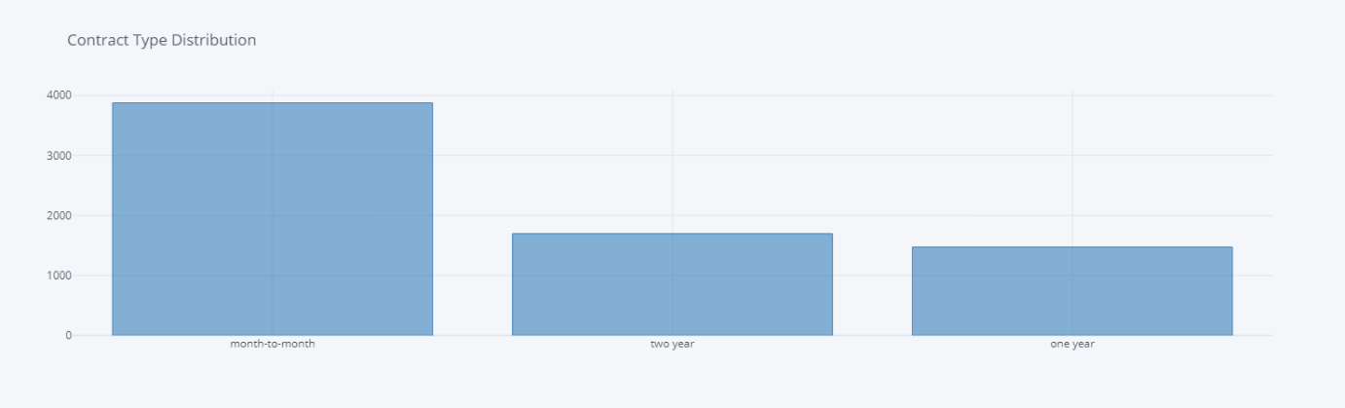**Bar chart**
* Contract: The type of contract each customer has with the telecom company. Contract types could include `Month-to-month`, `One year`, and  `Two year`.
  1. 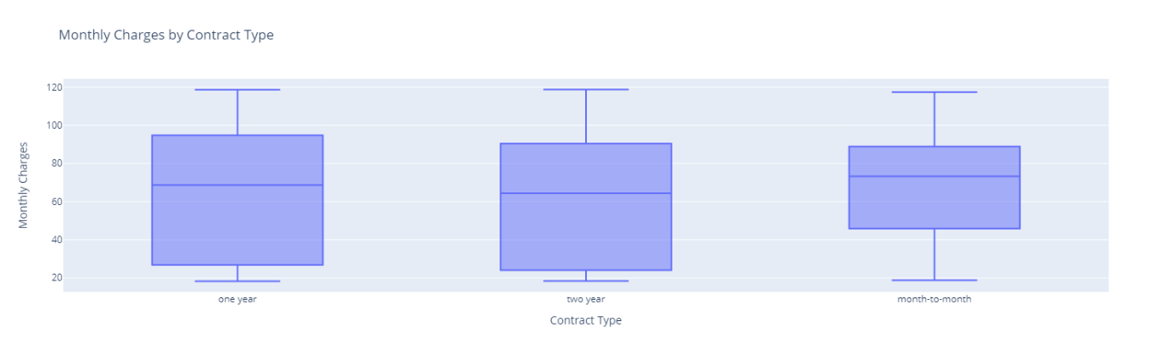**Box Plot**
* This diagram is useful for understanding how monthly charges vary with the type of contract. It can help in analyzing customer payment behavior and might be used by the company to adjust pricing strategies or promote certain contract types.
  1. 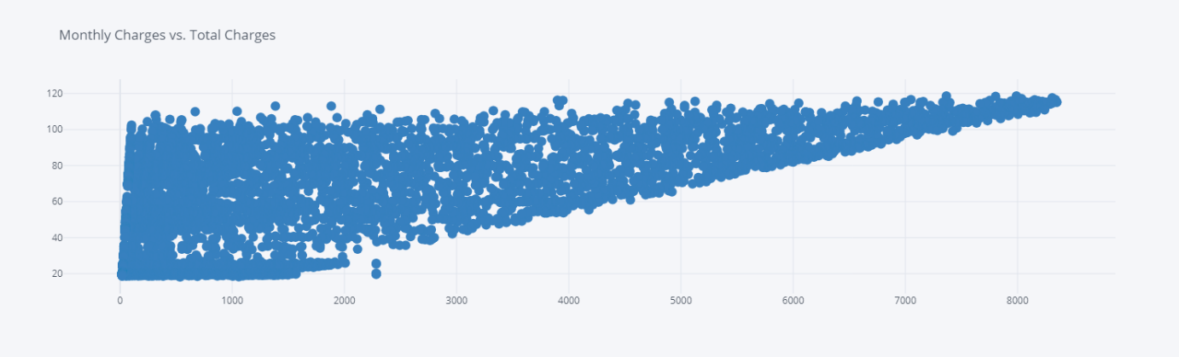**Scatter Plot**
* When total charges increase, monthly charges also tend to increase. This could indicate that customers with higher total charges are those who have been with the service for a longer time or who have higher monthly service plans.
* It helps to understand how monthly charges relate to the total charges, which can be important for analyzing customer spending behavior, billing strategies, and revenue forecasting.  
  1. 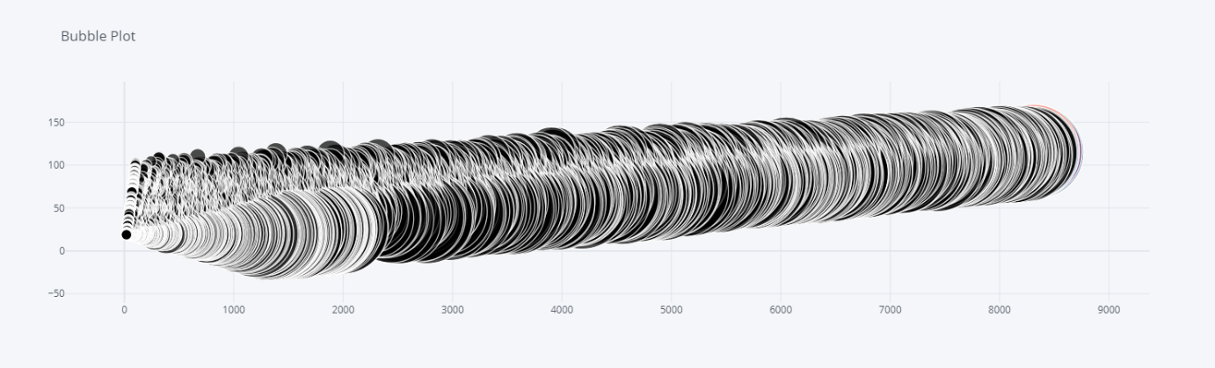**Bubble chart**
* The horizontal axis represents ‘Total Charges’, which likely indicates the cumulative amount a customer has been charged over time. The values range from 0 to 9000.
* The vertical axis represents ‘Monthly Charges’, which are the charges a customer pays each month for services.
* The size of each bubble represents the ‘tenure’, which is typically the length of time a customer has been with the service. Larger bubbles indicate a longer tenure.