LAB FINAL EXAMINATION
CS TOOLS

NAME: Taha Juzar
Reg no: 2022585
faculty: CYS

Q1) I) first created a permission.txt file
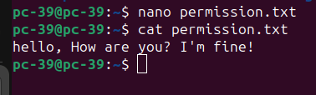

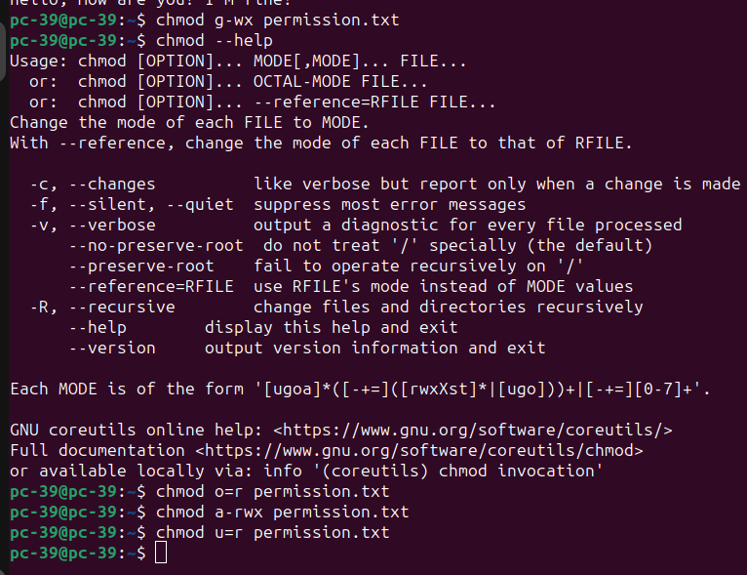
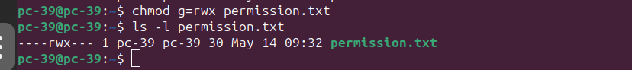
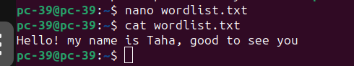
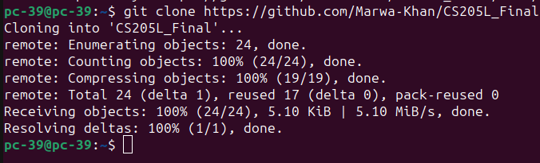
b) creating a file named wordlist.txt and adding some information

Q1 part 2) Debugging
first cloning into repo
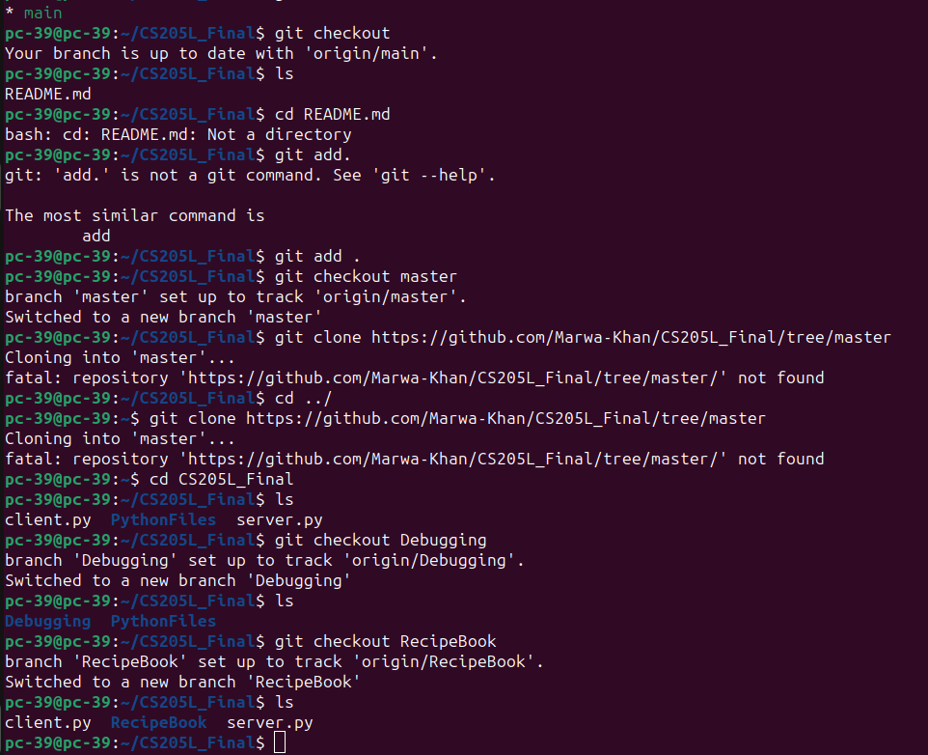
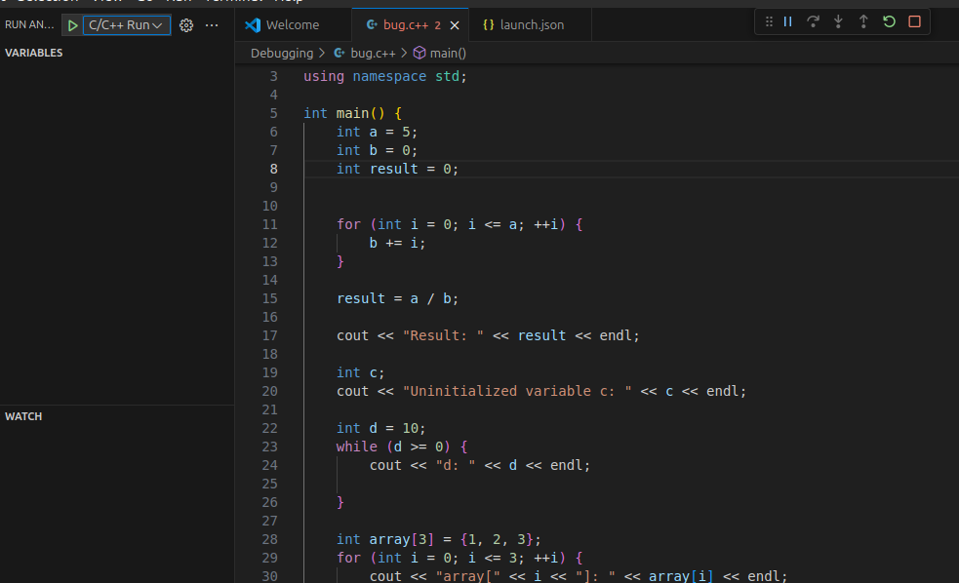
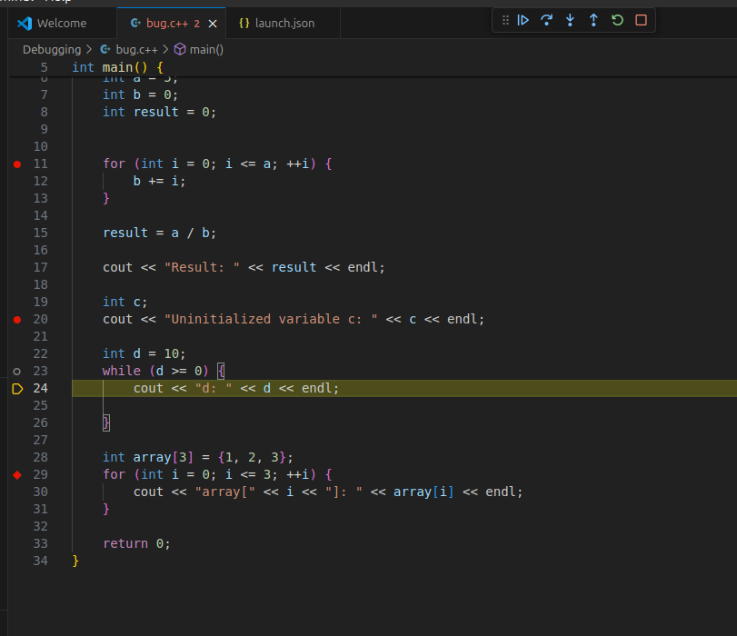
C++ code for debugging

edit the breakpoint, log points in the code and step iver, step into to debug it.

then edit the launch.json file

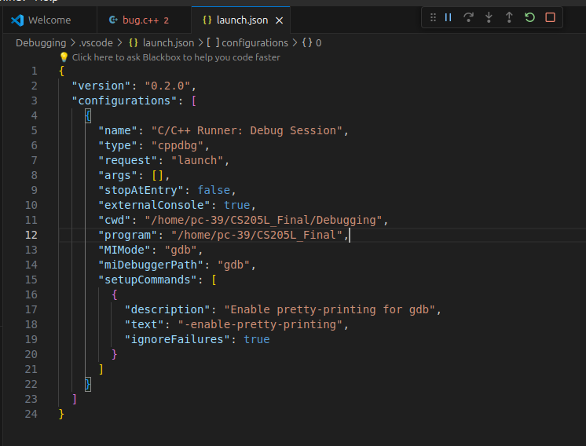
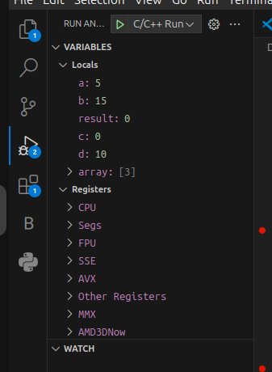

showing the breakpoints to the code
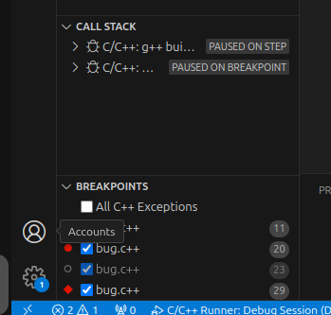

Now corrected the code and showing the output

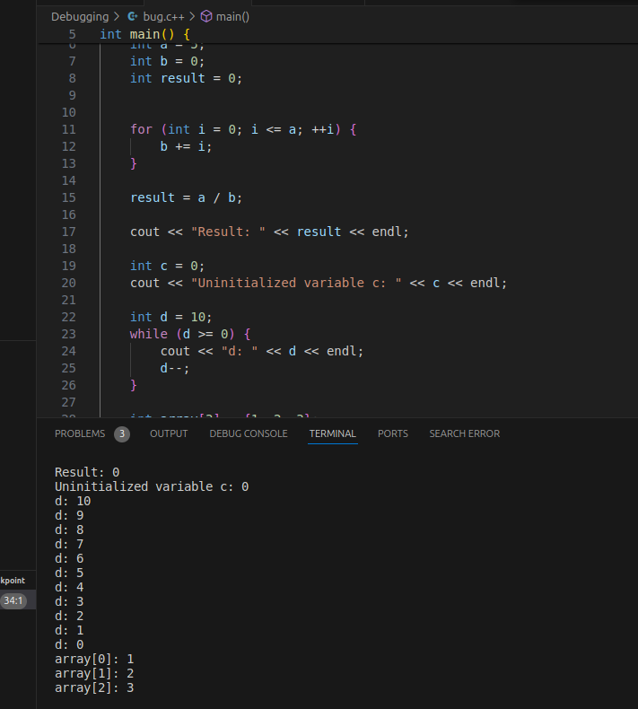
Q3) Recipe book switching branch to access files
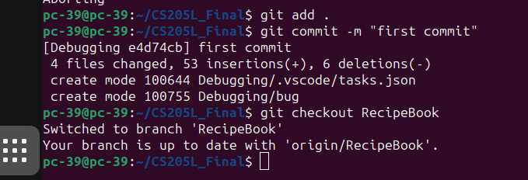
Changes done in the html code by adding personal details and information

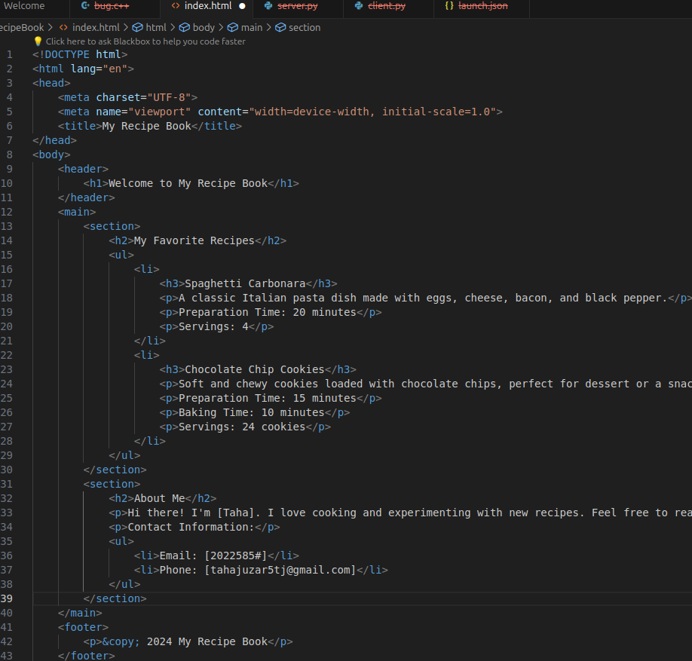

The below is the docker file
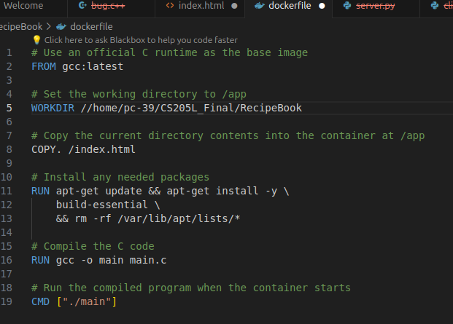

Image has been build with my registration number 2022585 and a tag
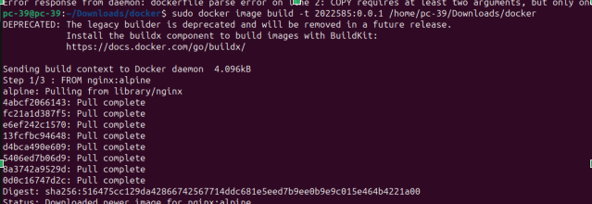
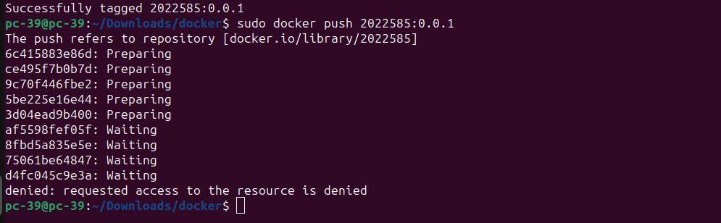
Pushing the image

creating the container
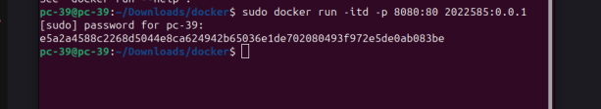

Q2) first switch to branch Debugging
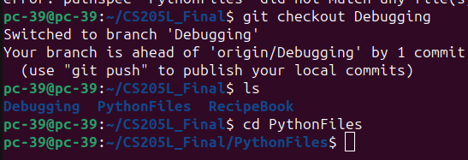

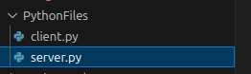

creating docker file for container build
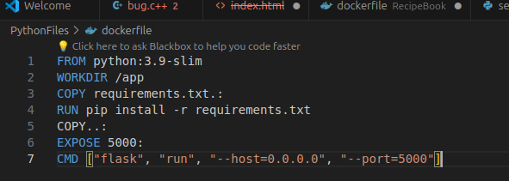
Docker compose file

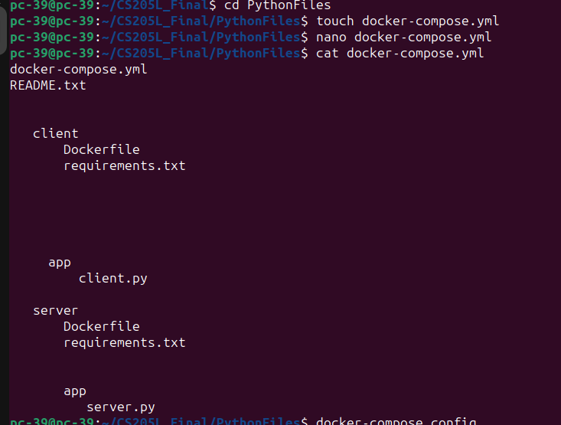
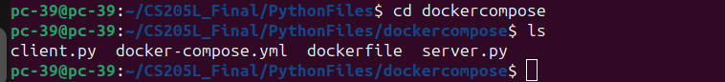
Created dockercompose folder and put all the files in it.
