Data Distributions and Their Applications
Taha Abbas Naqvi | 26I-8004 | MS DS, Section A | Data Science Tools & Techniques, Assignment 2

1. Distribution types
A distribution describes how often each value of a feature occurs.
Normal: symmetric bell, mean equals median, skewness ≈ 0, excess kurtosis ≈ 0 (BMI).
Uniform: every value in a range is equally likely, flat histogram, excess kurtosis ≈ −1.2 (age).
Skewed: one long tail pulls the mean away from the median; right-skewed if the tail points right (income containing outliers).
Multimodal: two or more peaks, usually a mixture of sub-populations; the mean can fall in a valley with no data.
IID vs Non-IID: IID means samples are independent draws from one common distribution; Non-IID means they come from different distributions or depend on each other.
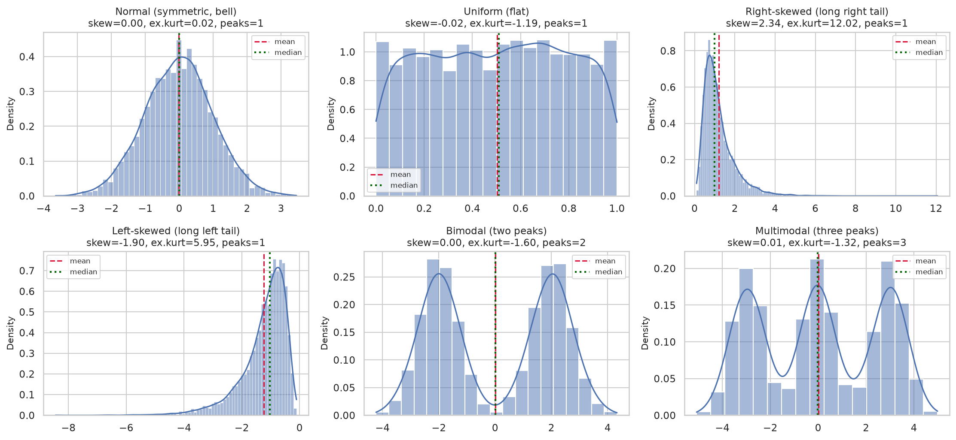
Figure 1. Synthetic examples of each distribution type (dashed = mean, dotted = median).

2. Dataset 1 (tabular, 5,050 rows × 20 columns)
Cleaning. The raw file had 49 duplicate rows, hidden "unknown" text in two numeric columns, three spellings of the USA, 12 negative incomes, about 5 % missing values and impossible outliers (hours up to 391, BMI up to 204, income up to 2.3 million). Outliers were flagged with the IQR rule, set to missing, and all gaps were filled by sampling observed values, which keeps distribution shapes intact.
Key insight. Before cleaning, hours, BMI and income looked extremely right-skewed (skewness 2.7, 9.1, 16.1). After cleaning the skewness is about 0, so the skew was an artefact of the outliers.
Distributions. age, hours per week, capital gain, capital loss, experience and credit score are uniform (skewness ≈ 0, kurtosis ≈ −1.2); job satisfaction is discrete uniform; BMI (27.1 ± 4.8) and annual income (≈ 70 k ± 24 k) are normal. No numeric feature is skewed or multimodal after cleaning. Categorical features are nearly balanced, but the target disease_risk is imbalanced (31 % positive).
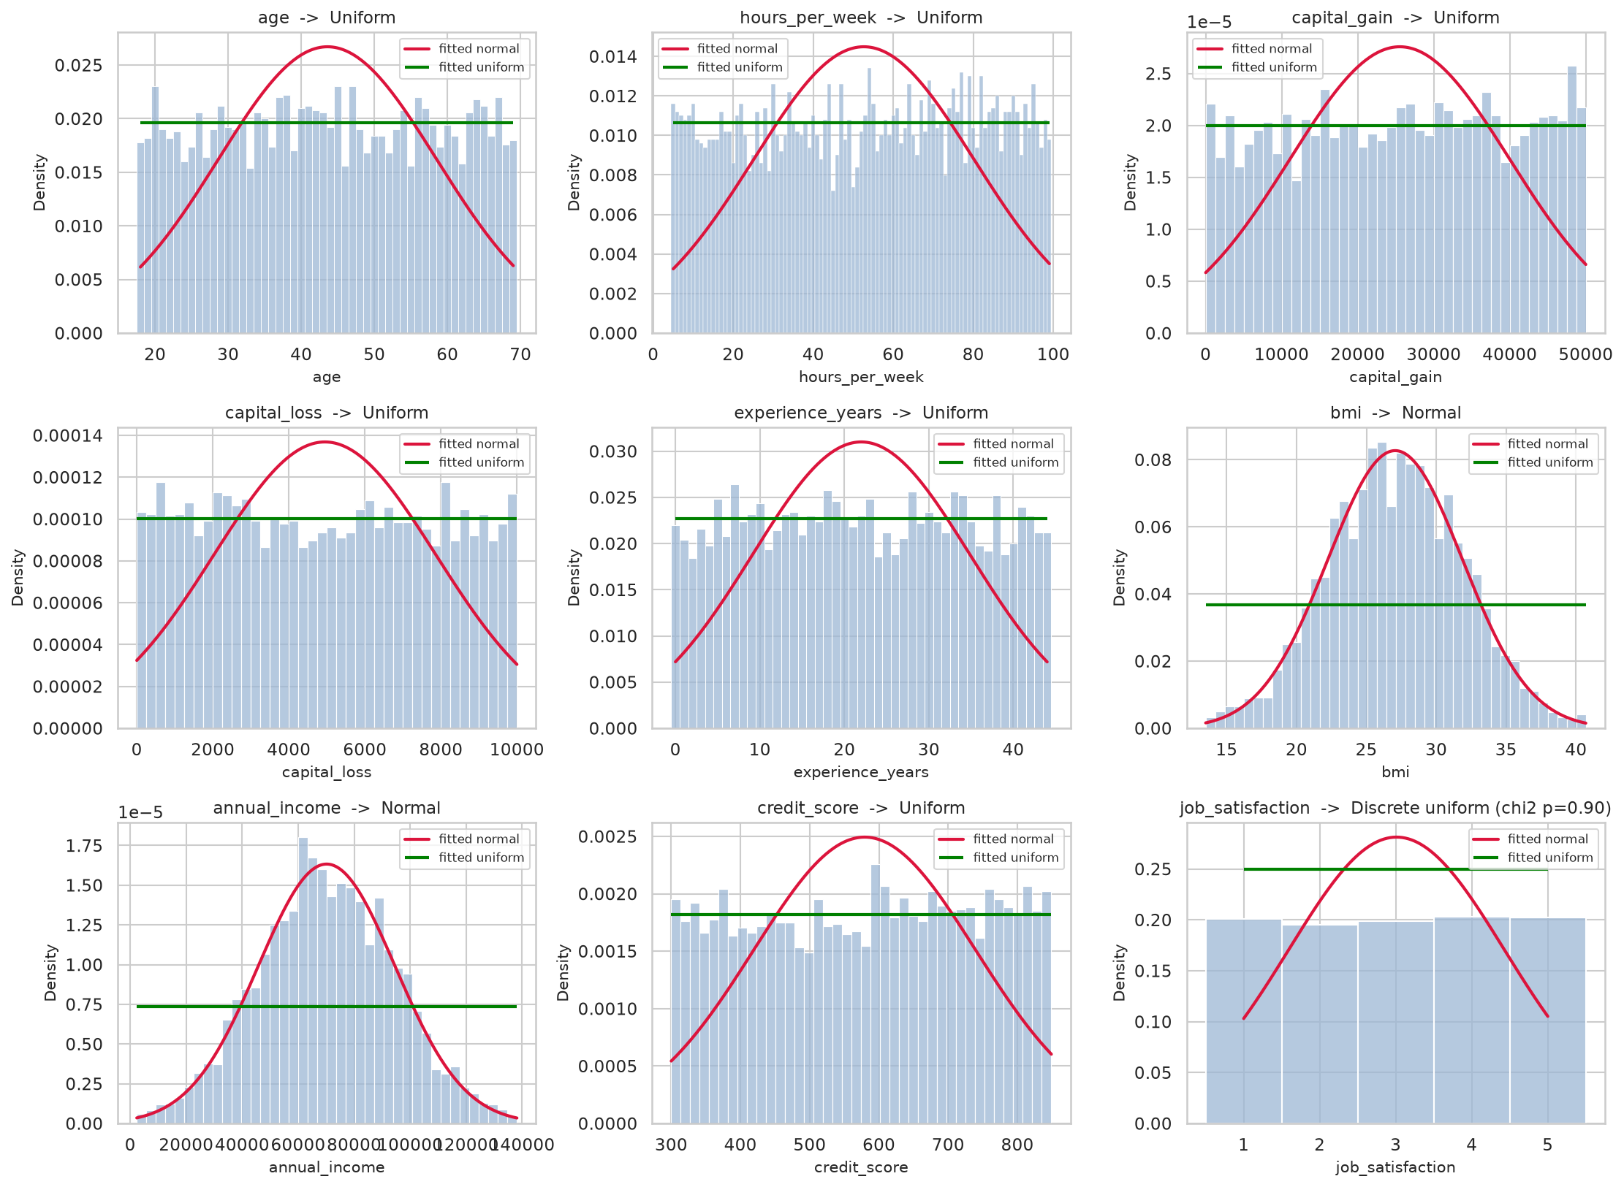
Figure 2. Cleaned features with fitted normal (red) and uniform (green) curves and the detected type.

3. Dataset 2 (CIFAR-10: airplane, automobile, cat)
Findings. CIFAR-10 has 60,000 colour images of 32 × 32 pixels in 10 balanced classes (50,000 training, 10,000 test). Per-image mean R, G, B, brightness and contrast are unimodal and roughly normal, with mild right skew for automobile and cat and mild left skew in the airplane blue channel. Airplanes are brightest (141 versus about 117) and bluest, cats are warmest, and automobiles have the highest contrast. Pixel-level histograms are not normal: they are broad with a spike at 255 from saturated pixels.
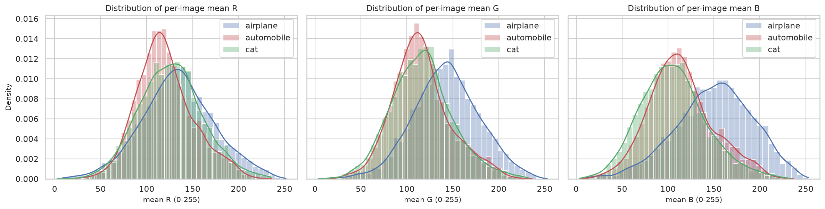
Figure 3. Distribution of per-image mean R, G and B for the three classes.
IID or Non-IID? Train and test data are statistically indistinguishable (KS distance ≤ 0.047), so shuffled CIFAR-10 is IID. The classes, however, differ clearly (all pairs p < 0.001), so a split by class is Non-IID (largest KS distance 0.213, versus 0.021 for a random split).

4. Why distributions matter
The distribution decides which statistic is meaningful (mean or median), which tests and models are valid (many assume normality), how to find outliers and impute values without distortion, and whether a transformation is needed. Here, cleaning changed the apparent shape of three features completely. For machine learning, IID data lets a test set estimate real performance, while Non-IID data, as in federated learning, breaks that assumption and needs special methods.

