Title: Medicine Stock and Expiry Management System
Group Members:
- Hammad Siddiqui [24k-0702]
- Taha Tofique [24k-0981]
Submission Date:
23st November 2025

1. Executive Summary
Overview:
The Medicine Stock and Expiry Management System is a console-based application developed in Assembly Language (MASM) using the Irvine32 library. The system manages medicine stock for small clinics or pharmacies, enabling users to add, view, check expiry, delete, and clear medicine records efficiently. The project demonstrates the practical application of Assembly Language concepts such as data handling, control flow, procedures, and arrays to solve real-world problems in healthcare.
Key Findings:
- Successfully developed a lightweight, menu-driven medicine management system.
- Automated identification of expired medicines, reducing potential human error.
- Maintained a clean and organized data structure using parallel arrays for medicine names, quantities, expiry months, and flags.
- Demonstrated effective collaboration, with Hammad handling core logic and Taha designing the menu interface and documentation.

2. Introduction
Background:
Healthcare facilities often face challenges in tracking medicine stock manually, which can lead to misplaced records, expired medicines, and financial losses. By developing an Assembly-based management system, this project provides a low-level, efficient solution for medicine tracking, highlighting the relevance of Computer Organization and Assembly Language (COAL) principles in practical applications.
Project Objectives:
- Develop a console-based system in MASM to manage medicine data.
- Automate expiry checks to prevent expired stock from remaining in inventory.
- Apply core COAL concepts such as arrays, procedures, and data manipulation in real-world scenarios.
- Provide a simple, intuitive interface for users to interact with the system.

3. Project Description
Scope:
Inclusions:
- Add, view, delete, and track medicines with attributes: name, quantity, and expiry month.
- Automatically identify and display expired medicines based on user input for the current month.
- Support up to 10 records in memory with a clear, menu-driven interface.
Exclusions:
- File storage and automated date retrieval (current month is entered manually).
- Graphical or database interface.
- Advanced features such as barcode scanning or IoT integration.
Technical Overview:
- Programming Language: Assembly (MASM)
- Library Used: Irvine32.inc
- Development Platform: Microsoft Visual Studio (Windows x86)
- Tools: MASM assembler, Visual Studio IDE for editing and debugging

4. Methodology
Approach:
The project followed an iterative development approach, implementing one feature at a time, testing it, and refining before proceeding to the next. Regular team meetings ensured alignment on functionality and interface design.
Roles and Responsibilities:
- Hammad: Core coding, procedure development, logic implementation, testing.
- Taha: Menu interface design, documentation, assisting with testing and debugging, preparing final report.

5. Project Implementation
Design and Structure:
- Data Organization: Parallel arrays for names, quantities, expiry months, and status flags.
- Menu Layout: A console-based menu offering six options: Add, View, Check Expiry, Delete, Clear, Exit.
- Procedures: Each functionality was encapsulated in a dedicated procedure for modularity and readability.
Functionalities Developed:
- AddMedicine: Adds a medicine to the first available slot.
- ViewAll: Displays all medicine records currently in memory.
- CheckExpired: Identifies medicines that have expired relative to the current month.
- DeleteMedicine: Deletes a medicine record by its index.
- ClearAll: Resets all records to an empty state.

Challenges Faced:
- Invalid scale error: MASM restricts index scaling to 1, 2, 4, or 8. Resolved by computing offsets using imul.
- Managing string input: Names required null-terminated handling to avoid buffer overflow.
- Maintaining modularity: Ensuring each procedure interacts properly with shared arrays without corrupting data.

6. Results
Project Outcomes:
- Fully functional console-based medicine management system.
- Accurate expiry checks prevent expired medicines from remaining unnoticed.
- Modular, clean code structure facilitates easy maintenance and debugging.
Screenshots and Illustrations:
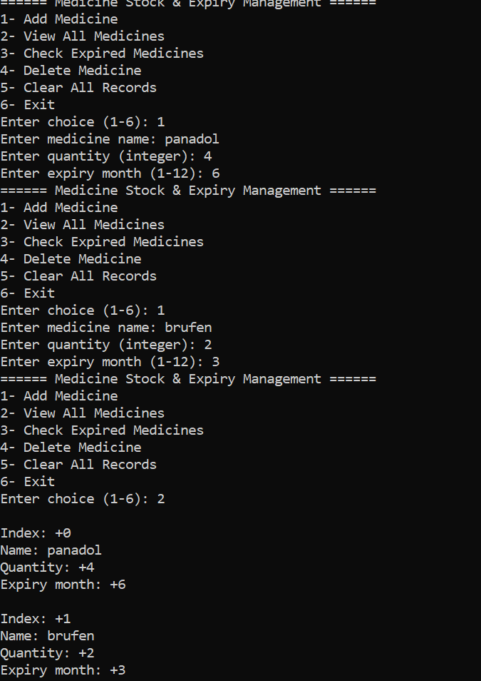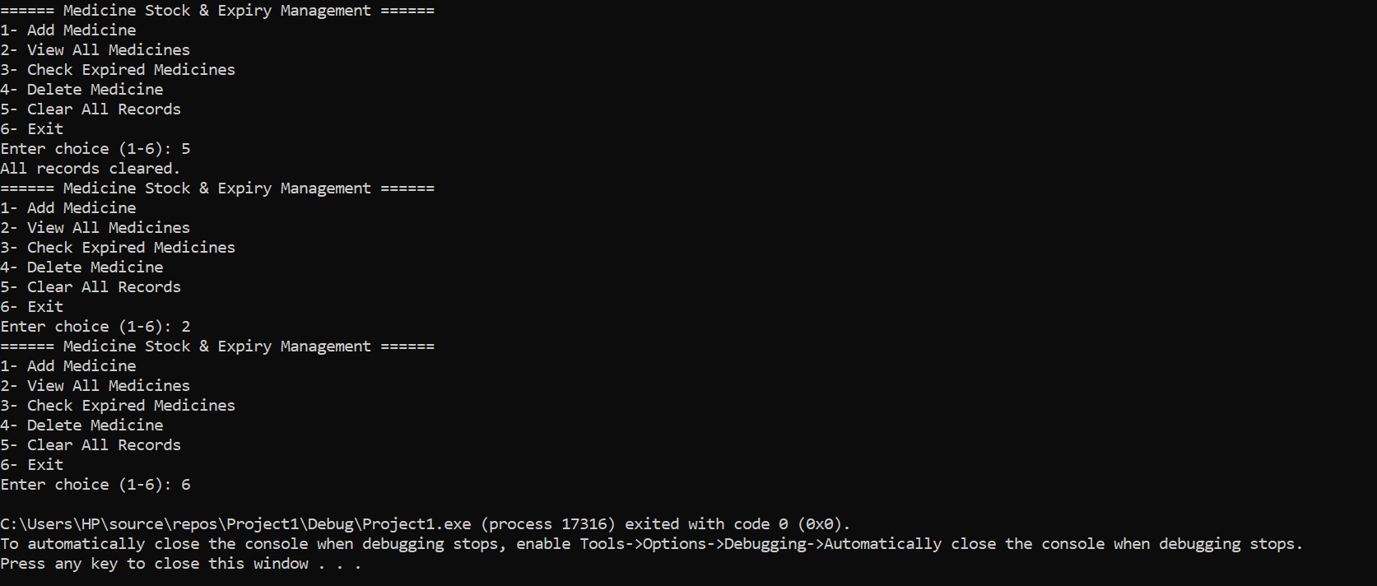

Testing and Validation:
- Tested all menu options individually and in sequence.
- Verified correct handling of full capacity, invalid inputs, and edge cases.
- Confirmed expiry checks against manually entered current month.

7. Conclusion
Summary of Findings:
The project successfully implements a robust Assembly-based system to manage medicine stock, achieving all initial objectives: adding, viewing, checking expiry, deleting, and clearing records. The system reduces human error in tracking stock and ensures expired medicines are easily identifiable.

Final Remarks:
This project demonstrates the practicality of COAL concepts in real-world applications, bridging low-level programming with healthcare management needs. Future improvements could include automated date handling, file storage, or a graphical interface for larger scale deployment.

