**CS355 – Database Systems**

Project ERD & Schema Diagram Group 10

**Name:** Taha Zahid (tz09220), Ayaan Merchant (am08853), Abdullah Shaikh (as09245)

1. **Updated Screens:**

Initial Screens:

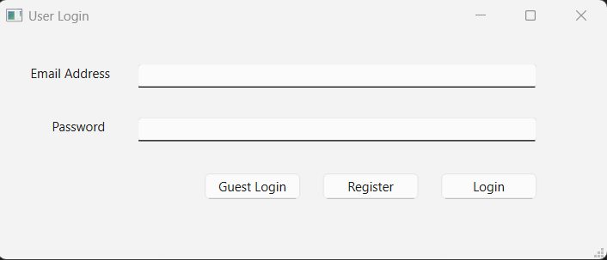

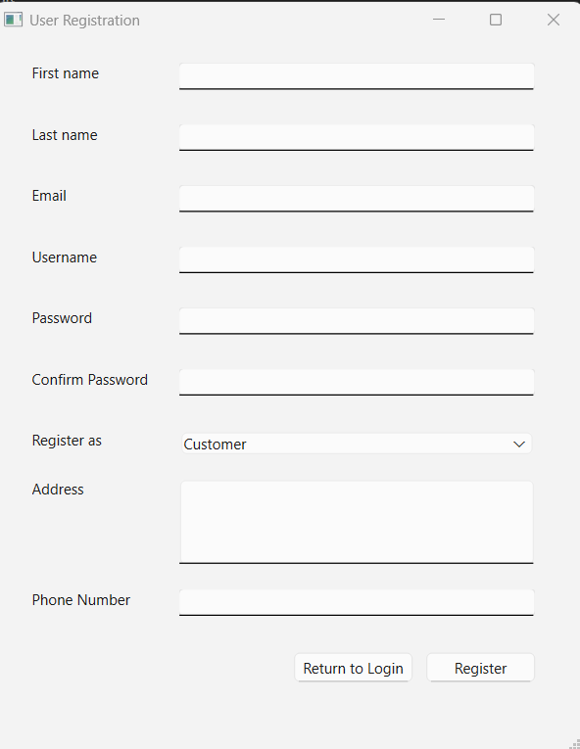

1. **User Interface**

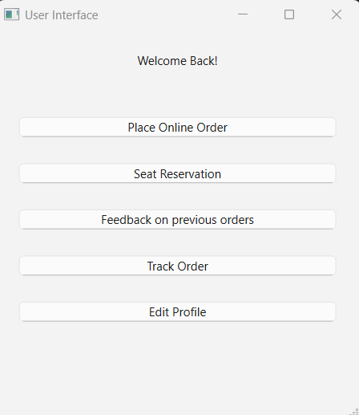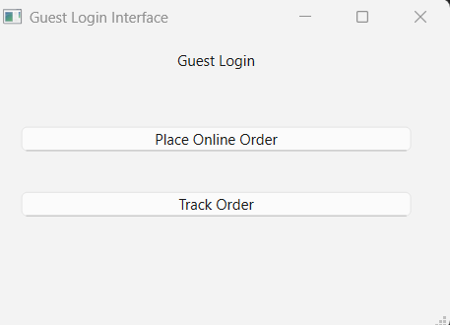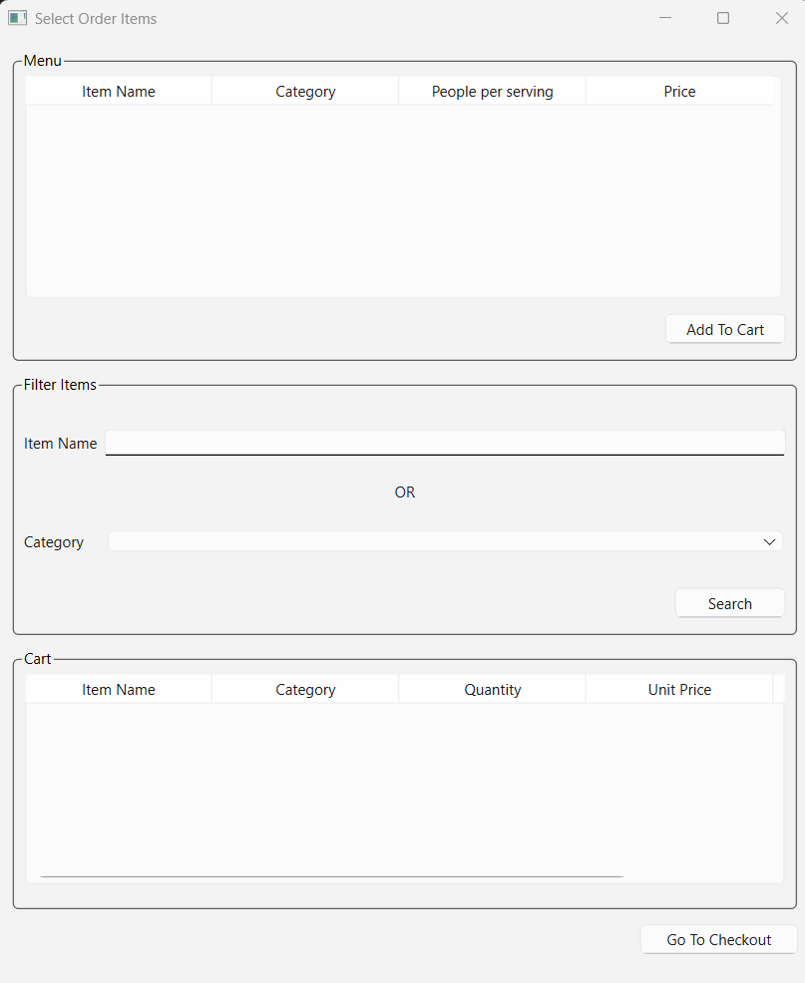

More options for registered user

This screen will open once “Place Online Order” button Is clicked

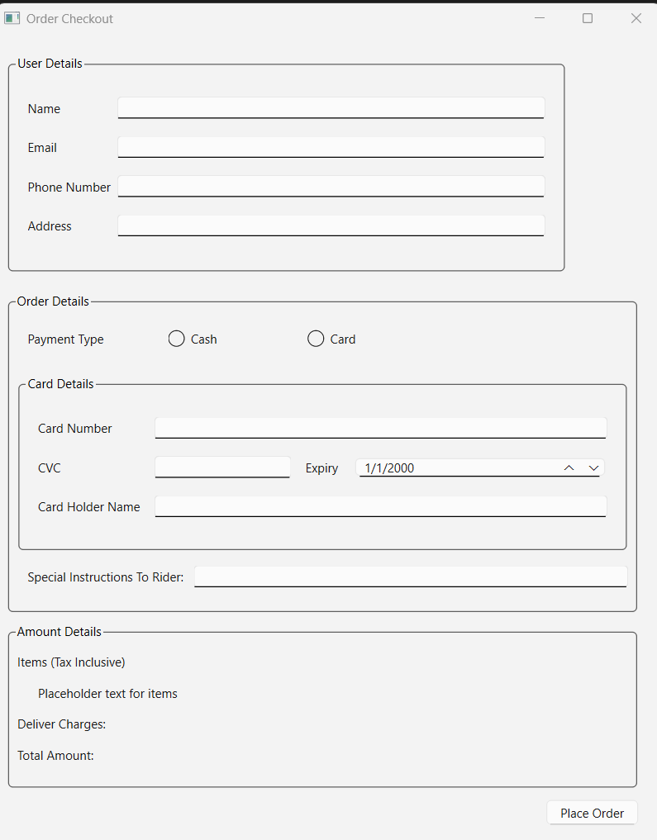

This screen would appear once “Go To Checkout” is clicked on Order Item Select screen.

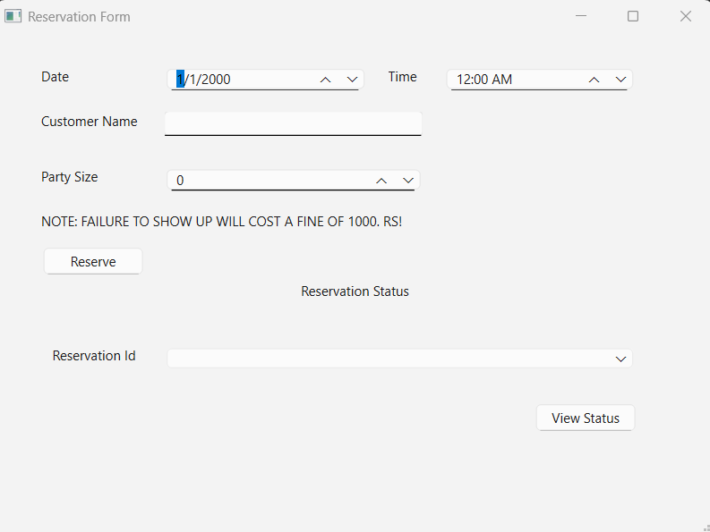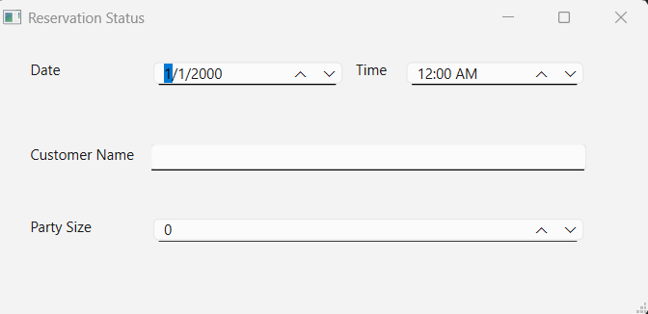

This screen would appear when “View Status” is clicked on Reservation Form.

This screen would appear when “Seat Reservation” button is clicked in user interface.

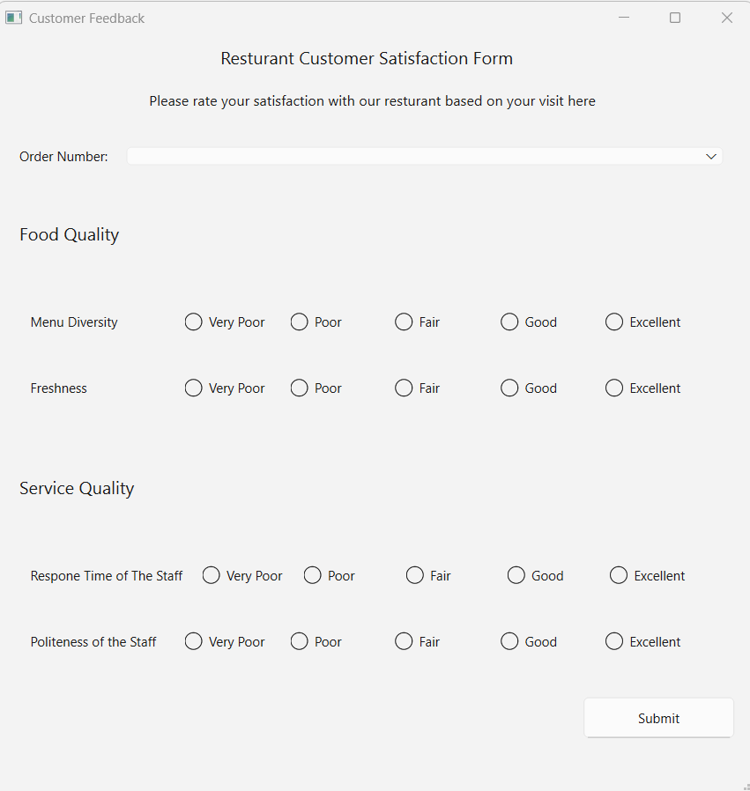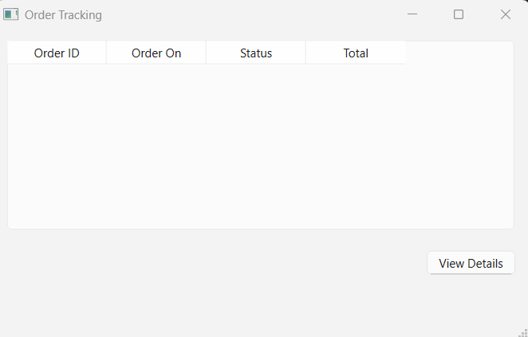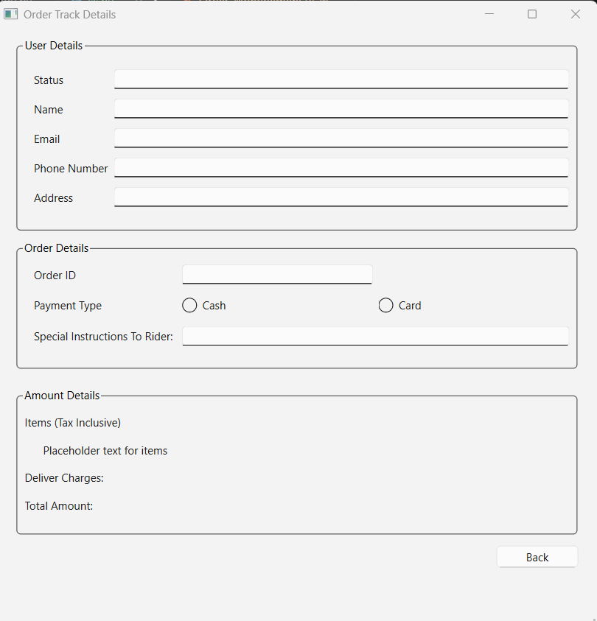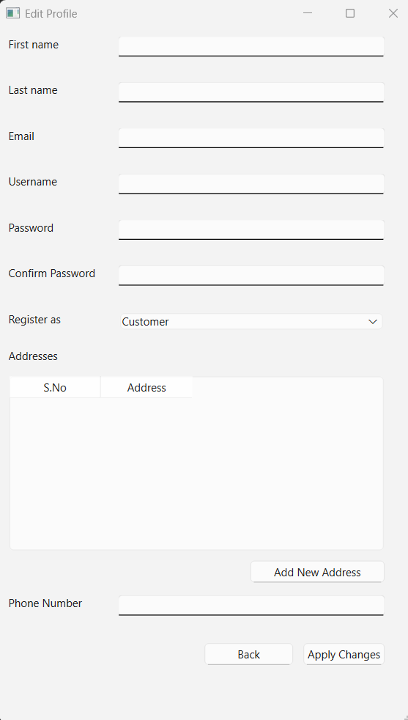

This screen would appear when “Track Order” is clicked on user interface.

This screen would appear when “Feedback on previous orders” is selected in user interface.

This screen would appear when an entry is selected and ‘View Details’ is clicked on Order Tracking screen.

This screen would appear when ‘Edit Profile’ is clicked on user interface.

1. **Admin Interface:**

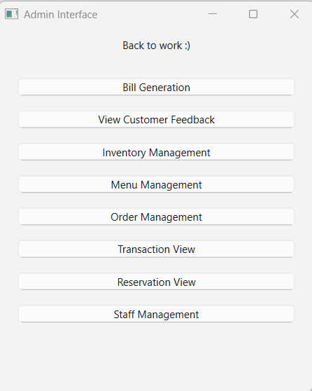

If an admin enters, this is the interface they would see.

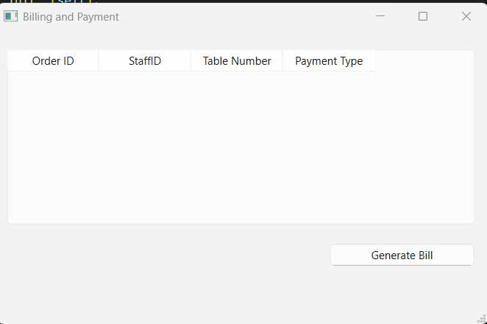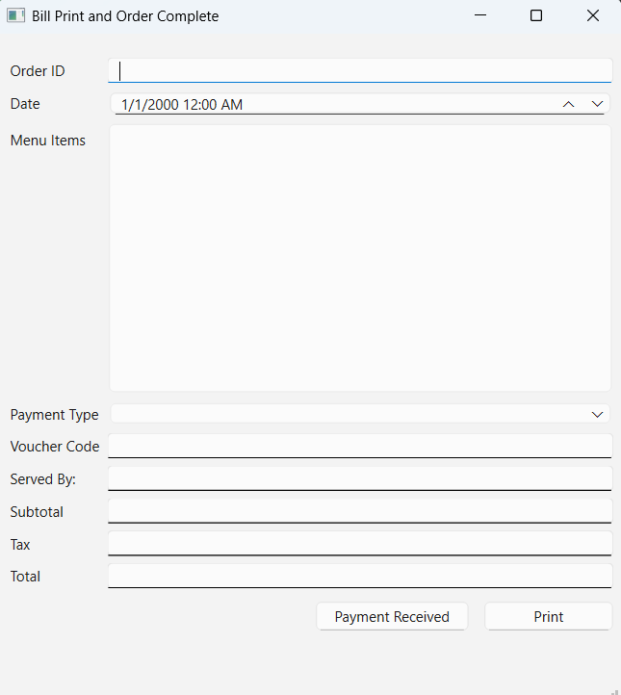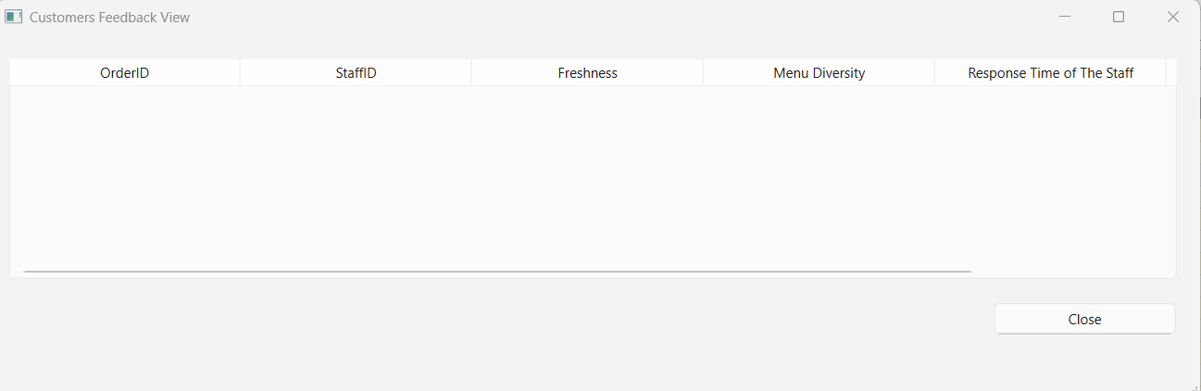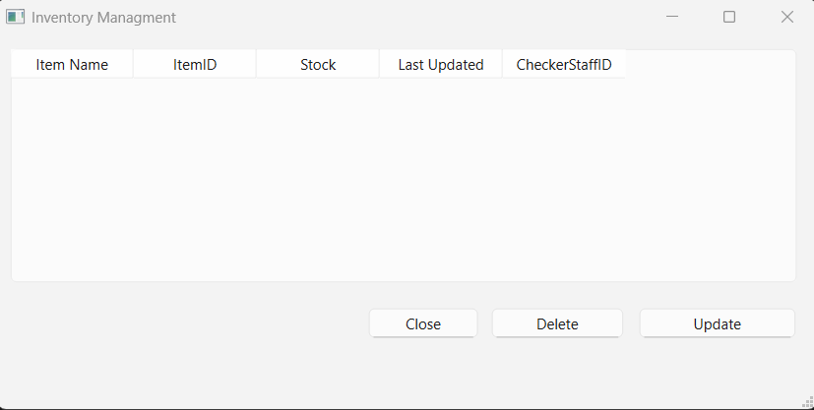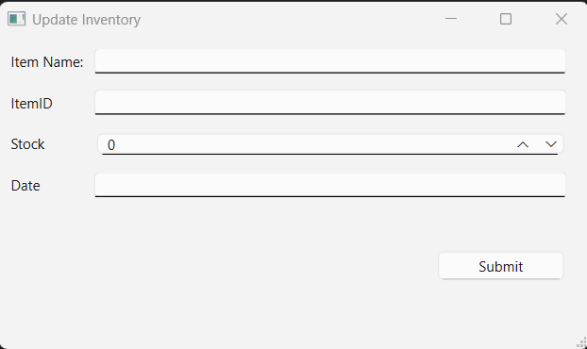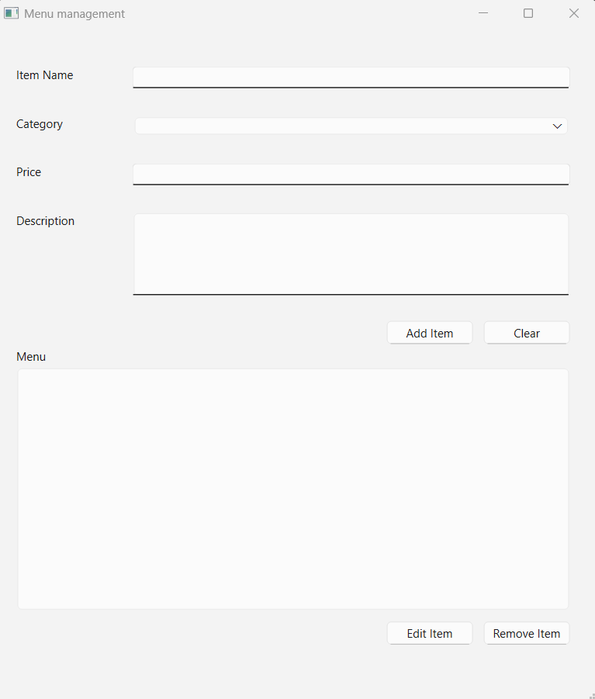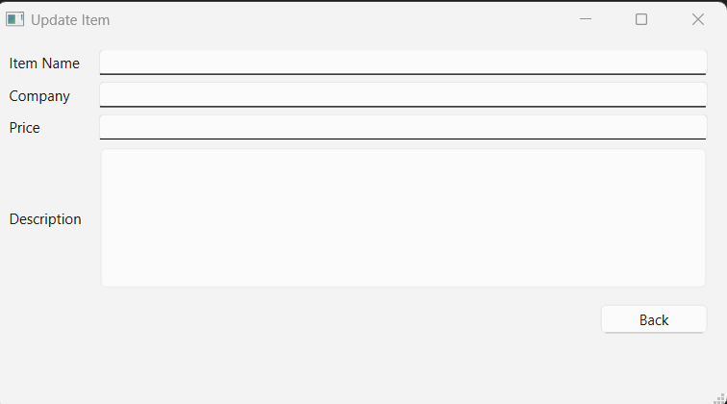

Following screen would appear when clicked on “View Customers Feedback” on admin screen.

“Billing and Payment” would open when clicked on “Bill Generation”. Clicking “Generate Bill” (while selecting an entry) would open “Bill Print and Order Complete”. “Payment Recevied” and “Print” won’t open new screens but rather just perform functions in the backend and display information messages.

“Menu Management” in admin screen opens the first image. “Edit item” opens Update Item to update the item.

“Inventory Management” in admin screen opens the screen. Clicking “Update” opens the next screen.

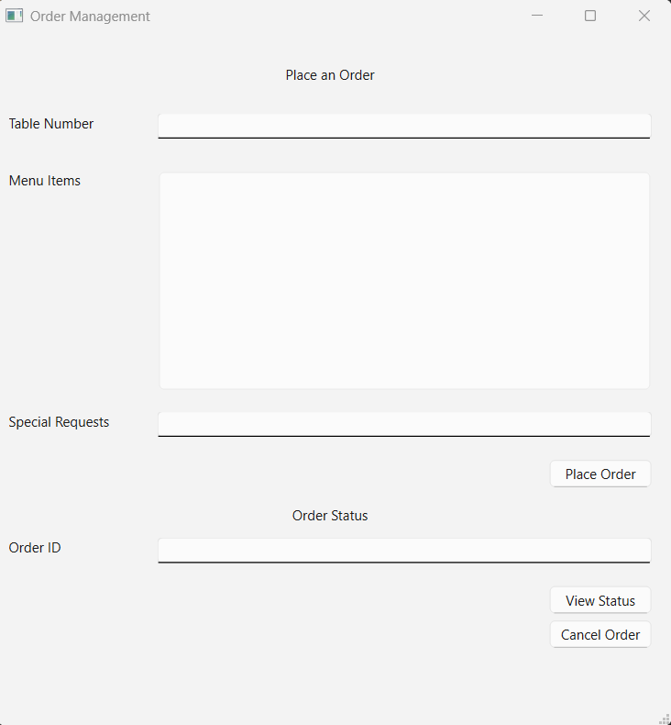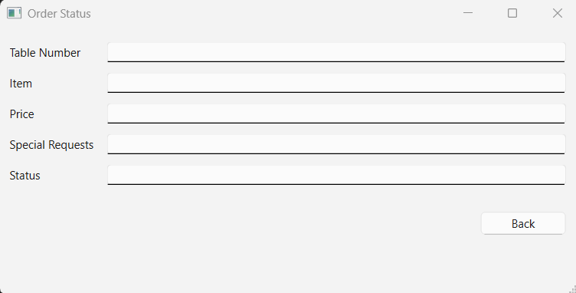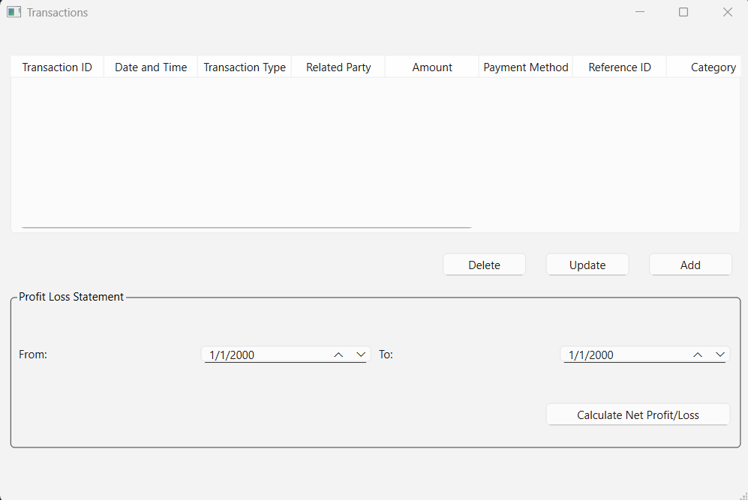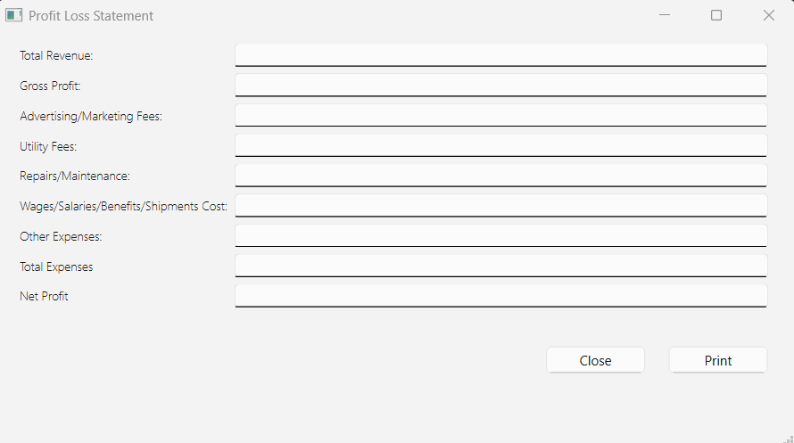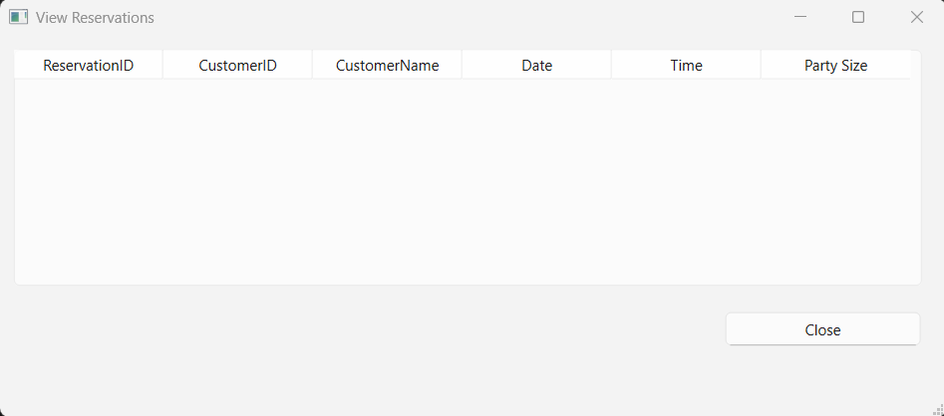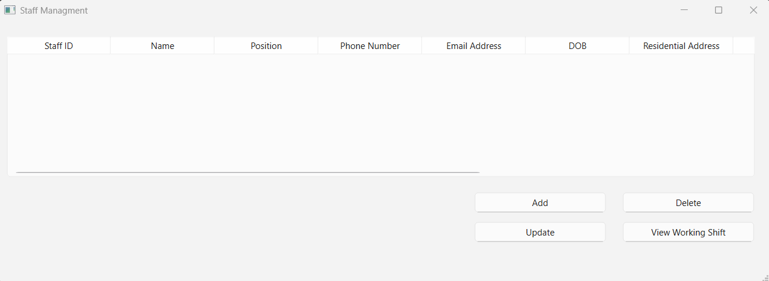

“Transaction View” in admin screen opens first image. Clicking on

“Calculate for Profit/Loss” opens second image.

“Order Management” in admin screen opens the first image. Clicking on “View Status” opens Order Status.

“Reservation View” in admin screen opens this screen. It would show all reservations from customers.

“Staff Management” in admin screen opens this screen.

Clicking “View Working Shift” opens this screen.

Clicking on “Add” or “Update” opens this screen. Update would have data already filled in

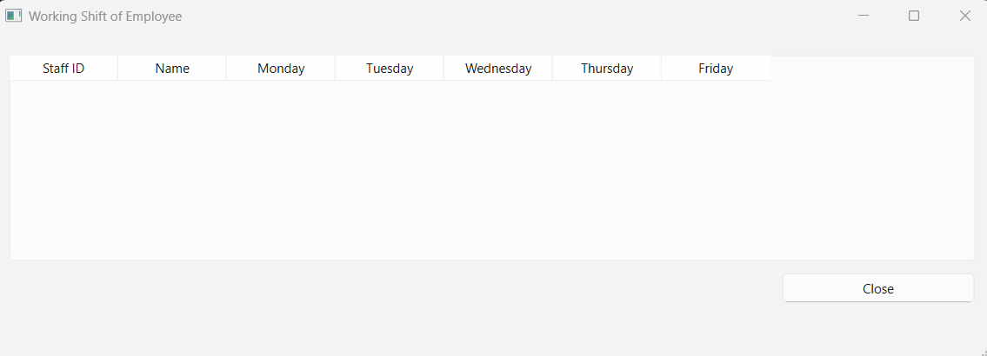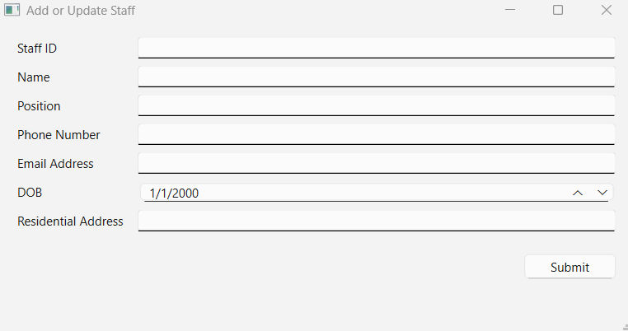

1. **ERD**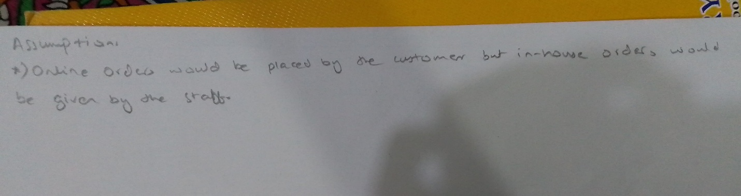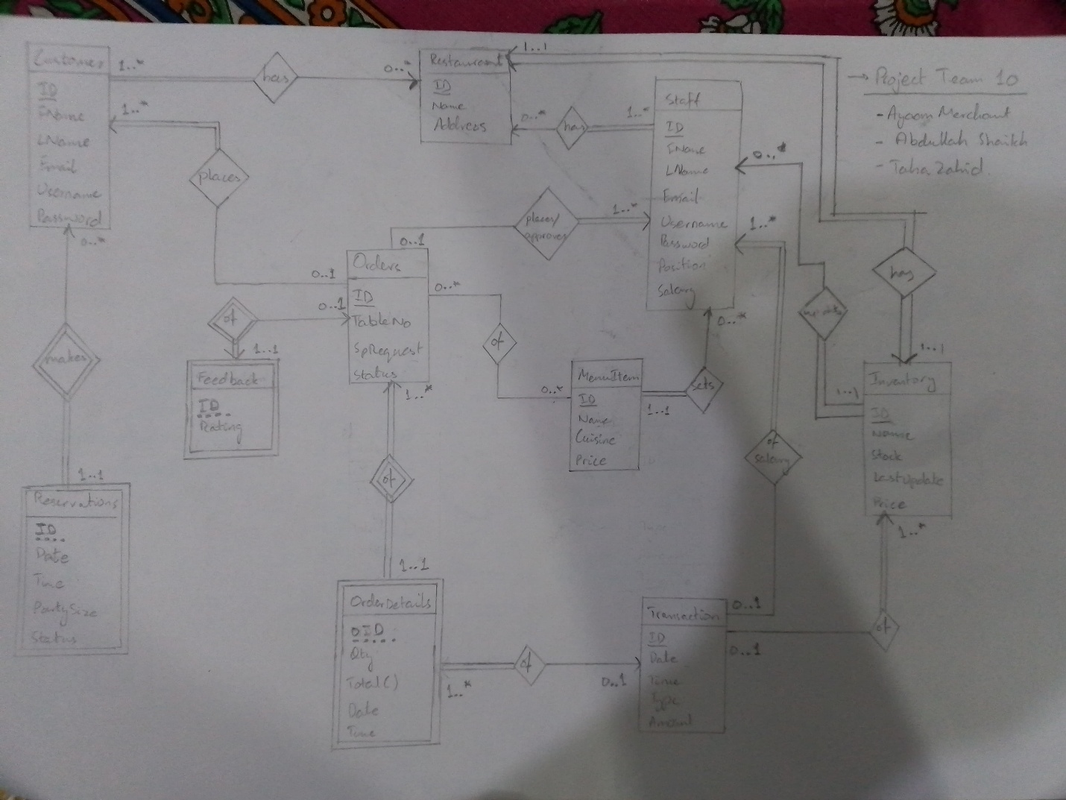
2. **Relational Schema Diagram**

