Analysis of the SF-salary Dataset MVP

The project aims is to ensure your Mercedes-Benz car ownership experience exceeds your expectations. to develop marketing plans for our next marketing campaign, we decided to analyse a dataset of San Francisco employees' salary base to know income level and target each category with the appropriate promotional campaign.

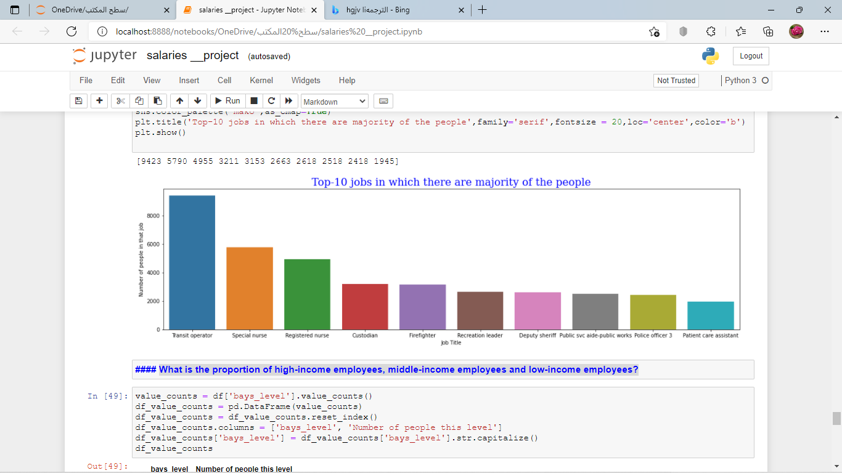

To explore this goal, Based on the 10 most popular jobs among San Francisco residents, we will offer promotions to their incumbents, such as (5% discount for health incumbents ...etc.)