Fota Sequence Diagram

1. Normal Operation:

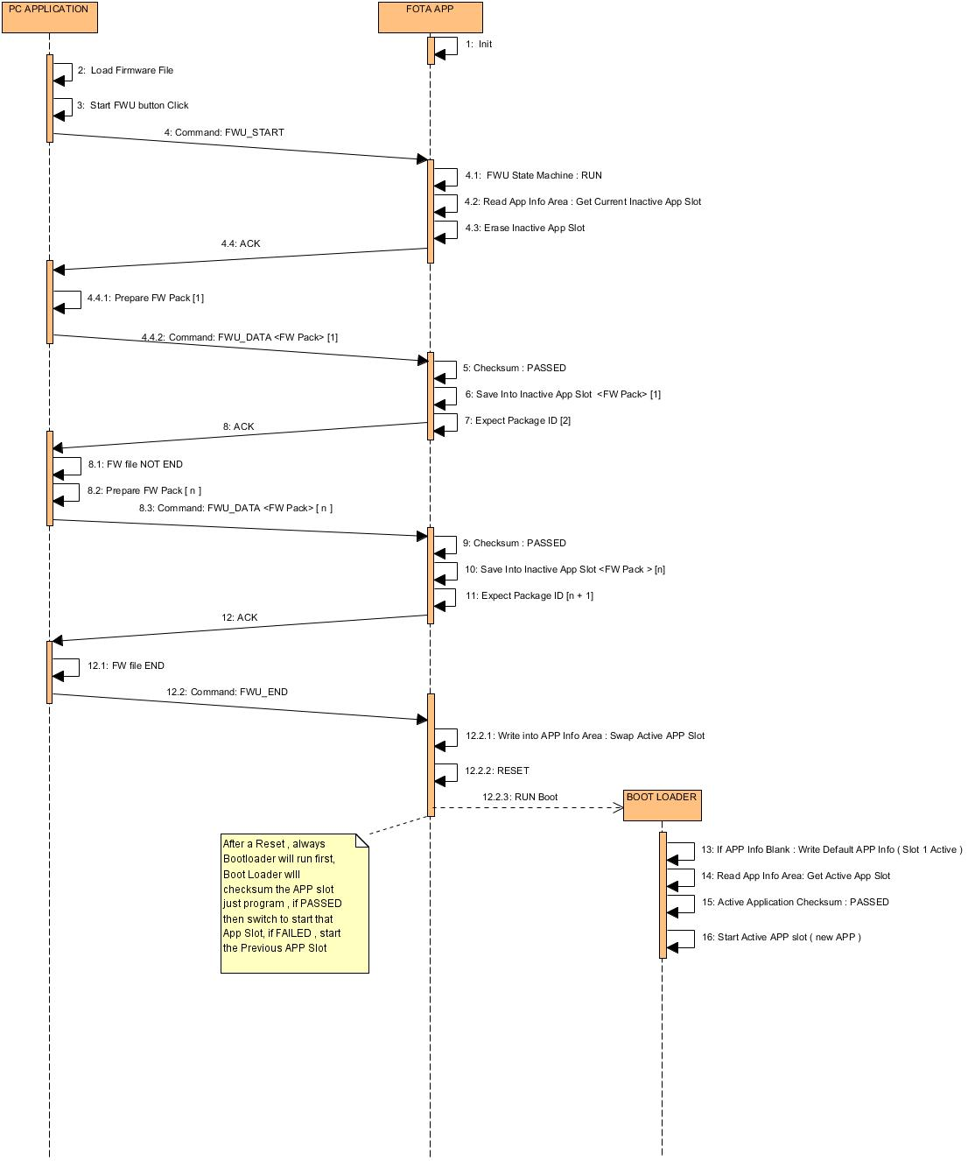

1. Error Handling:
2. Firmware Checksum failed:

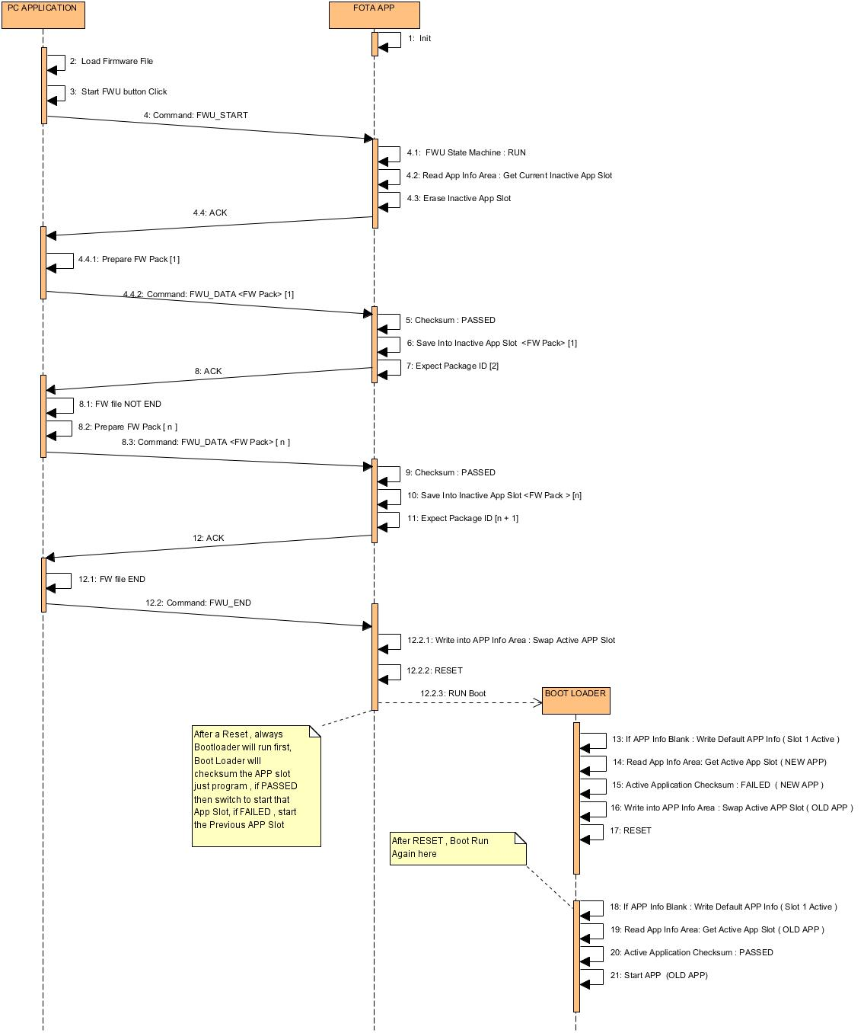

1. 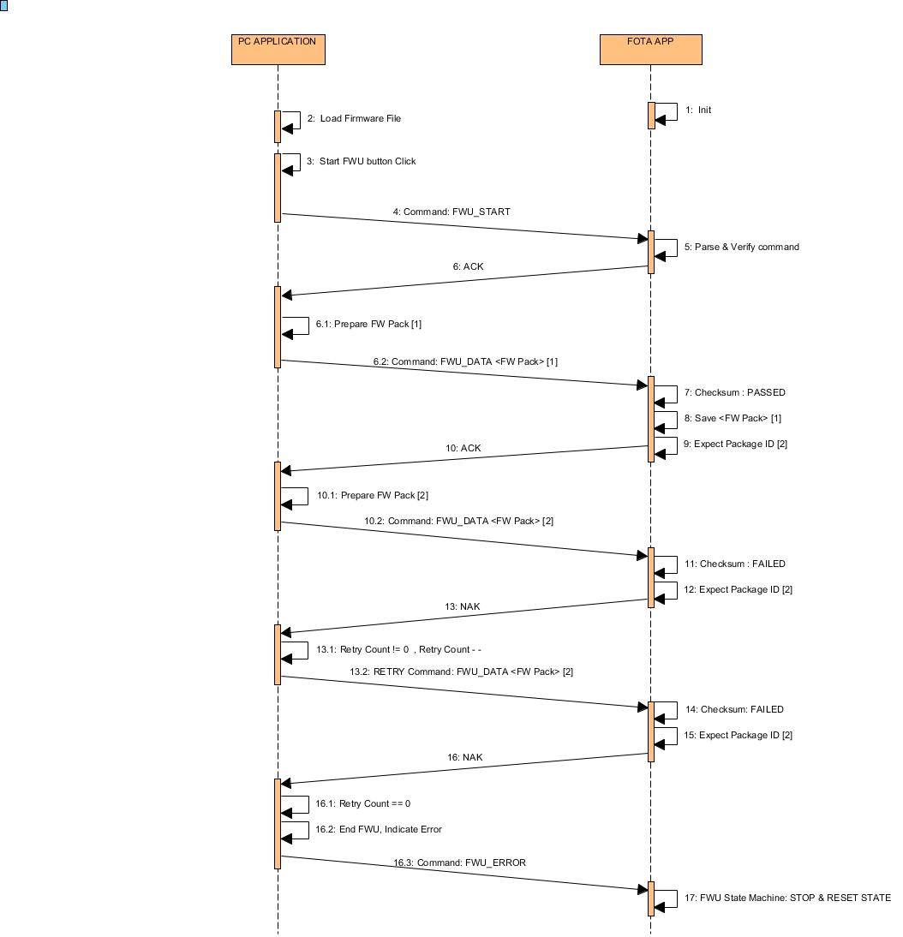Package Checksum failed:
2. Package Lost:

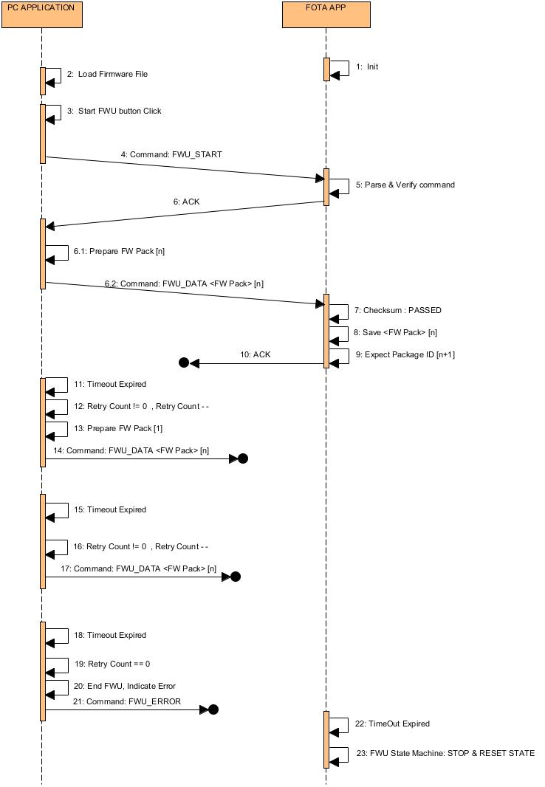

1. Package Duplicated:

