Fota Sequence Diagram

1. 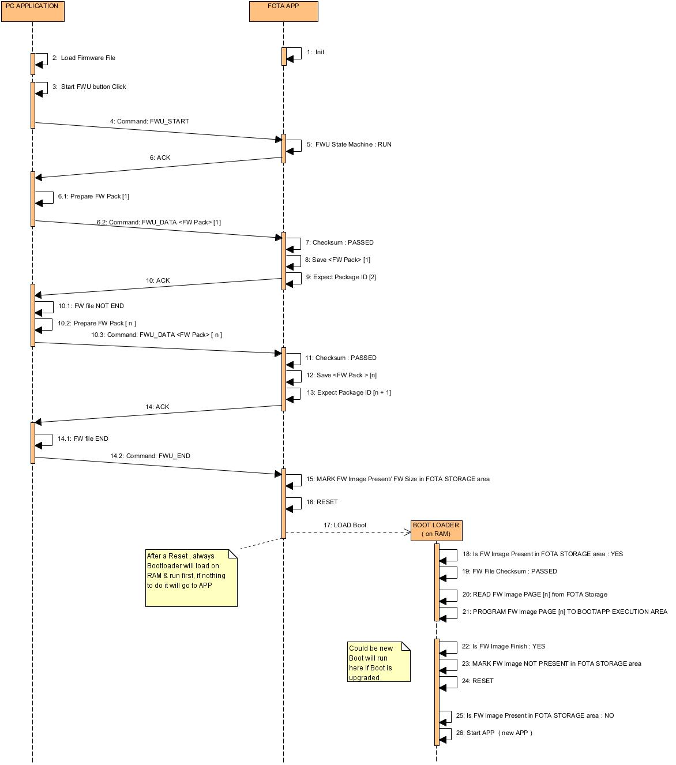Normal Operation:
2. Error Handling:
3. 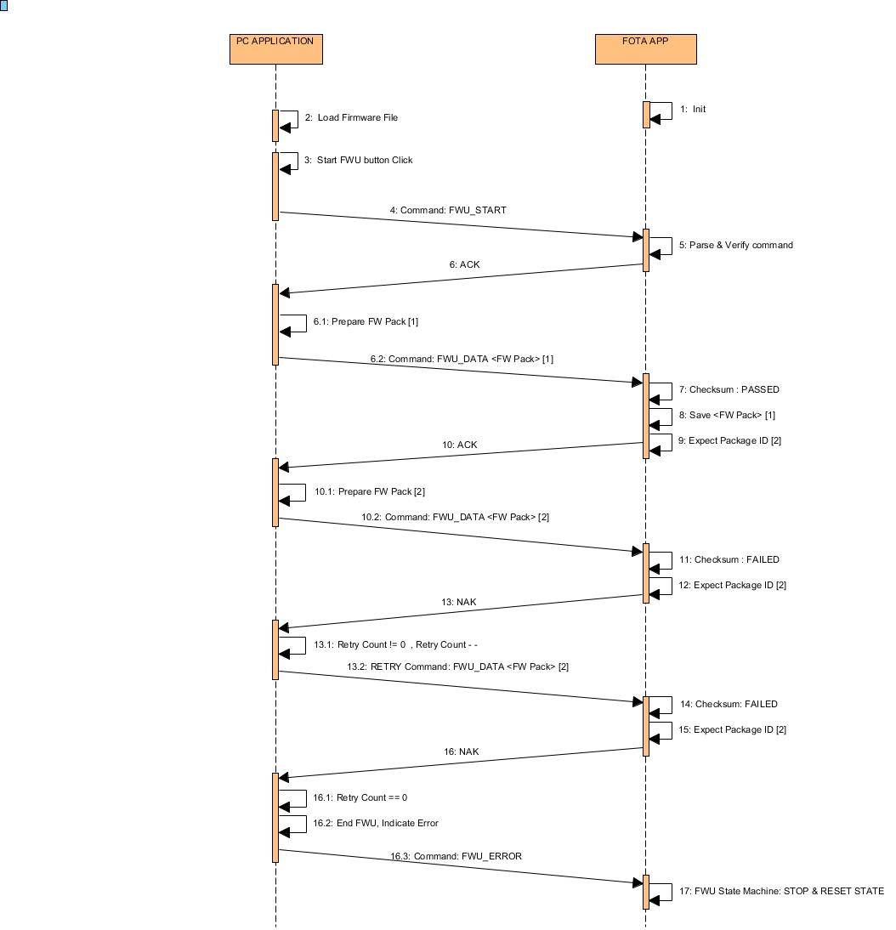Package Checksum failed:
4. Package Lost:

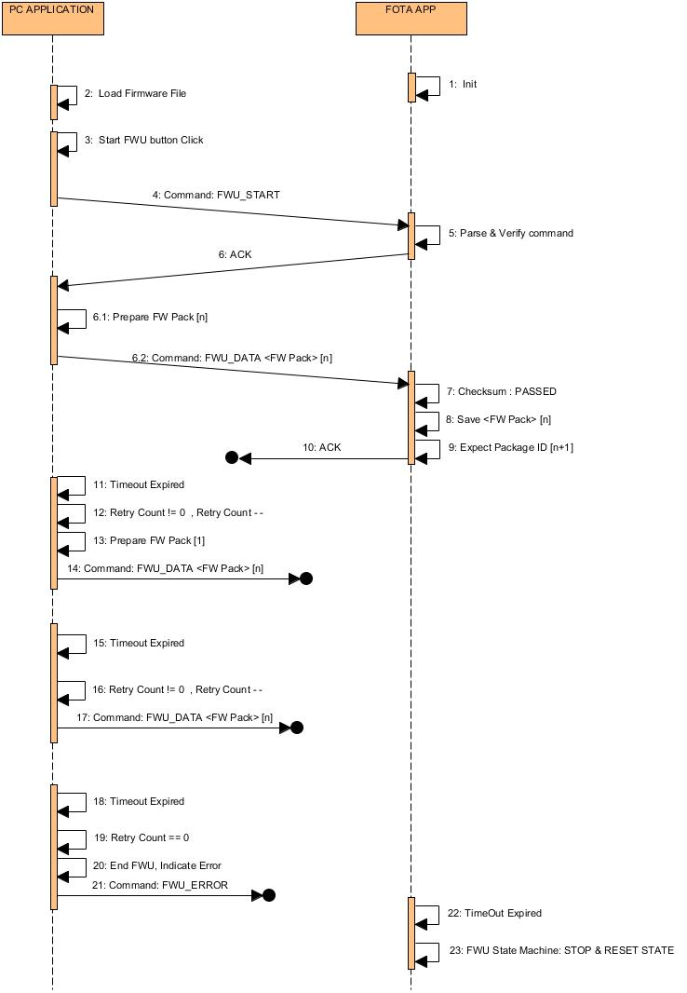

1. Package Duplicated:

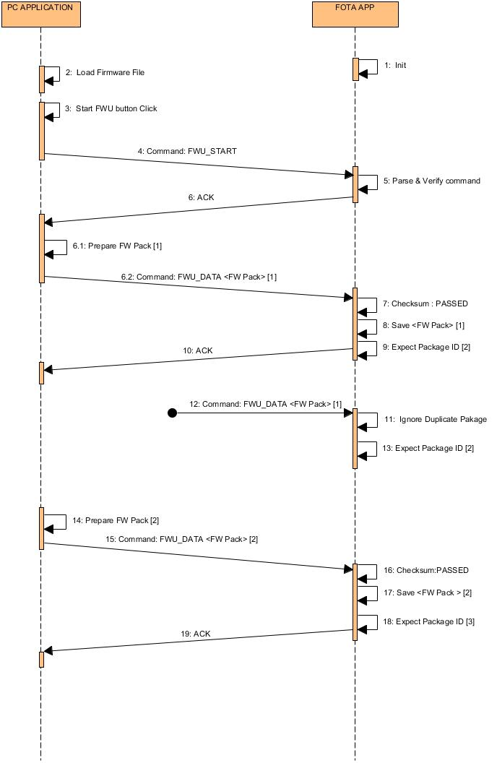

1. Firmware Checksum Failed:

