Maktabatus Salaf MERN Stack Book Store
Home
- Banner(Picture)
- Navbar
  - Home
  - লেখক
  - Prokashoni
  - Search bar Icon(বই অনুসন্ধান করুন প্লেসহোল্ডার)
  - একাউন্ট(Login + Register)
- Carousel
- Left side book author name + price range filter + filter using Category name + right side show total book card+ cart icon(right center position) + sort options(asc by name & price, desc by name & price, newly added first & last, most popular first last)
- Popular Books Cards Most Popular first Sorted view all this section top right corner
- New Published Books Cards Newly Added first Sorted view all this section top right corner
- Tuba Publications Books Cards
- Blog/Article
- Book Review YouTube video embedded
- Footer (contact, page and cannel links, refund policy, terms & condition)
Details Page
- Picture with magnify feature
- Book name, author name, Category name
- Buy Now & Add To Cart Button
- Read some page feature (At most 7 page)
- Share this book with others
Like:
Will Go:
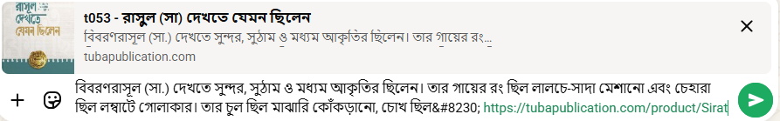
- এই বই সম্পর্কে সংক্ষিপ্ত বিবরণ
- Review & Rating section only for authorized users can make
- Below show related category other books card need show
Login Page
- Forget password
- Phone(Verified)
- Password
- Register link for new user
Register Page
- Phone(Verification code we sent using firebase free tier)
- Name
- Address(Village, Thana, District in one single field)
- Password
- Confirm Password
- Login link for old user
Cart Page
Checkout page
    - Guest Checkout(default) Name, phone, email(optional), address, thana, district
    - Returning User Option
    - Price + shipping charge 40tk fixed for single book = grand total
    - Below section mean upper footer section, we want to show recently viewed books
Featured Section
- Common section home, login, register, cart page & other pages
Like: 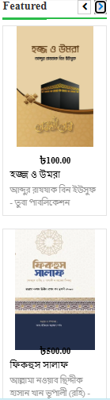
WhatsApp Contact Icon (Later we will make Chatbot):
- Position right bottom corner
- Connect WhatsApp Number with setup frequently asked questions
Authorized Customer Pages

Admin Pannel Pages

