

Matlab Assignment1

**Instructor: Dr. Qadri Mayyala**

**Course: Digital Signal Processing – ENCS4310**

First semester 2022/2023

Student : Taher Hasan – 1191740

Q1) A)

n=-5:1:5;

imp=n==0;

y=2*circshift(imp,-2) - circshift(imp,4);%circshift is a function that shifts the impulse

figure();

stem(n,y);

title("Q1 A");

xlabel("X-axis");

ylabel("Amplitude");

B)   
n=0:50;

y=cos(0.04*pi*n)+0.2*randn(size(n))

stem(n,y);

title("Q1 B");

xlabel("X-axis");

ylabel("Amplitude");

C)  
x=-10:1:9;

imp=x==0;

y=5*circshift(imp,-10)+4*circshift(imp,-9)+3*circshift(imp,-8)+2*circshift(imp,-7)+circshift(imp,-6);% at the first we add 5 impulses at points -10,-9,-8,-7,-6 with its amplitude

y=y+circshift(y,5)+circshift(y,10)+circshift(y,15)% then shifting the 5 impulses

stem(x,y)

title("Q1 C");

xlabel("X-axis");

ylabel("Amplitude");

Q2)

n=-5:1:5;

figure();

subplot(3,1,1)

g1 = cos(2 * pi * 5/50 * n) + 0.125 * cos(2 * pi * 15/50 * n);

stem(n, g1,'filled','r')

xlabel('n');

ylabel('g[n]');

title('A (Fs=50Hz)')

grid on;

subplot(3,1,2)

g1 = cos(2 * pi * 5/30 * n) + 0.125 * cos(2 * pi * 15/30 * n);

stem(n, g1,'filled','k')

xlabel('n');

ylabel('g[n]');

title('B (Fs=30Hz)')

grid on;

subplot(3,1,3)

g1 = cos(2 * pi * 5/20 * n) + 0.125 * cos(2 * pi * 15/20 * n);

stem(n, g1,'filled','b')

xlabel('n');

ylabel('g[n]');

title('C ((Fs=20Hz))')

grid on;

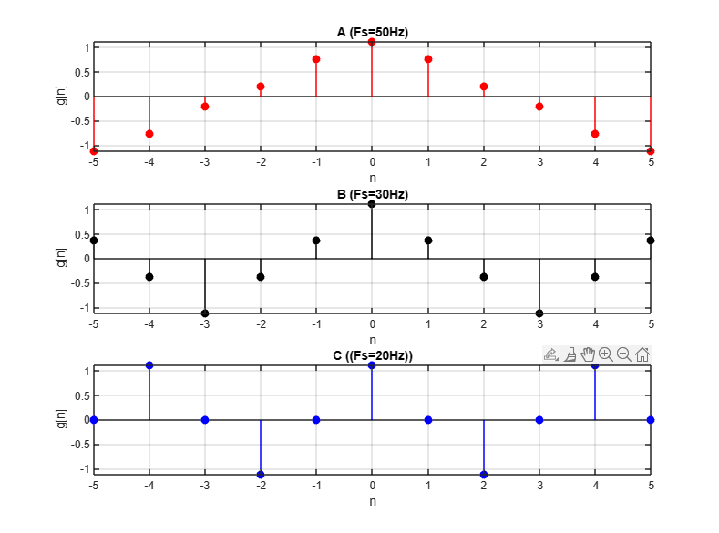  
  
  
  
  
  
  
  
  
  
  
  
  
  
  
  
  
Q3)

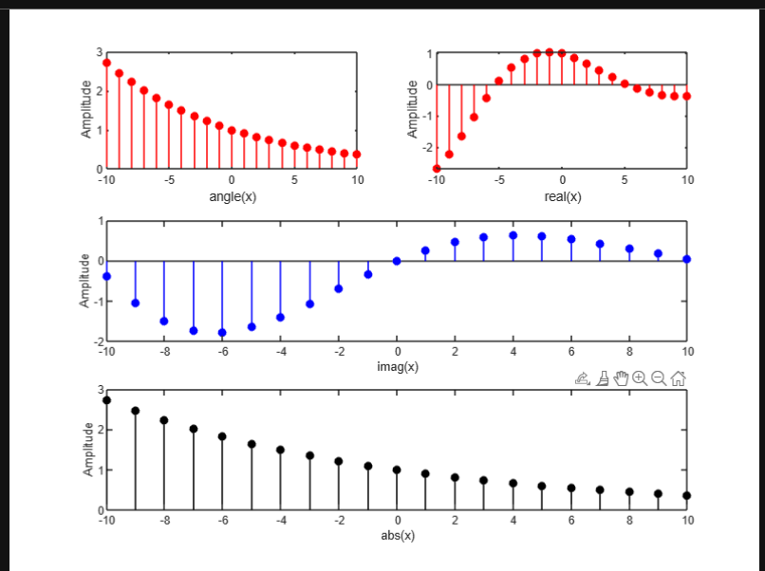  
t=-10:1:10;

x=exp(-0.1+1i*0.3).^t;

a=real(x);

b=imag(x);

c=abs(x);

d= angle(x) * 180 ./pi

subplot(3,2,2);

stem(t,a,'filled','r');

xlabel('real(x)');

ylabel("Amplitude");

subplot(3,1,2);

stem(t,b,'filled','b');

xlabel('imag(x)');

ylabel("Amplitude");

subplot(3,1,3);

stem(t,c,'filled','k');

xlabel('abs(x)');

ylabel("Amplitude");

subplot(3,2,1);

stem(t,c,'filled','r');

xlabel('angle(x)');

ylabel("Amplitude");

Q5)

n=-4:1:4;

nCon=-8:1:8;

x=[0,3,11,7,0,-1,4,2,0];

h=[0,0,0,2,3,0,-5,2,1];

con= (n(2) - n(1)) * conv(x,h);

figure(1);

subplot(3,1,1);

stem(n,x,'filled','r');

title('Impulse response x[n]');

grid on ;

subplot(3,1,2);

stem(n,h,'filled','k');

title('Impulse response h[n]');

grid on

subplot(3,1,3);

stem(nCon,con,'filled','b');

grid on ;

title('conv (x and h)');

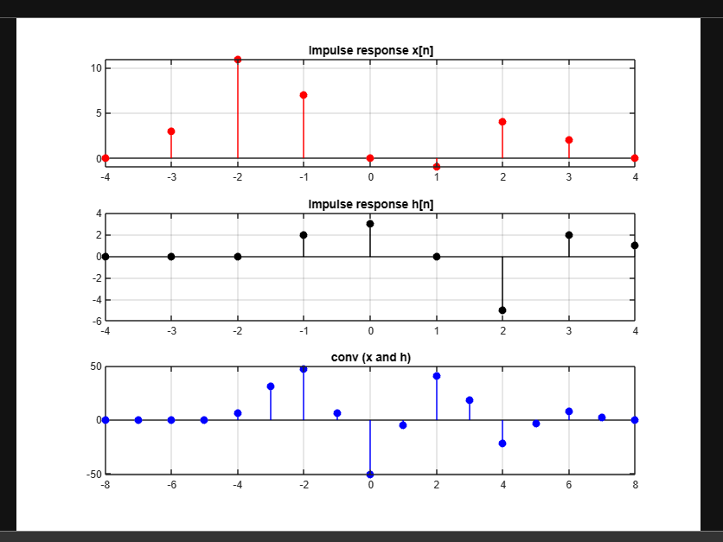

Q6)  
figure(2);

n = -5:1:45;

x = 1 * ((n>=0)-(n>=10));

h=((0.9).^n).*(n>=0);

nx=n;

nh=n;

nyb = nx(1)+nh(1);

nye = nx(length(x)) +nh(length(h));

ny = [nyb:nye];

y = conv(x,h);

subplot(3,1,1);

stem(n,x,'filled','r');

title('Input');

xlabel('n');

ylabel("Amplitude");

subplot(3,1,2);

stem(n,h,'filled','b');

title('Impulse response');

xlabel('n');

ylabel("Amplitude");

subplot(3,1,3);

stem(ny,y,'filled','k');

title('Output');

xlabel('n');

ylabel("Amplitude");

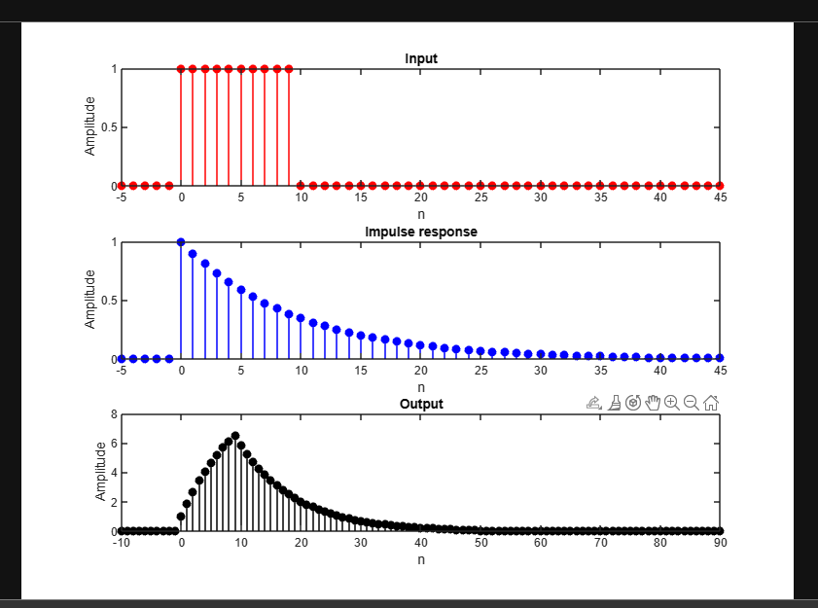

Q7)

n=-3:1:5;

x=[3,11,7,0,-1,4,2,0,0];

x=circshift(x,2);

y=x+randn(size(n));

figure();

subplot(2,1,1);

stem(n,y,'filled','b');

title('Q7)A');

xlabel('n');

ylabel('Ampliude');

z=xcorr(x,y);

display(z);

subplot(2,1,2);

nb=-3:1:7;

xb=[3,11,7,0,-1,4,2,0,0,0,0];

xb=circshift(xb,4);

yb=xb+randn(size(nb));

stem(nb,yb,'filled','r');

xlabel('n');

ylabel('Ampliude');

title('Q7)B');

zb=xcorr(xb,yb);

display(zb);

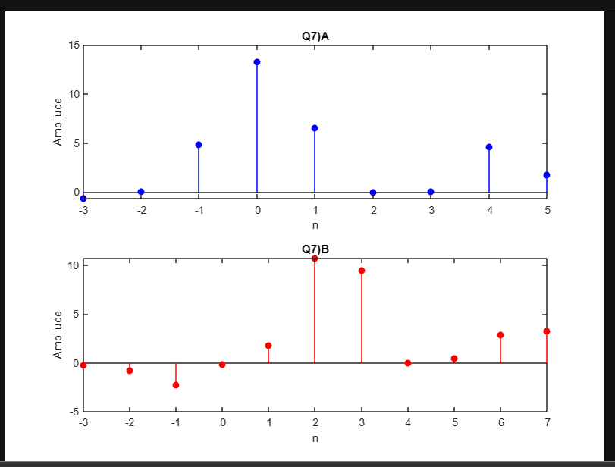

Q8)

n = -5:120; %discrete time domain

for i = 1:length(n)

if n(i) == 0

d(i) = 1; %impulse input

else

d(i) = 0;

end

if n(i) >= 0

u(i) = 1; %step input (from 0 to infinity u=1)

else

u(i) = 0;

end

end

h(1) = d(1);

h(2) = h(1) + d(2);

for i = 3:length(n)

h(i) = h(i-1) - 0.9*h(i-2) + d(i); %system equation

end

s(1) = u(1);

s(2) = s(1) + u(2);

for i = 3:length(n)

s(i) = s(i-1) - 0.9*s(i-2) + u(i); %system equation

end

subplot (2,1,1);

stem(n,h,'b');

xlabel('n');

ylabel('h[n]');

title('Impulse Response');

grid on;

subplot (2,1,2);

stem(n,s,'r');

xlabel('n');

ylabel('s[n]');

title('Step Response');

grid on;

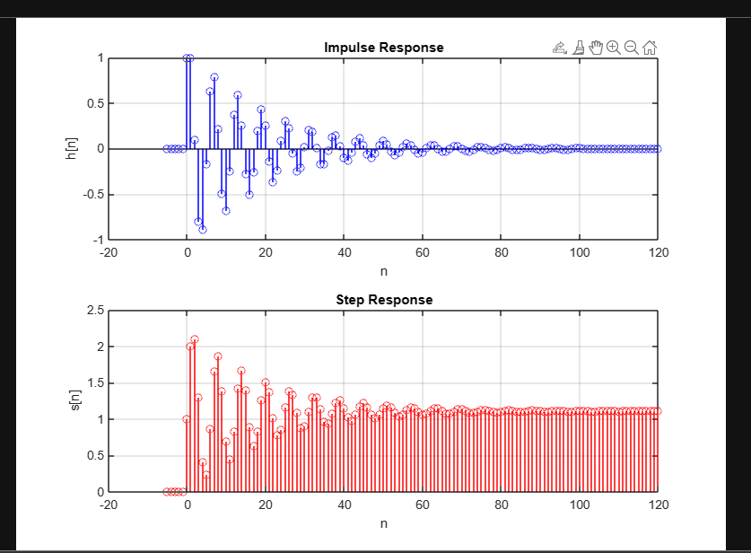

BIBO stability criterion x[n] < C => y[n] < B .then its **stable**

Q9)

clc;close all;clear all;

%Difference equation

b=[1 -1]%coefficients of x(n)

a=1%coeffiecient of y(n)

%Diffrentiator output for reactnagular pulse

n=0:1:100

x=5*((n>=0)-(n>=20))

y=filter(b,a,x)

figure(1);

subplot(2,1,1)

stem(n,x,'r')

xlabel('n')

ylabel('x(n)')

grid on;

title('A)Rectangular pulse')

subplot(2,1,2)

stem(n,y,'b')

xlabel('n')

ylabel('y(n)')

grid on;

figure(2);

x=[n.*((n>=0)-(n>=10))]+[(20-n).*((n>=10)-(n>=20))]%triangular pulse

y=filter(b,a,x)

subplot(2,1,1)

stem(n,x,'r')

xlabel('n')

ylabel('x(n)')

grid on;

title('B)Triangular pulse')

subplot(2,1,2)

stem(n,y,'b')

xlabel('n')

ylabel('y(n)')

grid on;

figure(3);

x=(sin(pi*n/25)).*[(n>=0)-(n>=100)];

y=filter(b,a,x)

subplot(2,1,1)

stem(n,x,'r')

xlabel('n')

ylabel('x(n)')

grid on;

title('C)Sinusoidal pulse')

subplot(2,1,2)

stem(n,y,'b')

xlabel('n')

ylabel('y(n)')

grid on;

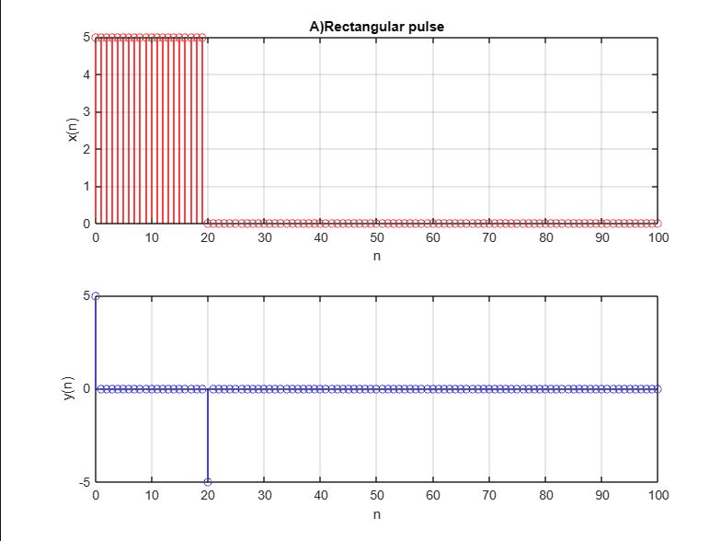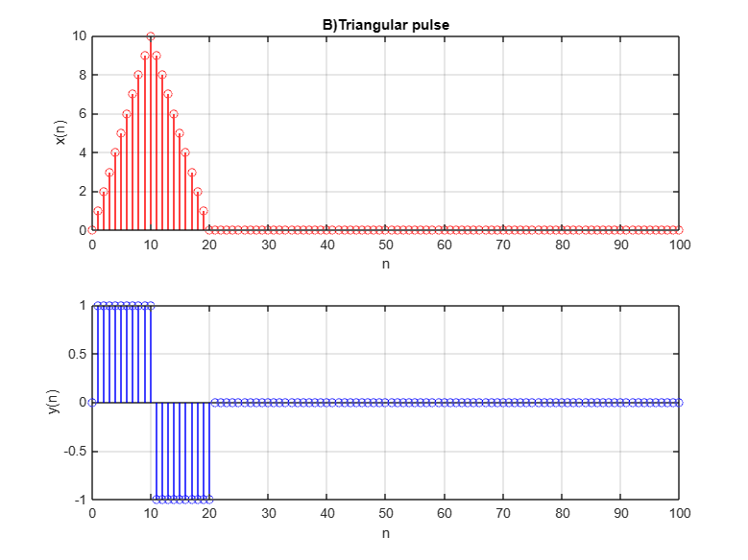

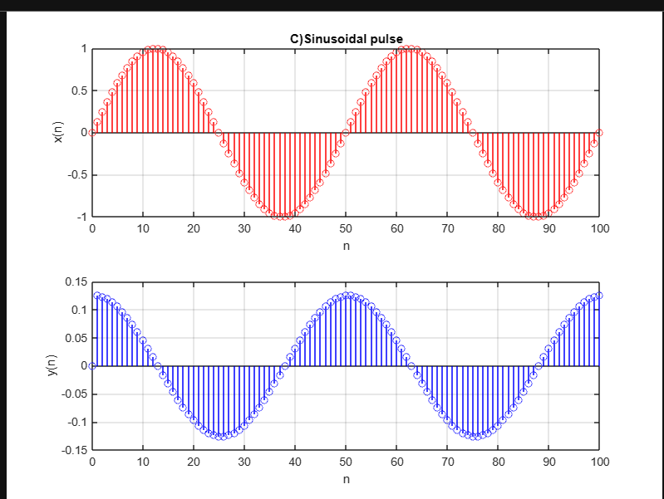

Q10)  
w = [0:1:500]*pi/500; % [0, pi] axis divided into 501 points.

X = exp(j*w) ./ (exp(j*w) - 0.5*ones(1,501));

% Note that to divided the w array by pi before plotting so that the frequency axes are in the units of π

%and therefore easier to read. This practice is strongly recommended.

figure();

magX = abs(X); angX = angle(X);

realX = real(X); imagX = imag(X);

subplot(2,2,1); plot(w/pi,magX,'b'); grid

xlabel('frequency (pi)'); title('Magnitude Part'); ylabel('Magnitude')

subplot(2,2,3); plot(w/pi,angX,'b'); grid

xlabel('frequency (pi)'); title('Angle Part'); ylabel('Radians')

subplot(2,2,2); plot(w/pi,realX,'b'); grid

xlabel('frequency (pi)'); title('Real Part'); ylabel('Real')

subplot(2,2,4); plot(w/pi,imagX,'b'); grid

xlabel('frequency (pi)'); title('Imaginary Part'); ylabel('Imaginary')

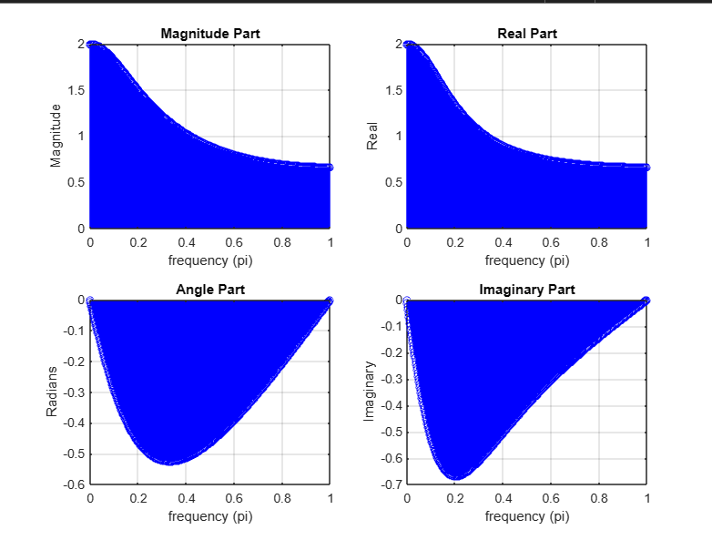

Q11)

n=-1:1:2;

x=[1, -.05, -0.3, -0.1];

X = x*exp(-j*n'*w);

figure();

subplot(4,1,1)

stem(w/pi,real(X));

xlabel('w');ylabel('X(e^jw)');title('Real Part');

subplot(4,1,2)

stem(w/pi,imag(X));xlabel('w');ylabel('X(e^jw)');

title('Imaginary Part');

subplot(4,1,3)

stem(w/pi,abs(X));

xlabel('w');ylabel('X(e^jw)');title('Magnitude');

subplot(4,1,4)

stem(w/pi,angle(X)*180/pi);

xlabel('w');ylabel('X(e^jw)');title('Phase');

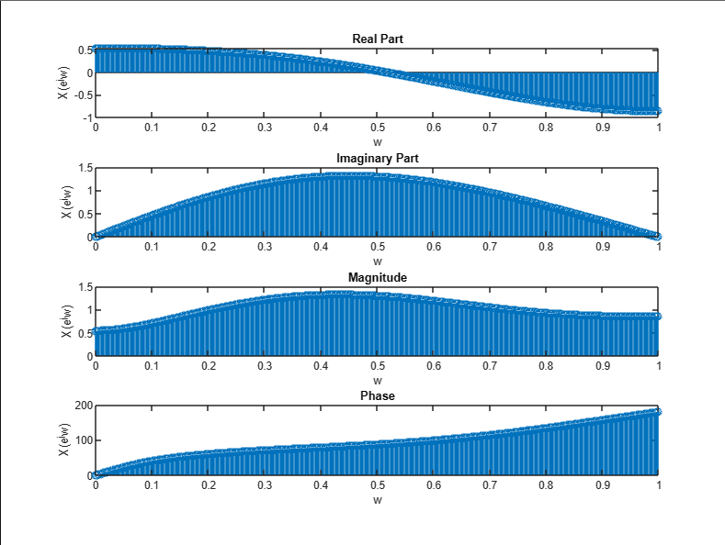

Q12)  
n=0:1:100;

x=cos(pi*n/2);

w=[-200:1:200]*2*pi/200;

X = x*exp(-j*n'*w);

y=x.*exp(j*pi*n/4);

Y = y*exp(-j*n'*w);

figure();

subplot(4,1,1)

stem(w/pi,real(X));

xlabel('w (pi)');ylabel('X(e^jw)');title('Real Part');

subplot(4,1,2)

stem(w/pi,imag(X));

xlabel('w (pi)');ylabel('X(e^jw)');title('Imaginary Part');

subplot(4,1,3)

stem(w/pi,abs(X));

xlabel('w (pi)');ylabel('X(e^jw)');title('Magnitude');

subplot(4,1,4)

stem(w/pi,angle(X)*180/pi);

xlabel('w (pi)');ylabel('X(e^jw)');title('Phase');

figure();

subplot(4,1,1)

stem(w/pi,real(Y));

xlabel('w (pi)');ylabel('Y(e^jw)');title('Real Part');

subplot(4,1,2)

stem(w/pi,imag(Y));

xlabel('w (pi)');ylabel('Y(e^jw)');title('Imaginary Part');

subplot(4,1,3)

stem(w/pi,abs(Y));

xlabel('w (pi)');ylabel('Y(e^jw)');title('Magnitude');

subplot(4,1,4)

stem(w,angle(Y)*180/pi);

xlabel('w (pi)');

ylabel('Y(e^jw)');

title('Phase');

***Input***

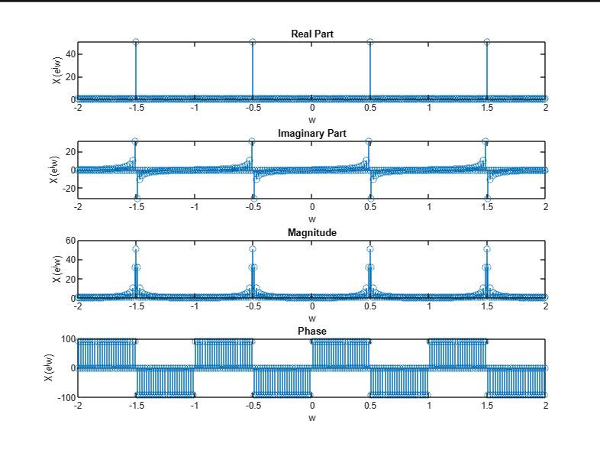  
  
  
***Output***   
