

**DEPARTMENT OF ELECTRICAL AND COMPUTER ENGINEERING**

ENCS3320 - Computer Networks

Course Project 2

Due date: Jun 17, 2022

Dr. AbdalKarim Awad

Dr. Mohammad Helal

Mr. Imad Tartir

**Important: Each screenshot should include the date and time of your computer.**

**Use packet tracer version 6.2 (attached!)**

**This is a group project, so you are allowed to work in groups of max 3 students**

**Part1:**

Using Wireshark, capture few DNS and ICMP packets. Show the packets, write some comments about each picture and explain at least 3 fields of each packet.

**Part2:**

Project Description:

Using Cisco Packet Tracer network simulator, build the topology presented in the diagram below and then configure the devices according the instruction that follow

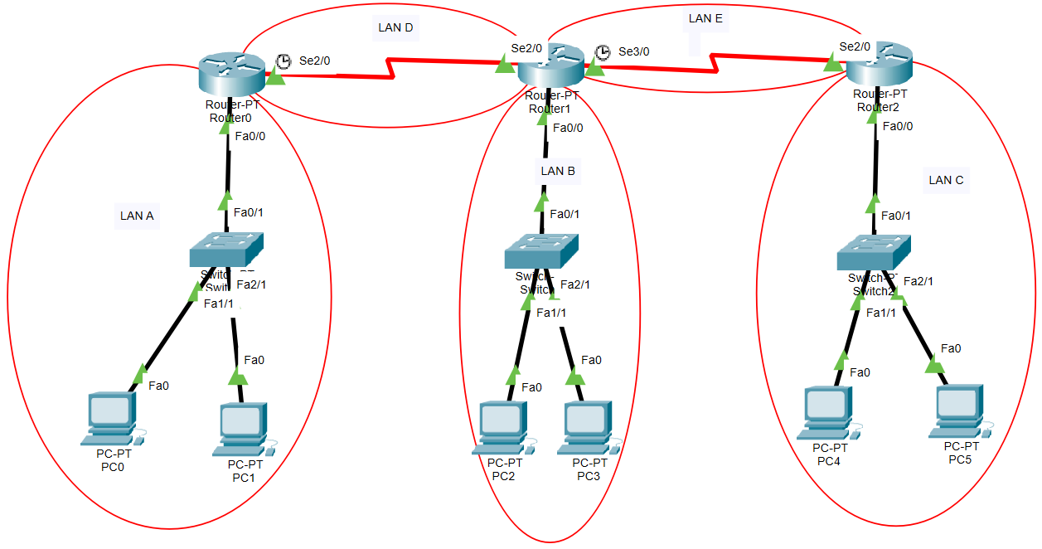

Requirements:

1. IP assignment:  
   - Divide the given IP address **192.AB.CD.0/24** where A, B, C, and D are the last 4 digits of your student ID. For example student with ID:1912345 would use the IP 192.23.45.0/24  
   - Divide the given IP address between the five LANs in the topology: LAN A, LAN B, LAN C, LAN D and LAN E. in such that each network reserves IP addresses in accordance with the following table

| **LAN** | **Number of Hosts (without the gateway)** |
| --- | --- |
| A | 125 |
| B | 32 |
| C | 12 |
| D | 2 |
| E | 2 |

- For each router interface and for each host, assign their IP addresses according to the following table:

|  |  |  |
| --- | --- | --- |
| **Device** | **Interface** | **IP description** |
| Router 0 | Fa0/0 | First available IP in LAN A |
| Se2/0 | First available IP in LAN D |
| Router 1 | Fa0/0 | First available IP in LAN B |
| Se2/0 | Second available IP in LAN D |
| Se3/0 | First available IP in LAN E |
| Router 2 | Fa0/0 | First available IP in LAN C |
| Se2/0 | Second available IP in LAN E |
| PC 0 | - | Second available IP in LAN A |
| PC 1 | - | Last available IP in LAN A |
| PC 2 | - | Second available IP in LAN B |
| PC 3 | - | Last available IP in LAN B |
| PC 4 | - | First available IP in LAN C |
| PC 5 | - | Last available IP in LAN C |

1. Routing Protocol:  
   - Run OSPF protocol using process ID= 10  
   - Make sure you have every router advertise each of the directly connected LANs  
   - After OSPF setup is done on all router: present the routing table for Router 1  
   - Make sure all PCs can PING each other  
   - Do a TRACERT command from PC 0 to PC 5 and take a screenshot
2. HTTP Server:  
   - Add an HTTP server to LAN B, give it any available IP address  
   - Do a test HTTP test from any of the PCs and take a screenshot for the result