

**DEPARTMENT OF ELECTRICAL AND COMPUTER ENGINEERING**

ENCS3320 - Computer Networks

Course Project 2

Due date: Jun 17, 2022

Dr. AbdalKarim Awad

Dr. Mohammad Helal

Mr. Imad Tartir

Student : Taher Hasan 1191740

Sec : 2

Date : 6/11/2022

First we will Using Wireshark, to capture few DNS and ICMP packets

And here we will capture ICMP packets, to do that we need to get port number to the filter to get ICMP packets only. and that’s with writing ICMP which its ‘52’ port number, we will try to ping ‘Ritaj’ as it shows in the pictures below.

In the protocol column we have the type of the message ‘UDP,UTP,DNS,ICMP ect… ‘

In the length column we have the length of the message sent

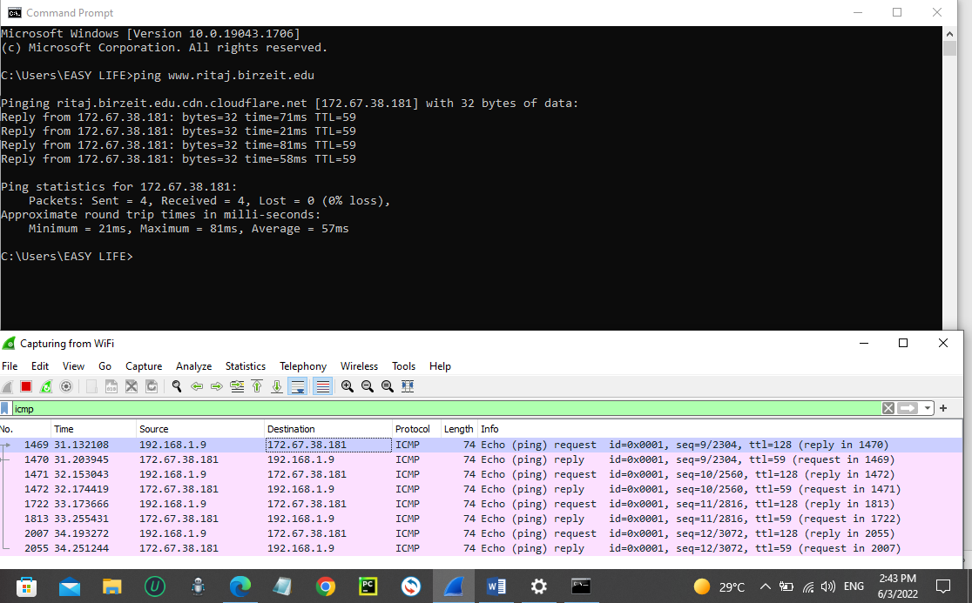

At the first line we can see that the source is my devise IP, and in Destination column it has Ritaj’s server IP, in Info we can know more information about the message like its request message or reply one, and in this line, I have send a ping request message first, while in the second line it’s when Ritaj’s server replied to me that it has received my message without any errors.

we have got four request packets and replies too.

Then we will ping ‘www.uom.ac.mu’ it’s a website that has more security on its firewall.

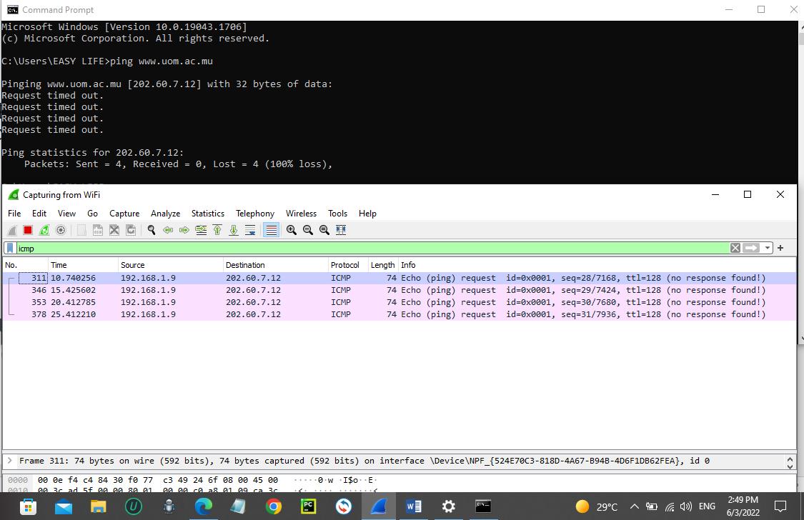

Here I send 4 request messages without any reply message from the website.

Writing ‘DNS’ on the filter to get only DNS packets

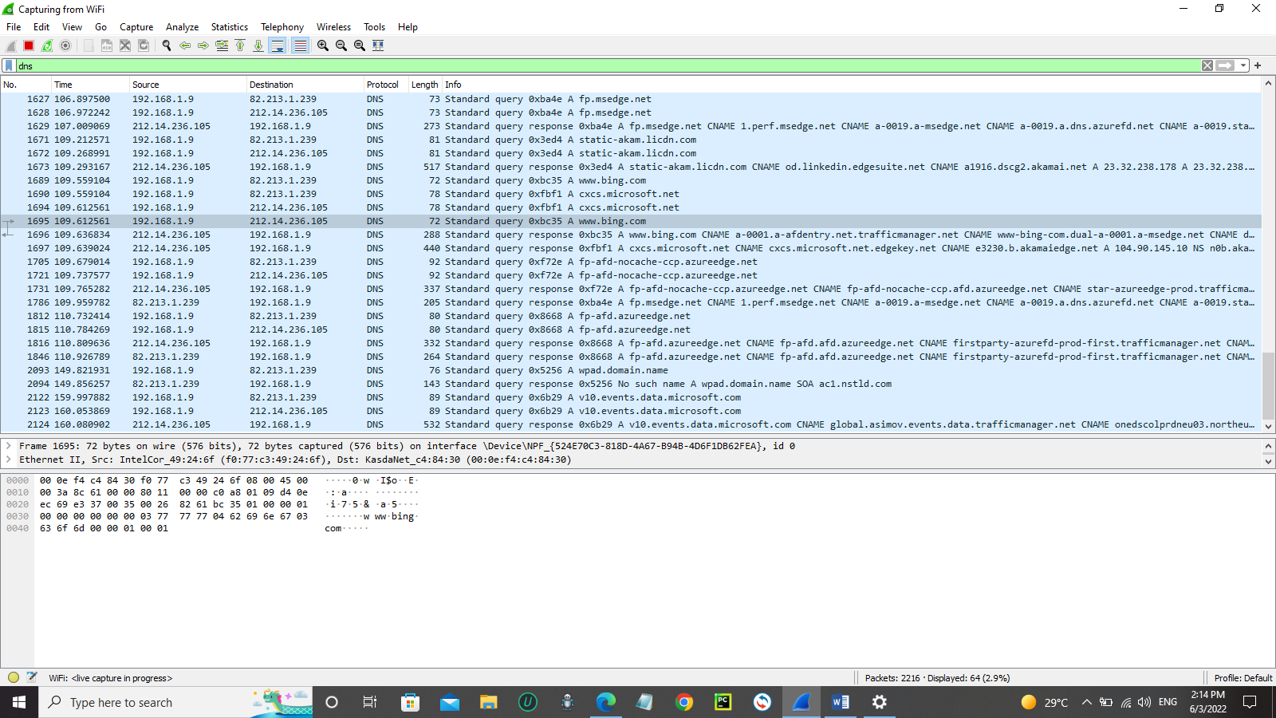

PART 2 )

In this part I have divided the IP addresses in this way:

192.17.40.0000 0000 /28

Subnet mask = 255.255.255.224

This for network IP and in the red one is IP addresses for the hosts

In layer A it has 125 for hosts and we will add +3 for the get way port and the network to be 128 IPs

192.17.40.0 ----- > 192.17.40.127 it has 128 IPs

192.17.40.0000 0000 ---- > 192.17.40.0111 1111

In layer B it has 32 for hosts and we will add +3 to be 35

192.17.40.128 ----- > 192.17.40.175

192.17.40.1000 0000 ---- > 192.17.40.1010 1111

In layer C it has 12 for hosts and we will add +3 to be 15

192.17.40.176 ----- > 192.17.40.191

192.17.40.1011 0000 ---- > 192.17.40.1011 1111

In layer D it has only 2 hosts with get way but we have to assign 192.17.40.1101 **** for it

192.17.40.192 ----- > 192.17.40.207

192.17.40.1100 0000 ---- > 192.17.40.1100 1111

In layer E

192.17.40.208 ----- > 192.17.40.223

192.17.40.1101 0000 ---- > 192.17.40.1101 1111

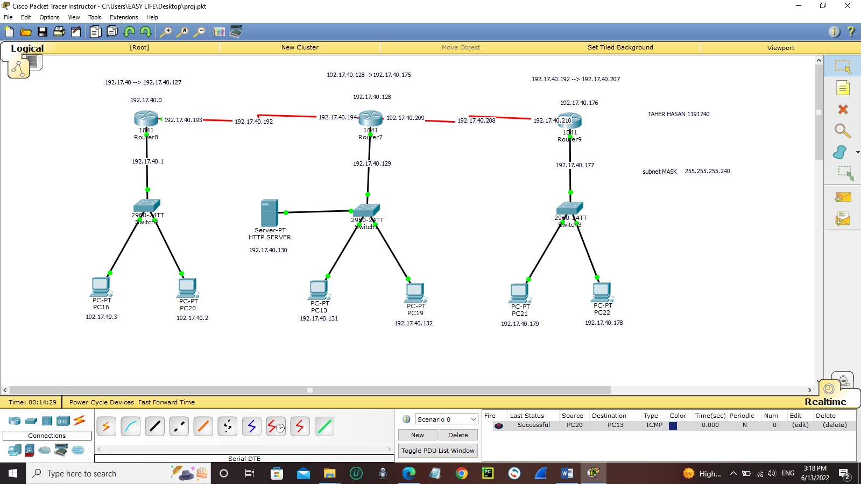

2) Routing Protocol:  
- Run OSPF protocol using process ID= 10

🡺In CLI command we have to save the network IP with complement subnet

MASK 0.0.0.15 with area ID = 10

- Make sure you have every router advertise each of the directly connected LANs

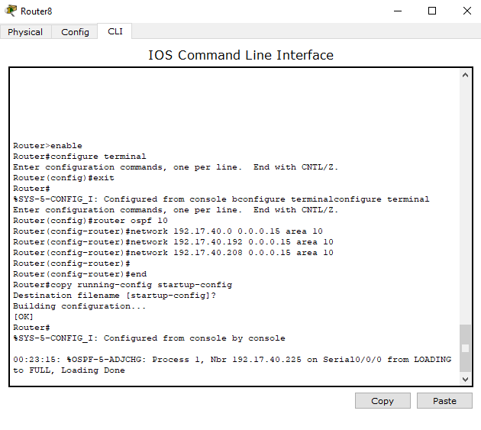

- After OSPF setup is done on all router: present the routing table for Router 1

* We can do it by this command “show IP route” to open routing table

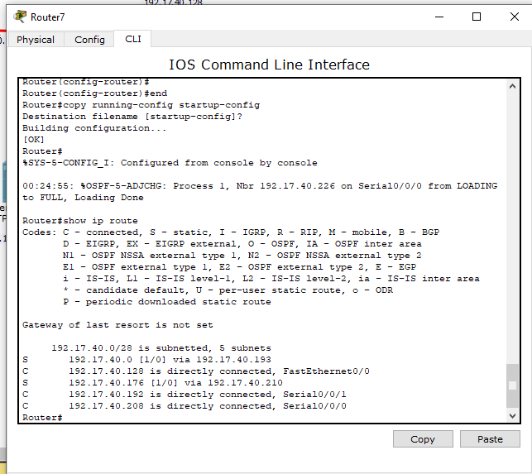

- Make sure all PCs can PING each other  
- Do a TRACERT command from PC 0 to PC 5 and take a screenshot

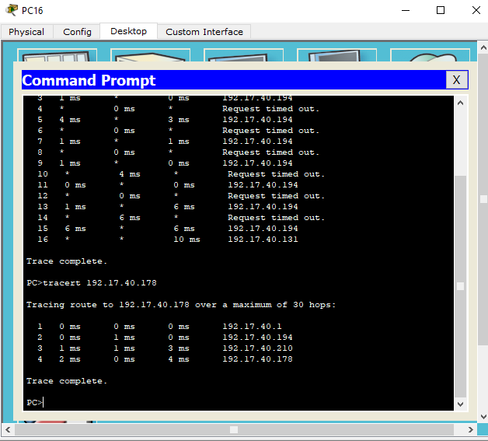

3) HTTP Server:  
- Add an HTTP server to LAN B, give it any available IP address  
- Do a test HTTP test from any of the PCs and take a screenshot for the result  
  
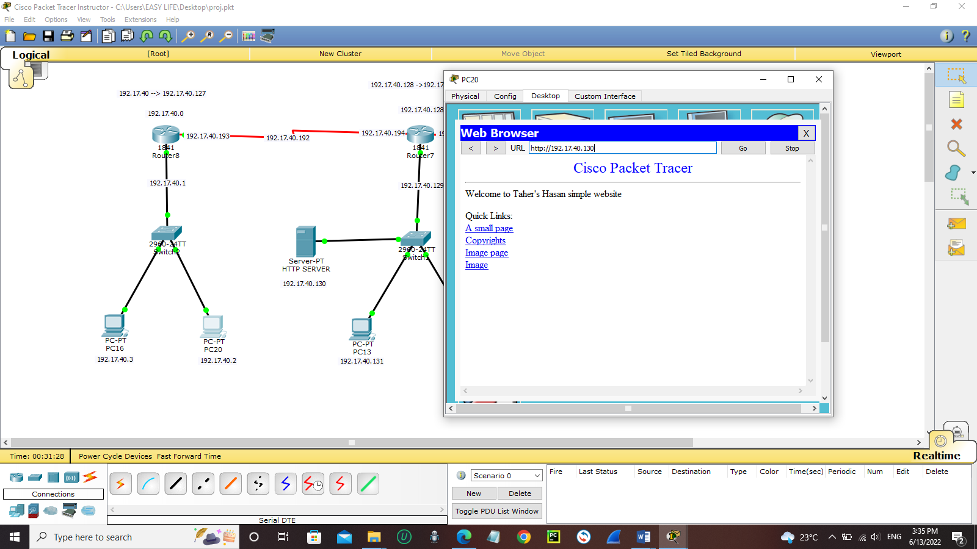

References that can help you with projects like this one   
  
ICMP packets capture using Wireshark <https://www.youtube.com/watch?v=i5C68u4gmeo&ab_channel=BibiRouksarDussoyea>

DNS packets capture using Wireshark

<https://www.youtube.com/watch?v=DTnaOWxUBGo&ab_channel=AlexanderDelRio>

in part 2 :-

to build the network and the routers :-

but you have to divide the IP addresses first!

<https://www.youtube.com/watch?v=rZw_b0wpQ00&ab_channel=Electrical%26ComputerEngineeringProject>

to configure OSPF Configuration in Packet Tracer

This video will learn you how to use configure with these commands only (>enable and #configure terminal) to start configure

From 2:25 -> 2:30

<https://www.youtube.com/watch?v=PQJzPkwPlhk&ab_channel=DipakBari>

then watch this one   
<https://www.youtube.com/watch?v=B7-7RcZCIbM&ab_channel=ThinkandLearn>

adding HTTP server   
<https://www.youtube.com/watch?v=Mtd2F2limSQ&ab_channel=AnubhavSingh>

for more information in Cisco Packet Tracer Instructor   
you can watch these videos :-

[Basics of Cisco Packet Tracer (Part 1) - YouTube](https://www.youtube.com/watch?v=frUQMHXhnvs&ab_channel=NesoAcademy)

[Basics of Cisco Packet Tracer (Part 2) | Hub - YouTube](https://www.youtube.com/watch?v=FZ8hRDakHvI&ab_channel=NesoAcademy)

[Basics of Cisco Packet Tracer (Part 3) | Switch - YouTube](https://www.youtube.com/watch?v=eFY6mi3lmRQ&ab_channel=NesoAcademy)

[Basics of Cisco Packet Tracer (Part 4) | Router - YouTube](https://www.youtube.com/watch?v=FnH1XUQsoD8&ab_channel=NesoAcademy)

And that’s all !

[Downloading Cisco Packet Tracer 6.2 Instructor Version from FileHorse.com](https://www.filehorse.com/download-cisco-packet-tracer-32/27895/download/)

[Wireshark · Download](https://www.wireshark.org/download.html)