IRIS SGP2 Figures and Results Guide
Report writer handoff | Project 3 | 27 October 2026
Use this guide to populate the UAEU SGP2 template. It identifies the required report elements, recommends evidence for the AI and engine sections, and supplies the recorded results and figure captions. It is a companion to the report, not a replacement for the required Overleaf template.
Main finding: the local engine demonstrates integration and approval-controlled updates. The two AI models have promising synthetic-test results but remain unreleased experimental candidates.

What the template actually requires
- Prepare the final report in Overleaf using the supplied 12 pt A4 report template. Keep its original cover and formatting; this Word guide does not redefine the submission layout.
- Target 25 to 35 pages excluding appendices. Include a concise one-page executive summary, contents, list of tables, list of figures, all seven chapters and references.
- Number tables and figures consecutively and refer to each in the text. Put table captions above tables and figure captions below figures. Remove all blue instructions and dummy examples.
- Use formal continuous prose and functional hyperlinks. Manage references with BibTeX or BibLaTeX. The template calls for APA reporting and permits APA or IEEE in-text citations; confirm the chosen consistent citation style with the advisor.
- The template explicitly includes a tasks and schedule Gantt-chart section, contribution percentages and signatures. It does not prescribe a fixed number of AI figures or require an ROC curve, learning curve or particular accuracy target.

Where the evidence belongs
Table 1. Evidence placement in the supplied structure
Template location | Content to include
Chapter 1 Introduction | Problem, objectives, deliverables and verified SGP1 to SGP2 changes.
Chapter 2 Professional standards | Economic, environmental, safety, UAE context and ethical constraints; distinguish guidance from certification.
Chapter 3 System design | Architecture, three-source integration, model tasks, features, configuration and setup.
Chapter 4 Implementation and results | Evaluation protocol, metrics, model results, engine changes, tests and limitations.
Chapter 5 Project management | Actual schedule, Gantt chart, resources and teamwork reflection.
Chapters 6 and 7 | Evidence-based conclusion, future work, agreed contributions and signatures.

Figures and tables to include
The figures below are recommended for IRIS except the schedule chart, whose section is explicitly present in the template. Figure numbers are proposed insertion numbers; renumber if additional figures are inserted.
Table 2. Proposed figure register
Figure | Subject | Report location | Evidence status
1 | Implemented architecture | 3.1 | Available
2 | Learning tasks and policy authority | 3.1 | Available
3 | Campaign-disjoint data partitions | 3.1 or 4.2 | Available
4 | Model 1 and rules confusion matrices | 4.3 | Available
5 | Model 1 versus rules | 4.3 | Available
6 | Confidence-threshold search | 4.3 | Available
7 | Control F1 and catalogue support | 4.3 | Available
8 | Approved risk and priority changes | 4.3 | Available
9 | Tasks and schedule Gantt chart | 5.1 | Actual dates needed
10 onward | Genuine successful dashboard captures | 4.3 or appendix | Capture during rehearsal

Results tables recommended for Chapter 4
- Corpus sizes and data-quality exclusions, separating training data from the demonstration batch.
- Candidate selection scores; held-out Model 1 metrics and per-class precision, recall, F1 and support; common-metric comparison with rules.
- Model 1 release checks; Model 2 metrics versus its baseline; per-control support and F1.
- Engine before and after approval values; executed test-suite counts; objective-to-evidence or requirement-verification matrix.

Other tables to retain
Chapter 3 should describe input contracts, feature meanings, model configuration and the actual technology stack. Chapter 5 should record actual resources. Chapter 7 must retain a task contribution table and signature table with all five students. These are reporting needs, not extra AI measurements.

Caption and discussion pattern
Every statistical caption should state the data subset and denominator. The accompanying paragraph should explain the result, compare it fairly and state its limitation. For conceptual diagrams, state that the figure shows architecture or workflow rather than measured performance.

Implemented architecture and model inputs
Place Figure 1 in Chapter 3 under System Modules Components and Setup. The three operational sources are asset inventory JSON, risk register JSON and SIEM alerts JSONL. Offline labels support training only and are not a fourth runtime input.
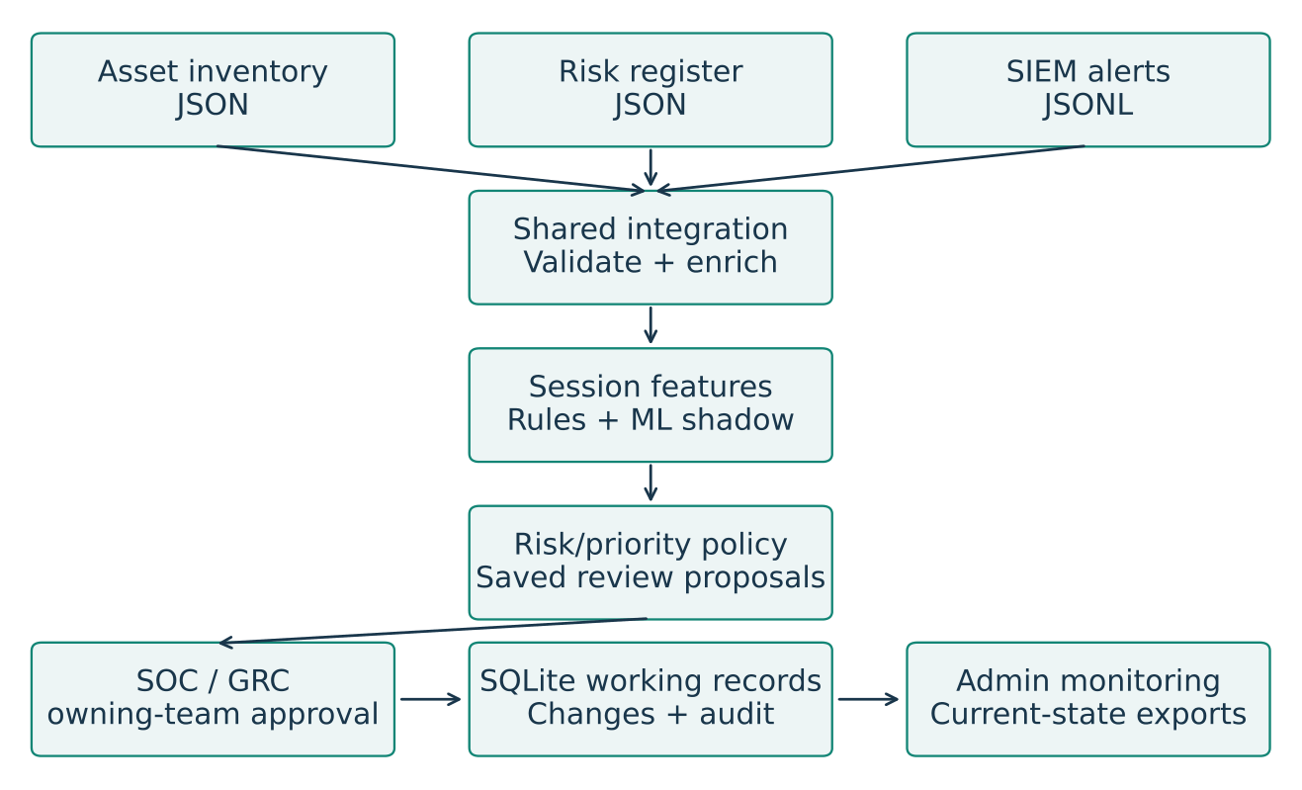
Figure 1. Implemented local IRIS architecture with three-source integration, review proposals and approval-controlled SQLite updates. External vendor SIEM and GRC systems are not connected.

What the accompanying paragraph must explain
Validate identities and timestamps, attach historically valid asset and risk context, remove exact duplicates, exclude conflicting or unresolved records and aggregate sessions. Use affected-asset identity and exact unique matching rather than treating an attacker source IP as the victim. Keep multiple risk records nested to avoid multiplying alerts.
The local demo uses a Python standard-library HTTP server, HTML and JavaScript, and SQLite. The trusted model bundle is loaded for inference; training is offline. Colab is a training environment, not a required runtime service.
Primary rules and explicit risk policy remain separate from experimental ML outputs. SOC or GRC approval controls persistent working-record changes. Do not describe the separately prepared FastAPI adapter or the earlier Streamlit plan as the active demo server.

Learning pipeline and evaluation design
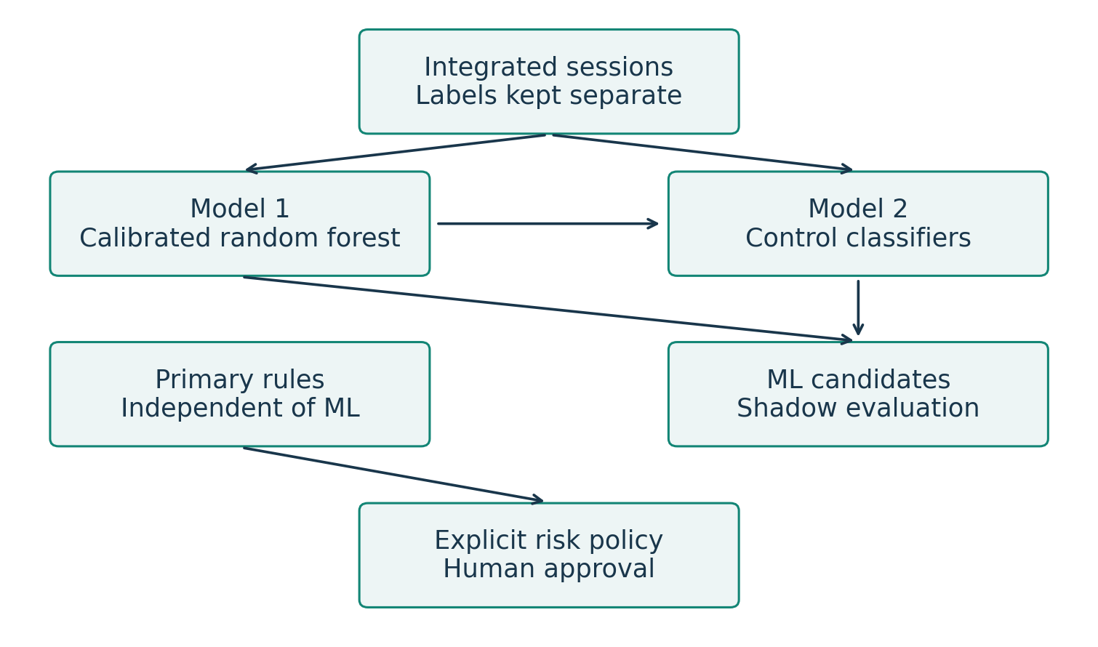
Figure 2. Separate scenario classification and multi-label control advice, with primary policy authority independent of the unreleased ML candidates.
Model 1 is a calibrated Random Forest with three scenario classes. Model 2 uses binary-relevance logistic regression for control membership. Its 22 named features comprise the 16 telemetry fields plus asset type, predicted scenario, criticality, likelihood, impact and previous similar-session count.
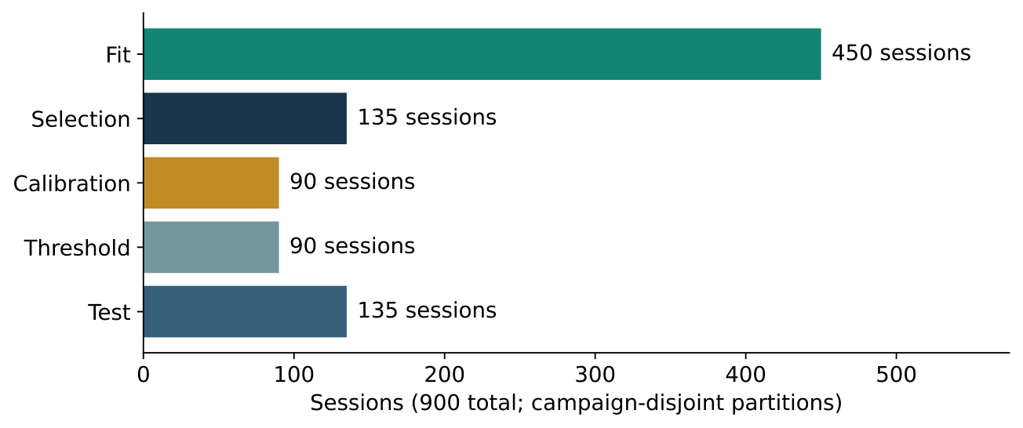
Figure 3. Allocation of 900 synthetic sessions across campaign-disjoint partitions. The final test contains 135 sessions, with 45 per class.
Initial candidate fitting uses 450 sessions and selection uses 135. Refit the selected base on the combined 585 sessions, then freeze it for calibration on 90 separate sessions. Threshold selection uses another 90; final testing uses 135. Model 2 also fits on 585 sessions, using grouped out-of-fold scenario predictions rather than oracle labels.
Record the seed 42, 60-second session window and campaign grouping. The 60 campaign groups do not overlap between roles. This is an unseen synthetic campaign holdout, not evidence of generalization to a real organization.

Model 1 classification results
The final test contains 135 labeled synthetic sessions. Figure 4 shows errors directly; Table 3 supplies the class-level metrics. No Model 1 test session was abstained at the selected 0.50 threshold.
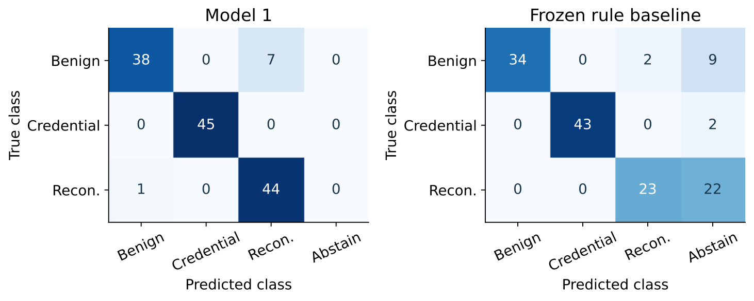
Figure 4. Held-out synthetic confusion matrices for Model 1 and the frozen rules baseline. Rows are true classes and columns are predictions. The rules abstain on 33 of 135 sessions.
Table 3. Model 1 class-level performance
Class | Precision | Recall | F1 | Support
Benign | 0.9744 | 0.8444 | 0.9048 | 45
Credential access | 1.0000 | 1.0000 | 1.0000 | 45
Reconnaissance | 0.8627 | 0.9778 | 0.9167 | 45
Macro average | 0.9457 | 0.9407 | 0.9405 | 135

Table 4. Model 1 overall test performance
Metric | Recorded result
Correct classifications | 127 of 135
Accuracy across all sessions | 94.07%
Macro F1 | 0.9405
Coverage | 100.00%
Accepted-only accuracy | 94.07%
Benign false-positive rate | 7 of 45 = 15.56%
Descriptive 95% Wilson interval for benign FPR | 7.75% to 28.78%

Interpretation: seven benign sessions were mistaken for reconnaissance; one reconnaissance session was labeled benign. Perfect classification of 45 synthetic credential-access examples is not proof of perfect real-world detection. The Wilson interval is binomial and is not adjusted for campaign clustering.

Model selection and baseline comparison
Table 5. Candidate scores on the separate selection partition
Candidate | Selection macro F1
Logistic regression | 0.9333
Random Forest selected | 0.9478
Histogram gradient boosting | 0.9259

These scores select the algorithm; they are not final-test results. Random Forest uses 160 trees, maximum depth 12, minimum leaf size three and balanced-subsample class weights. Categorical values are one-hot encoded and numeric fields use StandardScaler. No ANN or CNN comparison was performed.
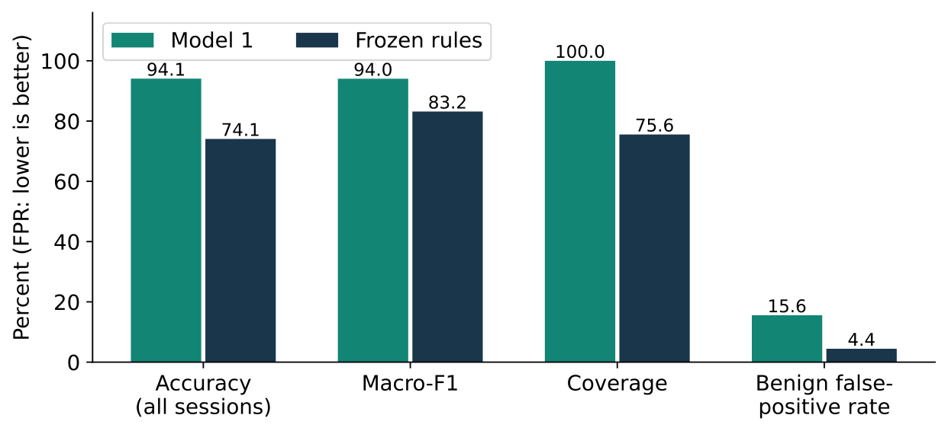
Figure 5. Model 1 and frozen-rule performance on the same 135 synthetic test sessions. Higher accuracy, F1 and coverage are desirable; lower benign false-positive rate is desirable.
Table 6. Common-metric comparison on the held-out test
Metric | Model 1 | Rules
All-session accuracy | 94.07% | 74.07%
Macro F1 | 0.9405 | 0.8317
Coverage | 100.00% | 75.56%
Accepted-only accuracy | 94.07% | 98.04%
Benign false positives | 7 of 45 | 2 of 45
Benign false-positive rate | 15.56% | 4.44%

Model 1 improves macro-F1 by 0.1088 and makes more accepted predictions, but has more false alarms. Rules correctly classify 100 of 102 accepted sessions, while 33 sessions are abstained. Do not compare their 98.04% accepted-only accuracy with the model all-session accuracy without disclosing coverage.

Threshold search and release decision
Figure 6 uses the 90-session threshold partition, not the test set. It is neither an ROC curve nor a training-loss curve. The 0.50 threshold determines whether to accept the highest calibrated scenario confidence; it is not a business-risk probability.
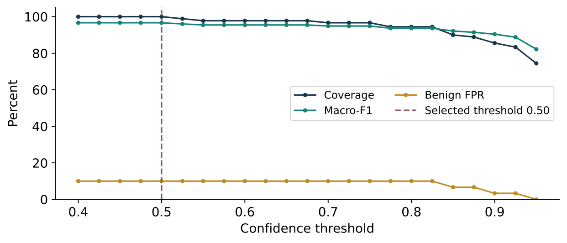
Figure 6. Recorded confidence-threshold search on 90 separate synthetic sessions. The dashed line marks the selected threshold of 0.50; no searched threshold satisfied every operational check.
At 0.50, threshold-partition coverage is 100%, macro-F1 is 0.9666 and benign FPR is 10%. At 0.90, FPR falls to 3.33% but reconnaissance recall falls to 66.67%, below the 75% requirement. A high threshold therefore does not solve every failure. The selection procedure falls back to F1, coverage and threshold tie-breaking when no candidate passes all checks.
Table 7. Final-test release assessment for Model 1
Project engineering criterion | Observed evidence | Result
Macro F1 at least 0.80 | 0.9405 | Pass
Each attack recall at least 0.75 | 1.0000 and 0.9778 | Pass
Benign FPR at most 5% | 15.56% | Fail
Coverage at least 80% | 100% | Pass
F1 improvement over rules at least 0.05 | 0.1088 | Pass
At least ten test sessions per class | 45 per class | Pass
Real reviewed cyber-range data | Synthetic only | Fail

Final status: unreleased shadow candidate. Saved metadata also flags source-exclusion review as unmet. These engineering thresholds are project criteria, not NIST or ISO requirements. Calibration was applied, but no reliability diagram, Brier score or expected calibration error was recorded.

Model 2 recommendation results
Model 2 is evaluated on agreement with synthetic control relevance labels. Scores do not establish whether implementing the controls prevents attacks. The catalogue contains 30 controls, but only six have positive held-out support.
Table 8. Held-out Model 2 metrics and scenario-frequency baseline
Metric | Model 2 | Baseline
Micro precision | 0.9542 | 0.8861
Micro recall | 0.9542 | 0.8750
Micro F1 | 0.9542 | 0.8805
Macro F1 across all 30 controls | 0.1905 | 0.1555
Exact-set accuracy | 90.37% | 65.19%
Hamming loss lower is better | 0.00543 | 0.01407

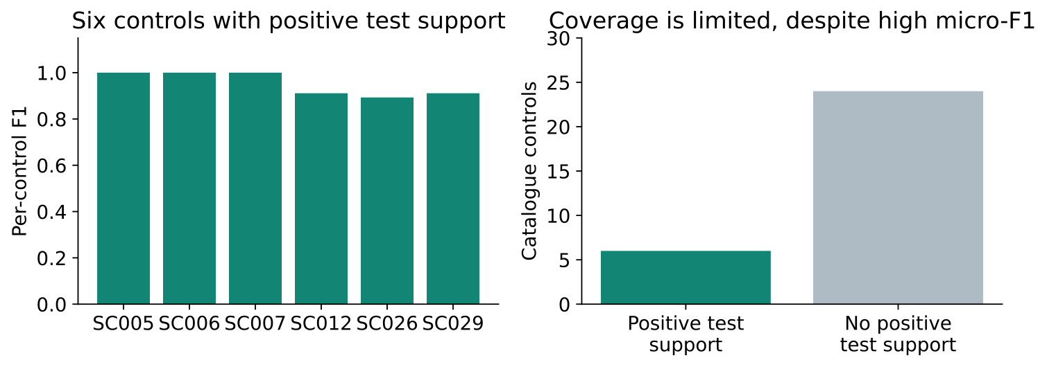
Figure 7. Per-control F1 for six positively supported controls and catalogue support of six versus 24 controls. High micro-F1 does not validate all 30 controls.
Table 9. Controls with positive test support
Control | Support | Precision | Recall | F1
SC005 | 45 | 1.0000 | 1.0000 | 1.0000
SC006 | 32 | 1.0000 | 1.0000 | 1.0000
SC007 | 45 | 1.0000 | 1.0000 | 1.0000
SC012 | 45 | 0.9111 | 0.9111 | 0.9111
SC026 | 28 | 0.8929 | 0.8929 | 0.8929
SC029 | 45 | 0.9111 | 0.9111 | 0.9111

There are 229 true positive recommendations, 11 false positives and 11 missed positives. Exact-set agreement is 122 of 135 sessions; Hamming loss is 22 errors across 4,050 binary decisions. Unsupported controls contribute zeros to macro-F1 under the recorded convention. The numerical control gate passes, but overall release remains blocked; scores are uncalibrated membership scores.

Engine integration and approved changes
Table 10. Training and active-demonstration corpus sizes
Quantity | Training | Active demo
Unique assets and snapshots | 60 and 120 | 30 and 36
Unique risks and snapshots | 120 and 240 | 60 and 72
Raw alert rows | 26,086 | 2,367
Matched prepared event rows | 26,071 | 2,355
Prepared sessions | 900 | 132
Held-out labeled test sessions | 135 | Not supplied

Demo row accounting: 2,367 raw rows minus six exact duplicates, one invalid timestamp, two conflicting event-ID versions and three unresolved asset rows equals 2,355 working alerts. These exclusions are data-quality cases, not twelve known false alarms. Analysis generates 132 cases, 123 SOC proposals and 63 GRC proposals; proposal counts are not approval or unique-risk counts.
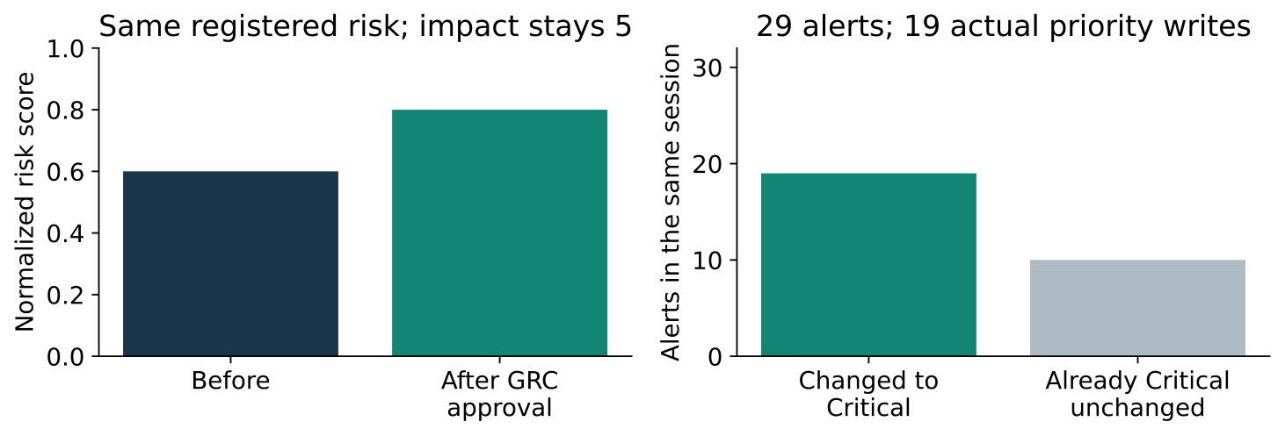
Figure 8. Policy-and-approval changes in fictional working records. Risk rises from 0.60 to 0.80 after GRC approval; SOC approval changes 19 alerts while preserving ten already-Critical alerts.
Table 11. Before and after owning-team approval
Attribute | Before | After
Risk DEMO-R001-1 likelihood | 3 | 4
Same risk impact | 5 | 5
Normalized risk score | 0.60 | 0.80
Risk revision | 1 | 2
Lower-priority alerts in the selected session | 19 alerts | Critical
Already-Critical alerts in the same session | 10 alerts | Unchanged

The policy divides likelihood times impact by 25: three times five gives 0.60; four times five gives 0.80. These are not attack probabilities or AI correctness counts. Updates persist in SQLite after restart; source inputs stay unchanged. No external vendor system was updated.

Verification results and dashboard evidence
Table 12. Executed software verification suites
Suite | Passed | Evidence dimension
Model and integration | 79 | Source and feature contracts; grouped training
Shared backend core | 33 | Execution and policy separation
Active demo core | 32 | Approval updates, revisions and persistence
Active demo HTTP | 29 | Actual requests, authorization and exports
Activity monitor unit | 4 | Bounded read-only telemetry
Total Python regressions | 177 | Software behavior on supplied fixtures
Frontend controller scenarios | 20 | Role loading and failure handling

These test counts are not ML accuracy observations. Frontend controller tests use DOM and API doubles and do not establish real-browser usability. The separate FastAPI HTTP suite was not included because its required dependencies were unavailable.

Recommended genuine screenshots to capture
- Admin overview after analysis, with the current case counts and model release status visible.
- GRC view of the same registered risk before approval and after approval, showing likelihood, impact, score and revision.
- SOC view before and after approval, showing changed priorities and queue ordering for the same session or alert identifiers.
- Admin backend activity and persistent audit evidence for the approval. Show actual recorded actions, not a staged animation of model steps.
Pair each before and after capture with matching record IDs and the approval action. Hide all role keys, tokens and personal information. Use only successful captures from a rehearsed run. The existing graph proves a recorded fixture result; it does not substitute for a real-browser capture of the final demonstration.

Suggested results discussion
The engine demonstrates integration, proposal generation, separate team authorization and persistent working-record updates. Stale revisions are rejected, repeat decisions are idempotent and exports reflect current state. These results establish local workflow behavior, not production SIEM/GRC interoperability, 24-hour availability or organizational effectiveness.

Schedule resources and contribution evidence
Chapter 5 explicitly requests a Tasks And Schedule Gantt Chart section. Include an actual schedule that the team can verify. Figure 9 is available only as a proposed relative sequence; do not present it as historical completion evidence.
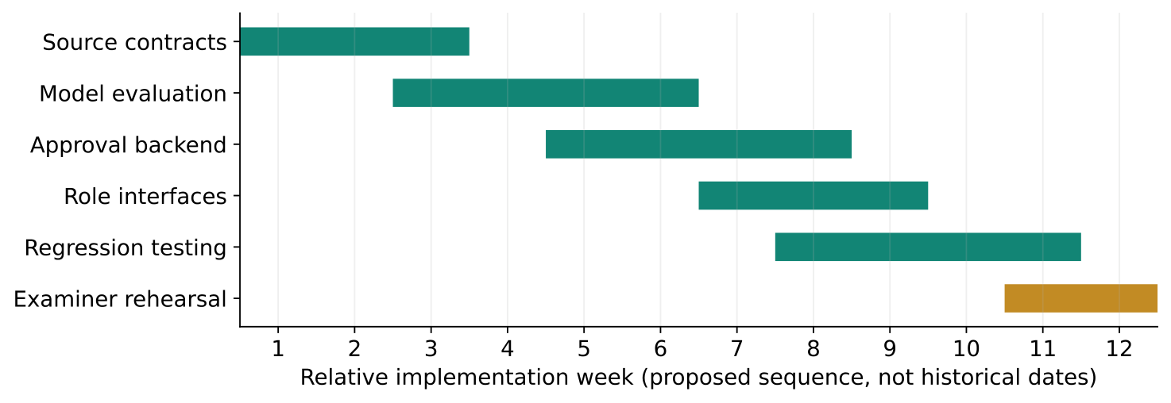
Figure 9. Proposed relative implementation sequence. Replace or reconcile the bars with team-confirmed actual dates before treating this as the completed project schedule.

Resources to report in Chapter 5
Record the actual development and presentation computer CPU, RAM and operating system, Python and library versions, Colab use, dataset and model versions, repository commit and any actual hosting costs. Distinguish resources used from technologies considered in SGP1. Do not claim live Wazuh, Suricata, GNS3 or company-system integration unless separately demonstrated.

Contribution tables required in Chapter 7
Retain a table identifying tasks, student IDs and contribution percentages. The percentages across students for each task must total 100%. Change the sample caption from SGP1 to SGP2 and replace dummy IDs. Obtain actual signatures from all five students; do not invent percentages or reuse SGP1 allocations as new contributions.
Table 13. Student identification for the contribution and signature tables
Student | Student ID
Ahmed Aref Alsehhi | 202110388
Taher Mousa | 700041185
Abdulla Alattas | 202102869
Abdulrahman Bin Braik | 700042473
Abdulaziz Al Rabeei | 700042076

Confirm the report semester with the advisor. The supplied template states Spring 2026, whereas the saved training evidence is dated 25 October 2026. Avoid silently backdating model results.

Metric definitions and writing checklist

Definitions to include in the evaluation section
- Precision is true positives divided by all positive predictions. Recall is true positives divided by all actual positives. F1 is their harmonic mean. Macro-F1 averages class or control F1 values equally.
- Model 1 all-session accuracy counts correct accepted predictions over all sessions. Coverage counts accepted predictions over all sessions. Accepted-only accuracy uses only accepted sessions. Abstentions remain missed true classes in recall and F1.
- Benign FPR is the fraction of benign sessions assigned an attack class. Read it alongside coverage because abstention can reduce FPR without detecting the attack cases.
- Model 2 micro scores pool label decisions. Exact-set accuracy requires the entire recommended set to match. Hamming loss is the fraction of incorrect binary session-control decisions; sparse negatives can make it look small.

Evidence sources for the writer
Template requirements come from the UAEU SGP2 LaTeX text supplied by the team. SGP1 provides the original problem, objectives and planned design; it is not proof that all planned SGP2 integrations were delivered. Use the saved model evidence and implementation for the actual results.
artifacts/user_colab_run/models/metadata.json records the saved model metrics, splits, support and release status.
artifacts/user_colab_run/models/threshold_search.json records the threshold-partition search.
IRIS_Models_v2/iris_models/training.py records selection, refitting, frozen-base calibration, control fitting and metric behavior.
demo/VERIFICATION.md and the demo_app and backend test suites document workflow verification. The inspected runtime implementation is commit 988af097bdd6ecb19335e603d954793f9fc6a5cd.
report/SGP2/IRIS_SGP2_Overleaf.zip contains the existing figure PDFs and copied evaluation evidence. Its earlier main.tex is not an exact formatting match to the university template; transfer content into the original template.

Before sending the report for approval
- Include the results and limitations together: 94.07% synthetic accuracy with 15.56% benign FPR; 0.9542 control micro-F1 with only six positively supported controls.
- Keep selection scores, threshold-search results, final-test results and software-test counts distinct. Describe the 132-case demo as workflow evidence, not a new accuracy evaluation.
- Do not invent ROC-AUC, learning curves, feature importance, calibration quality, two-second latency, real-company results or measured control effectiveness. These measurements require new experiments and are not template-mandated figures.
- Confirm actual dates, contributions and screenshots; preserve the original template formatting; update every caption, cross-reference and list of figures or tables after insertion.

