**PF Assignment #1**

**Name: Taher Mustansir**

**Roll: 25K-0119**

*All code in this file is available at:* [*https://github.com/TaherMustansir1929/bai-1c-pf-assignment-1*](https://github.com/TaherMustansir1929/bai-1c-pf-assignment-1)

**Question #1:**

PAC Chart:

| **Given Data** | **Required Result** |
| --- | --- |
| **Transaction Details:**   * Amount * country * timestamp   **Customer Info:**   * Fixed daily spending limit. * Customer's total spending for the current day * List of countries where the customer commonly shops * List of the customer's recent transactions (within the last hour) * Transaction frequency limit (more than 3 transactions in one hour) | * Transactions flagged either “NORMAL” or “SUSPICIOUS.” * Updated customer profile. |
| **Processing Required** | **Solution Alternatives** |
| 1. READ Transaction Details & Customer Info 2. Check daily spending limit 3. Check for foreign country 4. Check for transaction magnitude within the last hour 5. Apply if/else statement to filter out suspicious transactions 6. Raise/flag the suspicious transactions for further investigation. 7. Update customer info after saving transaction details | **Sequential Checks:**   * Nested if/else checks * Individual if checks   **Early exit**:   * IF/else ladder (exit after any one condition is met)   **OOP:**   * Use class system for handling transactions and customer info |

IPO Chart:

| **Input** | **Processing** | **Module Reference** | **Output** |
| --- | --- | --- | --- |
| **Transaction Details:**   * Amount * country * timestamp. | 1. Enter Amount 2. Enter Country 3. Enter Timestamp 4. Enter Customer Info 5. Check Total_Amount <= Spending Limit 6. Check Common_Countries includes Country 7. Check Total_Transactions_Per_Hour <= 3 8. Flag transactions as “Normal” or “Suspicious” 9. Display if a transaction is flagged “Suspicious” 10. End | 1. READ 2. READ 3. READ 4. READ 5. SELECTION 6. SELECTION 7. SELECTION 8. COMPUTE 9. PRINT 10. END | **Transaction status:**   * Normal   or   * Suspicious |

Algorithm:

1. **START**
2. **Initialize** predefined variables:
   * Spending_Limit = 5000
   * Common_Countries = {“Pakistan”, “UAE”}
   * Max_Transactions_Per_Hour = 3
3. **Declare** customer info:
   * Total_Transactions_Per_Hour (integer)
   * Total_Spending_Today (integer)
4. **READ** transaction details:
   * Amount
   * Country
   * Timestamp
5. **READ** customer info:
   * Total_Transactions_Per_Hour
   * Total_Spending_Today
6. **Declare** a flag as is_suspicious = false
7. **Set** Total_Spending_Today = Total_Spending_Today + Amount
8. **Increment** Total_Transactions_Per_Hour by one
9. **Check** for suspicious conditions:

a. **IF** Total_Spending_Today > Spending_Limit:

i. **SET** is_suspicious to TRUE.

ii. **OUTPUT** "Suspicious: Daily spending limit exceeded."

b. **ELSE IF** the Country of the transaction is NOT in Common_Countries:

i. **SET** is_suspicious to TRUE.

ii. **OUTPUT** "Suspicious: Foreign country transaction."

c. **ELSE IF** the number of Total_Transactions_Per_Hour is >= Max_Transactions_Per_Hour:

i. **SET** is_suspicious to TRUE.

ii. **OUTPUT** "Suspicious: Too many transactions in a short period."

10. **Check** if is_suspicious is True:

i. **OUTPUT** “Transaction is Normal”

11. **END**

Pseudocode:

START

DECLARE

Spending_Limit = 5000,

Common_Countries = {“Pakistan”, “UAE”},

Max_Transactions_Per_Hour = 3,

Total_Transactions_Per_Hour (integer),

Total_Spending_Today (integer),

Is_suspicious = false,

READ

Amount

Country

Timestamp

Total_Transactions_Per_Hour

Total_Spending_Today

COMPUTE

Total_Spending_Today += Amount

Total_Transactions_Per_Hour++

IF Total_Spending_Today > Spending_Limit:

SET is_suspicious = TRUE.

OUTPUT "Suspicious: Daily spending limit exceeded."

ELSE IF Country NOT in Common_Countries:

SET is_suspicious = TRUE.

OUTPUT "Suspicious: Foreign country transaction."

ELSE IF Total_Transactions_Per_Hour > Max_Transactions_Per_Hour:

SET is_suspicious = TRUE.

OUTPUT "Suspicious: Too many transactions in a short period."

ENDIF

IF is_suspicious = FALSE:

OUTPUT “Transaction is Normal”

ENDIF

END

Flowchart: (next page) (link: <https://app.eraser.io/workspace/r36Dc8la4TuC2qSB4vY3?origin=share>)

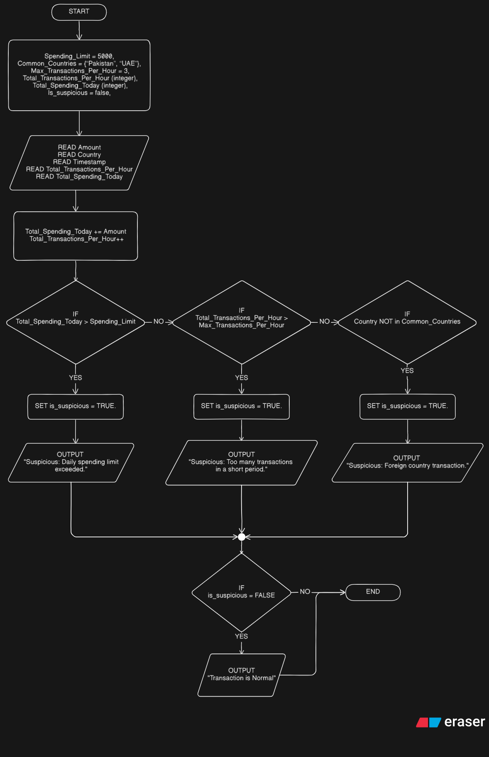

C Code:

#include <stdbool.h>

#include <stdio.h>

#include <string.h>

int main() {

const int spending_limit = 5000;

const char *common_countries[] = {"pakistan", "uae"};

const int max_transactions_per_hour = 3;

int total_transactions_per_hour;

int total_spending_today;

bool is_suspicious = false;

int amount;

char country[50];

printf("Enter transaction amount: ");

scanf("%d", &amount);

printf("Enter transaction country: ");

scanf("%s", country);

printf("Enter total transactions per hour before this one: ");

scanf("%d", &total_transactions_per_hour);

printf("Enter total spending today before this one: ");

scanf("%d", &total_spending_today);

total_spending_today += amount;

total_transactions_per_hour++;

if (total_spending_today > spending_limit) {

is_suspicious = true;

printf("Suspicious: Daily spending limit exceeded.\n");

} else {

bool is_common_country = false;

for (int i = 0; i < 2; i++) {

if (strcmp(country, common_countries[i]) == 0) {

is_common_country = true;

break;

}

}

if (!is_common_country) {

is_suspicious = true;

printf("Suspicious: Foreign country transaction.\n");

} else if (total_transactions_per_hour > max_transactions_per_hour) {

is_suspicious = true;

printf("Suspicious: Too many transactions in a short period.\n");

}

}

if (!is_suspicious) {

printf("Transaction is Normal\n");

}

return 0;

}

**Question #2:**

PAC Chart:

| **Given Data** | **Required Result** |
| --- | --- |
| * X (value of the coordinate on x-axis) * Y (value of the coordinate on y-axis) | Quadrant in which the coordinate lies |
| **Processing Required** | **Solution Alternatives** |
| Check if X > 0 & Y > 0 Then 1st Quadrant Else Check if X < 0 & Y > 0 Then 2nd Quadrant  Else Check if X < 0 & Y < 0 Then 3rd Quadrant  Else Check if X > 0 & Y < 0 Then 4th Quadrant | * Nested if-else * Switch case with objects/dictionary * Double if checks with logical operators * Skip last if statement |

IPO Chart:

| **Input** | **Processing** | **Module Reference** | **Output** |
| --- | --- | --- | --- |
| X (x-axis value)  Y (y-axis value) | 1. Enter X 2. Enter Y 3. Check X>0 & Y>0 4. Check X<0 & Y>0 5. Check X<0 & Y<0 6. Check X>0 & Y<0 7. Display the quadrant number 8. End | 1. READ 2. READ 3. SELECTION 4. SELECTION 5. SELECTION 6. SELECTION 7. OUTPUT 8. END | The number of quadrant with respect to the coordinate points |

Algorithm:

1. Start
2. Declare two variables for both axis:
   1. X
   2. Y
3. Read the values of X & Y from the user
4. Check if X > 0 and Y > 0 Then Display “The point (X, Y) lie in quadrant I” and exit otherwise continue...
5. Check if X < 0 and Y > 0 Then Display “The point (X, Y) lie in quadrant II” and exit otherwise continue...
6. Check if X < 0 and Y < 0 Then Display “The point (X, Y) lie in quadrant III” and exit otherwise continue...
7. Check if X > 0 and Y < 0 Then Display “The point (X, Y) lie in quadrant IV” and exit otherwise continue...
8. If no condition matches Then Display “The point (X, Y) is quadrantal”
9. End

Pseudocode:

START

DECLARE

X (number) , Y (number)

READ X & Y

IF X > 0 && Y > 0:

OUTPUT “The point (X, Y) lie in quadrant I”

ELSE IF X < 0 && Y > 0:

OUTPUT “The point (X, Y) lie in quadrant II”

ELSE IF X < 0 && Y < 0:

OUTPUT “The point (X, Y) lie in quadrant III”

ELSE IF X > 0 && Y < 0:

OUTPUT “The point (X, Y) lie in quadrant IV”

ELSE

OUTPUT “The point (X, Y) is quadrantal”

ENDIF

END

Flowchart: (next page) (link: <https://app.eraser.io/workspace/WGxYm9ZMbisNRrd78N80?origin=share>)

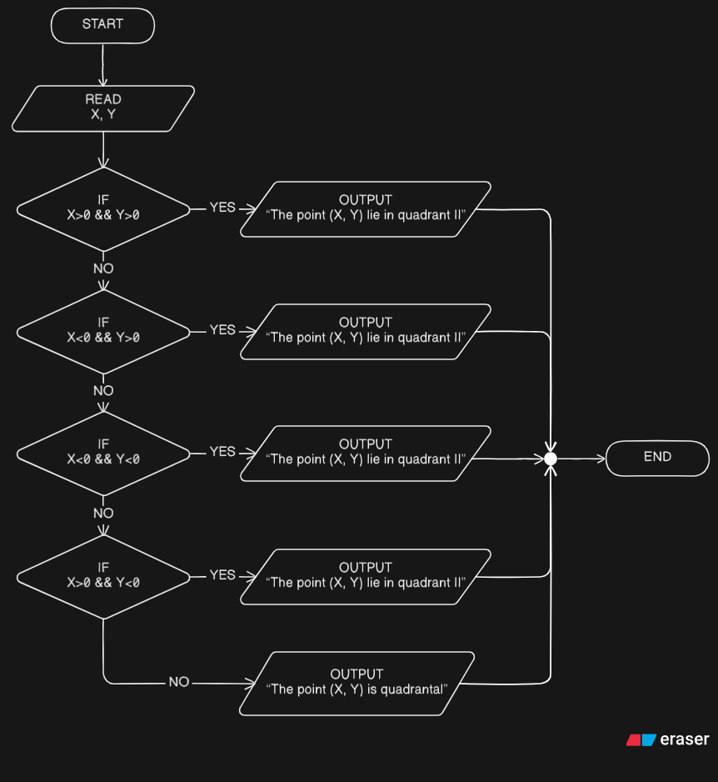

C Code:

#include <stdio.h>

int main() {

int x, y;

printf("Enter the value of coordinate (x, y): ");

scanf("%d %d", &x, &y);

if (x > 0 && y > 0) {

printf("The point (%d, %d) lies in quadrant I\n", x, y);

} else if (x < 0 && y > 0) {

printf("The point (%d, %d) lies in quadrant II\n", x, y);

} else if (x < 0 && y < 0) {

printf("The point (%d, %d) lies in quadrant III\n", x, y);

} else if (x > 0 && y < 0) {

printf("The point (%d, %d) lies in quadrant IV\n", x, y);

} else {

printf("The point (%d, %d) is quadrantal\n", x, y);

}

}

**Question #2:**

PAC Chart:

| **Given Data** | **Required Result** |
| --- | --- |
| * Age * Eyesight Test * Written Test * Driving Test * Medical Fitness Certificate | Whether the user is eligible for driving license or not |
| **Processing Required** | **Solution Alternatives** |
| Mark as ineligible IF:   * Age >= 18 * Passed eyesight test * Passed written test * Passed driving test * Age < 60 * Has medical fitness certificate | * Use nested if-else * Use switch case * Use OOP classes |

IPO Chart:

| **Input** | **Processing** | **Module Reference** | **Output** |
| --- | --- | --- | --- |
| Age  Eyesight Test  Written Test  Driving Test  Medical Fitness Certificate | 1. Enter Age 2. Check IF Age < 18 Then STOP 3. Enter Eyesight_Test 4. Check IF Eyesight_Test = failed Then STOP 5. Enter Written_Test 6. Check IF Written_Test = failed Then STOP 7. Enter Driving_Test 8. Check IF Driving_Test = failed Then STOP 9. Enter Medical_fitness_certificate 10. Check IF Medical_fitness_certificate = unavailable Then STOP 11. IF all clear Then OUTPUT “You are eligible for license” Otherwise OUTPUT “You are not eligible for license” 12. End | 1. READ 2. SELECTION 3. READ 4. SELECTION 5. READ 6. SELECTION 7. READ 8. SELECTION 9. READ 10. SELECTION 11. SELECTION + OUTPUT 12. END | Either “eligible” or “ineligible” |

Algorithm:

1. Start
2. Declare variables:
   1. Age
   2. Eyesight_Test
   3. Written_Test
   4. Driving_Test
   5. Medical_fitness_certificate
3. Read Age
4. Check If Age < 18 Then OUTPUT “You are not eligible” Otherwise continue...
5. Read Eyesight_Test result
6. Check If Eyesight_Test is failed (false) Then OUTPUT “You are not eligible” Otherwise continue...
7. Read Written_Test result
8. Check If Written_Test is failed (false) Then OUTPUT “You are not eligible” Otherwise continue...
9. Read Driving_Test result
10. Check If Driving_Test is failed (false) Then OUTPUT “You are not eligible” Otherwise continue...
11. Check If Age < 60 Then OUTPUT “You are not eligible” Otherwise continue...
12. Read Medical_fitness_certificate
13. Check IF Medical_fitness_certificate is unavailable (false) Then OUTPUT “You are not eligible” Otherwise continue...
14. If all conditions are true Then OUTPUT “You are eligible”
15. End

Pseudocode:

START

DECLARE

Age (number)

Eyesight (0/1)

Written (0/1)

Driving (0/1)

Med_certificate (0/1)

READ Age

IF Age < 18:

OUTPUT “You are not eligible”

END

ENDIF

READ Eyesight

IF Eyesight == 0:

OUTPUT “You are not eligible”

END

ENDIF

READ Written

IF Written == 0:

OUTPUT “You are not eligible”

END

ENDIF

READ Driving

IF Driving == 0:

OUTPUT “You are not eligible”

END

ENDIF

IF Age < 60:

OUTPUT “You are not eligible”

END

ENDIF

READ Med_certificate

IF Med_certificate == 0:

OUTPUT “You are not eligible”

END

ENDIF

OUTPUT “Congrats! You are eligible”

END

Flowchart: (next page) (link: <https://app.eraser.io/workspace/v7VULijSGszJ5veWztsu?origin=share>)

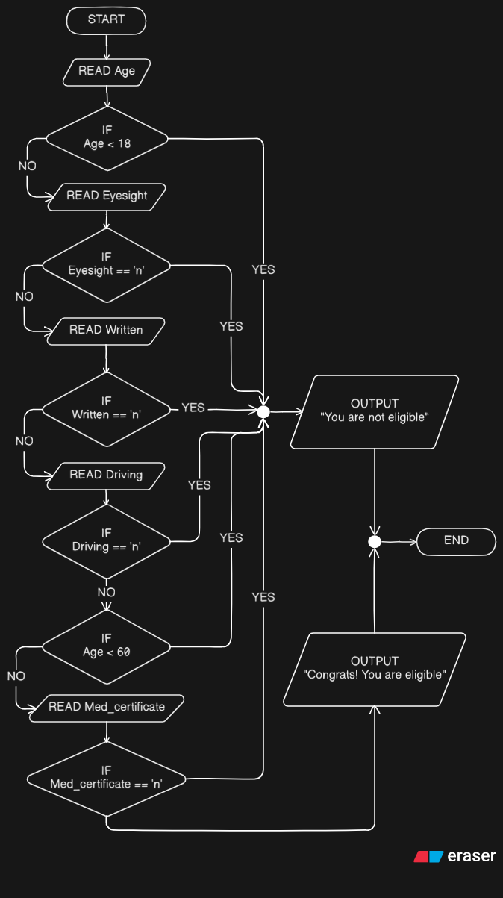

C Code:

#include <stdio.h>

#include <stdlib.h>

int main() {

int age = 0, eyesight = 0, written = 0, driving = 0, med_certificate = 0;

printf("Enter your age: ");

scanf("%d", &age);

if (age < 18) {

printf("You are not eligible.");

exit(0);

}

printf("Did you pass the eyesight test? (0/1): ");

scanf("%d", &eyesight);

if (eyesight == 0) {

printf("You are not eligible.");

exit(0);

}

printf("Did you pass the written test? (0/1): ");

scanf("%d", &written);

if (written == 0) {

printf("You are not eligible.");

exit(0);

}

printf("Did you pass the driving test? (0/1): ");

scanf("%d", &driving);

if (eyesight == 0 || age < 60) {

printf("You are not eligible.");

exit(0);

}

printf("Do you have Medical Fitness Certificate? (0/1): ");

scanf("%d", &med_certificate);

if (eyesight == 0) {

printf("You are not eligible.");

exit(0);

}

printf("Congrats! You are eligible.");

return 0;

}

**Question 2:**

PAC Chart:

| **Given Data** | **Required Result** |
| --- | --- |
| Hand -> array of 5 integers | Whether full house or not |
| **Processing required** | **Solution Alternatives** |
| Read input  Sort the array in ascending order  Check if first three and last 2 elements are the same.  Check if first 2 and last 3 elements are the same. | Use a faster sorting algorithm  Use manual sorting  Use iterations and loops |

IPO Chart:

| **Input** | **Processing** | **Module Reference** | **Output** |
| --- | --- | --- | --- |
| Hand: array of int[5] | 1. Read 5 integers from user 2. Sort in ascending order 3. Check if Hand[0] == Hand[1] AND Hand[1] == Hand[2] AND Hand[3] == Hand[4] 4. Check if Hand[0] == Hand[1] AND Hand[2] == Hand[3] AND Hand[3] == Hand[4] 5. OUTPUT “It is/is not a full house” 6. End | 1. READ 2. COMPUTE 3. SELECTION 4. SELECTION 5. OUTPUT 6. END | Whether the poker hand is full house or not. |

Algorithm:

1. Start.
2. Declare an array Hand of size 5.
3. Read 5 integers from user (1-13) and set into Hand array.
4. Sort the hand array in ascending order.
5. Check for a full house:
6. IF Hand[0] == Hand[1] AND Hand[1] == Hand[2] AND Hand[3] == Hand[4]
7. Then, print "This is a full house."
8. ELSE IF Hand[0] == Hand[1] AND Hand[2] == Hand[3] AND Hand[3] == Hand[4]
9. Then, print "This is a full house."
10. Otherwise:
11. Print "This is not a full house."
12. End.

Pseudocode:

START

DECLARE

Hand: int[5]

READ

Hand[0], Hand[1], Hand[2], Hand[3], Hand[4]

COMPUTE

sort(Hand, “ascending”); //Use built-in function for simplicity

IF (Hand[0] == Hand[1] AND Hand[1] == Hand[2] AND Hand[3] == Hand[4]):

OUTPUT “It is a full house.”

ELSE IF (Hand[0] == Hand[1] AND Hand[2] == Hand[3] AND Hand[3] == Hand[4]):

OUTPUT “It is a full house.”

ELSE:

OUTPUT “It is not a full house.”

ENDIF

END

Flowchart: (next page) (link: <https://app.eraser.io/workspace/Atsk7UZVHTxWaeZLrY8E?origin=share>)

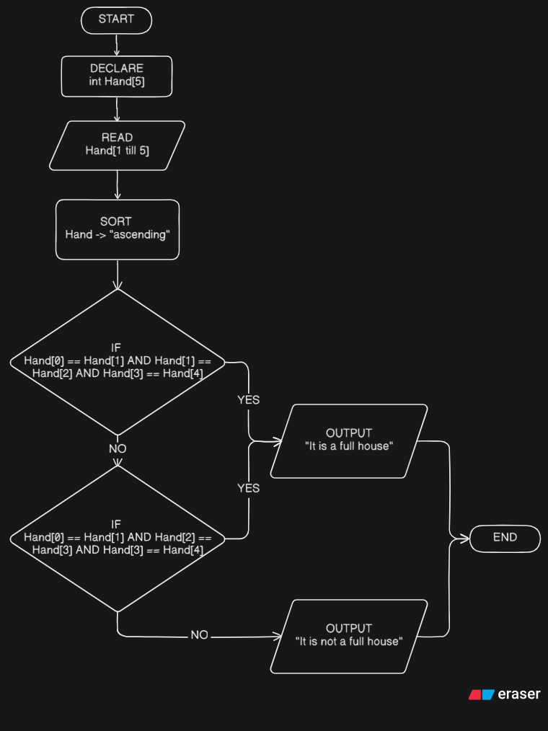

C Code:

#include <stdio.h>

#include <stdlib.h>

int compare(const void *a, const void *b) { return (*(int *)a - *(int *)b); }

int main() {

int hand[5] = {0, 0, 0, 0, 0};

int arr_size = sizeof(hand) / sizeof(int);

printf("Enter 5 card numbers (1-13): ");

scanf("%d %d %d %d %d", &hand[0], &hand[1], &hand[2], &hand[3], &hand[4]);

qsort(hand, arr_size, sizeof(int), compare);

if (hand[0] == hand[1] && hand[1] == hand[2] && hand[3] == hand[4]) {

printf("It is a full house.\n");

} else if (hand[0] == hand[1] && hand[2] == hand[3] && hand[3] == hand[4]) {

printf("It is a full house.\n");

} else {

printf("It is not a full house.\n");

}

return 0;

}

**Question #5:**

C Code:

#include <stdbool.h>

#include <stdio.h>

int main() {

int n, count[10];

printf("Enter a chain of numbers (0-9). Enter 2 digit number to stop: ");

while (true) {

scanf("%d", &n);

if (n < 0 || n > 9) {

break;

}

count[n]++;

}

printf("Number\tNo. of Occurrences\n");

for (int i = 0; i < 10; i++) {

printf("%d\t%d\n", i, count[i]);

}

}

Dry Run Table:

| **User Input (n)** | **if (n < 0 || n > 9)** | **Action** | **count Array Change** |
| --- | --- | --- | --- |
| 0 | FALSE | count[0]++ | count[0] = 1 |
| 0 | FALSE | count[0]++ | count[0] = 2 |
| 1 | FALSE | count[1]++ | count[1] = 1 |
| 1 | FALSE | count[1]++ | count[1] = 2 |
| 1 | FALSE | count[1]++ | count[1] = 3 |
| 1 | FALSE | count[1]++ | count[1] = 4 |
| 1 | FALSE | count[1]++ | count[1] = 5 |
| 1 | FALSE | count[1]++ | count[1] = 6 |
| 1 | FALSE | count[1]++ | count[1] = 7 |
| 1 | FALSE | count[1]++ | count[1] = 8 |
| 1 | FALSE | count[1]++ | count[1] = 9 |
| 1 | FALSE | count[1]++ | count[1] = 10 |
| 2 | FALSE | count[2]++ | count[2] = 1 |
| 2 | FALSE | count[2]++ | count[2] = 2 |
| 2 | FALSE | count[2]++ | count[2] = 3 |
| 3 | FALSE | count[3]++ | count[3] = 1 |
| 3 | FALSE | count[3]++ | count[3] = 2 |
| 3 | FALSE | count[3]++ | count[3] = 3 |
| 3 | FALSE | count[3]++ | count[3] = 4 |
| 4 | FALSE | count[4]++ | count[4] = 1 |
| 4 | FALSE | count[4]++ | count[4] = 2 |
| 4 | FALSE | count[4]++ | count[4] = 3 |
| 4 | FALSE | count[4]++ | count[4] = 4 |
| 4 | FALSE | count[4]++ | count[4] = 5 |
| 4 | FALSE | count[4]++ | count[4] = 6 |
| 4 | FALSE | count[4]++ | count[4] = 7 |
| 4 | FALSE | count[4]++ | count[4] = 8 |
| 5 | FALSE | count[5]++ | count[5] = 1 |
| 5 | FALSE | count[5]++ | count[5] = 2 |
| 5 | FALSE | count[5]++ | count[5] = 3 |
| 5 | FALSE | count[5]++ | count[5] = 4 |
| 5 | FALSE | count[5]++ | count[5] = 5 |
| 5 | FALSE | count[5]++ | count[5] = 6 |
| 5 | FALSE | count[5]++ | count[5] = 7 |
| 99 | TRUE | BREAK | NO CHANGE |

**FINAL VALUE of** *count = {2, 10, 3, 4, 8, 7, 0, 0, 0, 0};*

**Question #6:**

C Code (reference):

if(i<j){

if(j<k){

i = j;

}

else {

j = k;

if (j > k)

j = i;

else

i = k;

}

printf("%d %d %d\n", i, j, k);

Dry Run Table:

| **Case** | **Initial Values (i, j, k)** | **i < j** | **j < k** | **Change** | **j > k** | **Change** | **Output (i, j, k)** |
| --- | --- | --- | --- | --- | --- | --- | --- |
| a) | 3, 5, 7 | TRUE | TRUE | i=5 | - | - | 5 5 7 |
| b) | 3, 7, 5 | TRUE | FALSE | - | - | - | 3 7 5 |
| c) | 5, 3, 7 | FALSE | - | j=7 | FALSE | i=7 | 7 7 7 |
| d) | 5, 7, 3 | TRUE | FALSE | - | - | - | 5 7 3 |
| e) | 7, 3, 5 | FALSE | - | j=5 | FALSE | i=5 | 5 5 5 |
| f) | 7, 5, 3 | FALSE | - | j=3 | FALSE | i=3 | 3 3 3 |

**Question #7:**

Corrected Code:

#include <stdio.h>

int main() {

int value;

printf("Please enter a value in the range 1...7: ");

scanf("%d", &value);

if (value == 1) {

printf("You entered Monday\n");

} else if (value == 2) {

printf("You entered Tuesday\n");

} else if (value == 3) {

printf("You entered Wednesday\n");

} else if (value == 4) {

printf("You entered Thursday\n");

} else if (value == 5) {

printf("You entered Friday\n");

} else if (value == 6) {

printf("You entered Saturday\n");

} else if (value == 7) {

printf("You entered Sunday\n");

} else {

printf("You entered a value out of range\n");

}

}

Rewritten Code with Switch Case:

#include <stdio.h>

int main() {

int value;

printf("Please enter a value in the range 1...7: ");

scanf("%d", &value);

switch (value) {

case 1:

printf("You entered Monday\n");

break;

case 2:

printf("You entered Tuesday\n");

break;

case 3:

printf("You entered Wednesday\n");

break;

case 4:

printf("You entered Thursday\n");

break;

case 5:

printf("You entered Friday\n");

break;

case 6:

printf("You entered Saturday\n");

break;

case 7:

printf("You entered Sunday\n");

break;

default:

printf("You entered a value out of range\n");

break;

}

}