Diagnostic cast, photograph, radiograph, extracted teeth and previous denture.

B. Post extraction record:   
1.Central incisors restore philtrum if possible.

2.Central incisors restore vermillion border.

3.Incisal points and smile line determine height of tooth (age-related).

4.Position of canine points   
A. Relate to inter-alar width (smiling).

B. Relate to pupils (require pre-extraction photograph).

**Factors of selection of anterior teeth:**   
**1. Color**   
Show your patients a complete shade guide and select the two lightest and darkest tabs. Point out how different these two are and find out which one

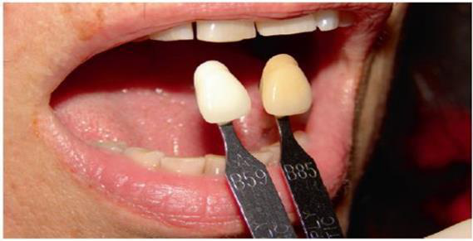

**2. Size:**   
Depend on:   
a) Existing dentures.

b) Models of previous teeth.

c) Photograph

**Factors that influence the size of anterior teeth are:** 1. Size of the face.

2. Amount of available interarch space.

3. Measured distance between distal of right and left maxillary cuspids.

4. Length of the lip.

5. Size and relation of arches.

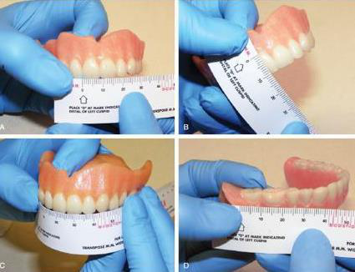

**3. Mold**   
select and agree on the mold of the teeth. Teeth of a similar size can appear

There is a choice of mold: square, tapering or ovoid. In general terms, square molds suit patients with large, rugged features. Long and narrow faces may be

**Form of the Anterior Teeth**   
The form or outline of the anterior teeth can be determined using the following factors:   
1. Shape of the patient’s face or facial form (previously mentioned) 2.