Learned Page Replacement for Adaptive Memory Management
CSE-307 Operating Systems | Track 1: Memory Management | Bonus: Explanation Confidence
1. Introduction
Page replacement is a core virtual-memory problem: when all available frames are occupied and a new page is needed, the operating system must choose a page to evict. This project implements FIFO, LRU, Optimal, and MRU and compares them with a lightweight learned policy. The objective is to examine whether simple access-history features can support an adaptive eviction decision when the workload changes from locality-heavy references to a more random/bursty pattern.
2. Problem and Objective
The experiment uses a synthetic reference string with a deliberate workload shift. The first 1,000 references emphasize locality, while the next 1,000 references use a random/bursty generator. All policies receive exactly the same 2,000-reference test trace. Page faults and hit ratio are measured separately before and after the shift. A decision-tree model is trained on a separate workload using recency, recent access frequency, and age.
3. Classical and Learned Policies
FIFO evicts the page that entered memory first. LRU evicts the least recently used page. Optimal selects the page whose next use is farthest in the future and is used as an offline reference policy. MRU evicts the most recently used page. The Learned policy uses a DecisionTreeClassifier with maximum depth 4. Future-reference information is used only to create training labels; final simulation uses current/past access information through the three features.
4. Experimental Setup
Parameter | Configuration
Test workload | 2,000 references; 1,000 + 1,000 phases
Pages / frames | 20 pages / 8 frames
Test seed | 42
Training workload | 2,000 references; seed 100
Learned model | Decision tree, max depth 4
Features | Recency, recent frequency, age
Metrics | Page faults and hit ratio
5. Results and Workload-Shift Analysis
Policy | Before faults | After faults | Before HR | After HR | Total faults
FIFO | 210 | 485 | 0.790 | 0.515 | 695
LRU | 133 | 489 | 0.867 | 0.511 | 622
Optimal | 80 | 260 | 0.920 | 0.740 | 340
MRU | 480 | 544 | 0.520 | 0.456 | 1024
Learned | 128 | 520 | 0.872 | 0.480 | 648
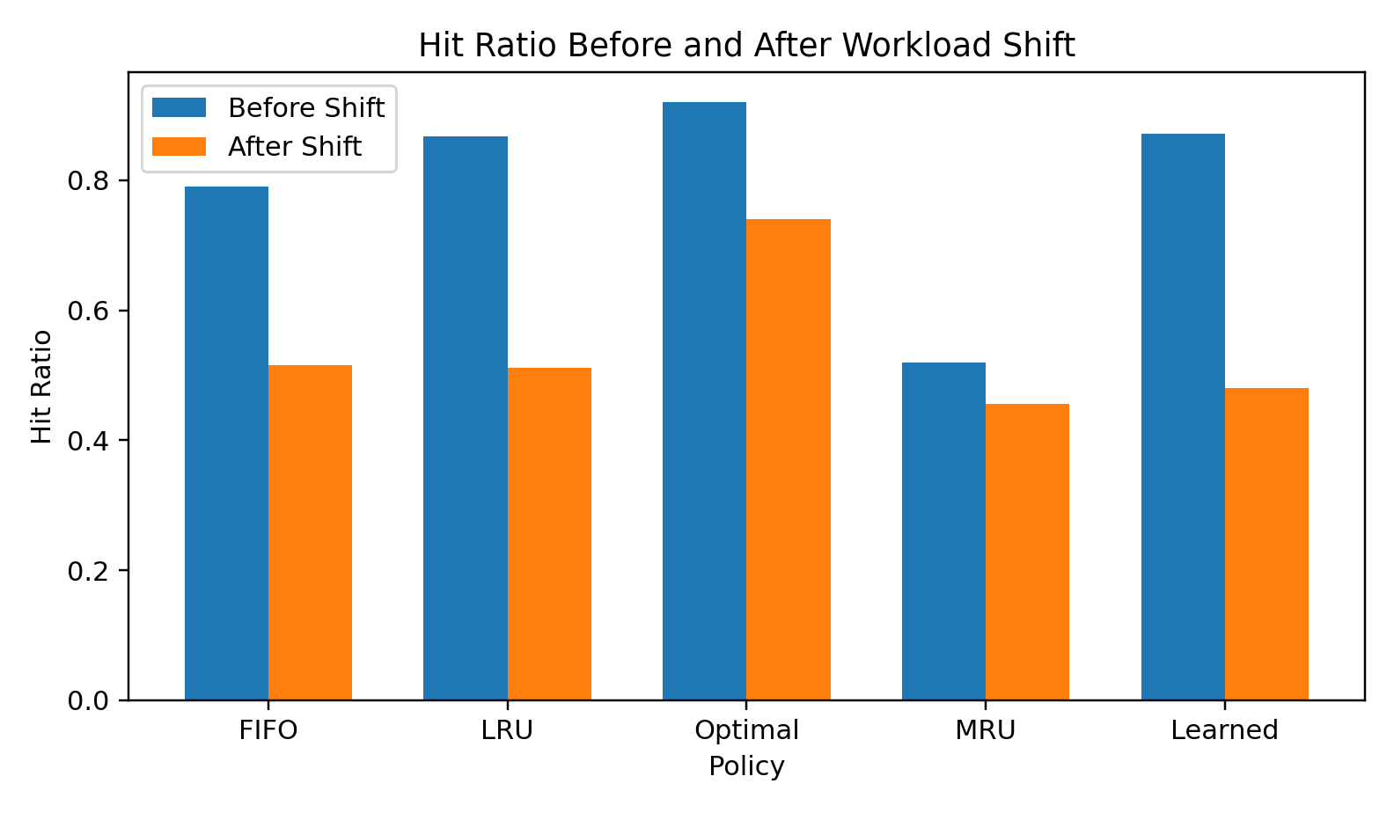
The locality-heavy phase produces higher hit ratios for all policies than the second phase. LRU decreases from 0.867 to 0.511, while the learned policy decreases from 0.872 to 0.480. The workload shift therefore changes policy behavior. Optimal remains an offline upper-reference because it has access to future references.
6. Page-Fault Behavior Around the Shift
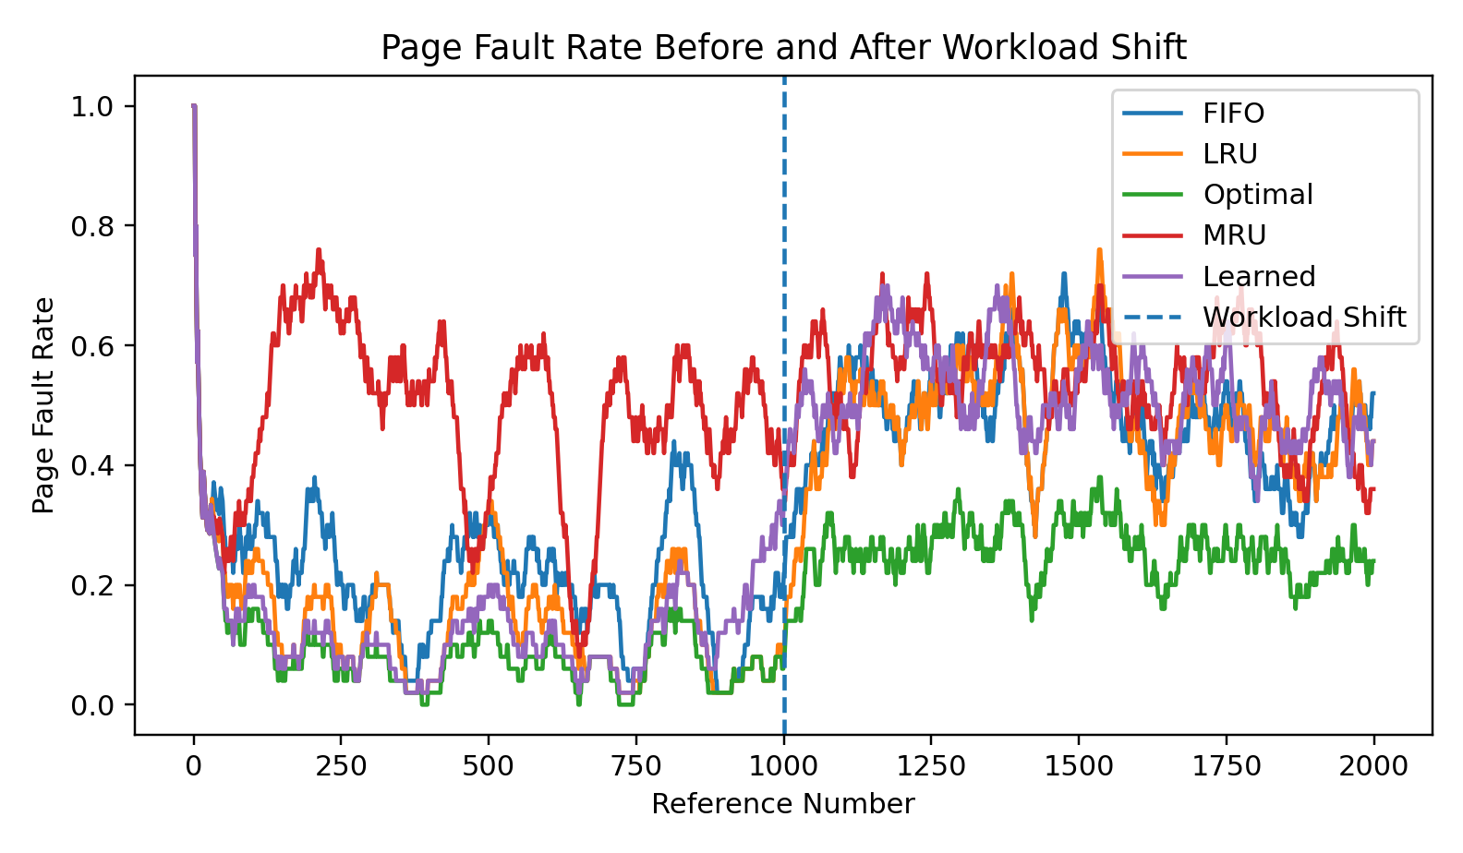
The rolling page-fault-rate graph shows the change around reference 1,000. The learned policy records 128 faults before the shift and 520 after it, for 648 total faults. The increase illustrates the effect of the more random/bursty workload and also shows that a policy trained on one workload distribution may degrade after a distribution change.
7. Bonus: Explanation Confidence
The bonus component gives a rule-based explanation for an eviction decision and a decision-confidence value. Confidence is the margin between the model's support for the selected candidate and the next-best candidate; it is not treated as a calibrated probability of correctness. There were 640 learned eviction decisions. The selected victim matched the offline Optimal victim in 0.125 of decisions, and mean decision confidence was 0.111.
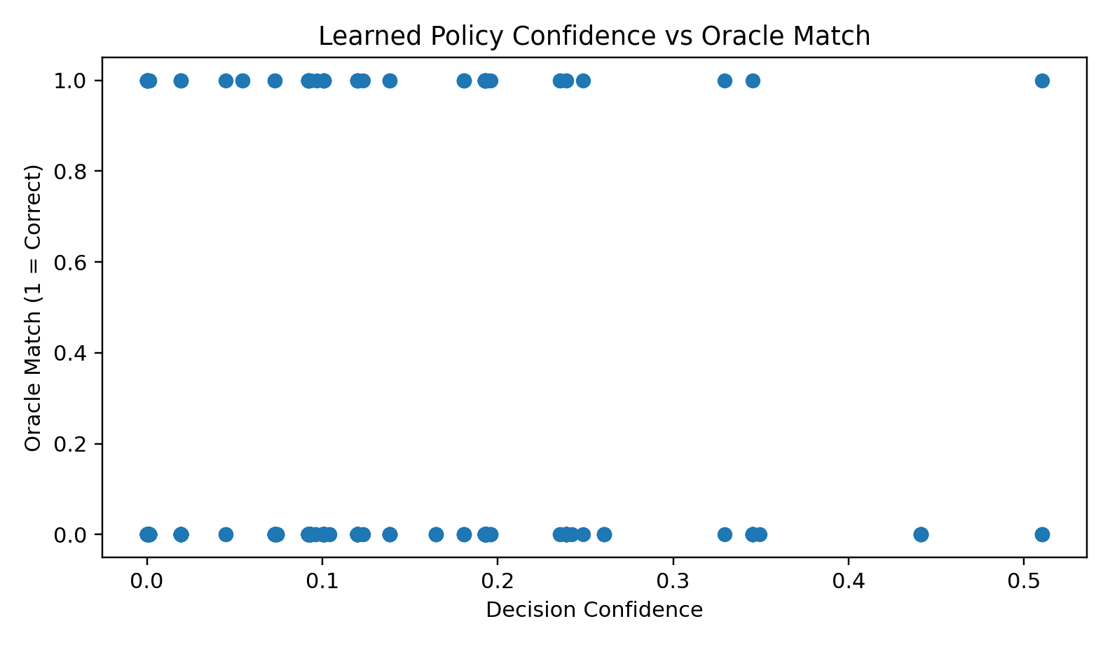
The experiment does not show a strong monotonic relationship between raw confidence and oracle-match correctness. Therefore, the confidence value is useful as a model-score margin but should not automatically be interpreted as a calibrated probability.
8. Limitations and Conclusion
The experiment uses synthetic workloads, three simple features, and a shallow decision tree. Optimal is not practical online because it requires future knowledge, so it is only a comparison reference. The results show that workload characteristics strongly affect page-replacement behavior and that a lightweight learned policy can be integrated into a simulator using past/current information. The second-phase results and low oracle-match rate also indicate that stronger features, more varied training traces, calibration, or online adaptation would be needed for a more robust learned policy.
AI Assistance Disclosure
AI tools were used for coding guidance, debugging assistance, and drafting portions of the implementation. The experimental configuration, workload design, experiment execution, generated results, and interpretation were reviewed and checked against the implemented project.

