QuakeNet
Earthquake Early Warning & Emergency Response Network
CSE421 — Computer Network
Section 07 | Group 703
Project Report
Group Members
Tahamidul Alam Chowdhury — 22299066
Bornil Barua — 22201838
Tabia Sultana Ritu — 23201510
Syed Kafi — 23101135

Table of Contents
1. Introduction 1
2. Network Topology 1
3. IP Addressing Scheme 2
4. Device Inventory 4
5. Router Configurations 4
6. DHCP Configuration 8
7. Routing Design 8
8. Server Configuration 9
9. Testing & Verification 9
10. Assumptions 11

1. Introduction
QuakeNet is a wide-area network designed to connect seven functional units of a national earthquake early-warning and emergency-response system: the National Emergency Operation Center (NEOC), Seismic Monitoring Station (SMS), Fire & Rescue Headquarters (FRH), Medical Emergency Center (MEC), Urban Search & Rescue Camp (USR), Communication Relay Center (CRC), and Mountain Observation Post (MOP).
The network was designed and built in Cisco Packet Tracer, and combines a redundant "warning loop" between the three most time-critical sites (NEOC, SMS, FRH) with a shared backbone switch, direct point-to-point links, VLSM-based IP addressing, RIPv2 with static-route redistribution, floating and recursive static backup routes, DHCP delivered through both router-based and server-based methods, and per-unit email/web/DNS services.
This report documents the design decisions, addressing scheme, full device configuration, and verification steps carried out to build and test the network.

2. Network Topology
Every unit is represented by one router, with its own LAN switch, two PCs, one network printer, and one server. Four units — NEOC, FRH, MEC, and CRC — additionally connect to a shared Central Switch, forming a backbone. Three further link types create the rest of the topology:
- Warning loop: three direct point-to-point links forming a triangle between NEOC, SMS, and FRH, layered on top of the shared switch connections NEOC and FRH already have — deliberate redundancy for the most time-critical alerting path.
- Direct fibre link: a dedicated point-to-point connection between NEOC and MEC, in addition to both already sharing the Central Switch.
- Stub links: USR connects only to MEC; MOP connects only to CRC.
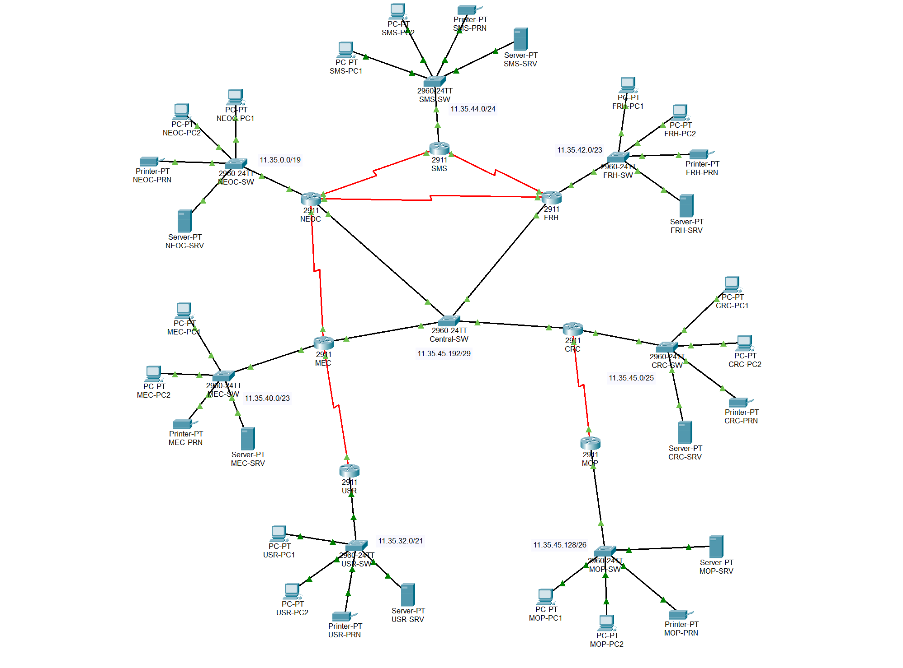
Figure 1 — QuakeNet network topology as built in Cisco Packet Tracer, with every device and subnet label as they appear on the live canvas.
Assumption: the spec describes the NEOC–MEC link as "direct fibre." It is implemented as a serial point-to-point link for consistency with the router hardware used across the rest of the design (Cisco 2911 routers with HWIC-2T serial modules) — no requirement is changed by this choice, only the simulated Layer-1 medium.

3. IP Addressing Scheme

3.1 Base network and key calculations
Base network address, derived from the last group member’s ID (23101135): last four digits 1135 → split into 11 and 35 → 11.35.0.0/16.
Custom Administrative Distance, derived from the first group member’s ID (22299066): digit sum 2+2+2+9+9+0+6+6 = 36, × group size 4 = 144. This value is used for every floating static route in Section 7.

3.2 VLSM allocation
Subnets were allocated from 11.35.0.0/16 largest-requirement-first, the standard VLSM procedure: each block is sized to the smallest power of two that satisfies its stated host requirement, and the next block begins immediately after the previous one ends.
Segment | Hosts req. | Prefix | Network | Usable range | Broadcast
NEOC-LAN | 5000 | /19 | 11.35.0.0 | 11.35.0.1 – 11.35.31.254 | 11.35.31.255
USR-LAN | 1040 | /21 | 11.35.32.0 | 11.35.32.1 – 11.35.39.254 | 11.35.39.255
MEC-LAN | 500 | /23 | 11.35.40.0 | 11.35.40.1 – 11.35.41.254 | 11.35.41.255
FRH-LAN | 320 | /23 | 11.35.42.0 | 11.35.42.1 – 11.35.43.254 | 11.35.43.255
SMS-LAN | 180 | /24 | 11.35.44.0 | 11.35.44.1 – 11.35.44.254 | 11.35.44.255
CRC-LAN | 100 | /25 | 11.35.45.0 | 11.35.45.1 – 11.35.45.126 | 11.35.45.127
MOP-LAN | 50 | /26 | 11.35.45.128 | 11.35.45.129 – 11.35.45.190 | 11.35.45.191
Central switch | 4 | /29 | 11.35.45.192 | 11.35.45.193 – 11.35.45.198 | 11.35.45.199
P2P NEOC–SMS | 2 | /30 | 11.35.45.200 | 11.35.45.201 – 11.35.45.202 | 11.35.45.203
P2P SMS–FRH | 2 | /30 | 11.35.45.204 | 11.35.45.205 – 11.35.45.206 | 11.35.45.207
P2P FRH–NEOC | 2 | /30 | 11.35.45.208 | 11.35.45.209 – 11.35.45.210 | 11.35.45.211
P2P NEOC–MEC | 2 | /30 | 11.35.45.212 | 11.35.45.213 – 11.35.45.214 | 11.35.45.215
P2P USR–MEC | 2 | /30 | 11.35.45.216 | 11.35.45.217 – 11.35.45.218 | 11.35.45.219
P2P CRC–MOP | 2 | /30 | 11.35.45.220 | 11.35.45.221 – 11.35.45.222 | 11.35.45.223
Table 1 — Full VLSM subnet allocation.
The tree below shows the same allocation as a branching diagram: starting from the full 11.35.0.0/16 block, each split halves the address space (borrowing one more host bit), continuing down whichever half still contains further requirements until every subnet in Table 1 is reached. Branches that reach a size no longer needed by any requirement are left unused rather than split further.
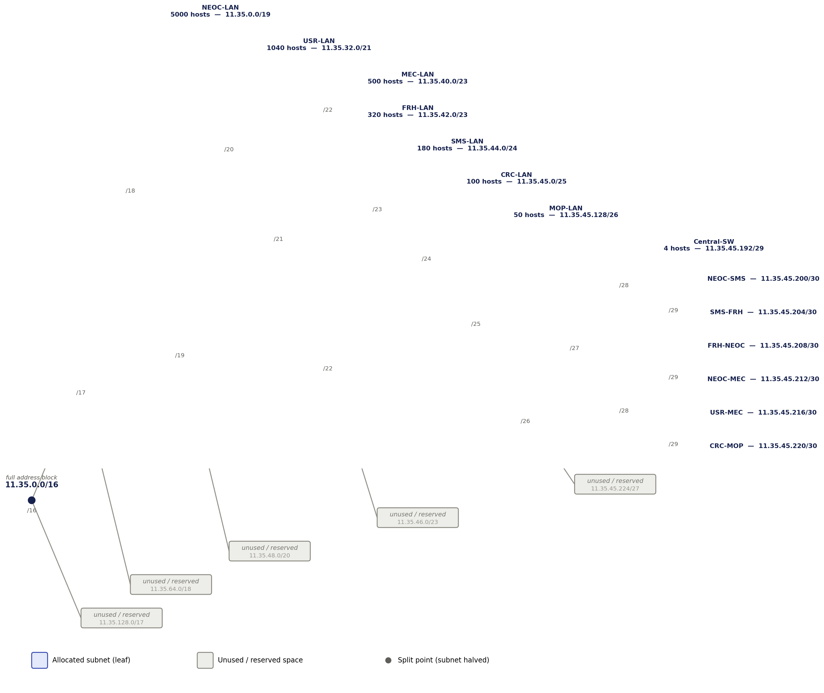
Figure 2 — VLSM tree: the 11.35.0.0/16 block subdivided down to every allocated subnet.

3.3 Per-site static addressing convention
Within every LAN subnet: the first usable address is the router’s gateway interface, the second is that unit’s server, the third is its printer, and the remainder of the range is the DHCP pool for its two PCs.
Device | IP | Mask | Gateway | DNS
NEOC-SRV | 11.35.0.2 | 255.255.224.0 | 11.35.0.1 | 11.35.0.2
NEOC-PRN | 11.35.0.3 | 255.255.224.0 | 11.35.0.1 | 11.35.0.2
SMS-SRV | 11.35.44.2 | 255.255.255.0 | 11.35.44.1 | 11.35.0.2
SMS-PRN | 11.35.44.3 | 255.255.255.0 | 11.35.44.1 | 11.35.0.2
FRH-SRV | 11.35.42.2 | 255.255.254.0 | 11.35.42.1 | 11.35.0.2
FRH-PRN | 11.35.42.3 | 255.255.254.0 | 11.35.42.1 | 11.35.0.2
MEC-SRV | 11.35.40.2 | 255.255.254.0 | 11.35.40.1 | 11.35.0.2
MEC-PRN | 11.35.40.3 | 255.255.254.0 | 11.35.40.1 | 11.35.0.2
USR-SRV | 11.35.32.2 | 255.255.248.0 | 11.35.32.1 | 11.35.0.2
USR-PRN | 11.35.32.3 | 255.255.248.0 | 11.35.32.1 | 11.35.0.2
CRC-SRV | 11.35.45.2 | 255.255.255.128 | 11.35.45.1 | 11.35.0.2
CRC-PRN | 11.35.45.3 | 255.255.255.128 | 11.35.45.1 | 11.35.0.2
MOP-SRV | 11.35.45.130 | 255.255.255.192 | 11.35.45.129 | 11.35.0.2
MOP-PRN | 11.35.45.131 | 255.255.255.192 | 11.35.45.129 | 11.35.0.2
Table 2 — Static addresses for every server and printer.

4. Device Inventory
Every router is a Cisco 2911. NEOC carries two HWIC-2T serial modules (three serial links); every other router carries one (one or two serial links). All switches are 2960-series. 43 devices in total: 7 routers, 8 switches (7 LAN + 1 central), 14 PCs, 7 printers, 7 servers.
Site | Router interfaces used | LAN switch | End devices
NEOC | Gi0/0, Gi0/1, S0/1/0, S0/1/1, S0/2/0 | NEOC-SW | 2 PC, 1 printer, 1 server
SMS | Gi0/0, S0/1/0, S0/1/1 | SMS-SW | 2 PC, 1 printer, 1 server
FRH | Gi0/0, Gi0/1, S0/1/0, S0/1/1 | FRH-SW | 2 PC, 1 printer, 1 server
MEC | Gi0/0, Gi0/1, S0/1/0, S0/1/1 | MEC-SW | 2 PC, 1 printer, 1 server
USR | Gi0/0, S0/1/0 | USR-SW | 2 PC, 1 printer, 1 server
CRC | Gi0/0, Gi0/1, S0/1/0 | CRC-SW | 2 PC, 1 printer, 1 server
MOP | Gi0/0, S0/1/0 | MOP-SW | 2 PC, 1 printer, 1 server
Table 3 — Device inventory by site.

5. Router Configurations
Full final running-configuration for each router (interfaces, DHCP, static routes, and RIP where applicable), reflecting the cumulative state after every configuration phase.

5.1 NEOC
hostname NEOC
!
interface GigabitEthernet0/0
ip address 11.35.0.1 255.255.224.0
no shutdown
!
interface GigabitEthernet0/1
ip address 11.35.45.193 255.255.255.248
no shutdown
!
interface Serial0/1/0
ip address 11.35.45.201 255.255.255.252
clock rate 64000
no shutdown
!
interface Serial0/1/1
ip address 11.35.45.210 255.255.255.252
clock rate 64000
no shutdown
!
interface Serial0/2/0
ip address 11.35.45.213 255.255.255.252
clock rate 64000
no shutdown
!
ip dhcp excluded-address 11.35.0.1 11.35.0.3
ip dhcp excluded-address 11.35.44.1 11.35.44.3
ip dhcp excluded-address 11.35.42.1 11.35.42.3
!
ip dhcp pool NEOC-POOL
network 11.35.0.0 255.255.224.0
default-router 11.35.0.1
dns-server 11.35.0.2
!
ip dhcp pool SMS-POOL
network 11.35.44.0 255.255.255.0
default-router 11.35.44.1
dns-server 11.35.0.2
!
ip dhcp pool FRH-POOL
network 11.35.42.0 255.255.254.0
default-router 11.35.42.1
dns-server 11.35.0.2
!
ip route 11.35.40.0 255.255.254.0 11.35.45.214
ip route 11.35.32.0 255.255.248.0 11.35.45.214
ip route 11.35.45.0 255.255.255.128 11.35.45.196
ip route 11.35.45.128 255.255.255.192 11.35.45.196
!
router rip
version 2
network 11.0.0.0
passive-interface GigabitEthernet0/0
passive-interface GigabitEthernet0/1
passive-interface Serial0/2/0
redistribute static
default-metric 1
no auto-summary

5.2 SMS
hostname SMS
!
interface GigabitEthernet0/0
ip address 11.35.44.1 255.255.255.0
ip helper-address 11.35.45.201
no shutdown
!
interface Serial0/1/0
ip address 11.35.45.202 255.255.255.252
no shutdown
!
interface Serial0/1/1
ip address 11.35.45.205 255.255.255.252
clock rate 64000
no shutdown
!
router rip
version 2
network 11.0.0.0
passive-interface GigabitEthernet0/0
no auto-summary

5.3 FRH
hostname FRH
!
interface GigabitEthernet0/0
ip address 11.35.42.1 255.255.254.0
ip helper-address 11.35.45.210
no shutdown
!
interface GigabitEthernet0/1
ip address 11.35.45.194 255.255.255.248
no shutdown
!
interface Serial0/1/0
ip address 11.35.45.206 255.255.255.252
no shutdown
!
interface Serial0/1/1
ip address 11.35.45.209 255.255.255.252
no shutdown
!
router rip
version 2
network 11.0.0.0
passive-interface GigabitEthernet0/0
passive-interface GigabitEthernet0/1
no auto-summary

5.4 MEC
hostname MEC
!
interface GigabitEthernet0/0
ip address 11.35.40.1 255.255.254.0
no shutdown
!
interface GigabitEthernet0/1
ip address 11.35.45.195 255.255.255.248
no shutdown
!
interface Serial0/1/0
ip address 11.35.45.214 255.255.255.252
no shutdown
!
interface Serial0/1/1
ip address 11.35.45.218 255.255.255.252
clock rate 64000
no shutdown
!
ip route 11.35.0.0 255.255.224.0 11.35.45.213
ip route 11.35.44.0 255.255.255.0 11.35.45.213
ip route 11.35.42.0 255.255.254.0 11.35.45.213
ip route 11.35.45.0 255.255.255.128 11.35.45.196
ip route 11.35.45.128 255.255.255.192 11.35.45.196
ip route 11.35.32.0 255.255.248.0 11.35.45.217
ip route 11.35.0.0 255.255.224.0 11.35.45.196 144
ip route 11.35.44.0 255.255.255.0 11.35.45.196 144
ip route 11.35.42.0 255.255.254.0 11.35.45.196 144

5.5 USR
hostname USR
!
interface GigabitEthernet0/0
ip address 11.35.32.1 255.255.248.0
ip helper-address 11.35.40.2
no shutdown
!
interface Serial0/1/0
ip address 11.35.45.217 255.255.255.252
no shutdown
!
ip route 11.35.0.0 255.255.224.0 Serial0/1/0
ip route 11.35.44.0 255.255.255.0 Serial0/1/0
ip route 11.35.42.0 255.255.254.0 Serial0/1/0
ip route 11.35.40.0 255.255.254.0 Serial0/1/0
ip route 11.35.45.0 255.255.255.128 Serial0/1/0
ip route 11.35.45.128 255.255.255.192 Serial0/1/0

5.6 CRC
hostname CRC
!
interface GigabitEthernet0/0
ip address 11.35.45.1 255.255.255.128
no shutdown
!
interface GigabitEthernet0/1
ip address 11.35.45.196 255.255.255.248
no shutdown
!
interface Serial0/1/0
ip address 11.35.45.221 255.255.255.252
clock rate 64000
no shutdown
!
ip route 11.35.0.0 255.255.224.0 11.35.45.193
ip route 11.35.44.0 255.255.255.0 11.35.45.193
ip route 11.35.42.0 255.255.254.0 11.35.45.193
ip route 11.35.40.0 255.255.254.0 11.35.45.195
ip route 11.35.32.0 255.255.248.0 11.35.45.195
ip route 11.35.45.128 255.255.255.192 11.35.45.222
ip route 11.35.0.0 255.255.224.0 11.35.45.194 144
ip route 11.35.44.0 255.255.255.0 11.35.45.194 144
ip route 11.35.42.0 255.255.254.0 11.35.45.194 144

5.7 MOP
hostname MOP
!
interface GigabitEthernet0/0
ip address 11.35.45.129 255.255.255.192
ip helper-address 11.35.45.2
no shutdown
!
interface Serial0/1/0
ip address 11.35.45.222 255.255.255.252
no shutdown
!
ip route 11.35.0.0 255.255.224.0 Serial0/1/0
ip route 11.35.44.0 255.255.255.0 Serial0/1/0
ip route 11.35.42.0 255.255.254.0 Serial0/1/0
ip route 11.35.40.0 255.255.254.0 Serial0/1/0
ip route 11.35.32.0 255.255.248.0 Serial0/1/0
ip route 11.35.45.0 255.255.255.128 Serial0/1/0

6. DHCP Configuration
DHCP is delivered two ways in this design, deliberately: router-based (native IOS) for the RIP-domain sites, and server-based (Packet Tracer Server service) elsewhere.
Server | Pool | Gateway | DNS | Start IP | Mask | Max users
NEOC (IOS) | NEOC-POOL | 11.35.0.1 | 11.35.0.2 | 11.35.0.4 | /19 | —
NEOC (IOS) | SMS-POOL | 11.35.44.1 | 11.35.0.2 | 11.35.44.4 | /24 | —
NEOC (IOS) | FRH-POOL | 11.35.42.1 | 11.35.0.2 | 11.35.42.4 | /23 | —
MEC-SRV | MEC-POOL | 11.35.40.1 | 11.35.0.2 | 11.35.40.4 | /23 | 500
MEC-SRV | USR-POOL | 11.35.32.1 | 11.35.0.2 | 11.35.32.4 | /21 | 1040
CRC-SRV | CRC-POOL | 11.35.45.1 | 11.35.0.2 | 11.35.45.4 | /25 | 100
CRC-SRV | MOP-POOL | 11.35.45.129 | 11.35.0.2 | 11.35.45.132 | /26 | 50
Table 4 — All seven DHCP pools.
SMS, FRH, USR, and MOP relay client broadcasts via ip helper-address (see Section 5) since they host no DHCP service of their own — SMS and FRH point at NEOC directly, USR at MEC-SRV, and MOP at CRC-SRV.

7. Routing Design

7.1 RIPv2 domain
NEOC, SMS, and FRH run RIPv2 over the warning-loop links. LAN-facing and non-RIP-domain interfaces are configured passive-interface so RIP neither forms unintended neighbor relationships (e.g. NEOC and FRH also share the Central Switch) nor advertises onto end-host segments — the connected subnets are still carried in RIP updates through the active interfaces regardless.

7.2 Redistribution
NEOC holds static routes to MEC-LAN, USR-LAN, CRC-LAN, and MOP-LAN (none of which are reachable via RIP), and redistributes them into RIPv2 with a seed metric of 1. This is how SMS and FRH — which never speak to MEC or CRC directly — learn that the rest of the network exists.

7.3 Floating and recursive static routes
MEC’s primary route to the NEOC/SMS/FRH networks uses the direct fibre link (next-hop 11.35.45.213); a floating, recursive backup route via CRC (next-hop 11.35.45.196) is installed at the custom Administrative Distance of 144, calculated in Section 3.1. It only appears in the routing table if the primary path is withdrawn.
CRC’s primary route to the same three networks uses NEOC directly across the Central Switch (11.35.45.193); its floating backup via FRH (11.35.45.194) also uses AD 144. Because both next-hops sit on the same shared switch segment, this backup demonstrates a real limitation of recursive floating statics: IOS considers the route resolved as long as some route covers the next-hop’s subnet, regardless of whether that specific host is alive, so the backup does not activate automatically the way MEC’s does. It was verified by temporarily withdrawing the primary route (see Section 8).

7.4 Static-only stubs
USR and MOP each have exactly one path out, so their routes to every other network use exit-interface syntax (Serial0/1/0) rather than a next-hop IP — a deliberate contrast with MEC and CRC’s recursive, next-hop-based routes. No default routes are used anywhere in the design.

8. Server Configuration

8.1 Email
All seven servers run the Email service. Each unit has two mailboxes (unit-prefixed, e.g. neoc1/neoc2), matched to that unit’s two PCs.
Server | Domain | Users
NEOC-SRV | mail.neoc.gov | neoc1, neoc2
SMS-SRV | mail.sms.gov | sms1, sms2
FRH-SRV | mail.frh.gov | frh1, frh2
MEC-SRV | mail.mec.gov | mec1, mec2
USR-SRV | mail.usr.gov | usr1, usr2
CRC-SRV | mail.crc.gov | crc1, crc2
MOP-SRV | mail.mop.gov | mop1, mop2
Table 5 — Email domains and accounts.
Cross-domain email between NEOC and MEC was verified with a round trip between neoc1 and mec2@mail.mec.gov (Section 9).

8.2 Web
NEOC-SRV and MEC-SRV run the HTTP service, serving www.neoc.alert.gov and www.mec.alert.gov respectively, each with a short custom status page.

8.3 DNS
NEOC-SRV runs the network’s only DNS service, authoritative for nine A-records: the seven mail.*.gov mailserver names and the two www.*.alert.gov web server names. Every device in the network — statically configured or DHCP-assigned — points to 11.35.0.2 as its DNS server.

9. Testing & Verification
The following checks were carried out to verify the design end-to-end.

9.1 Connectivity
- NEOC-PC1 → SMS-PC1 (warning loop / RIP)
- SMS-PC1 → FRH-PC1 (warning loop, other leg)
- NEOC-PC1 → CRC-PC1 (central switch)
- MEC-PC1 → USR-PC1 (stub link)
- CRC-PC1 → MOP-PC1 (stub link)
- SMS-PC1 → MOP-PC1 (full path: RIP → redistribution → static domain → stub)
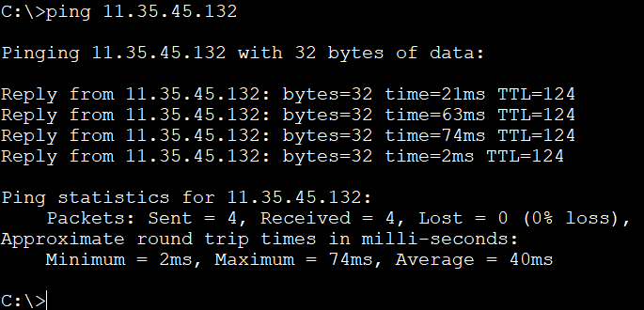
Figure 3 — Successful ping test confirming end-to-end connectivity across the network.

9.2 DHCP
All 14 PCs confirmed to hold a leased address from the correct pool (Desktop → IP Configuration).

9.3 Floating static route failover (MEC)
With NEOC’s Serial0/2/0 administratively shut down, MEC’s route to 11.35.0.0/19 was confirmed to switch from AD 1 (via 11.35.45.213) to AD 144 (via 11.35.45.196), and MEC-PC1 → NEOC-PC1 connectivity was confirmed to continue across the backup path. The primary link was then restored and the route confirmed to revert automatically.
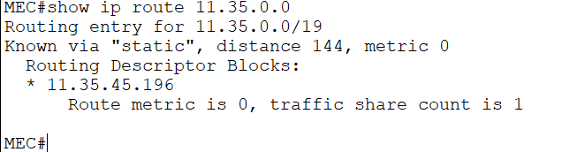
Figure 4 — MEC’s routing table showing the floating backup route active at administrative distance 144 once the primary link was withdrawn.

9.4 Floating static route (CRC) — backup verification
Because CRC’s primary and backup next-hops share the Central Switch segment (Section 7.3), the backup route was verified by temporarily removing the primary ip route entries and confirming the AD-144 entries appeared alone in the routing table, then restoring the primary configuration.

9.5 Warning-loop resilience
With NEOC’s Serial0/1/0 (to SMS) shut down, RIP reconverged and NEOC ↔ SMS traffic was confirmed to reroute via FRH.

9.6 Web and DNS verification
Both www.neoc.alert.gov and www.mec.alert.gov were confirmed to load by name from a PC (FRH-PC1), verifying DNS resolution, HTTP, and routing together in a single test.
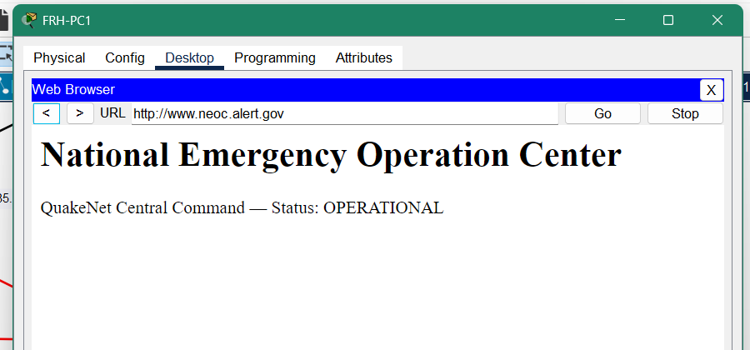
Figure 5 — www.neoc.alert.gov loading by name from FRH-PC1.
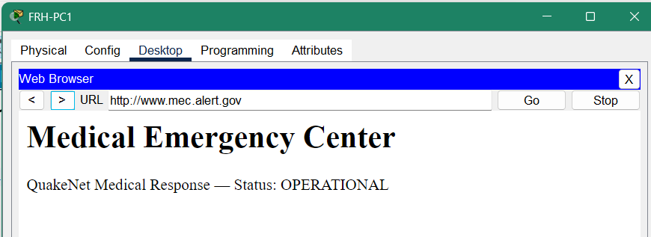
Figure 6 — www.mec.alert.gov loading by name from FRH-PC1.

9.7 Email verification
Intra-unit email delivery was confirmed for each site, along with the NEOC ↔ MEC cross-domain round trip: mail sent from neoc1@mail.neoc.gov was confirmed received in MEC-PC2’s inbox (mec2@mail.mec.gov), demonstrating that email routes correctly across site and domain boundaries.
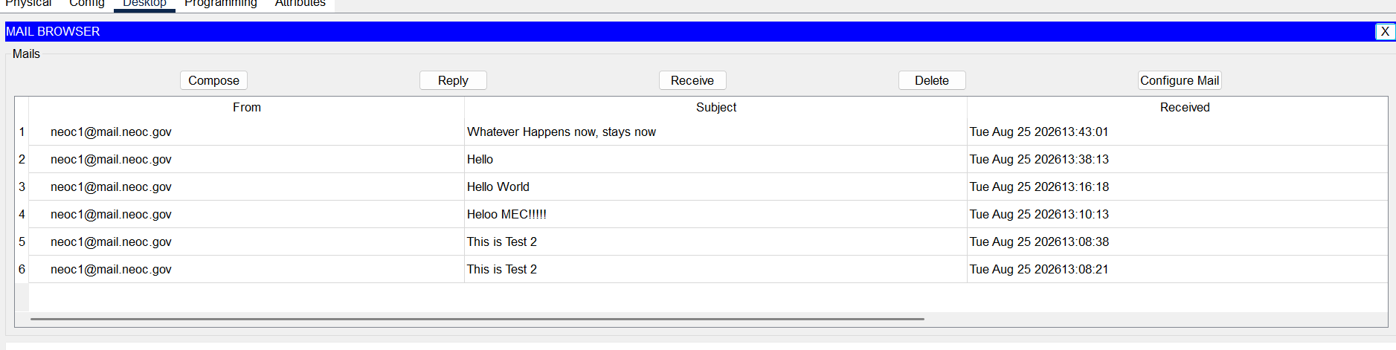
Figure 7 — MEC-PC2’s inbox showing mail delivered from neoc1@mail.neoc.gov, confirming cross-domain email.

10. Assumptions
- The last group member for the base-network calculation and the first member for the Administrative Distance calculation were taken in the order the group listed its own members (Member 1 → Member 4).
- The NEOC–MEC "direct fibre" link is implemented as a serial point-to-point link rather than a literal fibre medium, for consistency with the router hardware used everywhere else.
- MEC and CRC’s DHCP is server-based (Packet Tracer Server service) while NEOC’s is router-based (IOS), to demonstrate both methods within one project.
- CRC’s and MEC’s floating backup routes toward the RIP domain use the same next-hop granularity as their primary routes (i.e. all three RIP-domain LANs share one primary and one backup next-hop) rather than routing FRH-LAN directly via FRH, treating the RIP domain as one logical destination reachable through either NEOC or FRH.
- A shared password (Passw0rd123) is used for all email accounts for simplicity, since credential security is not part of this assignment’s scope.

