|  |
| --- |
| Software Requirements Specifications  **eBuy.store**  **Internal Advisor:** Mam Anam lodhi  **External Advisor:** None  **Project Manager:** Sir Fahad Maqbool  **Project Team:**   * Labeeb Ahmad Tahir (Leader) BSITF18E041 * Aimen Ilyas (Member) BSITF18E006 * Shameer Khan (Member) BSITF18E045   **Submission Date:** _____________________ Project Manager’s Signature |

**Table of Contents**

1. Introduction 4

1.1 Purpose of Document 4

1.2 Project Overview 4

1.3 Scope 4

2. Overall System Description 4

2.1 User characteristics 4

2.2 Operating environment 4

2.3 System constraints 4

3. External Interface Requirements 5

3.1 Hardware Interfaces 5

3.2 Software Interfaces 5

4. Functional Requirements 5

5. Non-functional Requirements 5

5.1 Performance Requirements 5

5.2 Safety Requirements 5

5.3 Security Requirements 5

5.4 User Documentation 6

6. References 6

1. Introduction

* 1. Purpose of Document

This document aims to present a detailed description of the eBuy.store, an ecommerce web application. It will explain the purpose of our intended ecommerce web application, its interface, functional requirements, non-functional requirements and constraints that it must operate.

**Intended Audience:**

This document is intended for the application’s stakeholders to assist in the ecommerce web application and serve reference to clarify any future issues that stakeholders may face.

The intended audience of stakeholders for this specification of the ecommerce web application include:

* **Project Managers**
* **Designers**

Whose design must meet the requirements specified in this SRS?

* **Programmers**

Whose software components must implement the requirements specified in this SRS?

* **Quality Engineers**

Who must ensure the quality of its quality requirements?

* **Testers**

Who must ensure that the requirements are valid and whose tests must validate the criteria?

* **Usability Engineers**

Who must ensure that the user interfaces fulfil the usability requirements?

* **Users**

For whom the web app will be designed and who will use this web app.

* 1. Project Overview

This project's actual concept is to carry out both research and development work belongs to ecommerce with the help of diverse intelligent machine learning and deep learning models to make it more valuable for the customers to get all possible benefits in the domain. More over our project will provide proved user friendly interface to make it a universal product for the people of every group including novelty, non-technologist and young ones. We will implement straight forward methods to serve the customers getting their products within no time.

* 1. Scope

The software system being produced is called eBuy.store an ecommerce system. Subjected to targeted online customers, our project is intended to serve the purpose of intelligent online shopping from catalog to delivery. Customers will be provided products matching their interests regarding most fundamental features including trends, sales and seasons. With the help of intelligent bots system will provide automation support to the customer.

Moreover, It is not intended to cover shipping services of fraud checks as this project is a part of this domain and does not covers Anomaly detection as Intelligent feature.

1. Overall System Description

System's Environment

**Development environment** includes first installing IDE, Node.js installation for back-end, Express.js installation through npm, and then create-react-app through npx and finally install MongoDB database.

**Set system environmental variable** path for node.js and git.

**For API testing environment** install postman.

**Anticipated users**

**1.** Admin

**2.** Clients/ Customers

**Known Constraints**

**1.**Hardware Constraints

**2.**Software Constraints

**3.**Cultural Constraints

**4.**Legal Constraints

**5.**User Constraints

**6.**Environmental. Constraints

                      (More information about this section is in 2.3 section)

**Assumptions and Dependencies**

* In local development environment server and react app should be running on seperate ports of local machine.
* Always connected to the Internet.
* MongoDB instance should always be connected with backend node.js server
* Limitless users can log in to the system per day.
* Only one admin.
  1. User characteristics

The typical eBuy.store user is simply anyone that has access to the Internet and a web browser. It is assumed that the user is familiar enough with a computer to operate the browser, keyboard and mouse and is capable of browsing to, from and within simple websites.

More over the user should be familiar with the Shopping Mall related terminology like Shopping cart/Checking out/Transaction etc.

* 1. Operating environment

The product will be operating in web environment. eBuy.store is a web application which will use ES6 Javascript syntax and shall operate in all latest browsers, such as :

* Chrome : 51
* Mozilla Firefox : 52
* Microsoft Edge : 14
* Safari. 10
* Opera. 38

This application can run on web environment of all operating system. Cookies and javascript should be enabled in web browsers. The requirement to use this online product would be the internet connection. The basic input devices required are keyboard, mouse and output devices are monitor, speaker etc.

* 1. System constraints

The constraints or limitations on the eBuy.store web application may include the following*:*

* **Software constraints :**

ES6 JavaScript syntax should be supported on the web browser on which the application will run.. Internet is required to run the web application and SSL (Secure Socket Layer) should be enabled in the browser.

* **Hardware constraints:** Development environment will not run on low end processors. Laptop or pc is required to run the development environment.
* **Cultural constraints**

None. The eBuy.store is for all types of users. Because of Bilingual support user can access this application in any language through intelligent chatbot.

* **Legal constraints**

Copyright protection.

* **Environmental constraints**

No noisy environment so the user will feel relax while using this eBuy.store.

* **User constraints**

As the project is for all types of users, the project will have more graphic controls than textual controls. The eBuy.store will also have textual controls where required.

* **Off the shelf components**

nodemailer, 3d-react-carousel, dialogflow.

1. External Interface Requirements

The system will be accessible for any operating system, Android, and IOS mobile phones using a web server. End-user require no special hardware for this system. Communication protocol should be HTTP (Hypertext Transfer Protocol) using TCP/IP ports to transfer information back and forth from the client to the server.

Machine learning based product recommendation system

Payment gateway

AI Chatbot

Product Forecasting using Machine learning

User Accounts

eBuy.store

Add to cart

Optimized NLP based searching

User login/Signup

Catalogue Management

* 1. Hardware Interfaces

The hardware requirements for the web application are:

* Input Devices: Mouse, Keyboard, Microphone.
* Output Devices: Display Screen, Speaker.
* RAM: minimum 4gb, recommended 8gb.
* Secondary Storage: SSD recommended.
* Processor: Recommended core i7.
  1. Software Interfaces

The whole system will run over the Internet. The software requirements for the web application are:

* Operating system: windows 10 or mac OS. Older versions of windows require so many more odd configurations hacks to get open source tools to run.
* IDE: Recommended Visual Studio code.
* GIT : Version 2.33.1
* Front-End : React.js version 17.0.2
* Back-End :
* Node.js version 14.17.3,
* Express.js version 4.17.1
* Databases :
* MongoDB x64
* Mongo Atlas : To manage MongoDB instance
* Major Packages: npm, react-bootstrap, react-router, firebase, dialogflow, nodemon.
* Testing: postman

eBuy.Store use case diagram

Use Case Description:

**Actors**

* Administrator
* Customer
* Identity Provider
* Credit payment service
* Online payment <<service>>
* Authentication <<Service>>

**Use Case Team member:**

* Labeeb Ahmad Tahir
* Aimen Ilyas
* Shameer Khan

1. **Registration**

|  |  |
| --- | --- |
| **Use Case** | **Client Registration** |
| Actor | **User** |
| Description | The use case begins when the actor indicates the intent to register to the system. It ends when the actor is registered or cancels registration. |
| Pre-Condition | The login exists |
| Post-Condition | The actor  register successfully |

1. **Administration Login**

|  |  |
| --- | --- |
| **Use Case** | **Login** |
| Actor | Administrator |
| Description | The use case begins when the actor indicates the intent to log in to the system. It ends when the actor is logged in or cancels the login. |
| Pre-Condition | The login exists |
| Post-Condition | The actor logs in successfully |

1. **Manage cart**

|  |  |
| --- | --- |
| **Use Case** | **Manage cart** |
| Actor | User |
| Description | The use case begins when the actor indicates the intent to add items into the cart. It ends when the actor enters the next |
| Pre-Condition | 1-The Category record exists for view.  2-The actor is logged in. |
| Post-Condition | The Cart record is added or updated. |

1. **View Products**

|  |  |
| --- | --- |
| **Use Case** | **View Items** |
| Actor | User |
| Description | The use case begins when the actor indicates to view the products. It ends when the actor is close to the application |
| Pre-Condition | The login exists |
| Post-Condition | The actor view product successfully |

1. **Place Order**

|  |  |
| --- | --- |
| **Use Case** | **Place Order** |
| Actor | User |
| Description | The use case begins when the actor indicates the intent to confirm the purchase of his selected items |
| Pre-Condition | 1-The product record exists for view.  2-The actor is logged in. |
| Post-Condition | The Cart record is added or updated. |

##### Manage Product

|  |  |
| --- | --- |
| **Use Case** | **Manage Product** |
| Actor | Administrator |
| Description | The use case begins when the actor indicates the intent to add, update, delete or view an item as a record. It ends when the actor closes the form. |
| Pre-Condition | 1-The Item’s record exists for editing/view.  2-The actor is logged in. |
| Post-Condition | The item’s record is added or updated. |

1. **View Order Detail**

|  |  |
| --- | --- |
| **Use Case** | **View Order Detail** |
| Actor | Admin |
| Description | The use case begins when the actor indicates the intent to view orders detail of customers. |
| Pre-Condition | 1-The order record exists for editing/view.  2-The actor is logged in. |
| Post-Condition | The actor dispatch or cancel the customer record. |

1. **Payment**

|  |  |
| --- | --- |
| **Use Case** | **Payment** |
| Actor | Payment service |
| Description | The use case begins when the actor indicates the intent to pay. |
| Pre-Condition | 1- The actor is logged in.  2-The actor should have a bank account for online payment. |
| Post-Condition | The payment is successful. |

1. **Chat Bot**

|  |  |
| --- | --- |
| **Use Case** | **Chat Bot** |
| Actor | user |
| Description | The use case begins when the actor indicates the intent to use chatbot services to resolve a query. |
| Pre-Condition | 1- The actor is logged in. |
| Post-Condition | User query resolved. |

Top Level Use Case

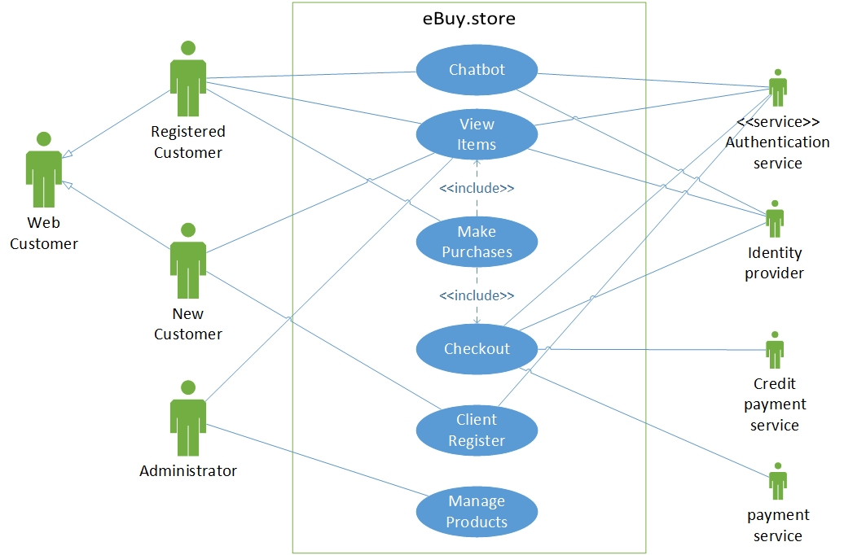

**View Items Use Case**

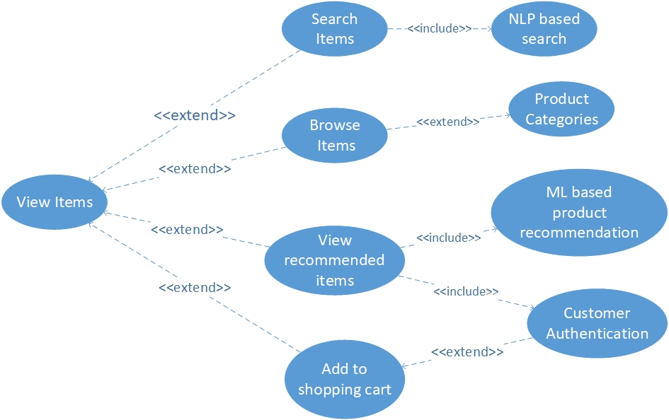

**Check Out Use Case**

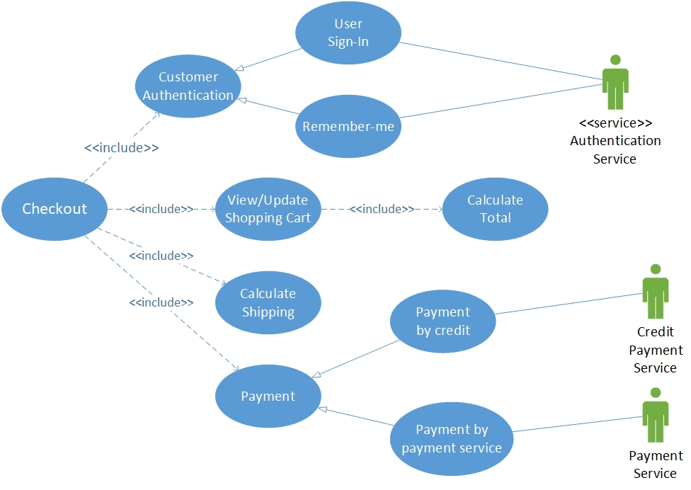

**Chatbot Use Case**

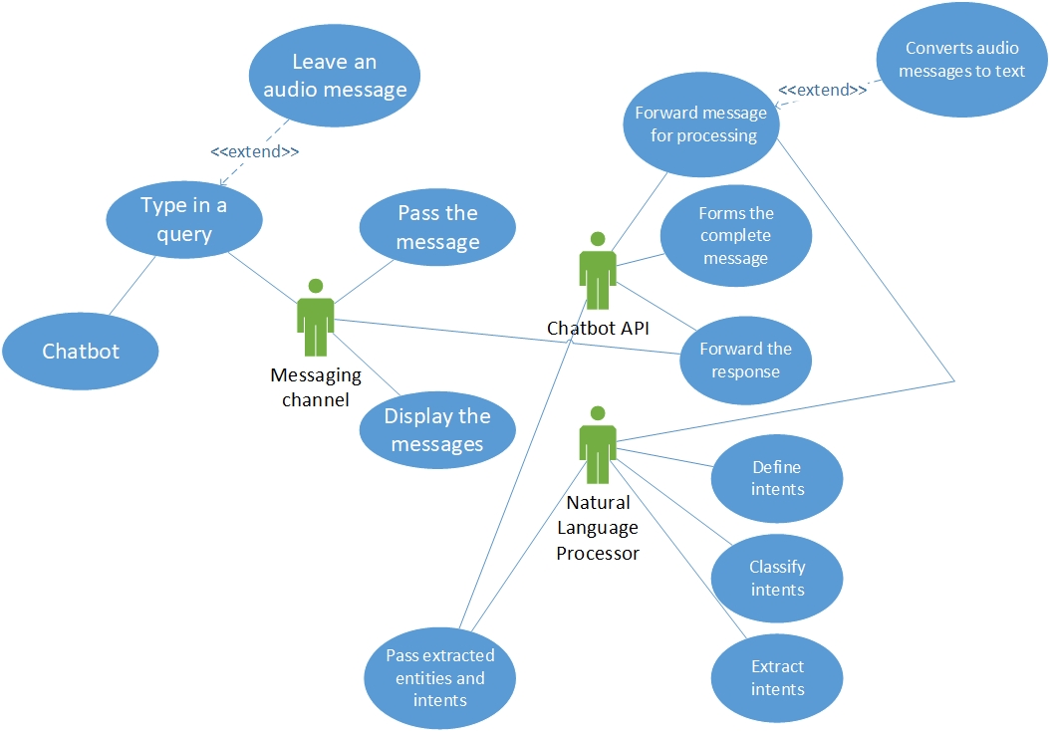

**Manage Products Use Case**

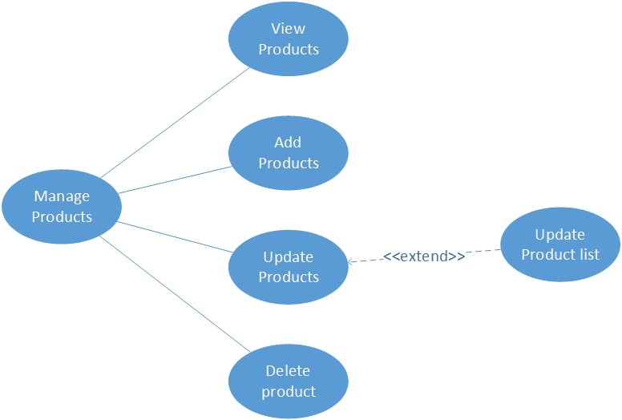

1. Functional Requirements

Here is the list of some functional requirements that eBuy.store needs to deliver.

**1. Intelligent user/customer support chatbot:**

Our eBuy.store should include an intelligent user/customer support chatbot which will provide natural language conversation support between user and chatbot. Moreover it will provide multi language, voice and speech conversation between user and chatbot.

**2. Product Recommendation Engine:**

Our eBuy.store should include a machine learning based product recommendation engine which will provide product forecasting service and will recommend products to the user based on their past history.

**3. Mobile Friendliness:**

Our eBuy.store should always be responsive to all mobile devices and screens.

**4. Ease of use in the checkout flow:**

Our eBuy.store will provide easy steps to complete the purchase and no unnecessary steps is required. Strive for a one-click experience.

5. Allow customers to search and view products

6. Allow customers to place products in shopping cart

7. Allow customers to purchase products

8. Manage customer information database

9. Store and manage product information

1. Non-functional Requirements
   1. Performance Requirements

Some performance measures that eBuy.store should meet.

**1. Speed:** As everyone is so busy in his life, no one has time for buffering. eBuy.store website response time should be as little as possible and will work effectively on slow internet connections as well.

**2. Capacity:** The server's capacity should be high because there can be so many users at the same time.

**3. Reliability:** eBuy.store should provide reliability to the user that the product will run with all the features mentioned in this document and execute flawlessly. It should be tested and debugged entirely.

* 1. Safety Requirements

There is no specific harm that could result in the use of eBuy.store. For safety measures, it must allow its user to sign up first in which he/she will enter his primary information like email, phone number, etc. So that if he/she forgets the password, he/she can recover it. The database may get crushed at any certain time due to virus or operating system failure. Therefor it is required to take the database backup so that the database is not lost. eBuy.store shall handle expected and non-expected errors in ways that prevent loss in information and long downtime period.

* 1. Security Requirements

Hackers try to hack different websites for illegal cause. eBuy.store must encrypt the user's sensitive data and his personal information related to his account. If a user tries to log in to another person's account system must notify that person about login failure. eBuy.store will ensure two-factor authentication. Only authorized users should be allowed to access databases and web pages.

Other security requirements include:

* System will use secured database.
* System will have different types of users and every user has access constraints.
  1. User Documentation

We will make a user manual and a video tutorial for troubleshooting and support. In the user manual, we'll describe detailed information on how to use our web application from a layman perspective to an expert. We will also demonstrate how to use our web application with a demo video in the video tutorial.