Assignment 3
Tahir Muhammad
1002537613

Theoretical Based Questions

1a)
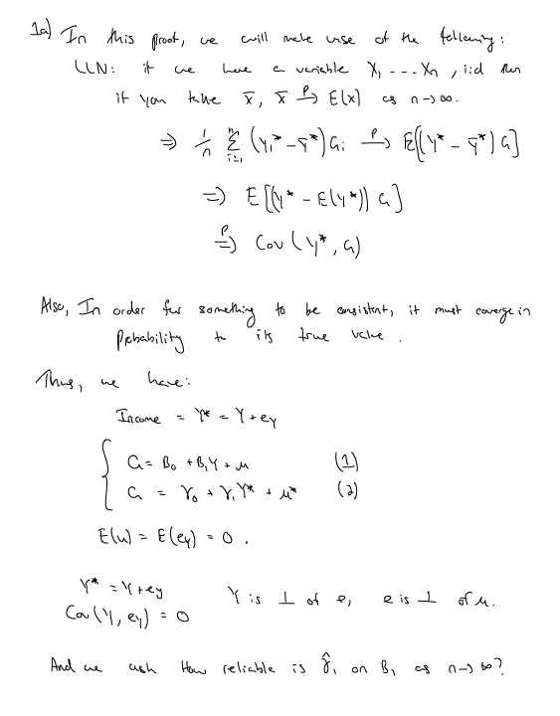
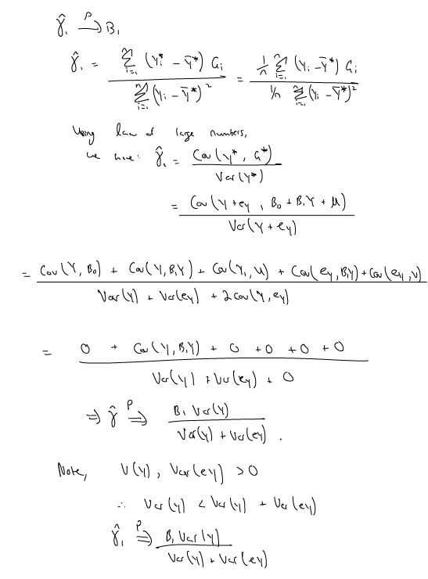
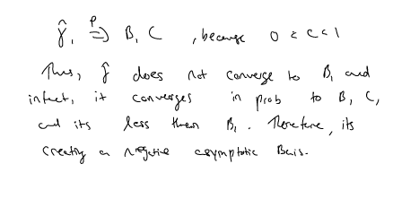

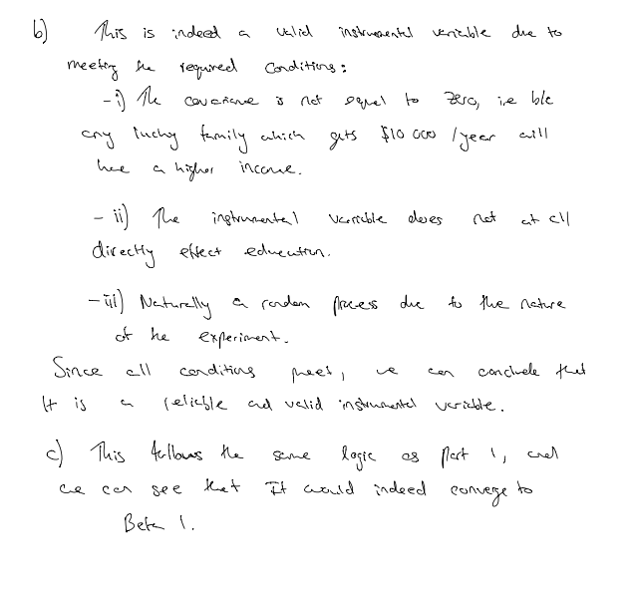

Question 2a)

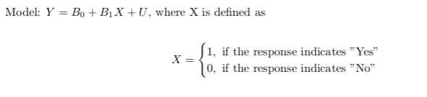
And Y is defined as the Log of Earnings. The problem here with using OLS is that Military Service is most likely co-related with a lot of unobserved factors which also effect their Human capital. Hence, there is a co-relation with between X and the unobservable U (More formally, this is an endogenity problem). Some of these factors can be: What academic level did they study till, or if they like office work or not, or if they value human capital in their life or have other priorities. Thus, due to these co-relations which most likely effect their earing/Human capital, the effect we get from OLS in magnitude at least will not be the correct estimate of the true casual effect of the military participation on human capital.

b) We can use the lottery draft as an instrumental variable because it has nothing to do with the unobserved variables. For example, for an individual to be drafted inside of the lottery is not co-related with their goals in life, or if they prefer a desk job or not, etc. To use the lottery as a instrumental variable is a great idea. What this does is create natural experiment, where some people are randomly assigned as if they served in the military or not. Thus, the population which gets assigned through this process is statistically identical to those which does not get assigned – and then when the changes in X occur, due to the instrumental variable (lottery) is unrelated to the co-related factors of X (The error term). This is how we are able to avoid the endogenity problem. Using this ideology, we can use the lottery variable to compare the human capital for individuals who were eligible for the draft vs they were not eligible for the draft, then that effect would solely be due to the causal effect of military participation on human capital.

Computer Based Questions

1a)
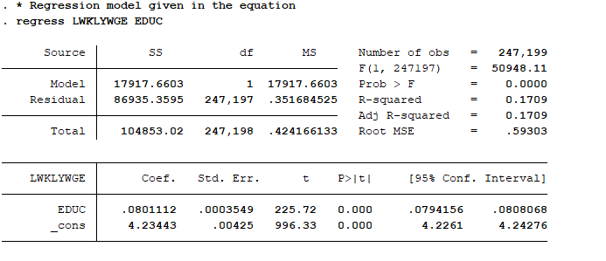

The return to education for this model is: 0.08 increase in wages from a 0.01 unit increase in education. Since the p-value is approximately 0, we can conclude this is statistically significant with alpha =0.05. Thus, it is indeed statistically different from 0.
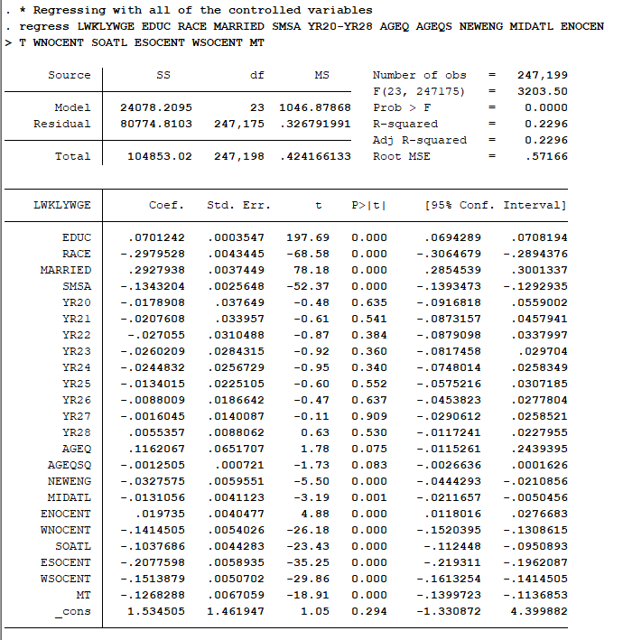

The return to education for this model is: 0.07 increase in wages from a 0.01 unit increase in education. Since the p-value is approximately 0, we can conclude this is statistically significant with alpha =0.05. Thus, it is indeed statistically different from 0. Difference in education with control variables should be more accurate due to the process being randomized however, it will not provide a unbiased estimator. The estimator will be biased, due to variables which are not included in the model but are co-related with education. These could be something like one’s academic drive, or parental support for education and which directly effect the wage.

Part B) This would be valid instrumental variable due to being co-related with education. Furthermore, it can explain the education by the person’s birthrate and how early on in the year they can start the education.

Part C)

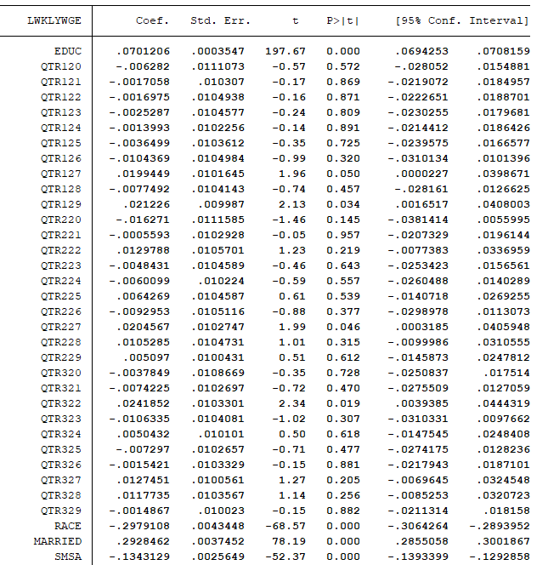

b) I believe they will be valid because of the randomly assigned values. The instrumental variable can explain the education level because
c)
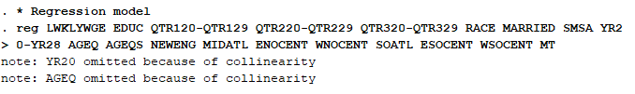

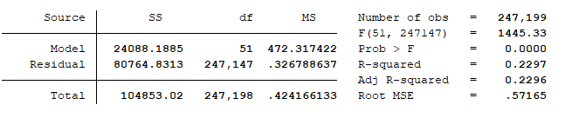

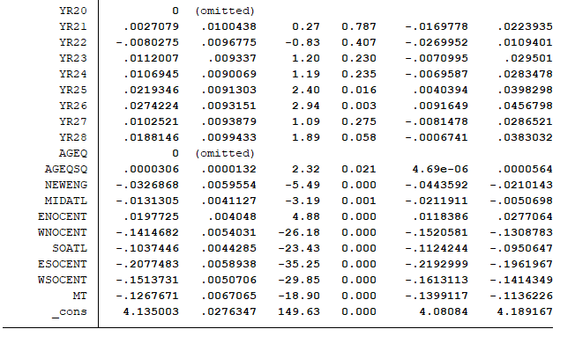

And the Ftest is:
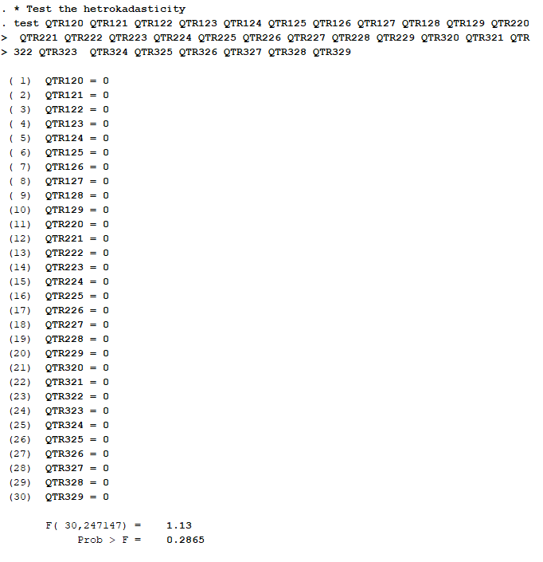

d) The return to education for this model is: 0.33% increase in wages from a 0.01 unit increase in education. Since the p-value is approximately 0.03, we can conclude this is statistically significant with alpha =0.05. There is a difference here where it is much higher, and that is because the S.E for 2SLS is always higher.
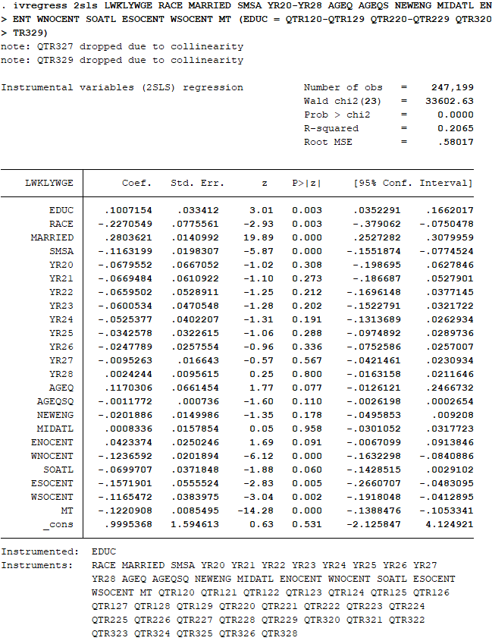

Here w
Question 2a)
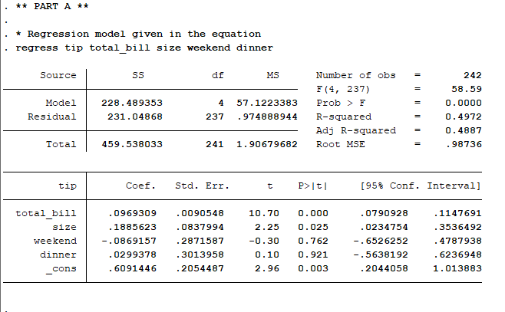

We can see that at the 5% level, we have total bill, and size variables are significant. Also, since the confidence interval of Total Bill and Size does not include 0, we can conclude that there is evidence suggesting these 2 variables are significant. On the other hand, weekend and dinner are not.

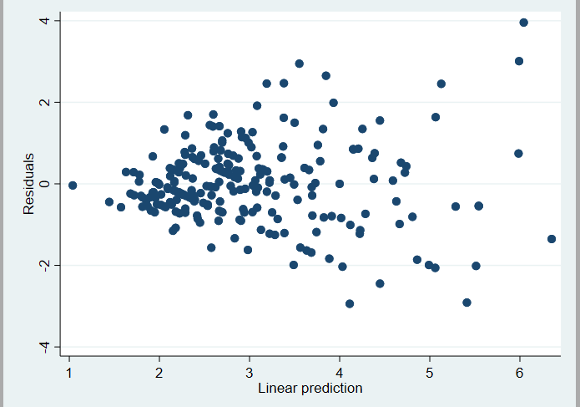
2b)

From observing the scatter plot, there might be heteroscedasticity present because the points on the plot appear to look unevenly spread as they are densed in one particular area of the graph. Furthermore, the graph roughly appears to have a cone shape where most points are on the right side of the graph. As a result, the model estimated in part a) may be inaccurate because the model does not take heteroscedasticity into consideration. Thus, the standard errors and the usual tests may be inaccurate.
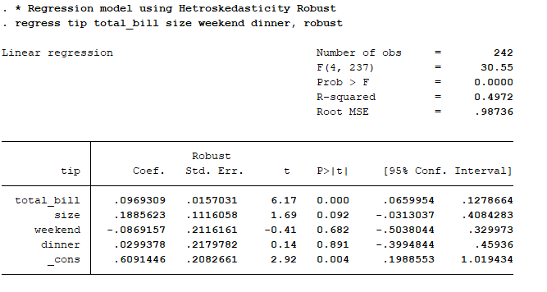
2c)

As we can see, the R^2 remained the same but only total variable is significant at the 5% significant level (Confidence interval does not include a 0). Furthermore, the standard error using robust errors is higher for the variable Total bill which means the confidence interval is wider and so the beta estimate may be less accurate. The size is not as significant as it was in part a) and robust standard errors is higher compare as well.

2d)
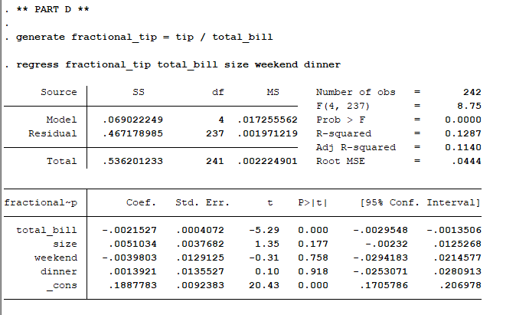
Regression Results:

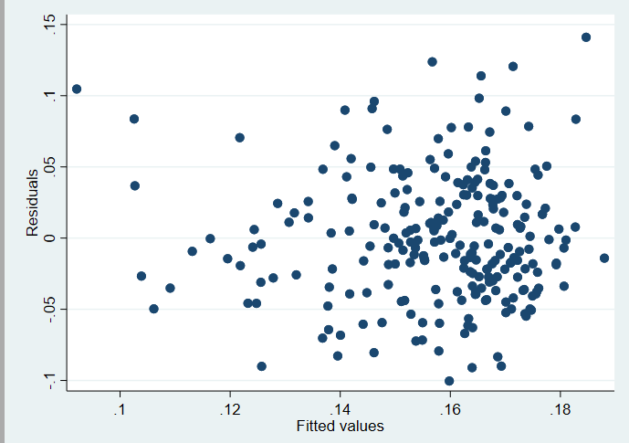
Scatter Plot:

The regression results from using fractional tip as a dependent variable actually decreases the overall validity of the model. From the table, the confidence intervals for all variables include a 0 which implies that all of the beta estimates are statistically insignificant and the model should not be relied on to gain insights. We can see that scatter plots for part d and part b are approximately the same. Furthermore, the larger the party the more tips the waiter will receive however the higher the total bill the less amount of tip he will receive. This does not make sense as the tip is a fraction of the total bill and logically the waiter should receive more tip on a higher bill.
2e)
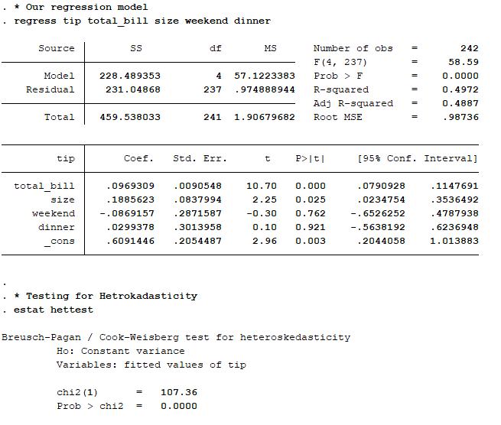
The observation from part b) coincides with the Breusch-Pagan test because the p-value from the test is very significantly low and the chi-square is very high as well. As a result, we reject the null hypothesis of homoscedasticity and conclude that there is strong evidence suggesting there is heteroscedasticity in the model from part a).

And the Robust Regression Model, along with its Hetrokadasticity test:
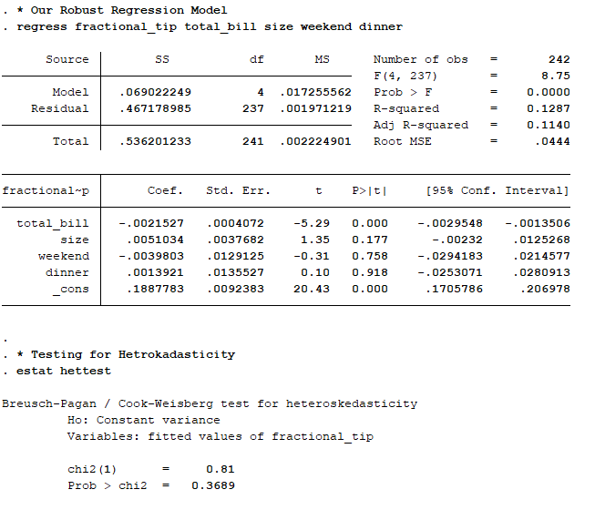
The observation from part d) after running the regression with fractional tips as the dependent variable does not coincide with Breusch-Pagan test. The p-value is very high and the chi-square value is very low. As a result, we fail to reject the null hypothesis of homoskedasticity and conclude that there is evidence suggesting lack of heteroskedasicity.

Question 3a)
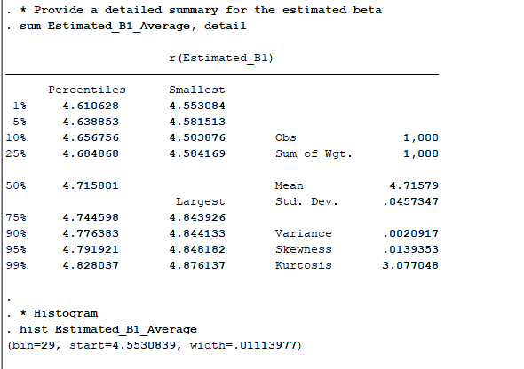
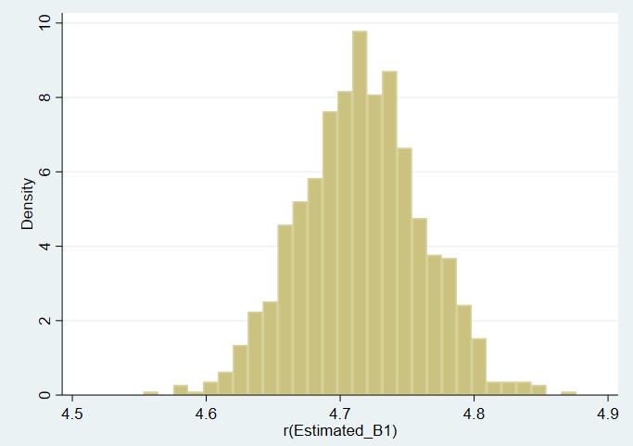

The results are consistent with my expectations of getting a biased estimate for beta because the variable X is correlated with the unobservable through X = γ Z + ρ U + V which violates one of the assumptions (cov(x,u)=0) of OLS.

Part B) Yes, because it is related to X and not directly related to Y as given in the questions.

Part C) Summary of the estimated Beta & its histogram
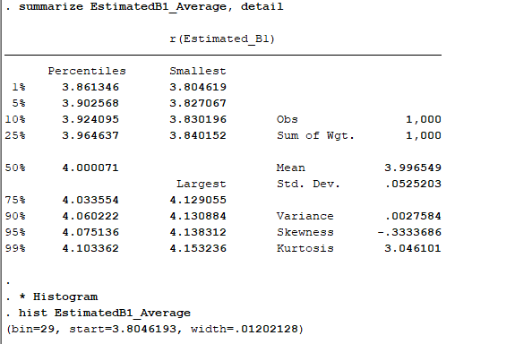

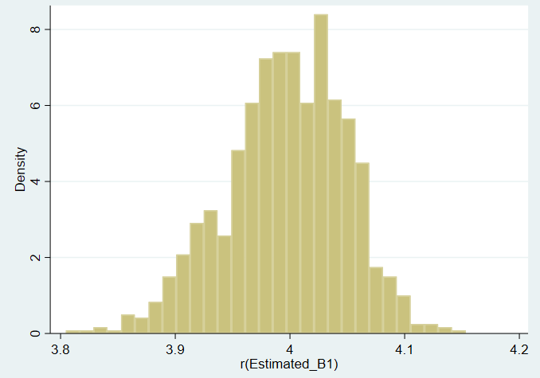

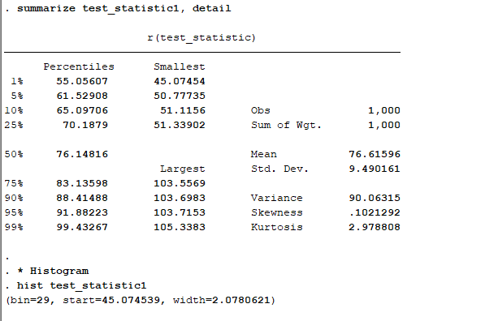
Summary of the Test Statistic and its Histogram:

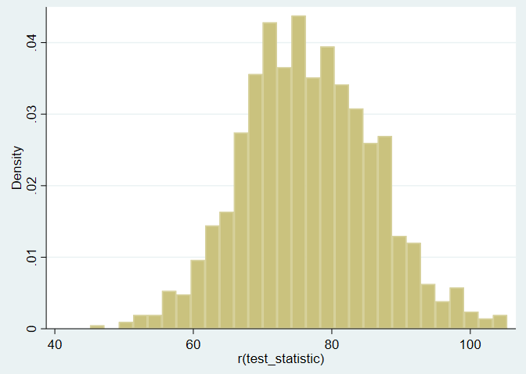

Here we can see that: That the results are in the expected direction due to instrumental variable is helping bring the estimator closer to the true value, which is 4 for beta 1.

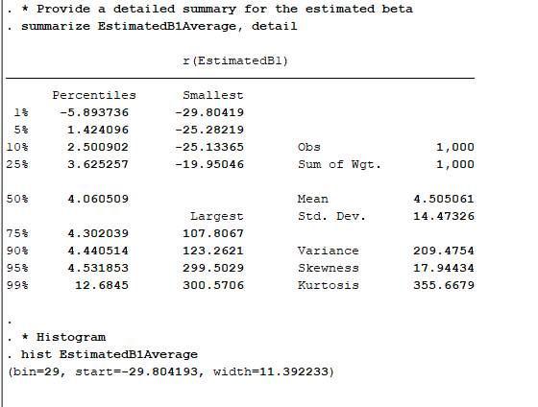
Part D) Summary of the estimated Beta & its histogram

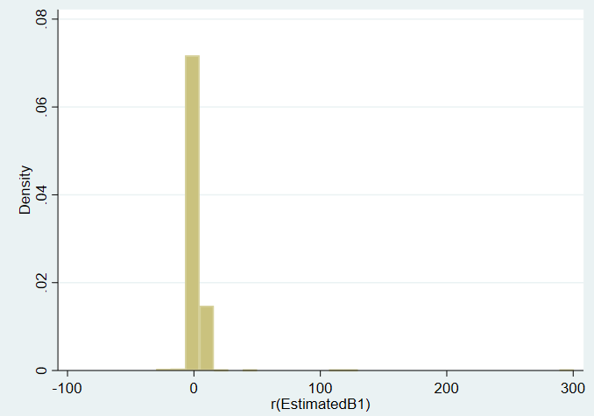
Summary of the Test Statistic and its Beta:
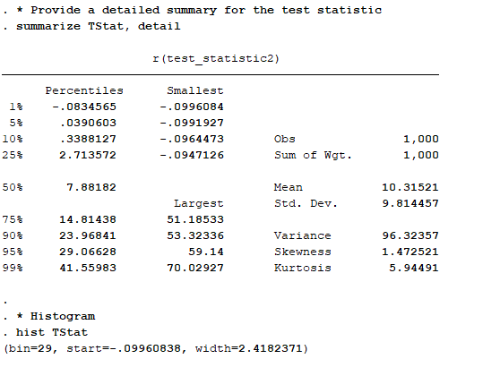

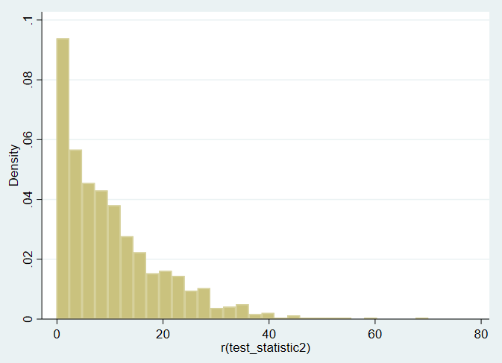

As we can see that both the test statistic and beta1, are skewed to the right, which can be seen from the graph and the summary tables. Driving this result, is the lower value of Gamma, which implies a weaker relationship between X and the instrumental variable, therefore the effect is less.

