AI-Based Disease Prediction System (Flask Project)

LinkedIn Profile:
https://www.linkedin.com/in/tahir-fareed-273035399/

1. Introduction
This project is an AI-based web application developed using Python and Flask. It predicts possible diseases based on user-provided symptoms. The system uses a trained machine learning model, and provides additional information such as disease description, precautions, and severity level.

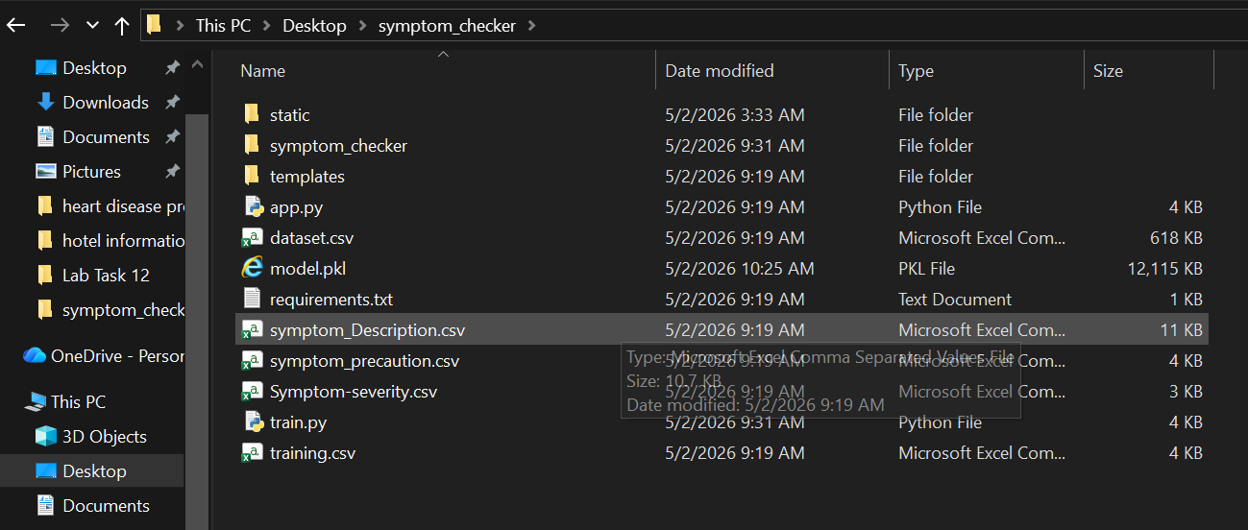

2. Objectives
- Predict disease based on symptoms
- Provide disease description
- Suggest precautions
- Show severity level
- Build a web-based AI system

3. Technologies Used
Python, Flask, Machine Learning, Pandas, Pickle, HTML, CSS, JavaScript
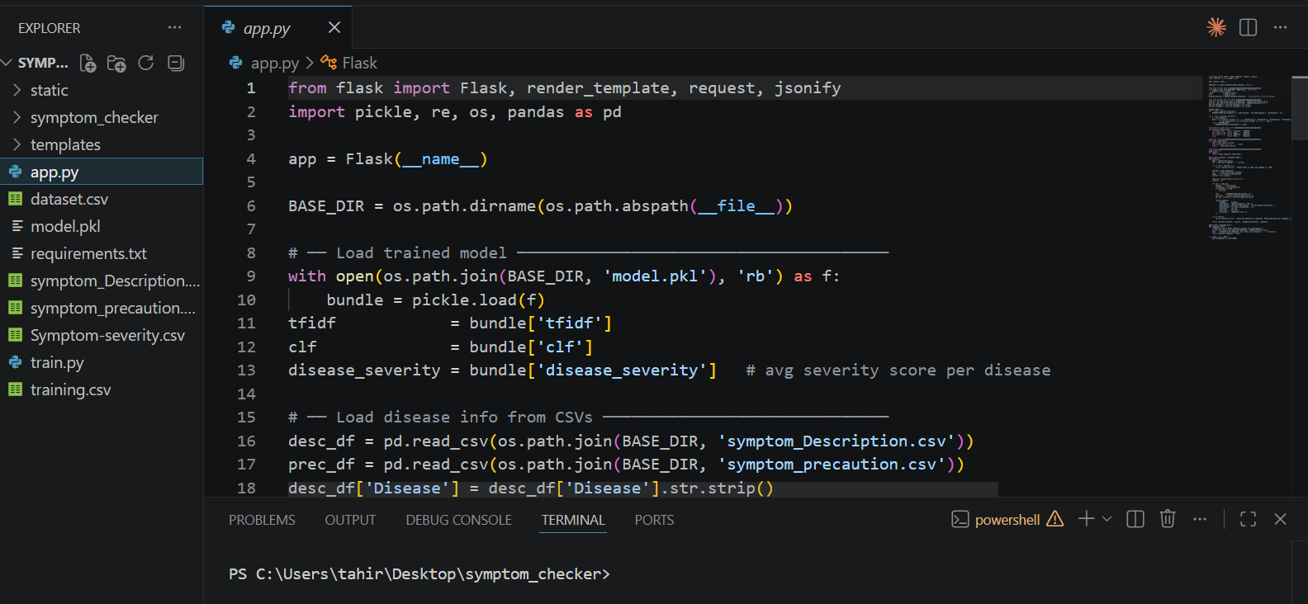

4. Project Structure
app.py - Main backend file
train.py - Model training file
model.pkl - Trained ML model
dataset.csv - Training dataset
templates/ - HTML frontend
static/ - CSS/JS files
symptom_Description.csv - Disease descriptions
symptom_precaution.csv - Precautions data
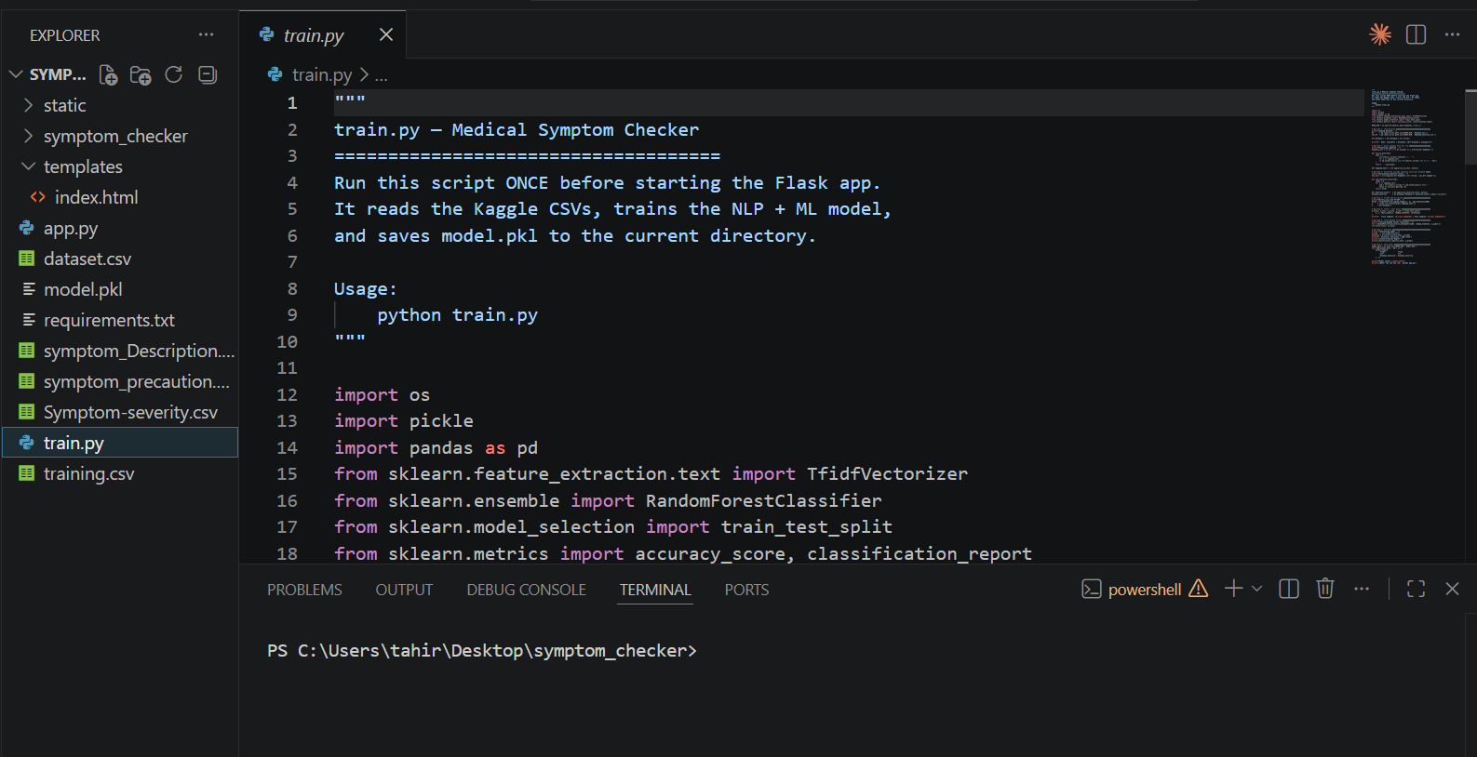

5. Working of the System
1. User enters symptoms on the website
2. Data is sent to Flask backend
3. Input is cleaned and processed
4. TF-IDF converts text into numerical form
5. ML model predicts disease probabilities
6. Top 3 diseases are selected
7. Additional info (description, precautions, severity) is added
8. Results are displayed to the user
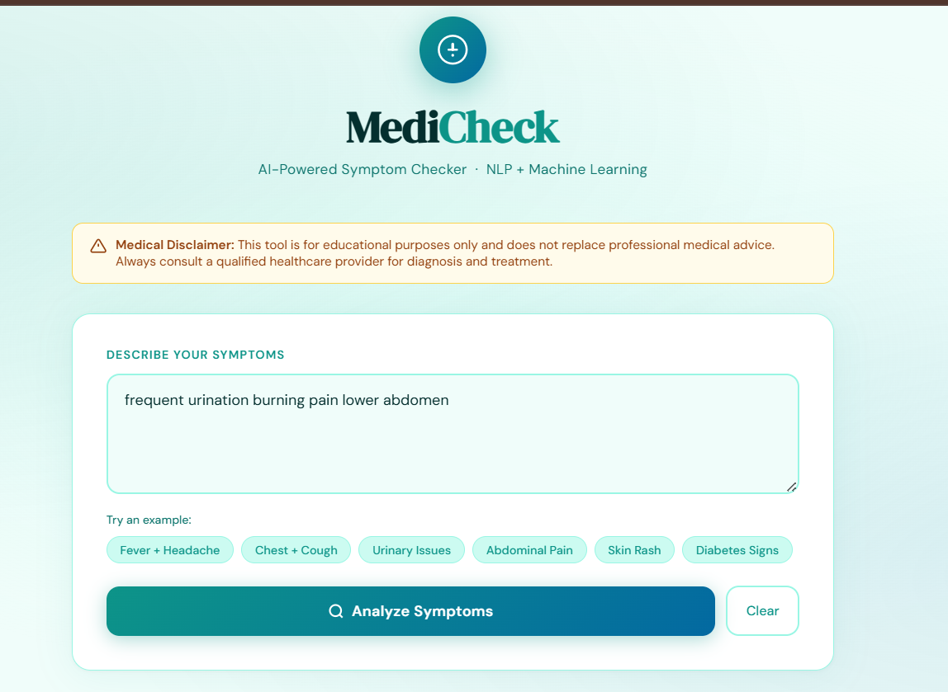

6. Flask Backend Explanation
Flask handles routing, user requests, and responses. It processes input data, interacts with the machine learning model, and sends prediction results to the frontend in JSON format.
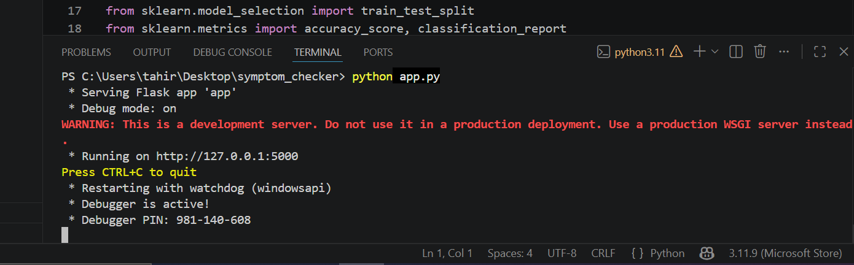

7. Machine Learning Model
The model is trained using TF-IDF and a classifier algorithm. It converts symptoms text into numerical vectors and predicts disease probabilities.

8. Key Features
- Predict multiple diseases
- Shows confidence percentage
- Displays severity levels
- Provides precautions
- Uses real datasets
- Web-based interface
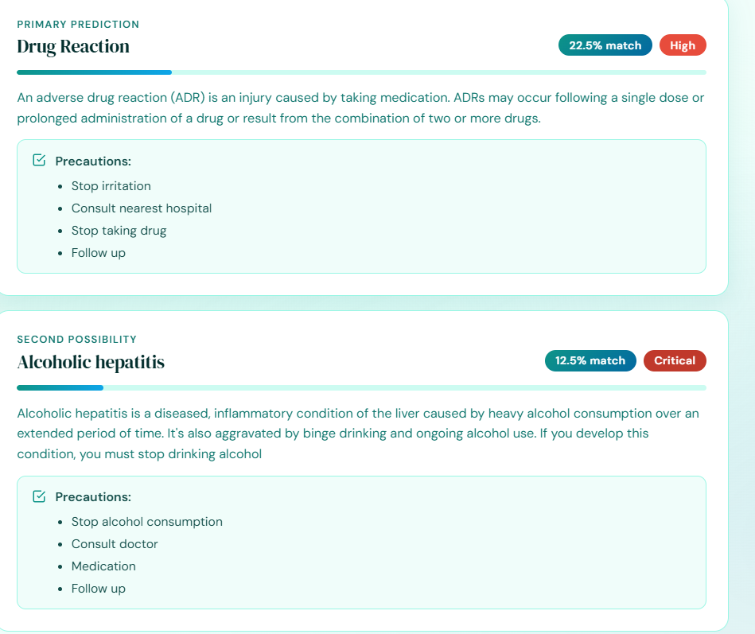

9. Advantages
- Fast prediction
- User-friendly interface
- Helps in early diagnosis
- Scalable system
- Easy to integrate with other systems

10. Conclusion
This project demonstrates the integration of Artificial Intelligence and Web Development. It provides a practical solution for symptom-based disease prediction and can be extended further for real-world applications.

