MODULE-1
INTRODUCTION TO DATA STRUCTURES

INTRODUCTION

“Data Structure is a way of collecting and organizing data in such a way that the operations on these data can be performed in an effective way”.

“Data structure is a representation of logical relationship existing between individual elements of data”. In other words, a data structure defines a way of organizing all data items that considers not only the elements stored but also their relationship to each other. The term data structure is used to describe the way data is stored. Data Structures is about rendering data elements in terms of some relationship, for better organization and storage in computer.

To develop a program of an algorithm we should select an appropriate data structure for that algorithm. Therefore, data structure is represented as:
Algorithm + Data structure = Program
For example, data can be player's name "Virat" and age 26. Here "Virat" is of String data type and 26 is of integer data type. This data can be recorded as a Player record. Now, it is possible to collect and store player’s records in a file or database as a data structure. For example: "Dhoni" 30, "Gambhir" 31, "Sehwag" 33.
In simple language, “Data Structures are structures programmed to store ordered data, so that various operations can be performed on it easily. It’s an arrangement of data in a computer’s memory. Algorithms manipulate the data in these structures in order to accomplish some task”.

Basic Terminology of Data Organization:
- Data: The term ‘DATA’ simply refers to a value or a set of values. These values may present anything about something, like it may be roll no of a student, marks, name of an employee, address of person etc.
- Data item: A data item refers to a single unit of value. For eg. roll no of a student, marks, name of an employee, address of person etc. are data items. Data items that can be divided into sub items are called group items (Eg. Address, date, name), where as those who can not be divided in to sub items are called elementary items (Eg. Roll no, marks, city, pin code etc.).
- Entity - with similar attributes ( e.g all employees of an organization) form an entity set.
- Information: Data with given attribute or processed data.
- Field is a single elementary unit of information representing an attribute of an entity.
- Record is the collection of field values of a given entity.
- File is the collection of records of the entities in a given entity set.
- Each record in a file may contain many field items but the value in a certain field may uniquely determine the record in the file. Such a field K is called a primary key, and the values K₁, K2, K3… in such a field are called keys or key values.
- Records can be classified as fixed-length records or variable-length records. In fixed length records, all the records contain the same data items with the same amount of space assigned to each data item .In variable length records , file records may contain different lengths.

EXAMPLE:
Attributes: Name Age Sex Roll Number Branch
Values: A 17 M 109cs0132 CSE
B 18 M 109ee1234 ISE

Here, it is an example of student details where STUDENT is the given entity. Then name, age, sex, roll number, branch are attributes and their values are properties (A, 17, M, 109cs0132, CSE). Collection of student details is student entity set and Roll number is the primary key which uniquely indicates each student details.
1.1 CLASSIFICATION OF DATA STRUCTURES

The logical or mathematical model of a particular organization of data is called a Data Structure.
Anything that can store data can be called as a data structure, hence Integer, Float, Boolean, Char etc, all are data structures. They are known as Primitive Data Structures and some complex Data Structures, which are used to store large and connected data. They are called Non-primitive Data Structures.
Examples:
- Array
- Stack
- Queue
- Linked List
- Tree
- Graph

All these data structures allow us to perform different operations on data. The selection of these data structures is based on which type of operation is required.
Data structures can be classified as
- Primitive data structure
- Non-Primitive data structure
- Linear data structure
- Nonlinear data structure
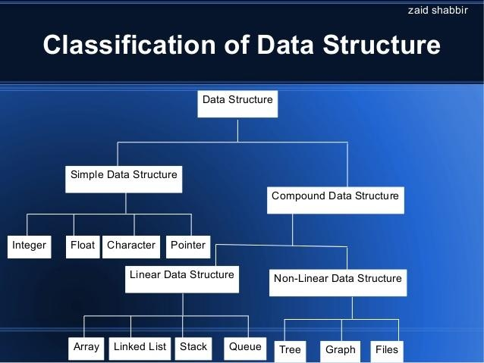
Figure 1: Classification of Data Structure

Figure 1 gives the complete classification of the data structure.
Primitive Data Structure: The data Structures that can be Manipulated directly by Machine Instructions are called Primitive Data Structures.
For Example, in C language, the different primitive data structures are defined using the data types such as int, float, char, double and pointers.
Non-Primitive Data structure:
The data Structures that cannot be Manipulated directly by Machine Instructions are called Non-Primitive Data Structures.
Non-Primitive data structure can be constructed with the help of any one of the primitive data structure and it is having a specific functionality. It can be designed by user. Arrays, Structure, Union, linked list, Stacks, Queue, trees, graphs etc are example for non primitive data structures.
It can be classified as
1) Linear data structure
2) Non-linear data structure
Linear Data Structures:
Linear data structures can be constructed as a continuous arrangement of data elements in the memory. In linear data structure the elements are stored in sequential order. In the linear Data Structures the relationship of adjacency is maintained between the Data elements .It can be represented by using array data type or linked list. The linear data structures are:
- Array: Array is a collection of data of same data type stored in consecutive memory location and is referred by common name
- Stack: A stack is a Last-In-First-Out linear data structure in which insertion and deletion takes place at only one end called the top of the stack.
- Queue: A Queue is a First in First-Out Linear data structure in which insertions takes place one end called the rear and the deletions takes place at one end called the Front.
- Linked list: Linked list is a collection of data of same data type but the data items need not be stored in consecutive memory locations.
Non Linear Data Structures
Non-linear data structure can be constructed as a collection of randomly distributed set of data item joined together by using a special pointer (tag). In non-linear Data structure the relationship of adjacency is not maintained between the Data items. Elements are stored based on the hierarchical relationship among the data. The following are some of the Non-Linear data structure
- Trees: Trees are used to represent data that has some hierarchical relationship among the data elements.(as shown in figure 2)
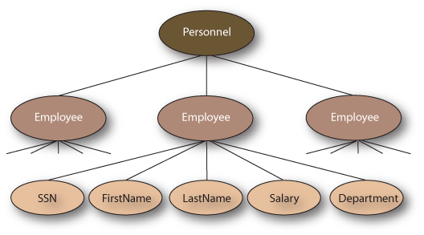
Figure 2: Trees
- Graph: Graph is used to represent data that has relationship between pair of elements not necessarily hierarchical in nature. For example electrical and communication networks, airline routes, flow chart, graphs for planning projects.(as shown in figure 3)
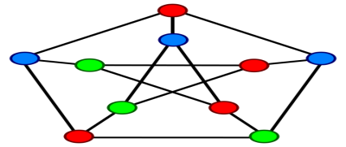

Figure 3: Graph

DATA STRUCTURE OPERATIONS
The data in the data structures are processed by certain operations. The particular data structure chosen largely depends on the frequency of the operation that needs to be performed on the data structure.

- Traversing
- Searching
- Insertion
- Deletion
- Sorting
- Merging

(1) Traversing: Accessing each record exactly once so that certain items in the record may be processed.
(2) Searching: Finding the location of a particular record with a given key value, or finding the location of all records which satisfy one or more conditions.
(3) Inserting: Adding a new record to the structure.
(4) Deleting: Removing the record from the structure.
(5) Sorting: Managing the data or record in some logical order (Ascending or descending order).
(6) Merging: Combining the record in two different sorted files into a single sorted file.

Operations on linear data structures
- Add an element
- Delete an element
- Traverse all the elements
- Sort the list of elements
- Search for a data element
Apply one or more functionality to create different types of data structures.
For example Stack, Queue, and Linked Lists.

Operations applied on non-linear data structures
The following list of operations applied on non-linear data structures.
1. Add elements.
2. Delete elements
3. Display the elements
4. Sort the list of elements
5. Search for A data element by applying one or more functionalities and different ways of joining randomly distributed data items to create different types of data structures. For example Tree, Graphs and Files.

