MODULE-2
STACKS AND QUEUES
TOPICS
TOPICS
Stacks: Definition, Stack Operations, Array Representation of Stacks, Stacks using Dynamic Arrays, Stack Applications: Polish notation, Infix to postfix conversion, evaluation of postfix expression.
Recursion - Factorial, GCD, Fibonacci Sequence, Tower of Hanoi, Ackerman's function.
Queues: Definition, Array Representation, Queue Operations, Circular Queues, Circular queues using Dynamic arrays, Dequeues, Priority Queues, A Mazing Problem. Multiple Stacks and Queues. Programming Examples.
STACK
“Stack is an ordered collection of elements or items of same type can be inserted and deleted at only one end called Top of stack”.
(OR)
STACK is an ordered-list in which insertions (called push) and deletions (called pop) are made at one end called the top. Since last element inserted into a stack is first element removed, a stack is also known as a LIFO list (Last In First Out). Stack can be implemented using the Linked List or Array.
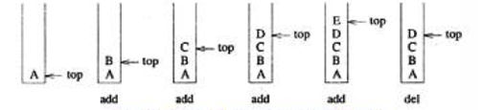
Figure 1: insertion and deletion of elements from the stack
Stack is LIFO Structure i,e Last in First Out as shown in figure 1.
example, we can place or remove a card or plate from top of the stack only.

Figure 2: stack of cards and plates
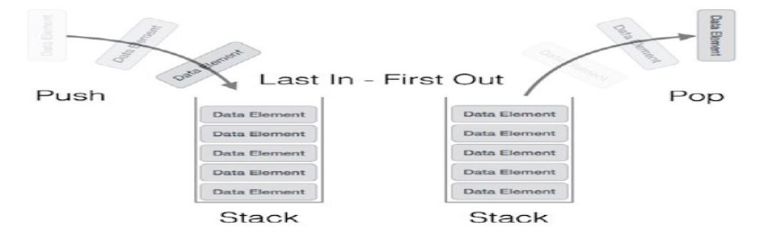
Figure 3: stack representation
Figure 2 shows the example stacks and figure 3 shows stack representation indicting LIFO operation.
STACK BASIC OPERATIONS
Stack operations may involve initializing the stack, using it and then de-initializing it. Apart from these basic stuffs, a stack is used for the following two primary operations −
- push() − pushing (storing / inserting) an element on the stack.
- pop() − removing (accessing/ deleting) an element from the stack.
When data is pushed onto stack, to use a stack efficiently we need to check status of stack as well. For the same purpose, the following functionality is added to stacks
- peek() − get the top data element of the stack, without removing it.
- isFull() − check if stack is full or overflow.
- isEmpty() − check if stack is empty or underflow.
At all times, we maintain a pointer to the last pushed data on the stack. As this pointer always represents the top of the stack, hence named top. The top pointer provides top value of the stack without actually removing it.

PUSH Operation
The process of putting a new data element onto stack is known as PUSH Operation. Push operation involves series of steps −
- Step 1 − Check if stack is full.
- Step 2 − If stack is full, produce error and exit.
- Step 3 − If stack is not full, increment top to point next empty space.
- Step 4 − Add data element to the stack location, where top is pointing.
- Step 5 − return success.
if linked-list is used to implement stack, then in step 3, we need to allocate space dynamically. Push operation is shown in figure 5.

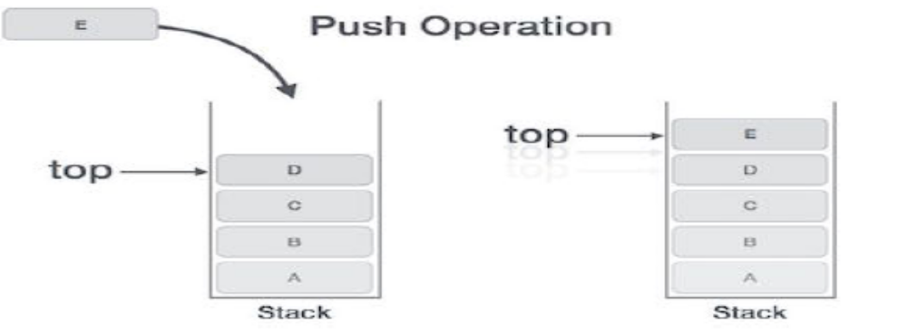
Figure 5: Push operation

POP Operation
Accessing the content while removing it from stack, is known as pop operation. In array implementation of pop() operation, data element is not actually removed, instead top is decremented to a lower position in stack to point to next value. But in linked-list implementation, pop() actually removes data element and deallocates memory space. Pop operation is shown in figure6.
A POP operation may involve the following steps −
- Step 1 − Check if stack is empty.
- Step 2 − If stack is empty, produce error and exit.
- Step 3 − If stack is not empty, access the data element at which top is pointing.
- Step 4 − Decrease the value of top by 1.
- Step 5 − return success.
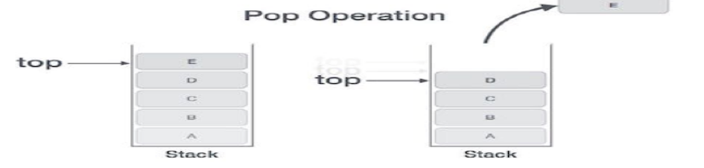
Figure 6: pop operation
Implementation of Stacks using Arrays
#include<stdio.h>
#define stacksize 5

// function to insert an element into the stack
void push(int item, int *top, int s[ ])
{
if(*top = = stacksize -1)
{
printf(“Stack overflow\n”);
return;
}
*top = *top + 1;
s[*top] = item;
}

// function to delete an element from the stack
int pop(int *top, int s[ ])
{
int item;
if(*top = = -1)
{
return -1;
}
item = s[*top];
*top = *top - 1;
return(item);
}

// function to display the contents of a stack
void display(int top, int s[])
{
int i;
if(top = = -1)
{
printf(“Stack is empty\n”);
return;
}
printf(“Contents of the stack are\n”);
for(i = 0; i< = top; i + +)
{
printf(“%d\n”, s[i]);
}

}

void main( )
{
int top, choice, item, s[stacksize], y;
top = -1;
for(;;)
{
printf(“1.Push 2.Pop 3.Display 4.Exit\n”);
printf(“Enter your choice\n”);
scanf(“%d”, &choice);
switch(choice)
{
case 1: printf(“Enter element to insert\n”);
scanf(“%d”, &item);
push(item,&top, s);
break;
case 2: y = pop(&top, s);
if(y = = -1)
printf(“Stack underflow\n”);
else
printf(“item deleted = %d\n”, y);
break;
case 3: display(top, s);
break;
case 4: exit(0);
}
}
}

Other Stack Functions
// function to check if the stack is full
void isfull(int top)
{
if(top = = stacksize -1)
{
printf(“Stack is full\n”);
}
else
{
printf(“Stack is not full\n”);
}
}
// function to check if the stack is empty
void isempty(int top)
{
if(top = = -1)
{
printf(“Stack is empty\n”);
}
else
{
printf(“Stack is not empty\n”);
}
}

Design, Develop and Implement a menu driven Program in C for the following operations on STACK of Integers (Array Implementation of Stack with maximum size MAX)
a. Push an Element on to Stack
b. Pop an Element from Stack
c. Demonstrate how Stack can be used to check Palindrome
d. Demonstrate Overflow and Underflow situations on Stack
e. Display the status of Stack
f. Exit
Support the program with appropriate functions for each of the above operations.

#include<stdlib.h>
#include<stdio.h>
#include<string.h>
#define max_size 5

int stack[max_size],top = -1;
void push();
void pop();
void display();
void pali();
int main()
{
int choice;
while(choice)
{
printf("\n\n--------STACK OPERATIONS-----------\n");
printf("1.Push\n");
printf("2.Pop\n");
printf("3.Palindrome\n");
printf("4.Display\n");
printf("5.Exit\n");
printf("-----------------------");
printf("\nEnter your choice:\t");
scanf("%d",&choice);
switch(choice)
{
case 1:
push();
break;
case 2:
pop();
break;
case 3:
pali();
break;
case 4:
display();
break;
case 5:
exit(0);
break;
default:
printf("\nInvalid choice:\n");
break;
}
}
return 0;
}

void push() //Inserting element into the stack
{
int item,n;
if(top==(max_size-1))
{
printf("\nStack Overflow:");
}
else
{
printf("Enter the element to be inserted:\t");
scanf("%d",&item);
top=top+1;
stack[top]=item;
}

}

void pop() //deleting an element from the stack
{
int item;
if(top==-1)
{
printf("Stack Underflow:");
}
else
{

printf("\nThe poped element: %d\t",stack[top--]); }

}
void pali()
{
int digit,j,k,len=top+1,flag=0,ind=0 ,length = 0;
int num[len],rev[len],i=0;
while(top!=-1)
{
digit= stack[top];
num[i]=digit;
top--;
i++;
}
for(j=0;j<len;j++)
{
printf("Numbers= %d\n",num[j]);
}
printf("reverse operation : \n");
for(k=len-1;k>=0;k--)
{
rev[k]=num[ind];
ind++;
}
printf("reverse array : ");
for(k=0;k<len;k++)
{
printf("%d\n",rev[k]);
}
printf("check for palindrome :\n");

for(i=0;i<len;i++)
{
if(num[i]==rev[i])
{
length = length+1;
}
}
if(length==len)
{
printf("It is palindrome number\n");
}
else
{
printf("It is not a palindrome number\n");
}
top = len-1;
}

void display()
{
int i;
if(top==-1)
{
printf("\nStack is Empty:");
}
else
{
printf("\nThe stack elements are:\n" );
for(i=top;i>=0;i--)
{
printf("%d\n",stack[i]);
}

}

}
APPLICATIONS OF STACKS
- Stack is used by compilers to check for balancing of parentheses, brackets and braces.
- Stack is used to evaluate a postfix expression.
- Stack is used to convert an infix expression into postfix/prefix form.
- In recursion, all intermediate arguments and return values are stored on the processor’s stack.
- During a function call the return address and arguments are pushed onto a stack and on return they are popped off.
Expressions
An algebraic expression is a legal combination of operators and operands. Operand isthe quantity on which a mathematical operation is performed. Operand may be a variable like x, y, z or a constant like 5, 4, 6 etc. Operator is a symbol which signifies a mathematical or logical operation between the operands. Examples of familiar operators include +, -, *, /, ^ etc.
Types of Expressions
The different types of expressions are
- Infix expression – Here an operator is in between 2 operands
EX: (a+b) / (c-d)
- Postfix (Suffix or Reverse Polish) expression – Here an operator follows the 2 operands.
EX: ab+cd-/
- Prefix (Polish) expression – Here an operator precedes the 2 operands.
EX: /+ab-cd
In both postfix and prefix expression operator and operands define correctly the order of operation.
The three important features of postfix expression are:
- The operands maintain the same order as in the equivalent infix expression.
- The parentheses are not needed to designate the expression unambiguously.
- While evaluating the postfix expression the priority of the operators is no longer relevant.
We consider five binary operations: +, -, *, / and $ or ↑ (exponentiation). For these binary operations, the following in the order of precedence (highest to lowest):
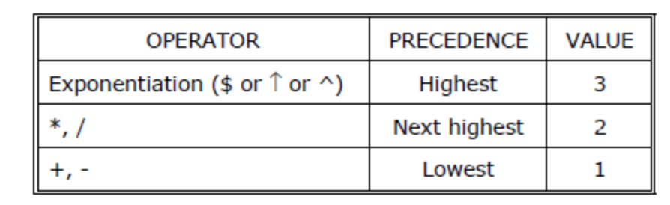
Problem 1
Convert the following infix expression to postfix and prefix
( ( 6 + ( 3 – 2 ) * 4 ) ^ 5 + 7 )

Postfix Conversion
( ( 6 + ( 3 – 2 ) * 4 ) ^ 5 + 7 ) // T1 = 3 2 -
( ( 6 + T1 * 4 ) ^ 5 + 7 ) // T2 = T1 4 *
( ( 6 + T2 ) ^ 5 + 7 ) // T3 = 6 T2 +
( T3 ^ 5 + 7 ) // T4 = T3 5 ^
( T4 + 7 ) // T5 = T4 7 +
T5
_____________________________________________
T4 7 +
T3 5 ^ 7 +
6 T2 + 5 ^ 7 +
6 T1 4 * + 5 ^ 7 +
6 3 2 - 4 * + 5 ^ 7 + (Postfix Expression)

Prefix Conversion
( ( 6 + ( 3 – 2 ) * 4 ) ^ 5 + 7 ) // T1 = - 3 2
( ( 6 + T1 * 4 ) ^ 5 + 7 ) // T2 = * T1 4
( ( 6 + T2 ) ^ 5 + 7 ) // T3 = + 6 T2
( T3 ^ 5 + 7 ) // T4 = ^ T3 5
( T4 + 7 ) // T5 = + T4 7
T5
_____________________________________________
+T4 7
+ ^ T3 5 7
+ ^ + 6 T2 5 7
+ ^ + 6 * T1 4 5 7
+ ^ + 6 * - 3 2 4 5 7 (Prefix Expression)

Problem 2
Convert the following infix expression to postfix and prefix
a + b ^ c ^ d
Postfix Conversion
a + b ^ c ^ d // T1 = c d ^
a + b ^ T1 // T2 = b T1 ^
a + T2 // T3 = a T2 +
T3
_____________________________________
a T2 +
a b T1 ^ +
a b c d ^ ^ + (Postfix Expression)

Prefix Conversion
a + b ^ c ^ d // T1 = ^ c d
a + b ^ T1 // T2 = ^ b T1
a + T2 // T3 = + a T2
T3
_____________________________________
+ a T2
+ a ^ b T1
+ a ^ b ^ c d (Prefix Expression)

Problem 3 (Scan from right to left)
Convert the prefix expression + - A B C to infix

+ - A B C T1 = A – B
+ T1 C T2 = T1 + C
T2
______________________________
T1 + C
(A – B)+ C

Problem 4 (Scan from right to left)
Convert the prefix expression + A – B C to infix
+ A – B C T1 = B – C
+ A T1 T2 = A + T1
T2
______________________________
A + T1
A + (B – C)

Problem 5 (Scan from left to right)
Convert the postfix expression A B + C - to infix
A B + C - T1 = A + B
T1 C - T1 = T1 – C
T2
______________________________
T1 – C
(A+B) -C

Problem 6 (Scan from left to right)
Convert the postfix expression A B C + - to infix
A B C + - T1 = B + C
A T1 - T2 = A - T1
T2
______________________________
A – T1
A – (B+C)

Converting expressions using Stack:
Let us convert the expressions from one type to another. These can be done as follows(Refer class notes)
1. Infix to postfix
2. Infix to prefix
3. Postfix to infix
4. Postfix to prefix
5. Prefix to infix
6. Prefix to postfix
CONVERSION FROM INFIX TO POSTFIX
Procedure to convert from infix expression to postfix expression is as follows:
- Scan the infix expression from left to right.
- a) If the scanned symbol is left parenthesis, push it onto the stack.
b) If the scanned symbol is an operand, then place directly in the postfix expression (output).
c) If the symbol scanned is a right parenthesis, then go on popping all the items from the stack and place them in the postfix expression till we get the matching left parenthesis.
d) If the scanned symbol is an operator, then go on removing all the operators from the stack and place them in the postfix expression, if and only if the precedence of the operator which is on the top of the stack is greater than (or greater than or equal) to the precedence of the scanned operator and push the scanned operator onto the stack otherwise.
Example 1:
Convert ((A – (B + C)) * D) ↑ (E + F) infix expression to postfix form:
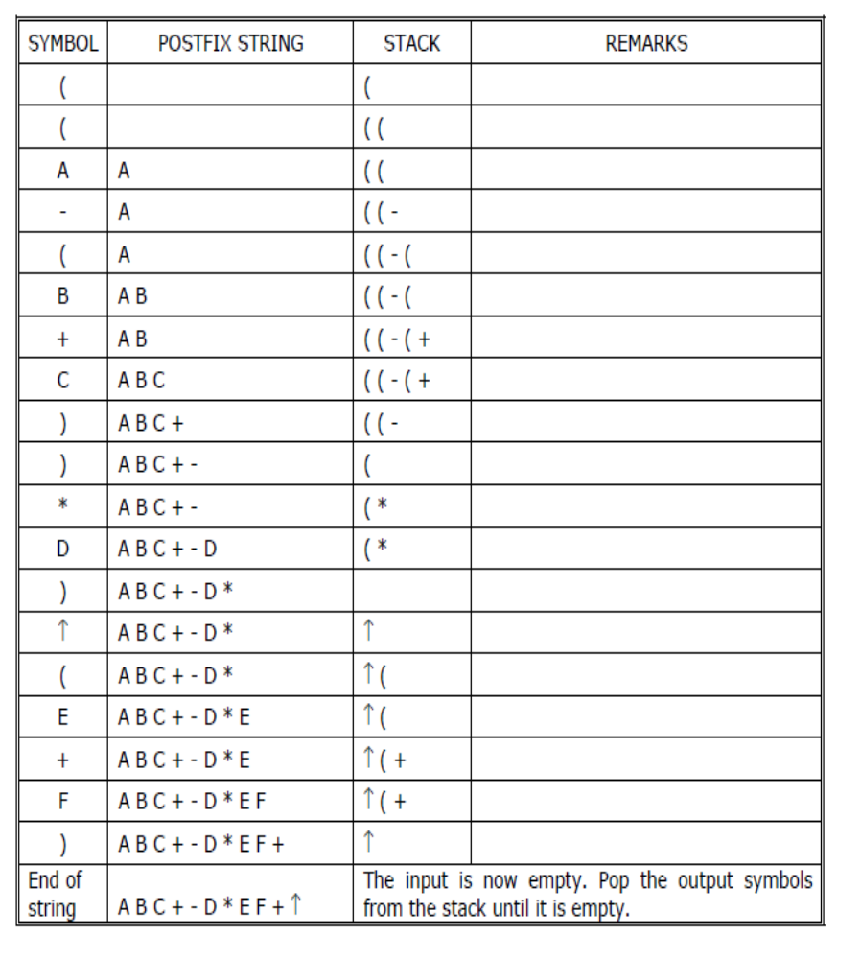
Example 2:
Convert the following infix expression A + B * C – D / E * H into its equivalent postfix
Expression
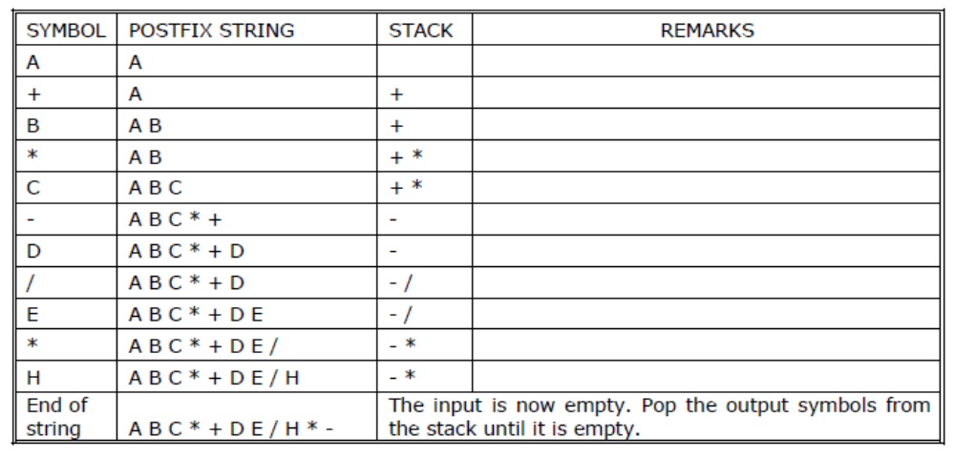
INFIX TO POSTFIX CONVERSION
Problem 1
Convert the expression ( 6 + ( 5 – 3 ) * 4 ) to postfix

Stack Contents | Scanned Symbol | Operation(Compare top of the stack and Scanned symbol) | Postfix Expression
# | ( | If the input symbol is open parenthesis then Push the symbol to stack.
# ( | 6 | 6 IS ALPHANUMERIC place in postfix expression | 6
# ( | + | 1 < 2, Push + | 6
# ( + | ( | If the input symbol is open parenthesis then Push the symbol to stack. | 6
# ( +( | 5 | 5 IS ALPHANUMERIC place in postfix expression | 65
# ( + ( | - | 1 < 2, Push - | 65
# ( + ( - | 3 | 3 IS ALPHANUMERIC place in postfix expression | 653
# ( + (- | ) | If Input symbol is closed parenthesis pop the element of the stack to postfix until open parenthesis encountered and delete the open parenthesis from stack | 653-
#(+ | * | 2 < 3 Push * | 653-
# ( + * | 4 | 4 IS ALPHANUMERIC place in postfix expression | 653-4
# ( + * | ) | If Input symbol is closed parenthesis pop the element of the stack to postfix until open parenthesis encountered and delete the open parenthesis from stack and Pop the stack until # | 653-4*+
# | End of Input |  | 653-4*+

Problem 2
Convert the expression 6 + 4 * 3 to postfix

Stack Contents | Scanned Symbol | Operation(Compare top of the stack and Scanned symbol) | Postfix Expression
# | 6 | 6 IS ALPHANUMERIC place in postfix expression | 6
# | + | 0 < 2, Push + | 6
#+ | 4 | 4 IS ALPHANUMERIC place in postfix expression | 64
# + | * | 2 < 3, Push *
# + * | 3 | 3 IS ALPHANUMERIC place in postfix expression | 643
# +* | End of Input | Pop the stack until # | 643*+

Design, Develop and Implement a Program in C for converting an Infix Expression to Postfix Expression. Program should support for both parenthesized and free parenthesized expressions with the operators: +, -, *, /, %(Remainder),^(Power) and alphanumeric operands.

#include <ctype.h>
#include <stdio.h>
#define SIZE 50 /* Size of Stack */

char s[SIZE];
int top = -1; /* Global declarations */
push(char elem) /* Function for PUSH operation */
{
s[++top] = elem;
}

char pop() /* Function for POP operation */
{
return (s[top--]);
}

int pr(char elem) /* Function for precedence */
{
switch (elem)
{
case '#':
return 0;
case '(':
return 1;
case '+':
case '-':
return 2;
case '*':
case '/':
case '%':
return 3;
case '^':
return 4;
}

}

void main() /* Main Program */
{
char infx[50], pofx[50], ch, elem;
int i = 0, k = 0;
printf("\n\nEnter the Infix Expression ");
scanf("%s", infx);
push('#');
while ((ch = infx[i++]) != '\0')
{
if (ch == '(')
push(ch);
else if (isalnum(ch))
pofx[k++] = ch;
else if (ch == ')')
{
while (s[top] != '(')
pofx[k++] = pop();
elem = pop(); /* Remove ( */
}
else /* Operator */
{
while (pr(s[top]) >= pr(ch))
pofx[k++] = pop();
push(ch);

}

}

while (s[top] != '#') /* Pop from stack till empty */
pofx[k++] = pop();
pofx[k] = '\0'; /* Make pofx as valid string */
printf("\n\nGiven Infix Expn: %s Postfix Expn: %s\n", infx, pofx);
}

EVALUATION OF POSTFIX EXPRESSION
The postfix expression is evaluated easily by the use of a stack. When a number is seen, it is pushed onto the stack; when an operator is seen, the operator is applied to the two numbers that are popped from the stack and the result is pushed onto the stack. When an expression is given in postfix notation, there is no need to know any precedence rules; this is our obvious advantage. Although infix notation is the most common way of writhing expressions, it is not the one used by compilers to evaluate expressions. Instead compilers typically use a parenthesis-free postfix notation.
Steps for evaluating postfix expression
1) Scan the symbol from left to right.
2) If the scanned-symbol is an operand, push it on to the stack.
3) If the scanned-symbol is an operator, pop 2 elements from the stack. And perform the indicated operation.
4) Push the result on to the stack.
5) Repeat the above procedure till the end of input is encountered
Pseudocode for Evaluation of Postfix Expression
While( not end of input)
{
Obtain the next input symbol
if(symbol is an operand)
push(symbol, top, s)
else
{
op2 = pop(top, s);
op1 = pop(top, s);
res = op1 op op2;
push(res, top, s);
}
}
return( pop(top, s));

Example: Consider the postfix expression 6 3 2 – 5 * + for the infix expression ( 6 + ( 3 – 2 ) * 5 ). It is evaluated as shown below.

6 3 2 – 5 * + 3 – 2 = 1
6 1 5 * + 1 * 5 = 5
6 5 + 6 + 5 = 11
Example 1: Tracing the Evaluation of the postfix expression 6 3 2 – 5 * + is as shown below
Scanned Symbol | op2 | op1 | res = op1 op op2 | Stack Contents
6 |  |  |  | 6
3 |  |  |  | 6 3
2 |  |  |  | 6 3 2
- | 2 | 3 | 3 – 2 = 1 | 6 1
5 |  |  |  | 6 1 5
* | 5 | 1 | 1 * 5 = 5 | 6 5
+ | 5 | 6 | 6 + 5 = 11 | 11
End of input |  |  |  | Return 11

Example 2: Tracing the Evaluation of the postfix expression: 6 5 2 3 + 8 * + 3 + *
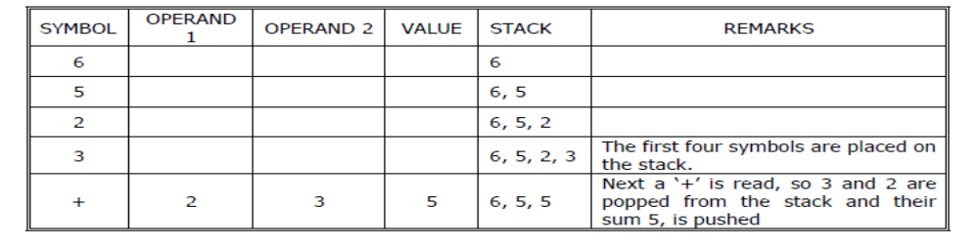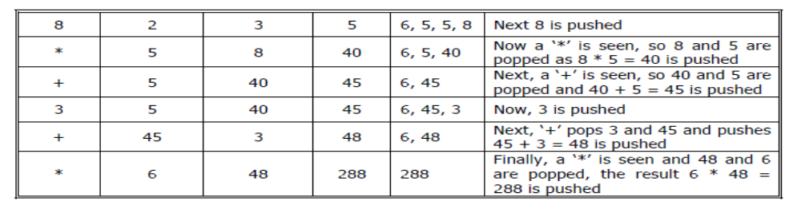
Program for Evaluation of Postfix Expression
Design, Develop and Implement a Program in C for Evaluation of Suffix expression with single digit operands and operators: +, -, *, /, %, ^
#include<stdio.h>
#include<string.h>
#include<stdlib.h>
#include<math.h>
#define MAX 50
int stack[MAX];
char post[MAX];
int top= -1;

/*FUNCTION PROTOYPE */
void pushstack(int tmp);
void calculator(char c);
void main()
{
int i;
printf("Insert a postfix notation :: ");
scanf("%s",post);
for(i=0;i<strlen(post);i++)
{
if(post[i]>='0' && post[i]<='9')
{
pushstack(i);
}
if(post[i]=='+' || post[i]=='-' || post[i]=='*' || post[i]=='/' || post[i]=='^')
{
calculator(post[i]);
}
}
printf("\n\nResult :: %d",stack[top]);
}

void pushstack(int tmp)
{
stack[++top]=(int)(post[tmp]-48);
}

void calculator(char c)
{
int a,b,ans;
a=stack[top--];
b=stack[top--];

switch(c)
{
case '+':
ans=b+a;
break;
case '-':
ans=b-a;
break;
case '*':
ans=b*a;
break;
case '/':
ans=b/a;
break;
case '^':
ans=pow(b,a);
break;
default:
ans=0;
}
top++;
stack[top]=ans;
}
Note: In the above program the symbol – ‘0’ is used to convert character to integer.
EX: ‘6’ – ‘0’ = 54 – 48 = 6
STACK USING DYNAMIC ARRAYS
Shortcoming of static stack implementation: is the need to know at compile-time, a good bound (MAX_STACK_SIZE) on how large the stack will become.
• This shortcoming can be overcome by using a dynamically allocated array for the elements & then increasing the size of the array as needed Initially, capacity=1 where capacity=maximum no. of stack-elements that may be stored in array.
Once the stack is full, realloc() function is used to increase the size of array. In array-doubling, we double array-capacity whenever it becomes necessary to increase the capacity of an array.
Stacks using Dynamic Arrays (with the concept of array doubling)

#include<stdio.h>
int capacity = 1;
int *s;
// function to insert an element into the stack
void push(int item,int *top)
{
if(*top = = capacity -1)
{
// When stack is full double the size using realloc function
s = (int *) realloc(s, 2 * capacity * sizeof(int));
capacity = capacity * 2;
}
*top = *top + 1;
s[*top] = item;
}

// function to delete an element from the stack
int pop(int *top)
{
int item;
if(*top = = -1)
{
return -1;
}
item = s[*top];
*top =*top - 1;
return(item);
}
// function to display the contents of a stack
void display(int top)
{
int i;
if(top = = -1)
{
printf(“Stack is empty\n”);
return;
}
printf(“Contents of the stack are\n”);
for(i = 0; i< = top; i + +)
{
printf(“%d\n”, s[i]);
}

}

void main( )
{
int top,choice,item, y;
top = -1;
s = (int *) malloc(sizeof(int));
for(;;)
{
printf(“1.Push 2.Pop 3.Display 4.Exit\n”);
printf(“Enter your choice\n”);
scanf(“%d”, &choice);
switch(choice)
{
case 1: printf(“Enter element to insert\n”);
scanf(“%d”, &item);
push(item,&top);
break;
case 2: y = pop(&top);
if(y = = -1)
printf(“Stack underflow\n”);
else
printf(“item deleted = %d\n”, y);
break;
case 3: display(top);
break;
free(s);
case 4: exit(0);
}
}
}

MULTIPLE STACKS AND QUEUES
Assume that we have ‘n’ stacks, we can divide the available memory into ‘n’ segments (Figure:21).Let ‘i’ = stack number of one of n stacks. Let boundary[i] (0<=i<MAX_STACKS) points to position immediately to left of bottom element of stack i, while top[i] (0<=i<MAX_STACKS) points to top element. Stack i is empty iff boundary[i]=top[i]
The relevant declaration are:
#define MEMORY_SIZE 100 /* size of memory */
#define MAX_STACKS 10 /* max number of stacks plus 1 */
element memory[MEMORY_SIZE];
int top[MAX_STACKS];
int n; /* number of stacks entered by the user */
To divide the array into equal segment, we use the following code:
top[0]=boundary[0]=-1;
for(j=1;j<n;j++)
top[j]=boundary[j]=(MEMORY_SIZE/n)*j;
boundary[n]=MEMORY_SIZE-1;
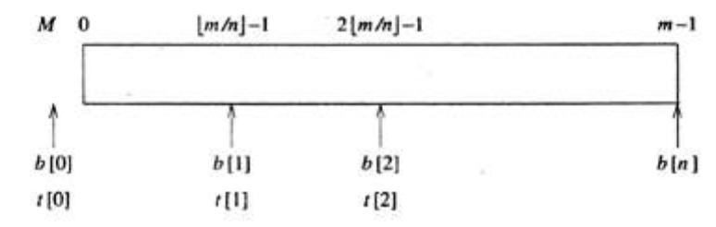
Figure 21: initial configuration for n stacks in memory
Void push(int I,element item)
{
If(top[i]==boundary[i+1])
Stackfull(i);
Memory[++top[i]]=item;
}
Element pop(int i)
{
If(top[i]==boundary[i])
Return stackempty(i);
Return memory[top[i]--];
}
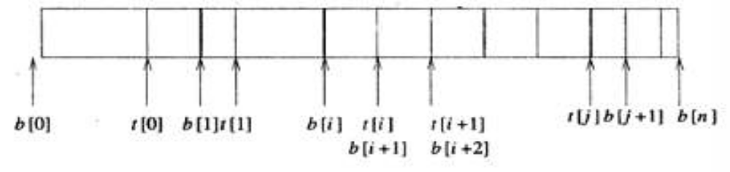
Figure 22 :configuration when stack I meets stack i+1,but the memory is not full
In push function, top[i]==boundary[i+1] condition implies only that a particular stack ran out of memory, not that the entire memory is full.(In fact, there may be a lot of unused space between other stacks in array memory).(as shown in figure 22)
Therefore, an error recovery function is created, stackFull, which determines if there is any free space in memory. If there is space available, it should shift the stacks so that space is allocated to the full stack. We can guarantee that stackFull adds elements as long as there is free space in array memory if we:
1) Determine the least j, i<j<n such that there is free space between stacks j and j+1 i.e. top[j]<boundary[j+1]. If there is such a j, then move stacks i+1,i+2 . . . . . .j one position to the right. This creates a space between stacks i and i+1.
2) If there is no j as in (i),then look to the left of stack i. Find the largest j such that 0<=j<I and there is space between stacks j and j+1 i.e. top[j]<boundary[j+1]. If there is such a j, then move stacks j+1,j+2. . . . . .i one space to the left. This also creates a space between stacks I and i+1.
3) If there is no j satisfying either (i) or (ii),then all MEMORY_SIZE spaces of memory utilized and there is no free space. In this case, stackFull terminates with an error message.

RECURSION
Recursion is the process of repeating items in a self-similar way. In programming languages, if a program allows you to call a function inside the same function, then it is called a recursive call of the function.
void recursion()
{
recursion(); /* function calls itself */
}
void main()
{
recursion();
}
The C programming language supports recursion, i.e., a function to call itself. But while using recursion, programmers need to be careful to define an exit condition from the function; otherwise it will go into an infinite loop.
Recursive functions are very useful to solve many mathematical problems, such as calculating the factorial of a number, generating Fibonacci series, etc.

FACTORIAL NUMBER
The product of the positive integers from 1 to n, inclusive is called n factorial and is usually denoted by n!
n!=1*2*3*4*………*(n-2)*(n-1)*n.
Factorial function may be defined as
a. if n=0 then n!=1
b. if n>0, then n!=n*(n-1)!
The following example calculates the factorial of a given number using a recursive function
#include <stdio.h>
int factorial(int n)
{
if(n <= 1)
{
return 1;
}
return n * factorial(n - 1);
}
void main()
{
int n;
printf(“Enter the n\n”);
scanf(“%d”,&n);
printf("Factorial of %d is %d\n", n, factorial(n));
}
When the above code is compiled and executed, it produces the following result –
OUTPUT
Enter the n:- 5
Factorial of 5 is 120

Sum of Natural Numbers
Consider the sum of series: 4+3+2+1+0
The function for finding the sum of natural numbers may be defined as
a. if n==-1 return 0
b. if n>=0, then F(n)=n+F(n-1)
The following example calculates the sum of natural numbers for the given number using a recursive function
#include <stdio.h>
int F(int n)
{
if(n <= 0)
{
return 0;
}
return n + F(n - 1);
}
void main()
{
int n;
printf(“Enter the n\n”);
scanf(“%d”,&n);
printf("Sum of natural numbers of %d is %d\n", n, F(n));
}
When the above code is compiled and executed, it produces the following result –
OUTPUT
Enter the n:- 4
Sum of natural numbers of 4 is 10

Sum of array elements
F(a,n)=a[4]+a[3]+a[2]+a[2]+a[1]+a[0]

The function for finding the sum of natural numbers may be defined as
a. if n==-1 return 0
b. if n>=0, then F(a,n)=a[n]+F(a,n-1)
The following example calculates the sum of array elements for the given number using a recursive function
#include <stdio.h>
int F(int a[],int n)
{
if(n <= 0)
{
return 0;
}
return a[n] + F(a,n - 1);
}
void main()
{
int n,i,a[20];
printf(“Enter the n\n”);
scanf(“%d”,&n);
printf(“Enter the %d items\n”);
for(i=0;i<n;i++)
scanf(“%d”,&a[i]);
printf("Sum of array elements of %d is %d\n", n, F(a,n-1));
}
When the above code is compiled and executed, it produces the following result –
OUTPUT
Enter the n:- 4
Sum of array elements of 4 is 10

GCD OF TWO NUMBERS
GCD is calculated by using GCD(m,n)=GCD(n,m mod n).
#include <stdio.h>
int gcd(int m, int n);
void main()
{
int n1, n2;
printf("Enter two positive integers: ");
scanf("%d %d", &n1, &n2);
printf("G.C.D of %d and %d is %d.", n1, n2, gcd(n1,n2));
}
int gcd(int m, int n)
{
if (n!=0)
return gcd(n, m%n);
else
return n;
}
Output
Enter two positive integers:
366 60
G.C.D of 366 and 60 is 6

FIBONACCI SERIES
The Fibonacci sequence is the sequence of integers, where each number in this sequence is the sum of two preceding elements.
A formal definition is
- If n=0 or 1,then F_{n}=n
- If n>1,then Fn=Fn+1+Fn+2
#include <stdio.h>
int fib(int i)
{
if(i == 0)
{
return 0;
}
if(i == 1)
{
return 1;
}
return fib(i-1) + fib(i-2);
}
void main()
{
int i;
for (i = 0; i < 10; i++)
{
printf("%d\t", fib(i));
}
}
When the above code is compiled and executed, it produces the following result −
0 1 1 2 3 5 8 13 21 34

TOWER OF HANOI PROBLEM
Tower of Hanoi, is a mathematical puzzle which consists of three tower (pegs) and more than one rings; as depicted in below figure 7
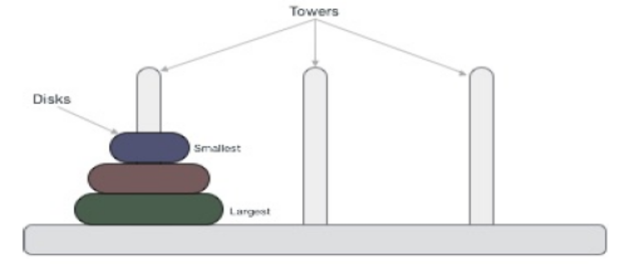
Figure 7: Tower of Hanoi

These rings are of different sizes and stacked upon in ascending order i.e. the smaller one sits over the larger one. There are other variations of puzzle where the number of disks increase, but the tower count remains the same.
Rules
The mission is to move all the disks to some another tower without violating the sequence of arrangement. The below mentioned are few rules which are to be followed for tower of hanoi −
- Only one disk can be moved among the towers at any given time.
- Only the "top" disk can be removed.
- No large disk can sit over a small disk.
Here is an animated representation in figure 8 of solving a tower of hanoi puzzle with three disks −Tower of hanoi puzzle with n disks can be solved in minimum 2n−1 steps. This presentation shows that a puzzle with 3 disks has taken 23−1 = 7 steps.
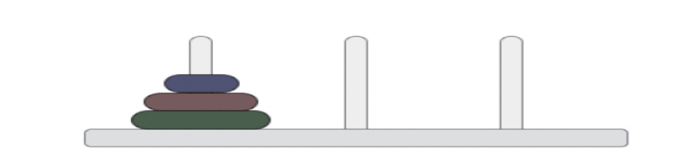
Figure 8: Tower of Hanoi
Algorithm
To write an algorithm for Tower of Hanoi, first we need to learn how to solve this problem with lesser amount of disks, say → 1 or 2. We mark three towers with name, source, destination and aux (only to help moving disks). If we have only one disk, then it can easily be moved from source to destination peg.
If we have 2 disks −
- First we move the smaller one (top) disk to aux peg
- Then we move the larger one (bottom) disk to destination peg
- And finally, we move the smaller one from aux to destination peg.
So now we are in a position to design algorithm for Tower of Hanoi with more than two disks. We divide the stack of disks in two parts. The largest disk (nthdisk) is in one part and all other (n-1) disks are in second part. Our ultimate aim is to move disk n from source to destination and then put all other (n-1) disks onto it. Now we can imagine to apply the same in recursive way for all given set of disks.
So steps to follow are −
- Step 1 − Move n-1 disks from source to aux
- Step 2 − Move nth disk from source to dest
- Step 3 − Move n-1 disks from aux to dest

A recursive algorithm for Tower of Hanoi can be driven as follows −
START
Procedure Hanoi(disk, source, dest, aux)
IF disk == 0, THEN
move disk from source to dest
ELSE
Hanoi(disk - 1, source, aux, dest) // Step 1
move disk from source to dest // Step 2
Hanoi(disk - 1, aux, dest, source) // Step 3
END IF
END Procedure
STOP

PROGRAM:
#include <stdio.h>
void towers(int, char, char, char);
int main()
{
int num;
printf("Enter the number of disks : ");
scanf("%d", &num);
printf("The sequence of moves involved in the Tower of Hanoi are :\n");
towers(num, 'A', 'C', 'B');
return 0;
}

void towers(int num, char frompeg, char topeg, char auxpeg)
{
if (num == 1)
{
printf("\n Move disk 1 from peg %c to peg %c", frompeg, topeg);
return;
}
towers(num - 1, frompeg, auxpeg, topeg);
printf("\n Move disk %d from peg %c to peg %c", num, frompeg, topeg);
towers(num - 1, auxpeg, topeg, frompeg);
}
SAMPLE OUTPUT:
Enter the number of disks : 3

The sequence of moves involved in the Tower of Hanoi are :
Move disk 1 from peg A to peg C

Move disk 2 from peg A to peg B

Move disk 1 from peg C to peg B

Move disk 3 from peg A to peg C

Move disk 1 from peg B to peg A

Move disk 2 from peg B to peg C

Move disk 1 from peg A to peg C

