**HOME PAGE**

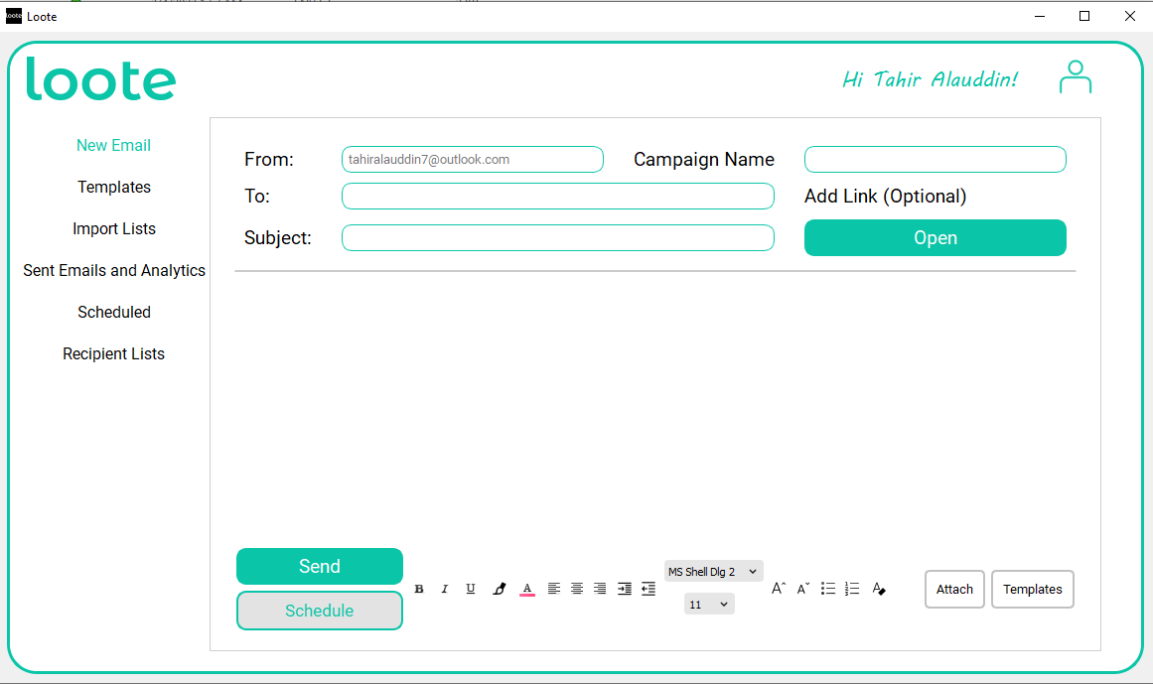

**ADD LINK WINDOW**

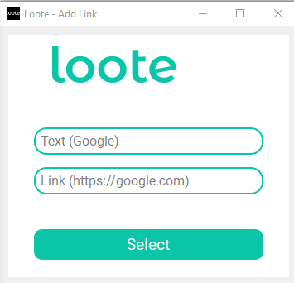

**TEMPLATE PAGE**

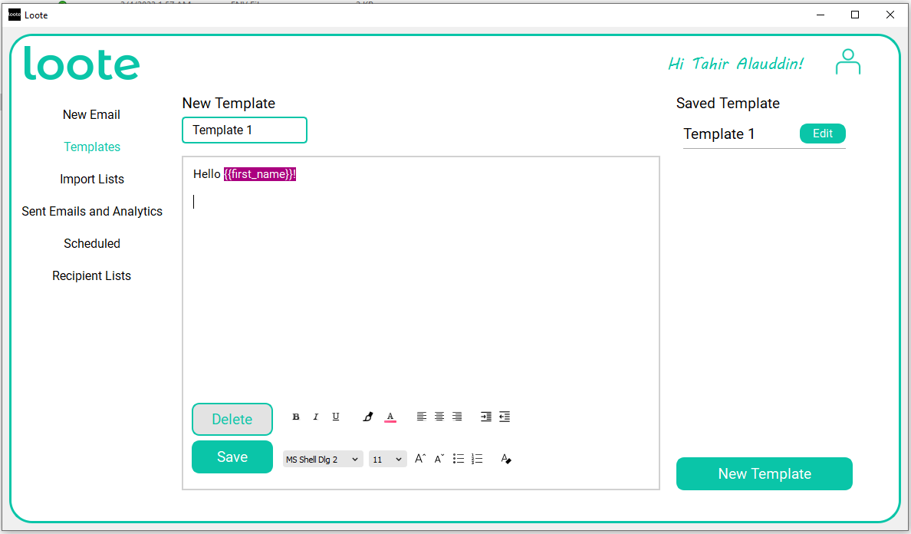

**IMPORT LIST PAGE**

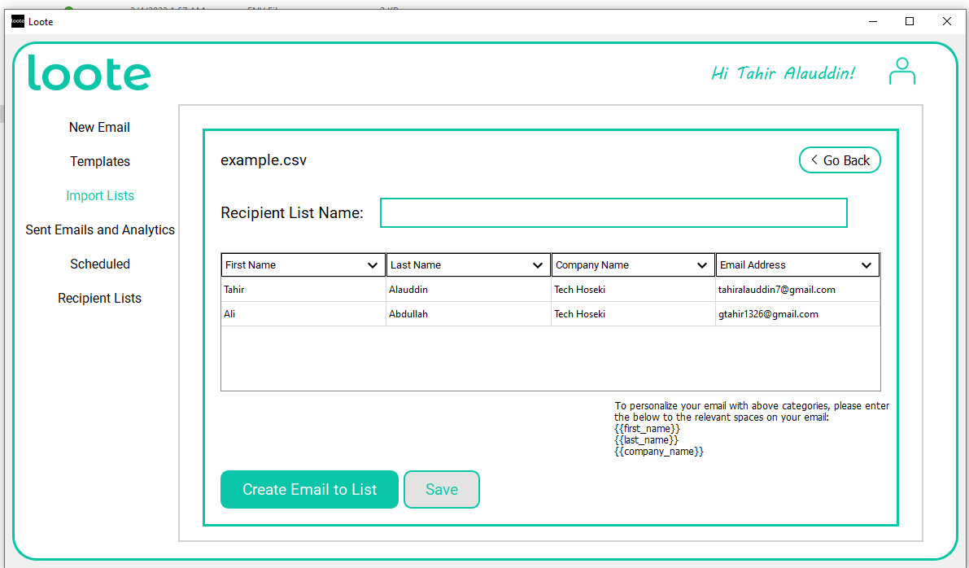

**IMPORT LIST PAGE 2**

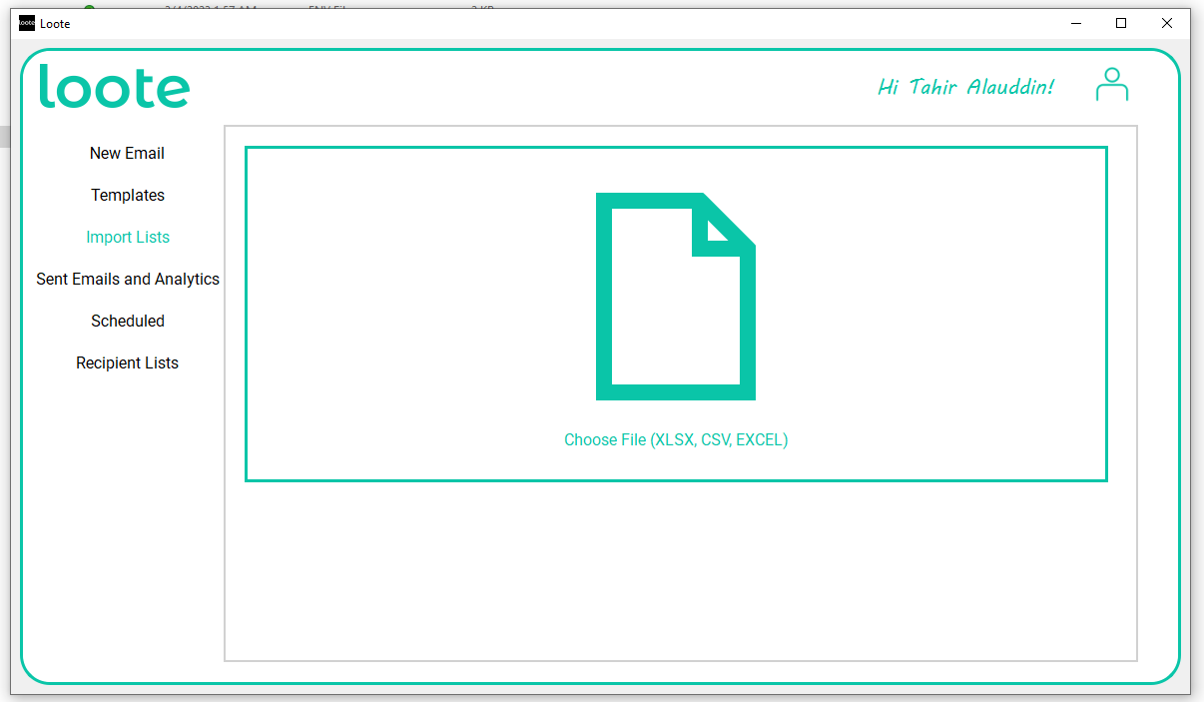

**ANALYTICS PAGE**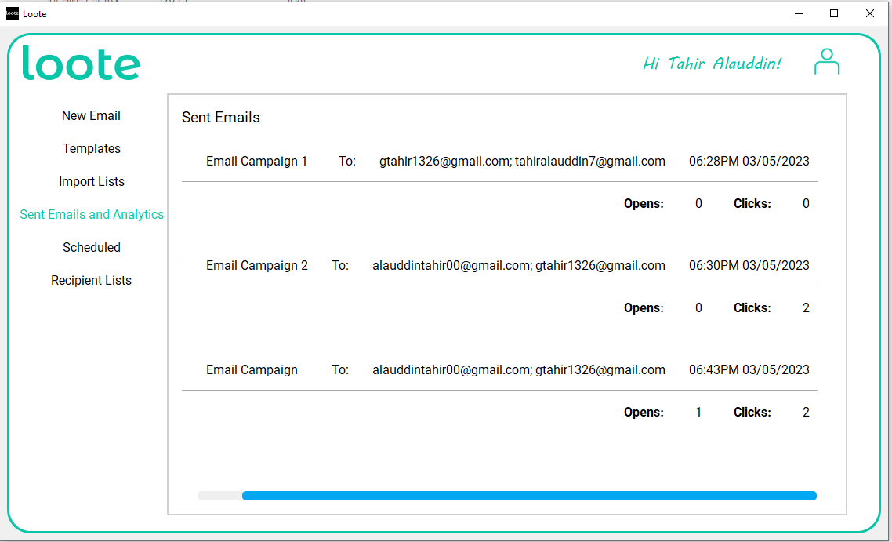

**SCHEDULED EMAILS PAGE**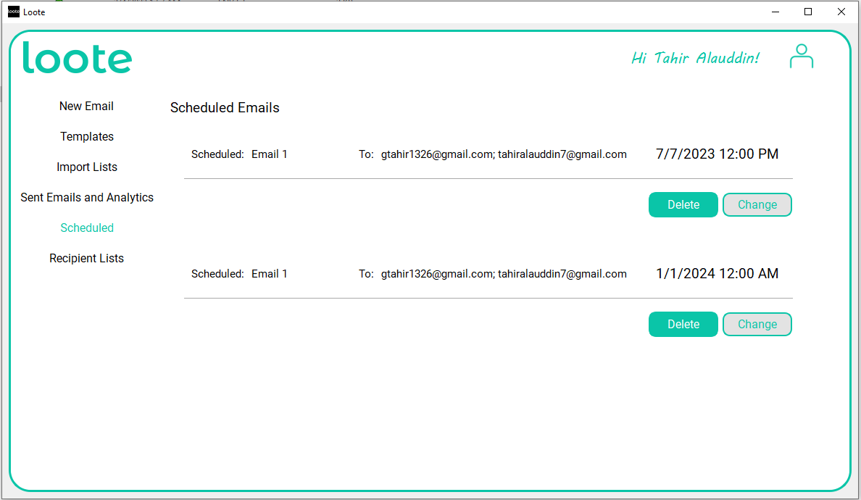

**RECIPIENT LIST PAGE**

