


[LAB # 01] [MACHINE LEARNING]
[DATA CLEANING WITH PANDAS]

Karachi Campus

LAB EXPERIMENT NO.
01
LISTOF TASKS
TAS K  NO | OBJECTIVE
1. | SOLVE THE TASKS ON “PAKISTANI SUCIDAL ATTACKS” DATASET.
2. | SOLVE THE TASKS ON "NFL Play by Play 2009-2017 (v4).csv” DATASET.

Submitted On: 10/09/2025
(Date: DD/MM/YY)

[NAME: Umair Latif [ENROLL: 02-131232-002]

[LAB # 01] [MACHINE LEARNING]
[DATA CLEANING WITH PANDAS]
TASK # 01:
SOLVE THE FOLLOWING TASKS:
SOLUTION:
- Take a look at all the unique values in the "Province" column in suisides_attacks dataset. Then convert the column to lowercase and remove any trailing white spaces.
CODE:
print("Unique Provinces before cleaning:") print(sucide_attacks['Province'].unique())
sucide_attacks['Province'] = sucide_attacks['Province'].str.lower().str.strip() print("\nUnique Provinces after cleaning:") print(sucide_attacks['Province'].unique())

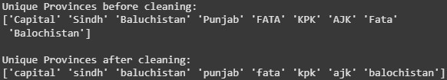
- In "Province" Column 'Balochistan' and 'Baluchistan' should be the same province so correct this inconsistency in the Province column.
CODE:
sucide_attacks['Province'] = sucide_attacks['Province'].replace({'baluchistan': 'balochistan'}) print("Unique Provinces after merging balochistan/baluchistan:") print(sucide_attacks['Province'].unique())

[NAME: TAHIR HAMEED [ENROLL: 02-131232-106]

[LAB # 01] [MACHINE LEARNING]
[DATA CLEANING WITH PANDAS]
- In Province column "FATA' and 'Fata' should be considered same so correct this inconsistency as well.
CODE:
sucide_attacks['Province'] = sucide_attacks['Province'].replace({'fata ': 'FATA'}) print("Unique Provinces after fixing fata:") print(sucide_attacks['Province'].unique())

- In suisides_attacks dataset type of 'Longitude' column should be numeric rather than 'Object'. Parse this value from Object to Numeric and show graphical representation using seaborn library.
CODE:
sucide_attacks['Longitude'] = pd.to_numeric(sucide_attacks['Longitude'], errors='coerce') print("Longitude dtype:", sucide_attacks['Longitude'].dtype) sns.histplot(sucide_attacks['Longitude'].dropna(), bins=50, kde=True) plt.title("Distribution of Longitude values")
plt.xlabel("Longitude") plt.ylabel("Frequency ") plt.show()

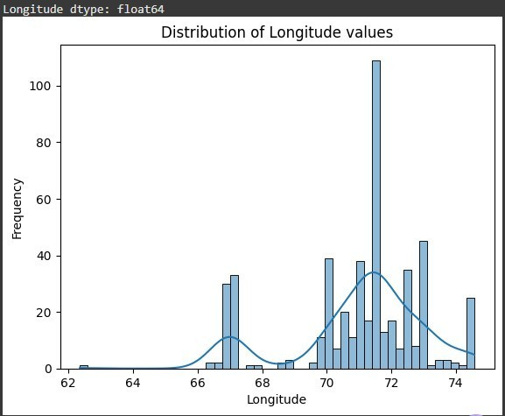

[NAME: TAHIR HAMEED [ENROLL: 02-131232-106]

[LAB # 01] [MACHINE LEARNING]
[DATA CLEANING WITH PANDAS]
5. It looks like 'karma agency' and 'kurram agency' should be the same City column. Correct the dataframe so that they are considered same.
CODE:
sucide_attacks['City'] = sucide_attacks['City'].str.lower().str.strip() sucide_attacks['City'] = sucide_attacks['City'].replace({'karma agency': 'kurram agency'})
print("\nCities after cleaning (sample):", sucide_attacks['City'].unique()[:20])

TASK # 02:
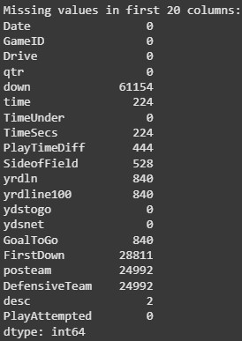
SOLVE THE FOLLOWING TASKS:
SOLUTION:
1. Get the count of missing values in first twenty columns.
CODE:
first_20_cols = nfl_play.iloc[:, :20] missing_counts = first_20_cols.isnull().sum() print("Missing values in first 20 columns:") print(missing_counts)
[NAME: TAHIR HAMEED [ENROLL: 02-131232-106]

[LAB # 01] [MACHINE LEARNING]
[DATA CLEANING WITH PANDAS]
- Get the percentage of data missing in this dataset.
CODE:
total_missing = nfl_play.isnull().sum().sum() total_cells = nfl_play.size
percent_missing = (total_missing / total_cells) * 100 print(f"Percentage of data missing: {percent_missing:.2f}%")

- Take a look at the # of missing points in the columns ranging from 20 to 30.
CODE:
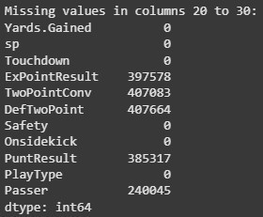
cols_20_30 = nfl_play.iloc[:, 20:31] missing_in_range = cols_20_30.isnull().sum() print("Missing values in columns 20 to 30:") print(missing_in_range)

- Try removing all the rows from this dataset that contain missing values. How many are left?
CODE:
nfl_play_no_rows_missing = nfl_play.dropna() rows_left, cols_left = nfl_play_no_rows_missing.shape
print(f"After removing rows with missing values: {rows_left} rows and
{cols_left} columns left")
print(f"Rows removed: {nfl_play.shape[0] - rows_left}")

[NAME: TAHIR HAMEED [ENROLL: 02-131232-106]

[LAB # 01] [MACHINE LEARNING]
[DATA CLEANING WITH PANDAS]
- Now try removing all the columns with empty values. Now how much of your data is left?
CODE:
nfl_play_no_empty_cols = nfl_play.dropna(axis=1, how='all') rows_left, cols_left = nfl_play_no_empty_cols.shape
print(f"After removing columns with empty values: {rows_left} rows and
{cols_left} columns left")
print(f"Columns removed: {nfl_play.shape[1] - cols_left}")

- Try replacing all the Nan's in this data with the one that comes directly after it and then replacing any remaining Nan's with 0.
CODE:
df_imputed = nfl_play.ffill().fillna(0)
print(f"NaNs left: {df_imputed.isnull().sum().sum()}") print(f"Shape: {df_imputed.shape}")

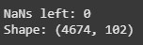

[NAME: TAHIR HAMEED [ENROLL: 02-131232-106]



[LAB # 02] [MACHINE LEARNING]
[EDA]

Karachi Campus

LAB EXPERIMENT NO.
02
LIST OFTASKS
TAS K  NO | OBJECTIVE
1. | DATA PROFILING OF DIABETES DATASET.
2. | FEATURE CORRELATION OF DIABETES DATASET.
3. | OUTLIER DETECTION OF DIABETES DATASET.
4. | TARGET VARIABLE ANALYSIS OF DIABETES DATASET.

Submitted On: 17/09/2025
(Date: DD/MM/YY)

[NAME:Umair Latif] [ENROLL: 02-131232-002]

[LAB # 02] [MACHINE LEARNING]
[EDA]
TASK # 01:
DATA PROFILING OF DIABETES DATASET.
SOLUTION:
- Perform a basic data profiling to understand the structure of the dataset, including the number of rows, columns, and data types.
CODE:
import pandas as pd import numpy as np
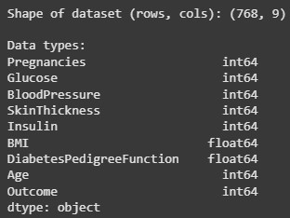
diabetes = pd.read_csv("/content/diabetes.csv") print("Shape of dataset (rows, cols):", diabetes.shape) print("\nData types:") print(diabetes.dtypes)

- Identify the target variable and the predictor variables.
CODE:
target = "Outcome"
predictors = [col for col in diabetes.columns if col != target]

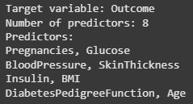
print("Target variable:", target) print("Number of predictors:", len(predictors)) print("Predictors:")
for i in range(0, len(predictors), 2): print(", ".join(predictors[i:i+2]))
[NAME:TAHIR HAMEED] [ENROLL: 02-131232-106]

[LAB # 02] [MACHINE LEARNING]
[EDA]
- Compute summary statistics (mean, median, standard deviation, etc.) for each numerical variable.
CODE:
summary_stats = pd.DataFrame({
"Mean": diabetes.mean(),"Median": diabetes.median(), "Standard Deviation": diabetes.std()})
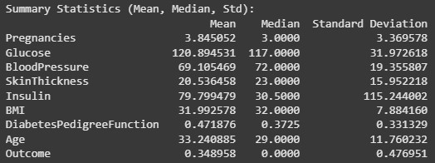
print("Summary Statistics (Mean, Median, Std):") print(summary_stats)

- Identify missing values and their distribution across variables.
CODE:
missing_counts = diabetes.isnull().sum() missing_percent = (missing_counts / len(diabetes)) * 100 print(pd.DataFrame({
"MissingCount": missing_counts,"MissingPercent": missing_percent
}))

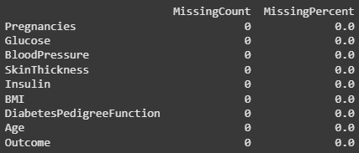

[NAME:TAHIR HAMEED] [ENROLL: 02-131232-106]

[LAB # 02] [MACHINE LEARNING]
[EDA]
TASK # 02:
FEATURE CORRELATION OF DIABETES DATASET.
SOLUTION:
1. Calculate pairwise correlation coefficients between all numerical variables.
CODE:
corr = diabetes.corr() print("Pairwise correlation matrix:") print(corr)

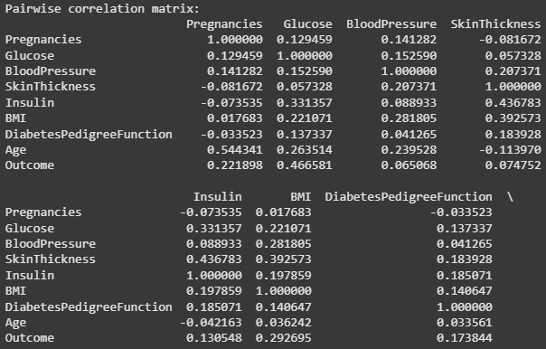

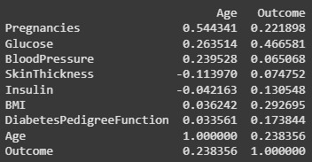

[NAME:TAHIR HAMEED] [ENROLL: 02-131232-106]

[LAB # 02] [MACHINE LEARNING]
[EDA]
- Create a correlation matrix and visualize it using a heatmap.
CODE:
import seaborn as sns
import matplotlib.pyplot as plt plt.figure(figsize=(8,6))
sns.heatmap(corr, annot=True, cmap="coolwarm", fmt=".2f") plt.title("Correlation Heatmap")
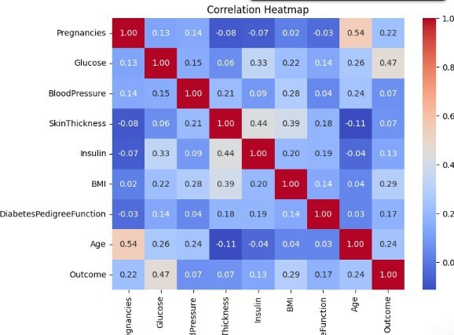
plt.show()

- Identify highly correlated variables and discuss their potential impact on model performance.
CODE:
corr = diabetes.corr() threshold = 0.75 high_corr_pairs = [
(c1, c2, corr.loc[c1, c2]) for i, c1 in
enumerate(corr.columns) for j, c2 in enumerate(corr.columns)
if i < j and abs(corr.loc[c1, c2]) >= threshold
[NAME:TAHIR HAMEED] [ENROLL: 02-131232-106]

[LAB # 02] [MACHINE LEARNING]
[EDA]
]
print("Highly correlated pairs (|corr| >= 0.75):") print(high_corr_pairs if high_corr_pairs else "None found")

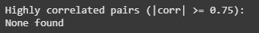
TASK # 03:
OUTLIER DETECTION OF DIABETES DATASET.
SOLUTION:
1. Identify potential outliers in the dataset using appropriate techniques, such as box plots, scatter plots.
CODE:
import matplotlib.pyplot as plt plt.figure(figsize=(6,3))
for i, col in enumerate(diabetes.columns[:- 1]): Q1 = diabetes[col].quantile(0.25) Q3 = diabetes[col].quantile(0.75)
IQR = Q3 - Q1
lower = Q1 - 1.5 * IQR upper
= Q3 + 1.5 * IQR
outliers = (diabetes[col] < lower) | (diabetes[col] > upper) normal = ~outliers
plt.scatter([i]*normal.sum(), diabetes.loc[normal, col], color="blue", alpha=0.6, s=20)
plt.scatter([i]*outliers.sum(), diabetes.loc[outliers, col], color="red", alpha=0.8, s=20) plt.xticks(range(len(diabetes.columns[:-1])), diabetes.columns[:-1], rotation=45)
plt.title("Scatter Plot of All Features with Outliers Highlighted") plt.ylabel("Values")
plt.legend(["Normal", "Outlier"]) plt.show()
[NAME:TAHIR HAMEED] [ENROLL: 02-131232-106]

[LAB # 02] [MACHINE LEARNING]
[EDA]
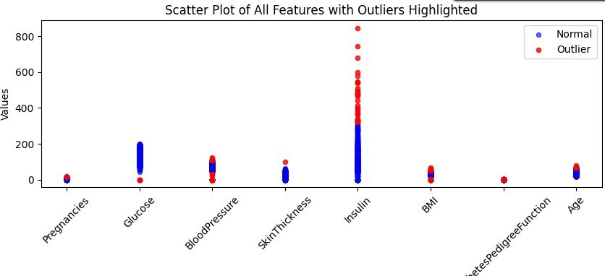
2. Visualize the distribution of each numerical variable to identify any extreme values.
CODE:
import matplotlib.pyplot as plt plt.figure(figsize=(10,3)) diabetes.drop(columns=["Outcome"]).boxplot() plt.title("Boxplot")
plt.xticks(rotation=45) plt.show()

plt.figure(figsize=(7,3))
for col in diabetes.columns[:-1]:
plt.hist(diabetes[col], bins=20, alpha=0.5, label=col) plt.title("Histogram") plt.xlabel("Value")
plt.ylabel("Frequency") plt.legend()
plt.show()
[NAME:TAHIR HAMEED] [ENROLL: 02-131232-106]

[LAB # 02] [MACHINE LEARNING]
[EDA]
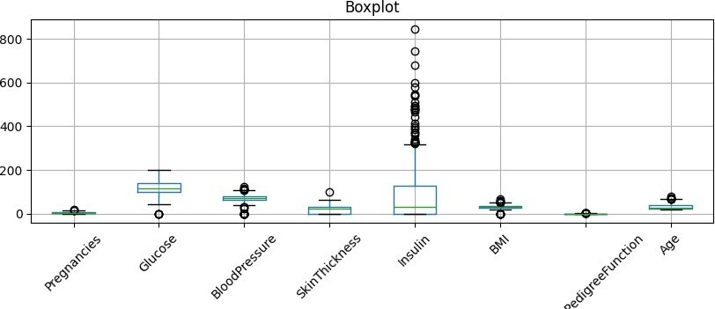
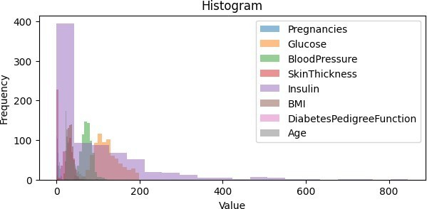
3. Discuss the potential impact of outliers on the analysis and modeling process.
Outliers are values that don’t fit the usual pattern of the data. They can make averages and other statistics misleading, and in graphs they often stretch the scale, so the normal values look squeezed. For models, outliers may confuse the training process especially for methods like regression or KNN that rely on distances and averages. Even though tree-based models are less sensitive, they can still be influenced. Because of this, it’s important to spot outliers and decide whether to remove them, adjust them, or keep them if they are genuine values.
[NAME:TAHIR HAMEED] [ENROLL: 02-131232-106]

TASK # 04:
TARGET VARIABLE ANALYSIS OF DIABETES DATASET.

SOLUTION:
- Analyze the distribution of the target variable (diabetes or non-diabetes).

CODE:
print("Target distribution (0=Non-diabetes, 1=Diabetes):") print(diabetes["Outcome"].value_counts())

- Visualize the target variable distribution using a histogram or a bar chart.

CODE:
diabetes["Outcome"].value_counts().plot(kind="bar", color=["pink","maroon"]) plt.title("Diabetes Outcome Distribution") plt.xlabel("Outcome (0=No Diabetes, 1=Diabetes)") plt.ylabel("Count")
plt.show()

- Identify any potential imbalance in the target variable and discuss its impact on model performance.

CODE:
counts = diabetes["Outcome"].value_counts() imbalance_ratio = counts.min() / counts.max() print(f"Imbalance ratio:
{imbalance_ratio:.2f}") if imbalance_ratio < 0.8:
print("Dataset is Imbalanced.") else:
print("Dataset is balanced.")

Karachi Campus

LAB EXPERIMENT NO.
03
LISTOF TASKS
TAS K NO | OBJECTIVE
1. | Write a python program on the given dataset and implement linear regression to check best fit line.
2. | Write a linear Regression based python program to analyze the following dataset and give the result.

Submitted On: 24/09/2025
(Date: DD/MM/YY)

TASK # 01:
Write a python program on the given dataset and implement linear regression to check best fit line.

SOLUTION:
CODE:
import pandas as pd import numpy as np import seaborn as sns
import matplotlib.pyplot as plt
from sklearn.model_selection import train_test_split from sklearn.linear_model import LinearRegression from sklearn import metrics

data = pd.read_csv("/content/Real estate.csv") feature = data[['X2 house age']]
target = data['Y house price of unit area']

X_train_set, X_test_set, y_train_set, y_test_set = train_test_split( feature, target, test_size=0.2, random_state=42
)

regressor = LinearRegression() regressor.fit(X_train_set, y_train_set)

predictions = regressor.predict(X_test_set)

print("Intercept:", regressor.intercept_) print("Coefficient:", regressor.coef_[0])

r2_score_value = metrics.r2_score(y_test_set, predictions)
rmse_value = np.sqrt(metrics.mean_squared_error(y_test_set, predictions))

print(f"R² Score: {r2_score_value:.4f}")
print(f"Root Mean Squared Error: {rmse_value:.4f}")

plt.figure(figsize=(8, 3))
sns.scatterplot(x=X_test_set.squeeze(), y=y_test_set, color='blue', label='Actual') sns.lineplot(x=X_test_set.squeeze(), y=predictions, color='red', label='Predicted') plt.xlabel('House Age') plt.ylabel('House Price per Unit Area')
plt.title('Simple Linear Regression: House Price vs House Age') plt.legend()

plt.show()

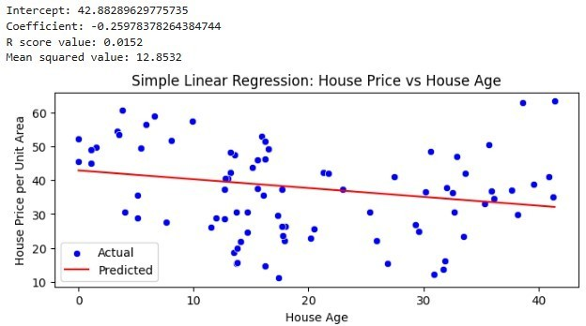
OUTPUT:

TASK # 02:
Write a linear Regression based python program to analyze the following dataset and give the result.

SOLUTION: CODE:
import pandas as pd import numpy as np import seaborn as sns
import matplotlib.pyplot as plt
from sklearn.model_selection import train_test_split from sklearn.linear_model import LinearRegression from sklearn import metrics

records = {

}

"PaymentTotal": [36.66, 37.05, 34.71, 32.5, 32.63, 34.45, 36.79, 37.44, 38.09,
38.09, 38.74, 39.00, 40.00, 36.21, 34.05, 41.79, 30.25, 38.83, 39.66],
"MilesTotal": [390, 403, 396.5, 383.5, 321.1, 391.3, 386.1, 371.8, 404.3,
392.6, 386.49, 395.2, 385.50, 372, 397, 407, 372.33, 375.6, 399]

df_data = pd.DataFrame(records) print(df_data.head()) feature_col = df_data[['MilesTotal']]
target_col = df_data['PaymentTotal']

X_train_set, X_test_set, y_train_set, y_test_set = train_test_split( feature_col, target_col, test_size=0.2, random_state=42
)

regressor = LinearRegression() regressor.fit(X_train_set, y_train_set)

pred_output = regressor.predict(X_test_set)

r2_value = metrics.r2_score(y_test_set, pred_output)
rmse_value = np.sqrt(metrics.mean_squared_error(y_test_set, pred_output))

print(f"Intercept: {regressor.intercept_:.4f}") print(f"Coefficient: {regressor.coef_[0]:.4f}") print(f"R² Score: {r2_value:.4f}") print(f"RMSE:
{rmse_value:.4f}")

plt.figure(figsize=(7, 3))
sns.scatterplot(x=X_test_set.squeeze(), y=y_test_set, color='blue', label='Actual') sns.lineplot(x=X_test_set.squeeze(), y=pred_output, color='red', label='Predicted') plt.xlabel('Total Miles') plt.ylabel('Total Payment')
plt.title('Linear Regression: Payment vs Miles') plt.legend()
plt.grid(True) plt.show()

OUTPUT:
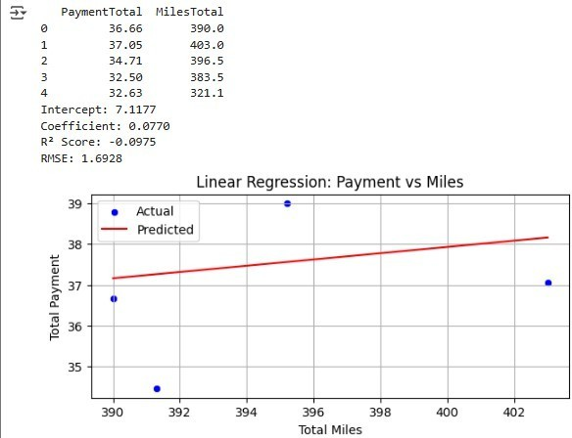

BAHRIA UNIVERSITY
Karachi Campus


LAB EXPERIMENT NO.
04
LISTOFTASKS
Task NO | objective
01 | You are a data analyst working for a healthcare organization, and your task is to predict the likelihood of diabetes in patients using logistic regression in Python. The goal is to identify high risk individuals to enable early intervention and better management of diabetes.

Task 01
You are a data analyst working for a healthcare organization, and your task is to predict the likelihood of diabetes in patients using logistic regression in Python. The goal is to identify high risk individuals to enable early intervention and better management of diabetes.

code
import pandas as pd
from sklearn.model_selection import train_test_split from sklearn.linear_model import LogisticRegression
from sklearn.metrics import accuracy_score, confusion_matrix, classification_report import warnings warnings.filterwarnings('ignore') url =
"/content/diabetesdata.csv"
column_names = ['preg', 'plas', 'pres', 'skin', 'test', 'mass', 'pedi', 'age', 'class'] df = pd.read_csv(url, names=column_names)

print("--- First 5 rows of the dataset ---") print(df.head()) print("\n")
X = df.iloc[:, :-1]
y = df.iloc[:, -1]

X_train, X_test, y_train, y_test = train_test_split(X, y, test_size=0.2, random_state=42) print(f"--- Data Split ---") print(f"Training set size: {X_train.shape[0]} samples") print(f"Testing set size:
{X_test.shape[0]} samples") print("\n")

model = LogisticRegression() model.fit(X_train, y_train)
print("--- Model Training Complete ---")
print("A logistic regression model has been trained on the diabetes dataset.") print("\n")

y_pred = model.predict(X_test)

accuracy = accuracy_score(y_test, y_pred) conf_matrix = confusion_matrix(y_test, y_pred) class_report = classification_report(y_test, y_pred)
print("--- Model Evaluation Results ---") print(f"Accuracy:
{accuracy:.2f}") print("\nConfusion Matrix:") print(conf_matrix) print("\nClassification Report:") print(class_report)
hypothetical_patient = [[6, 148, 72, 35, 0, 33.6, 0.627, 50]] prediction = model.predict(hypothetical_patient) prediction_proba = model.predict_proba(hypothetical_patient)
print("\n--- Example Prediction for a New Patient ---") print(f"Patient Data:
{hypothetical_patient[0]}") if prediction[0] == 1:
print("Prediction: High risk of diabetes.") else: print("Prediction: Low risk of diabetes.")
print(f"Probability [No Diabetes, Has Diabetes]: {prediction_proba}")

output
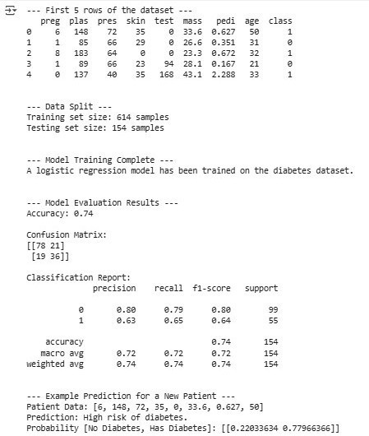

BAHRIA UNIVERSITY
Karachi Campus

LAB EXPERIMENT NO.
05
LISTOFTASKS

Task NO | objective
01 | Write a python program on the given dataset and implement KNN for multiple labels and plot your result.
02 | Implement KNN without using Sklearn Library

Task 01
Write a python program on the given dataset and implement KNN for multiple labels and plot your result.

code
import pandas as pd
import matplotlib.pyplot as plt
from sklearn.model_selection import train_test_split from sklearn.neighbors import KNeighborsClassifier from sklearn.metrics import accuracy_score import seaborn as sns

url = "/content/fruits_dataset.csv" fruits_df = pd.read_csv(url)

print("--- First 5 rows of the dataset ---") print(fruits_df.head()) print("\n--- Dataset Information ---") fruits_df.info()
print("\n")

X = fruits_df[['mass', 'width', 'height', 'color_score']] y = fruits_df['fruit_name']

X_train, X_test, y_train, y_test = train_test_split(X, y, test_size=0.25, random_state=42) print(f"--- Data Split ---") print(f"Training set size: {X_train.shape[0]} samples") print(f"Testing set size:
{X_test.shape[0]} samples") print("\n")

k = 5
knn = KNeighborsClassifier(n_neighbors=k) knn.fit(X_train, y_train) print(f"--- KNN Model (k={k}) Training Complete ---\n")
y_pred = knn.predict(X_test)
accuracy = accuracy_score(y_test, y_pred)

print("--- Model Evaluation ---") print(f"Predictions on the test set:
{y_pred}")
print(f"Actual labels of the test set: {y_test.values}") print(f"Accuracy of the KNN classifier is: {accuracy:.2f}\n")

fruit_to_color = { 'apple': 0, 'mandarin': 1,
'orange': 2,

'lemon': 3
}
colors = y_train.map(fruit_to_color)

print("--- Plotting Results ---") plt.figure(figsize=(10, 6))
scatter = plt.scatter(X_train['width'], X_train['height'], c=colors, cmap='viridis', alpha=0.8)

legend_labels = list(fruit_to_color.keys())
handles = [plt.Line2D([0], [0], marker='o', color='w',
markerfacecolor=scatter.cmap(scatter.norm(i)), markersize=10) for i in range(len(legend_labels))]
plt.title('Fruit Dataset: Width vs. Height (Training Data)') plt.xlabel('Width') plt.ylabel('Height') plt.legend(handles,
legend_labels) plt.grid(True) plt.show()

output
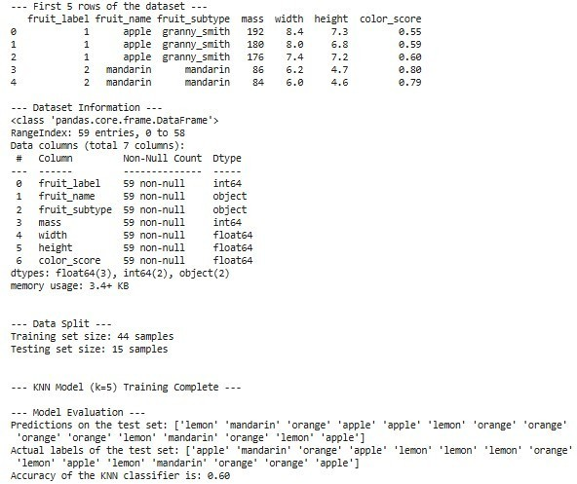

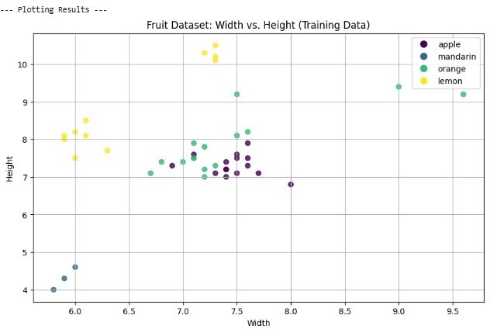

Task 02
Implement KNN without using Sklearn Library.

Code
import numpy as np
from collections import Counter

def euclidean_distance(x1, x2):
return np.sqrt(np.sum((x1 - x2)**2))

class KNN:
def init(self, k=3): self.k = k

def fit(self, X, y): self.X_train = X self.y_train = y
def predict(self, X_test):
predictions = [self._predict_single(x) for x in X_test] return np.array(predictions)

def _predict_single(self, x):
distances = [euclidean_distance(x, x_train) for x_train in self.X_train] k_neighbor_indices = np.argsort(distances)[:self.k]
k_neighbor_labels = [self.y_train[i] for i in k_neighbor_indices] most_common = Counter(k_neighbor_labels).most_common(1)
return most_common[0][0]

if name == 'main': X_train = np.array([
[158, 58], [158, 59], [158, 63], [160, 59], [160, 60],
[163, 60], [163, 61], [160, 64], [163, 64], [165, 61],

X_test = np.array([[161, 61], [167, 62]])
[165, | 62], [165, 65], | [168, | 62], [168, 63], [168, 66],
[170, | 63], [170, 64], | [170, | 68]
])  y_train = | np.array([0, 0, | 0, 0, | 0, 0, 0, 1, 1, 1, 1, 1, 1, 1, 1, 1, 1, 1])

print("--- KNN Implementation from Scratch ---\n") print(f"Training Data (X_train) has
{X_train.shape[0]} samples.") print(f"Test Data (X_test) has {X_test.shape[0]} samples.\n")

k = 3
model = KNN(k=k) model.fit(X_train, y_train)
predictions = model.predict(X_test)

print(f"--- Predictions with k={k} ---") print(f"Test data points:
{X_test.tolist()}")
print(f"Predicted labels (0=Medium, 1=Large): {predictions.tolist()}")
Output
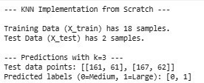

BahriaUniversity,

Karachi Campus

LAB EXPERIMENT NO.
06

LIST OF TASKS

TASKS | OBJECTIVE
01 | Write a python program to implement the support vector machine on Diabetes dataset. Implement the following different kernels of SVM and compare the accuracy score and visualize the confusion matrix and hyperplane

TASK 01
Write a python program to implement the support vector machine on Diabetes dataset. Implement the following different kernels of SVM and compare the accuracy score and visualize the confusion matrix and hyperplane

Code
import pandas as pd
import numpy as np
import matplotlib.pyplot as plt import seaborn as sns
from sklearn.model_selection import train_test_split from sklearn.preprocessing import StandardScaler from sklearn.svm import SVC
from sklearn.metrics import accuracy_score, confusion_matrix, ConfusionMatrixDisplay

# Load your uploaded CSV
df = pd.read_csv('/content/diabetes.csv')

# Show first few rows and column names print("Dataset Preview:\n", df.head()) print("\nColumns:\n", df.columns)
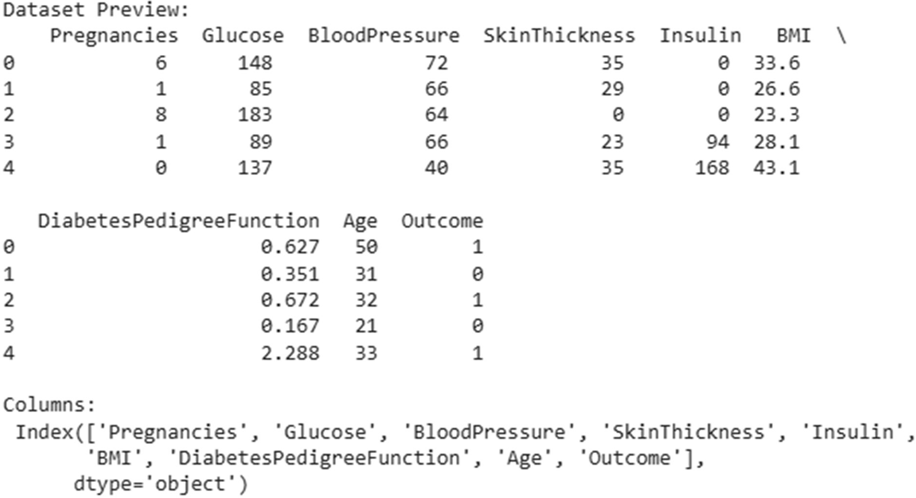

X = df.drop('Outcome', axis=1)

y = df['Outcome']

X_train, X_test, y_train, y_test = train_test_split( X, y, test_size=0.2, random_state=42
)

scaler = StandardScaler()
X_train = scaler.fit_transform(X_train) X_test
= scaler.transform(X_test)

kernels = ['linear', 'poly', 'rbf', 'sigmoid'] results
= {}

for kernel in kernels:
model = SVC(kernel=kernel, random_state=42) model.fit(X_train, y_train)
y_pred = model.predict(X_test)

acc = accuracy_score(y_test, y_pred) results[kernel] = acc

print(f"\nKernel: {kernel}") print(f"Accuracy: {acc:.4f}")

cm = confusion_matrix(y_test, y_pred)
disp = ConfusionMatrixDisplay(confusion_matrix=cm) disp.plot(cmap='Blues')
plt.title(f"Confusion Matrix ({kernel} kernel)") plt.show()

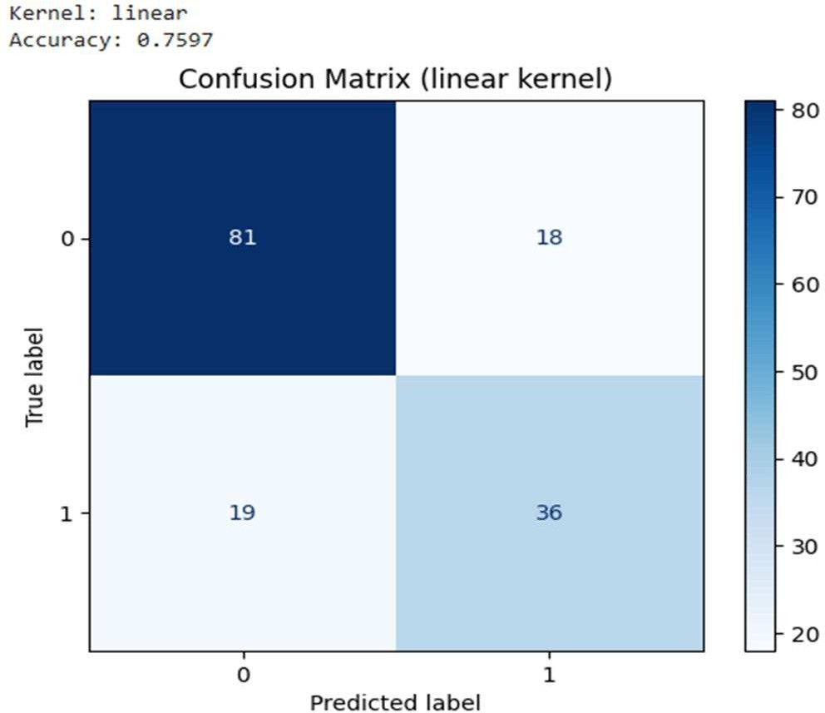
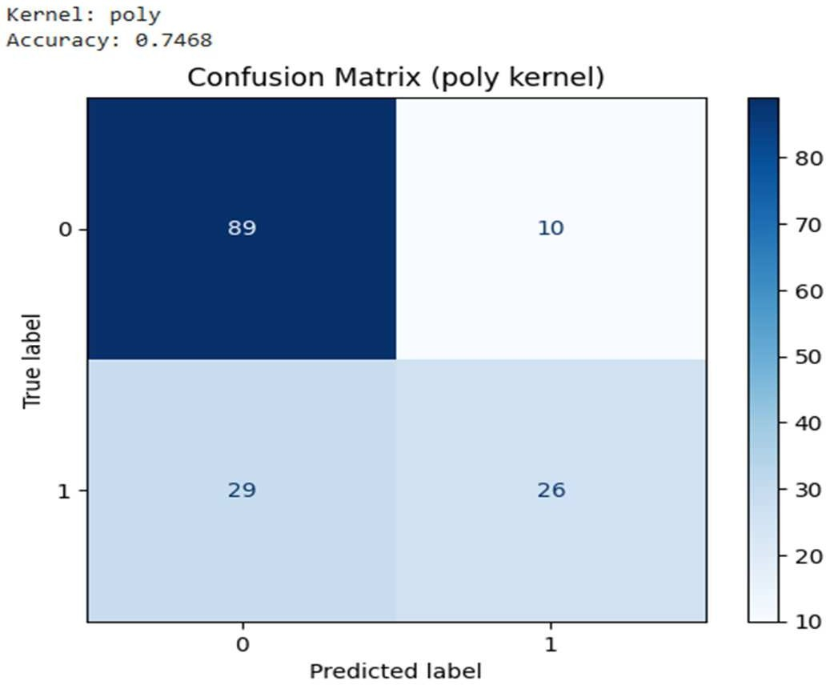

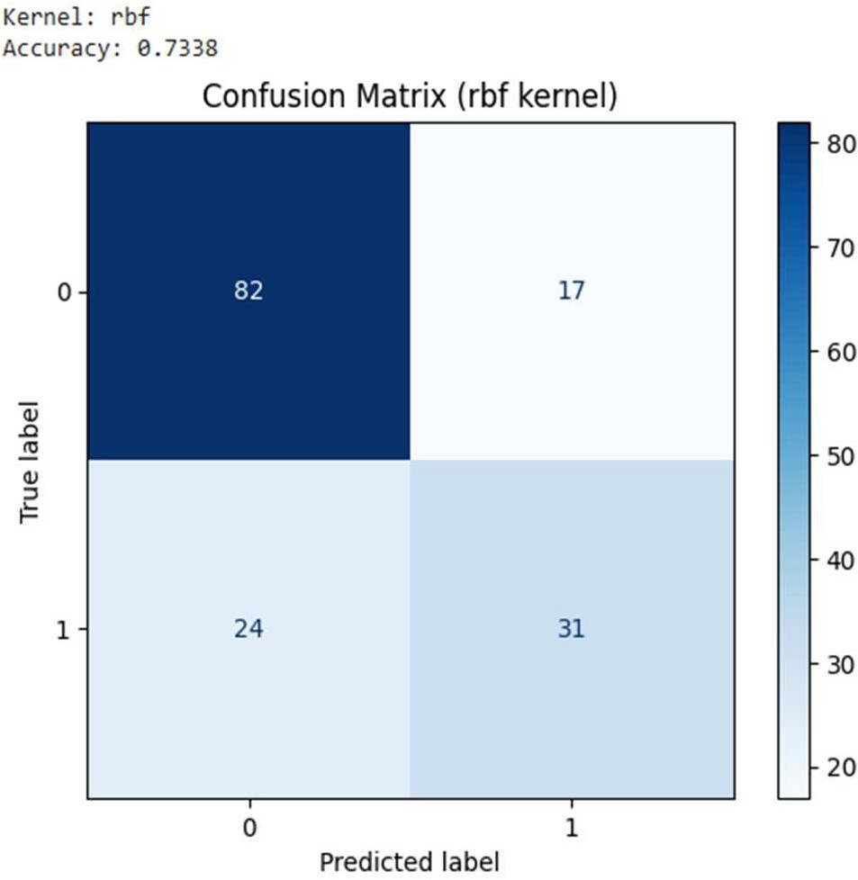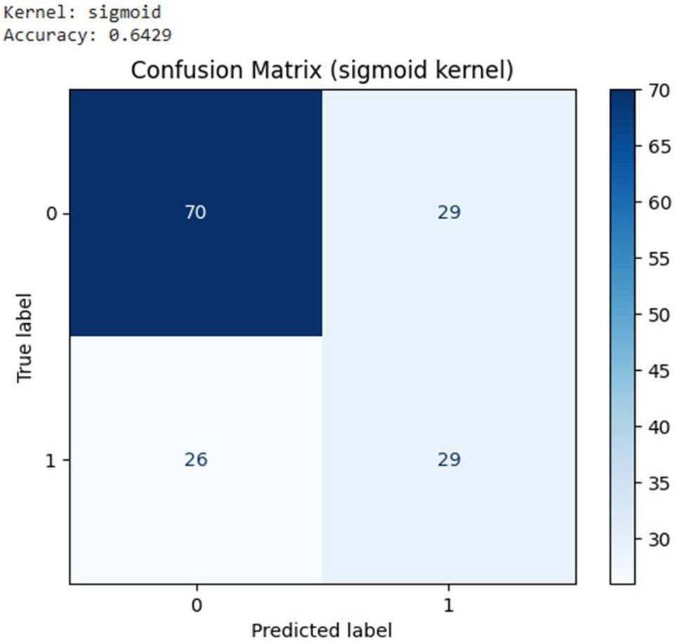

plt.figure(figsize=(6,4)) sns.barplot(x=list(results.keys()), y=list(results.values())) plt.title("SVM Kernel Accuracy Comparison") plt.xlabel("Kernel Type") plt.ylabel("Accuracy") plt.show()
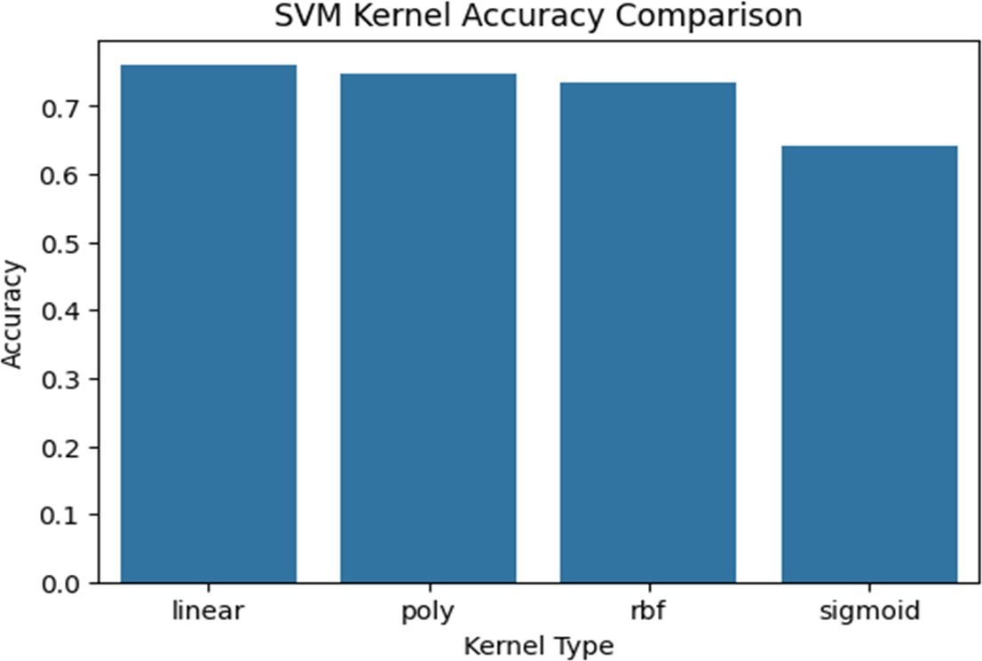

X_vis = df.iloc[:, [0, 1]].values y_vis = df['Outcome'].values

X_train_vis, X_test_vis, y_train_vis, y_test_vis = train_test_split( X_vis, y_vis, test_size=0.2, random_state=42

)

scaler = StandardScaler()
X_train_vis = scaler.fit_transform(X_train_vis) X_test_vis = scaler.transform(X_test_vis)

svm_vis = SVC(kernel='linear') svm_vis.fit(X_train_vis, y_train_vis)

# Create mesh grid
x_min, x_max = X_train_vis[:, 0].min() - 1, X_train_vis[:, 0].max() + 1 y_min, y_max = X_train_vis[:, 1].min() - 1, X_train_vis[:, 1].max() + 1 xx, yy = np.meshgrid(np.arange(x_min, x_max, 0.02),
np.arange(y_min, y_max, 0.02))
Z = svm_vis.predict(np.c_[xx.ravel(), yy.ravel()]) Z = Z.reshape(xx.shape)

plt.figure(figsize=(8,6)) plt.contourf(xx, yy, Z, alpha=0.3)
plt.scatter(X_train_vis[:, 0], X_train_vis[:, 1], c=y_train_vis, edgecolors='k') plt.title("SVM Decision Boundary (Linear Kernel)") plt.xlabel(df.columns[0]) plt.ylabel(df.columns[1])
plt.show()
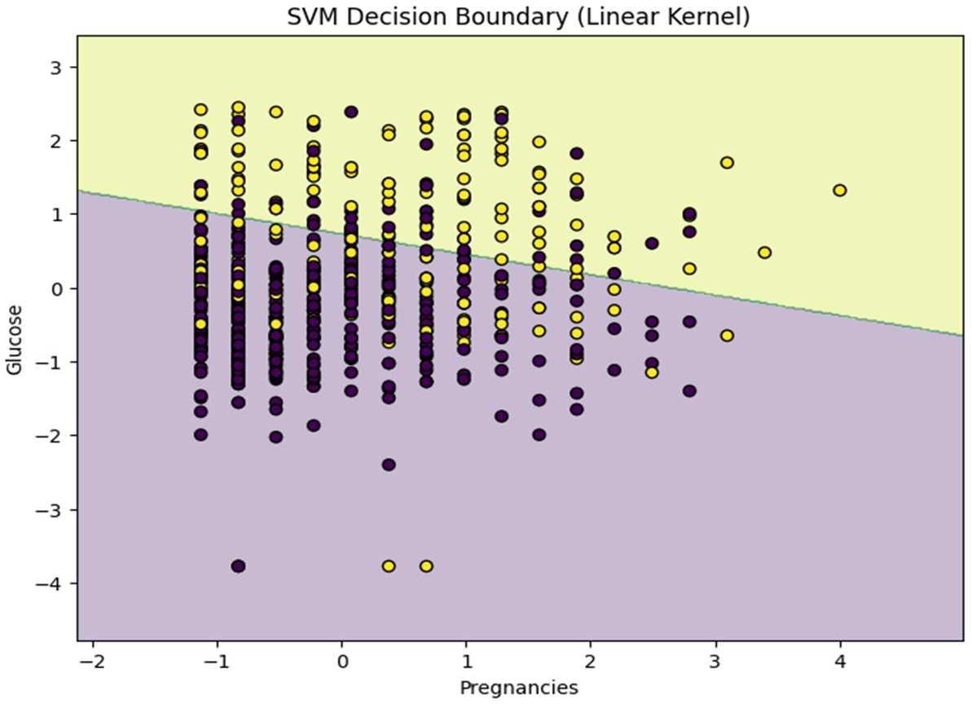

# Select first 2 features for visualization X_vis
= df.iloc[:, [0, 1]].values y_vis = df['Outcome'].values

X_train_vis, X_test_vis, y_train_vis, y_test_vis = train_test_split(

X_vis, y_vis, test_size=0.2, random_state=42
)

scaler = StandardScaler()
X_train_vis = scaler.fit_transform(X_train_vis) X_test_vis = scaler.transform(X_test_vis)

svm_vis = SVC(kernel='poly') svm_vis.fit(X_train_vis, y_train_vis)

# Create mesh grid
x_min, x_max = X_train_vis[:, 0].min() - 1, X_train_vis[:, 0].max() + 1 y_min, y_max = X_train_vis[:, 1].min() - 1, X_train_vis[:, 1].max() + 1 xx, yy = np.meshgrid(np.arange(x_min, x_max, 0.02),
np.arange(y_min, y_max, 0.02))
Z = svm_vis.predict(np.c_[xx.ravel(), yy.ravel()]) Z = Z.reshape(xx.shape)

plt.figure(figsize=(8,6)) plt.contourf(xx, yy, Z, alpha=0.3)
plt.scatter(X_train_vis[:, 0], X_train_vis[:, 1], c=y_train_vis, edgecolors='k') plt.title("SVM Decision Boundary (Poly Kernel)")
plt.xlabel(df.columns[0]) plt.ylabel(df.columns[1]) plt.show()
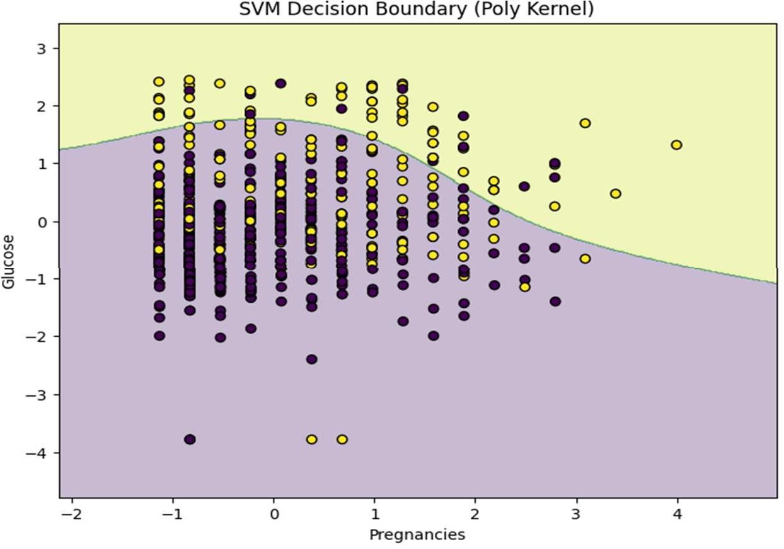

# Select first 2 features for visualization X_vis
= df.iloc[:, [0, 1]].values y_vis = df['Outcome'].values

X_train_vis, X_test_vis, y_train_vis, y_test_vis = train_test_split( X_vis, y_vis, test_size=0.2, random_state=42
)

scaler = StandardScaler()
X_train_vis = scaler.fit_transform(X_train_vis) X_test_vis = scaler.transform(X_test_vis)

svm_vis = SVC(kernel='rbf') svm_vis.fit(X_train_vis, y_train_vis)

# Create mesh grid
x_min, x_max = X_train_vis[:, 0].min() - 1, X_train_vis[:, 0].max() + 1 y_min, y_max = X_train_vis[:, 1].min() - 1, X_train_vis[:, 1].max() + 1 xx, yy = np.meshgrid(np.arange(x_min, x_max, 0.02),
np.arange(y_min, y_max, 0.02))
Z = svm_vis.predict(np.c_[xx.ravel(), yy.ravel()]) Z = Z.reshape(xx.shape)

plt.figure(figsize=(8,6)) plt.contourf(xx, yy, Z, alpha=0.3)
plt.scatter(X_train_vis[:, 0], X_train_vis[:, 1], c=y_train_vis, edgecolors='k') plt.title("SVM Decision Boundary (RBF Kernel)")
plt.xlabel(df.columns[0]) plt.ylabel(df.columns[1]) plt.show()
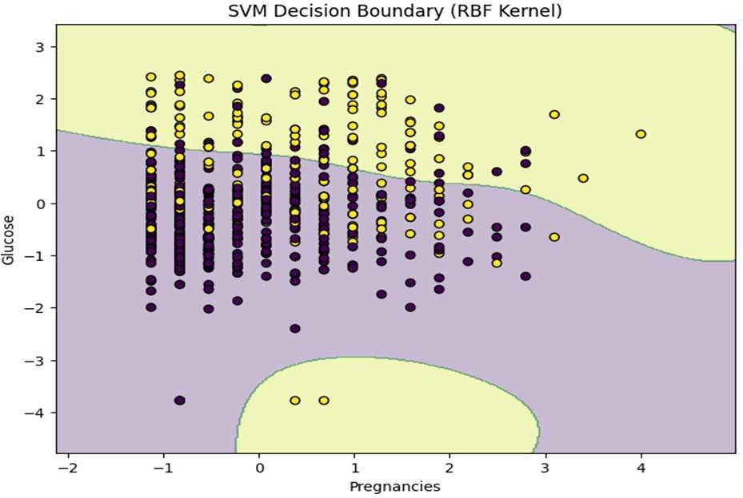

# Select first 2 features for visualization X_vis
= df.iloc[:, [0, 1]].values y_vis = df['Outcome'].values

X_train_vis, X_test_vis, y_train_vis, y_test_vis = train_test_split( X_vis, y_vis, test_size=0.2, random_state=42
)

scaler = StandardScaler()
X_train_vis = scaler.fit_transform(X_train_vis) X_test_vis = scaler.transform(X_test_vis)

svm_vis = SVC(kernel='sigmoid') svm_vis.fit(X_train_vis, y_train_vis)

# Create mesh grid
x_min, x_max = X_train_vis[:, 0].min() - 1, X_train_vis[:, 0].max() + 1 y_min, y_max = X_train_vis[:, 1].min() - 1, X_train_vis[:, 1].max() + 1 xx, yy = np.meshgrid(np.arange(x_min, x_max, 0.02),
np.arange(y_min, y_max, 0.02))
Z = svm_vis.predict(np.c_[xx.ravel(), yy.ravel()]) Z = Z.reshape(xx.shape)

plt.figure(figsize=(8,6)) plt.contourf(xx, yy, Z, alpha=0.3)
plt.scatter(X_train_vis[:, 0], X_train_vis[:, 1], c=y_train_vis, edgecolors='k') plt.title("SVM Decision Boundary (Sigmoid Kernel)") plt.xlabel(df.columns[0]) plt.ylabel(df.columns[1])
plt.show()
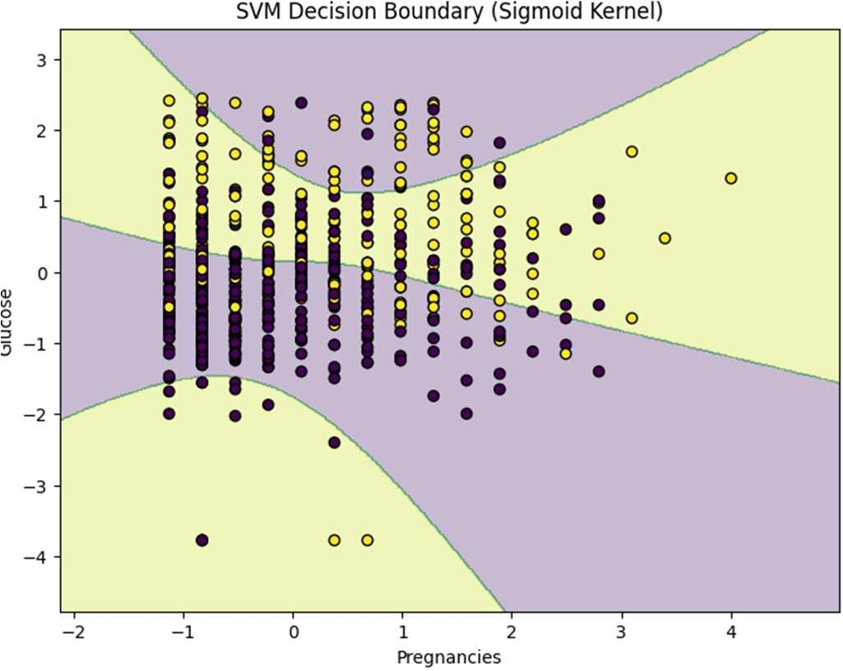

BahriaUniversity,

Karachi Campus
LAB EXPERIMENT NO.
07

LIST OF TASKS

TASKS | OBJECTIVE
01 | Using python implement Naïve Bayes with two different splitting ratios on Heart Attack Analysis & prediction dataset to  predict the chances of heart failure in a person and performed the following steps: Data Pre-processing step  Fitting Naive Bayes to the Training set Predicting the test result  Test accuracy of the result(Creation of Confusion matrix) Visualizing the test set result.  Compare the accuracies

TASK 01
Using python implement Naïve Bayes with two different splitting ratios on Heart Attack Analysis & prediction dataset to predict the chances of heart failure in a person and performed the following steps:
Data Pre-processing step
Fitting Naive Bayes to the Training set Predicting the test result
Test accuracy of the result(Creation of Confusion matrix) Visualizing the test set result.
Compare the accuracies

Code
import pandas as pd import numpy as np
import matplotlib.pyplot as plt import seaborn as sns
from sklearn.model_selection import train_test_split from sklearn.preprocessing import StandardScaler from sklearn.naive_bayes import GaussianNB
from sklearn.metrics import confusion_matrix, accuracy_score, classification_report

df = pd.read_csv('/content/heartFailureDataset.csv') print("Dataset loaded successfully.") print(df.head()) df.info()

X = df.drop('DEATH_EVENT',
axis=1) y = df['DEATH_EVENT'] results = {}

def run_naive_bayes(test_split_ratio):
print(f"\n{'='*50}")
print(f"Running Naive Bayes with a {int(test_split_ratio*100)}% Test Split") print(f"{'='*50}")

X_train, X_test, y_train, y_test = train_test_split(X, y, test_size=test_split_ratio, random_state=42) scaler = StandardScaler()

X_train_scaled = scaler.fit_transform(X_train) X_test_scaled = scaler.transform(X_test)

classifier = GaussianNB() classifier.fit(X_train_scaled, y_train) y_pred
= classifier.predict(X_test_scaled)

accuracy = accuracy_score(y_test, y_pred)
results[f'{int(100-test_split_ratio*100)}/{int(test_split_ratio*100)} Split'] = accuracy print(f"\nAccuracy: {accuracy:.4f} ({accuracy*100:.2f}%)")
cm = confusion_matrix(y_test, y_pred) print("\nConfusion Matrix:") print(cm) print("\nClassification Report:")
print(classification_report(y_test, y_pred))

plt.figure(figsize=(8, 6))
sns.heatmap(cm, annot=True, fmt='d', cmap='Blues', xticklabels=['Survived (0)', 'Died (1)'],
yticklabels=['Survived (0)', 'Died (1)'])
plt.title(f'Confusion Matrix for {int(100-test_split_ratio*100)}/{int(test_split_ratio*100)} Split') plt.xlabel('Predicted Label')
plt.ylabel('True Label') plt.show()
run_naive_bayes(test_split_ratio=0.20) run_naive_bayes(test_split_ratio=0.30)

print(f"\n{'='*50}")
print("Final Comparison of Accuracies") print(f"{'='*50}")

for split, acc in results.items():
print(f"Accuracy for {split}: {acc*100:.2f}%")

plt.figure(figsize=(8, 5)) split_ratios
= list(results.keys()) accuracies = list(results.values())
plt.bar(split_ratios, accuracies, color=['skyblue', 'lightgreen']) plt.title('Comparison of Naive Bayes Accuracies for Different Split Ratios') plt.xlabel('Train/Test Split Ratio') plt.ylabel('Accuracy Score')
plt.ylim(0, 1.0)
for i, v in enumerate(accuracies):
plt.text(i, v + 0.02, f"{v:.4f}", ha='center', fontweight='bold') plt.show()

