

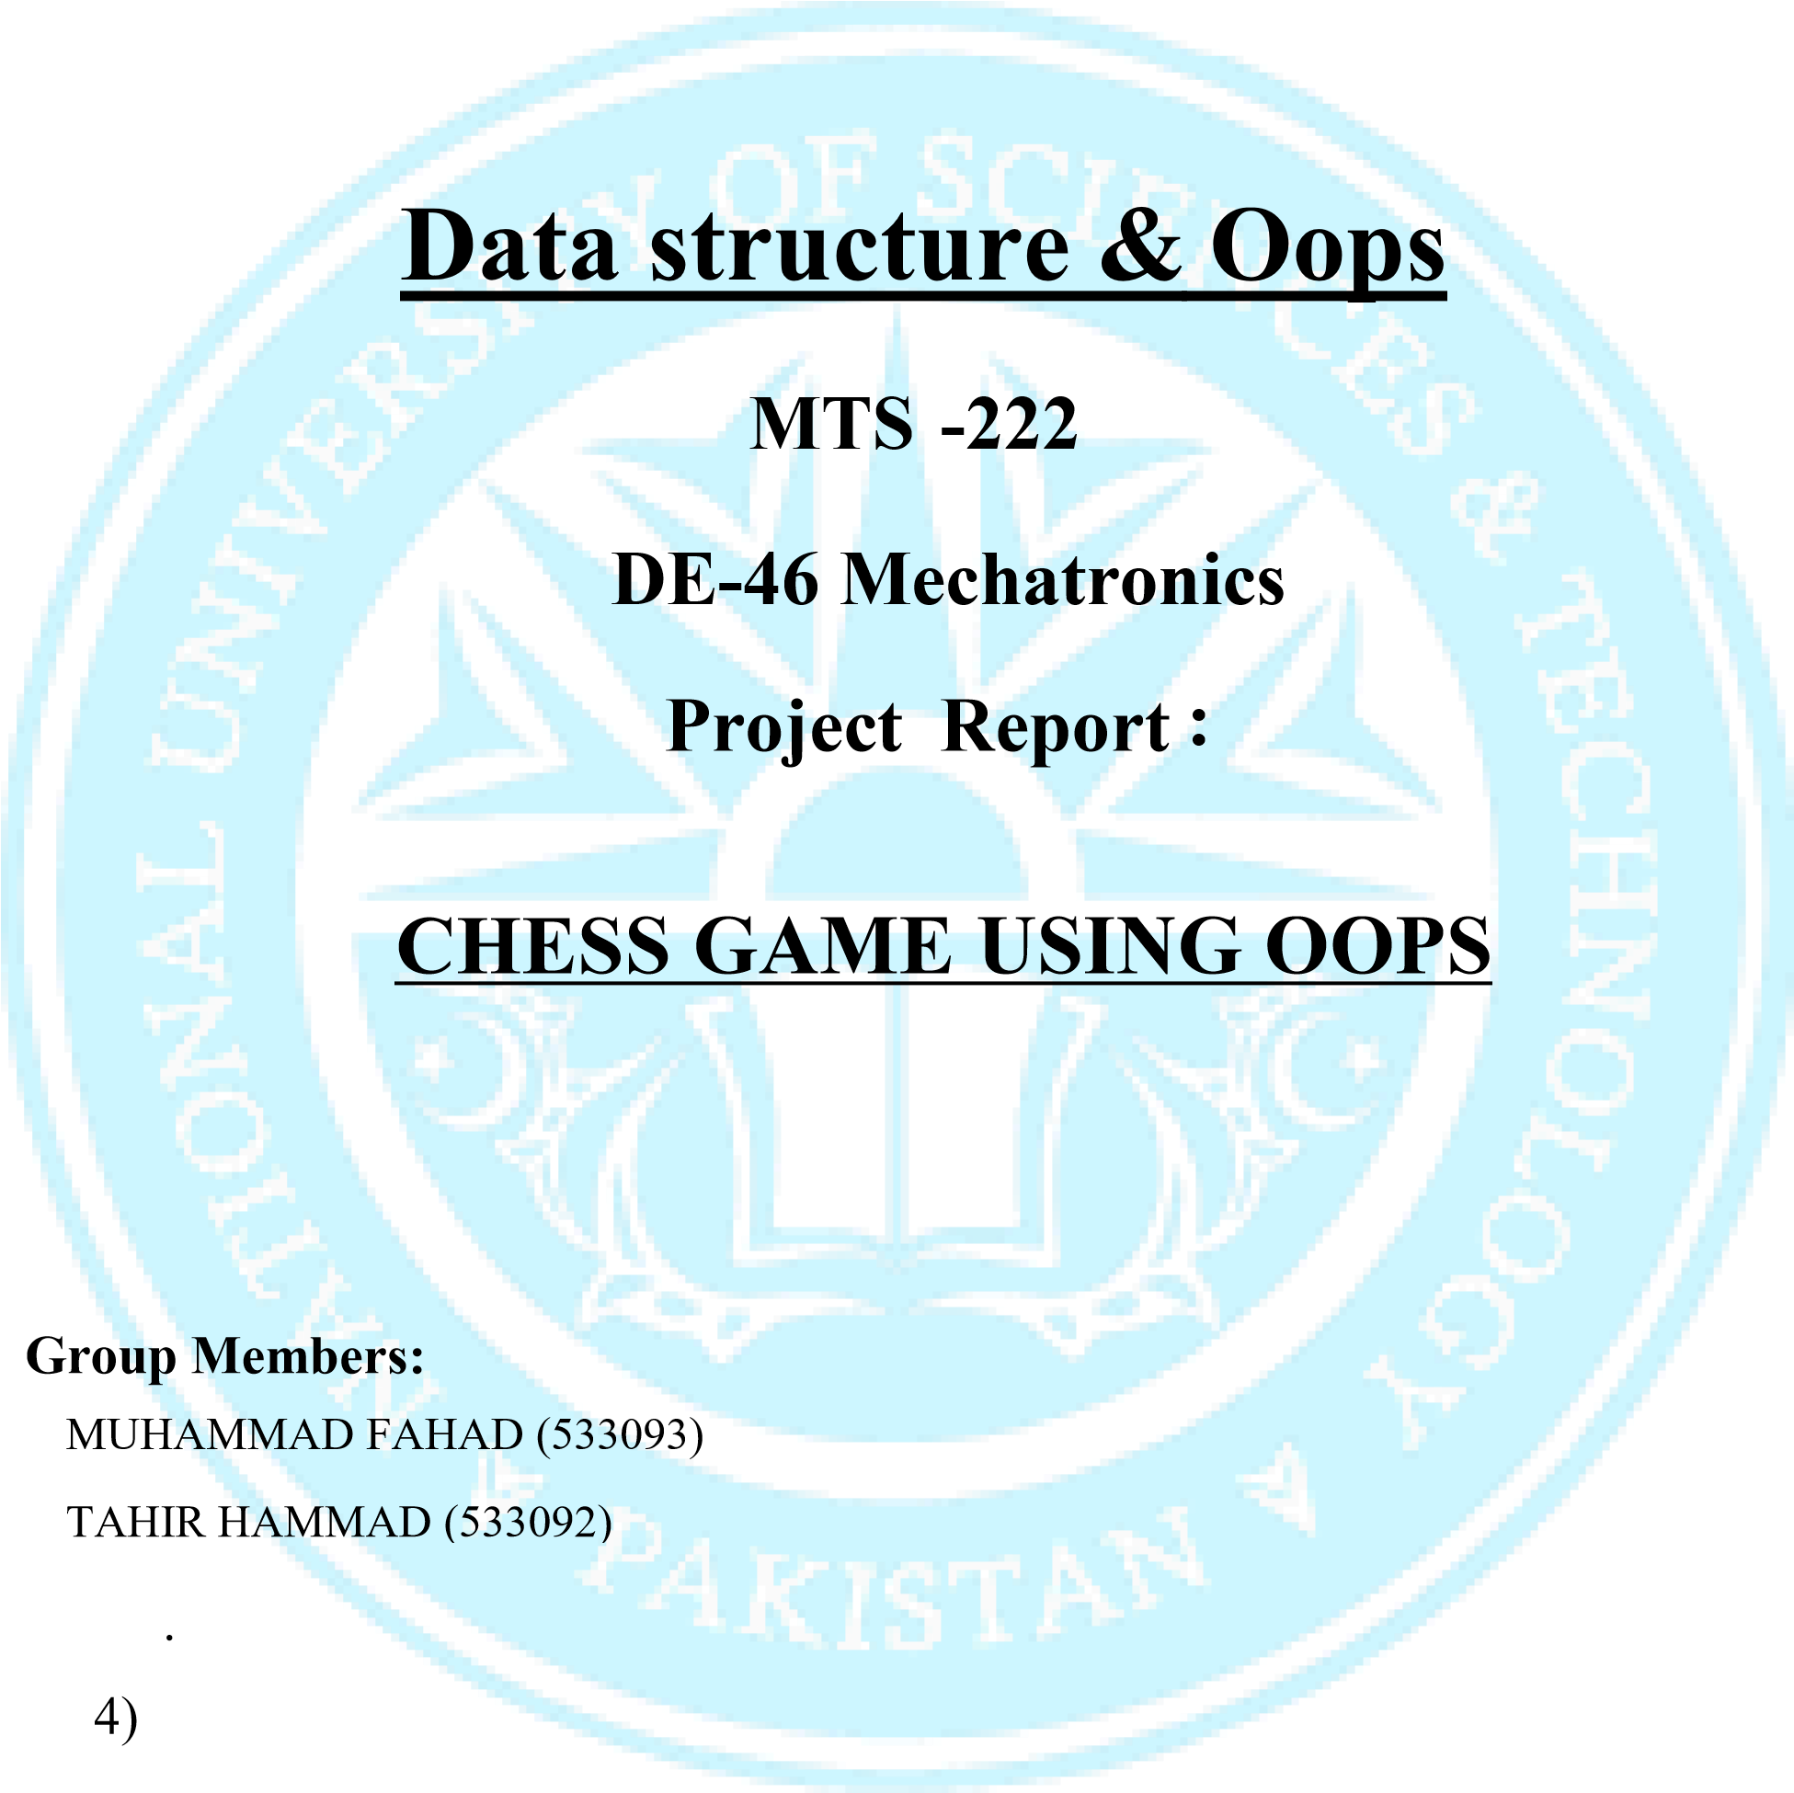

Submitted To: Dr Ayesha Zeb
LE Kashan Ansari 
Submission Date: 18th December 2025

Abstract
This project presents the design and implementation of a complete two-player Chess game developed in C++ using the SFML (Simple and Fast Multimedia Library). The system follows an Object-Oriented Programming (OOP) approach, where each chess piece is modeled as an object with its own movement rules. The project supports all standard chess rules including legal move validation, castling, en passant, pawn promotion, check, and checkmate detection. A graphical user interface is implemented for real-time interaction, making the game intuitive and visually appealing.

Motivation
The motivation behind this project is to practically apply Object-Oriented Programming concepts, data structures, and game logic design in a real-world application. Chess is a well-defined problem domain that naturally maps to OOP principles such as inheritance and polymorphism. Additionally, using SFML provides hands-on experience with graphics rendering, event handling, and real-time input processing, which are essential skills for game development and interactive software systems.

Technologies and Tools Used
- Programming Language: C++
- Graphics Library: SFML
- Development Paradigm: Object-Oriented Programming (OOP)
- IDE/Compiler: Visual studio compiler

Object-Oriented Concepts Used

1. Abstraction
Abstraction is achieved using the abstract base class Piece. It defines common properties and functions such as position, color, and the pure virtual function isValidMove(), hiding implementation details from the main game logic.

2. Inheritance
All chess pieces (Pawn, Rook, Knight, Bishop, Queen, King) inherit from the base class Piece, allowing code reuse.

3. Polymorphism
Polymorphism is implemented through the overridden isValidMove() function. Each piece defines its own movement logic, but all are accessed through a Piece* pointer.

4. Encapsulation
Data members such as position, color, and movement state are protected or private, and accessed using public getter and setter functions, ensuring controlled access.

5. Dynamic Memory Allocation
Chess pieces are created dynamically using new and destroyed using delete, allowing flexible piece management during captures and promotions.

Core Programming Concepts Used

1. Arrays and 2D Grid
A 2D array (8×8) is used to represent the chessboard, where each cell stores a pointer to a Piece object.

2. Event Handling
Mouse and window events are handled using SFML’s event system, enabling interactive gameplay.

3. Control Structures
Conditional statements and loops are extensively used for move validation, board traversal, and game-state checks.
4. Type Casting dynamic_cast is used to identify pawn objects for promotion logic.

Game Logic Concepts Implemented

1. Move Validation
Each piece validates its movement according to chess rules using its own implementation of isValidMove().
2. Turn Management
A boolean flag ensures alternate turns between white and black players.

3. Check Detection
The king’s position is checked against all opponent moves to determine if it is under attack.

4. Checkmate Detection
If the king is in check and no legal move can remove the check, the game ends in checkmate.

5. Special Chess Rules
- Castling: Simultaneous movement of king and rook
- En Passant: Special pawn capture
- Pawn Promotion: Pawn promoted to Queen, Rook, Bishop, or Knight

Graphical User Interface (GUI)
The GUI is built using SFML. It includes:
- A chessboard rendered using colored tiles
- Sprite-based chess pieces
- Visual indicators for selected pieces and possible moves
- Capture highlights and smooth rendering

Overall Code Flow Description
- The program starts by creating a window using SFML.
- The Board object is initialized, textures are loaded, and pieces are placed on the board.
- The game enters the main loop, which runs until the window is closed.
- User input is captured using mouse clicks.
- If a valid move is selected, the game state is updated.
- Special rules such as castling, en passant, and promotion are checked.
- The system checks for check or checkmate conditions.
- The board and pieces are redrawn every frame.

Flowcharts
Detailed flowcharts illustrating:
Rendering process
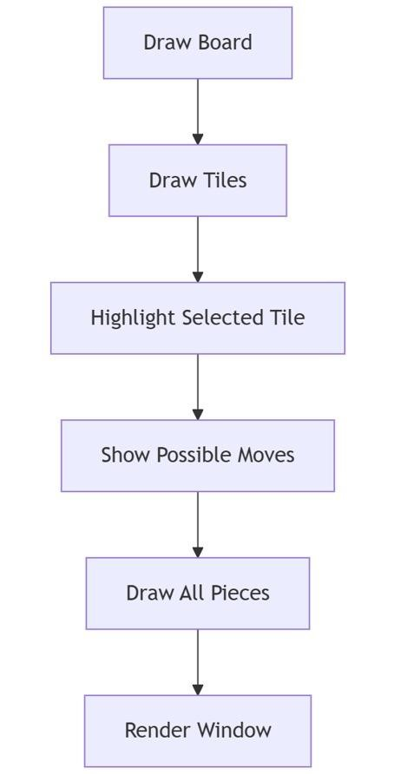

Overall program execution

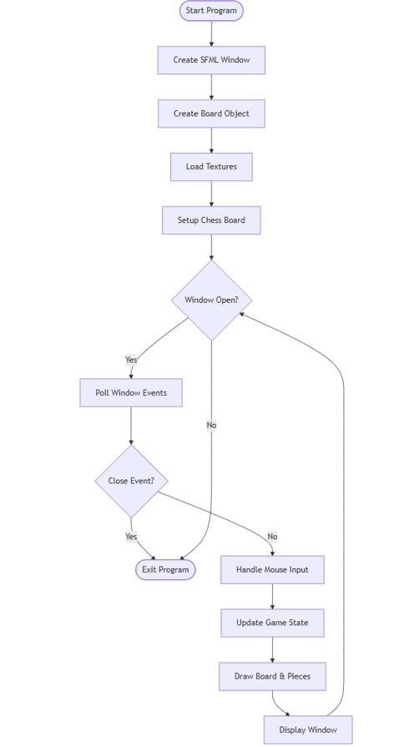

Input handling

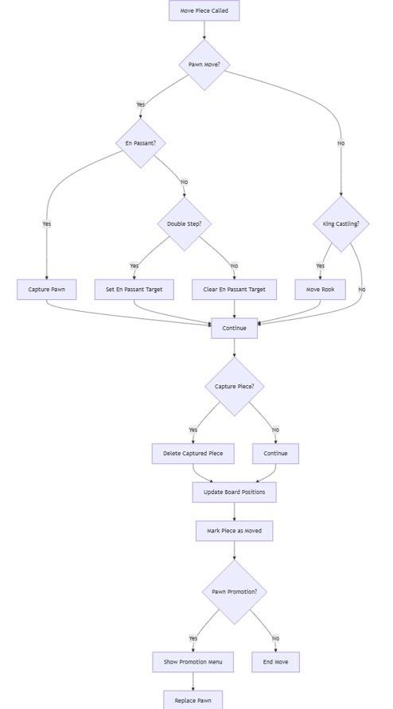

Move execution 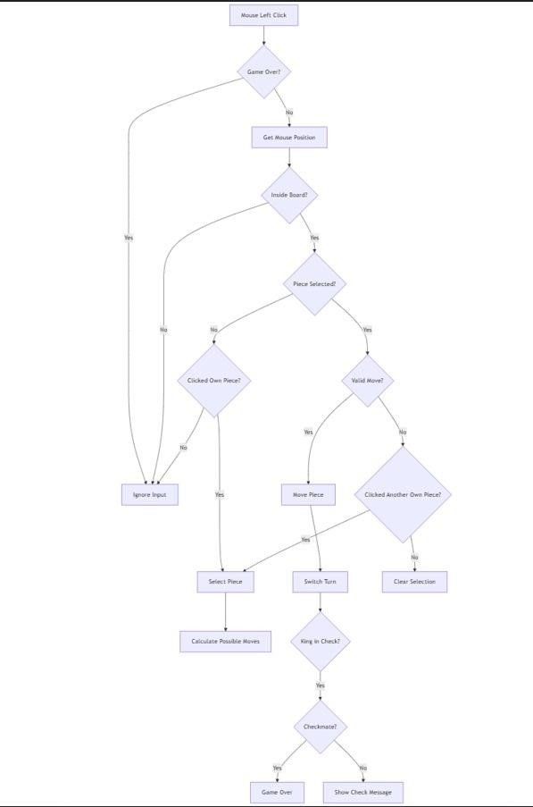

Check and checkmate detection

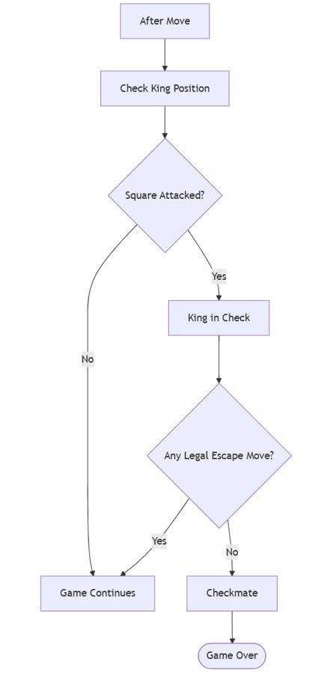

Conclusion
This project successfully demonstrates the practical application of Object-Oriented Programming principles, game logic implementation, and graphical programming using SFML. By modeling chess pieces as objects and implementing real chess rules, the project achieves both functional correctness and clean software design. The system is modular, scalable, and easy to understand, making it an excellent academic project for learning advanced C++ programming and game development concepts.

Future Enhancements
- Single-player mode with AI opponent
- Undo/redo move functionality
- Move history and game saving
- Online multiplayer support

