25K-0957
Lab-04_Tasks_Outputs
Task1:
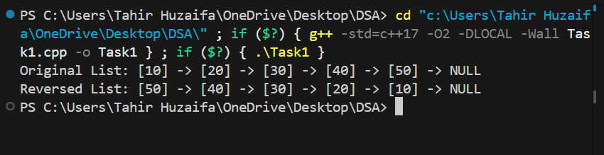
Task2:
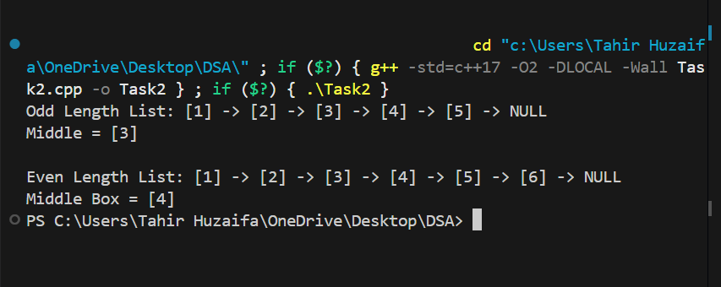

Task3:
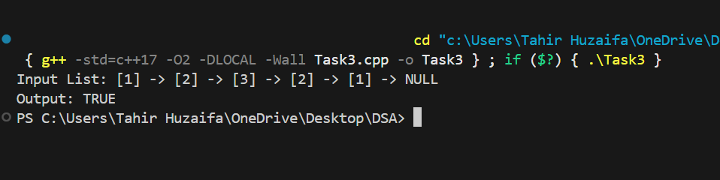

Task4:
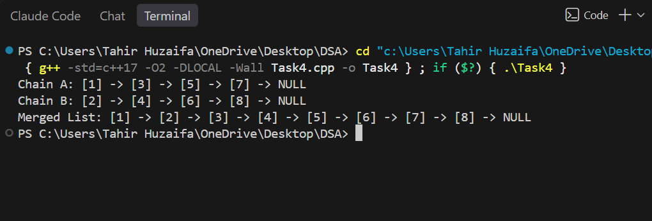

Task5:
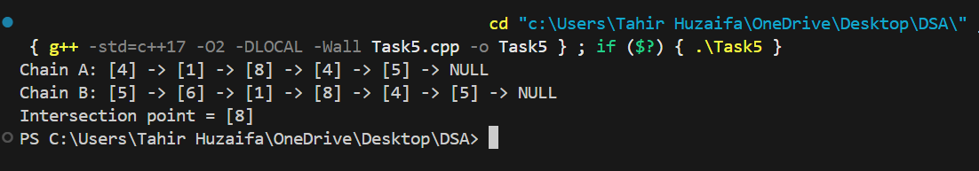

Task6:
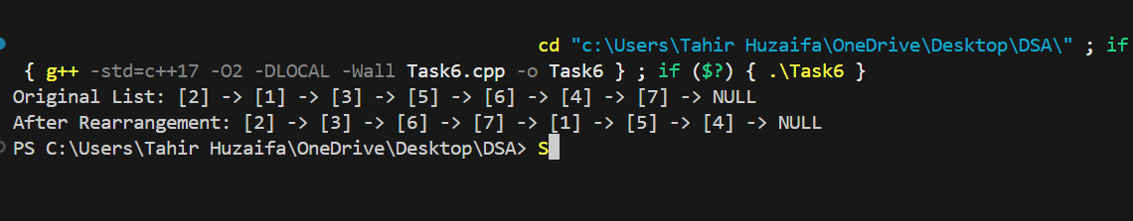
Task7:
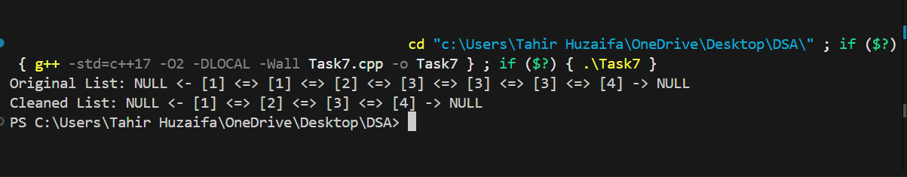

Task8:
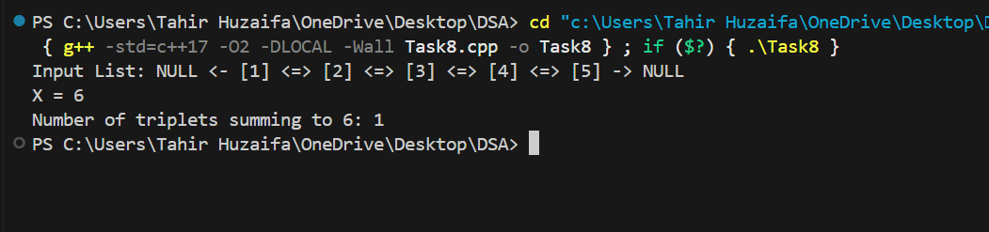
Task9:
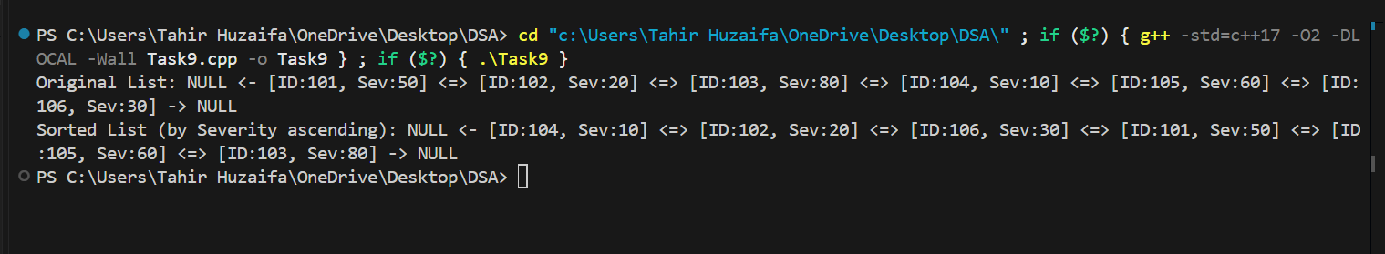
Task10:
