25K-0957
Lab-05_Tasks_Outputs
Task1:
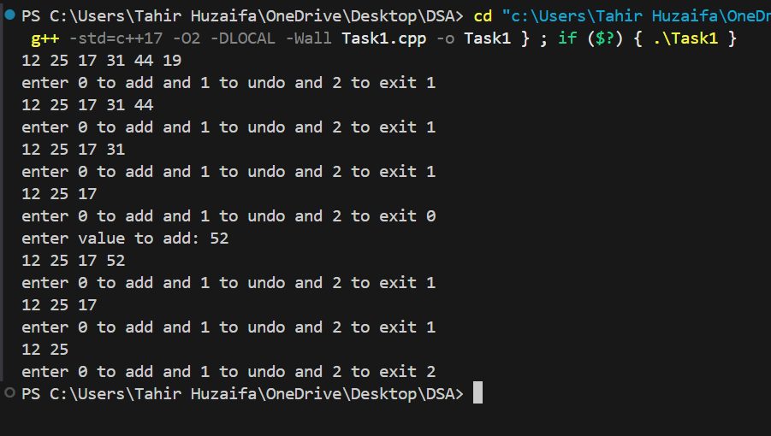
Task2:
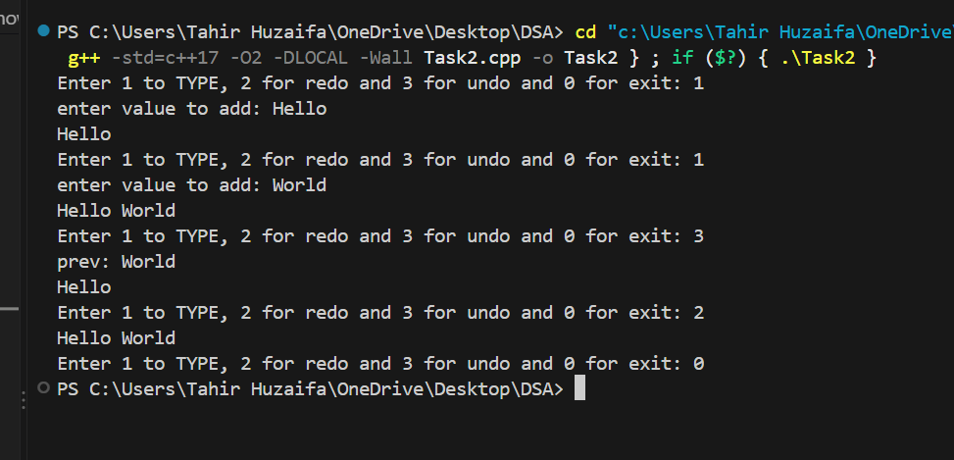

Task3:
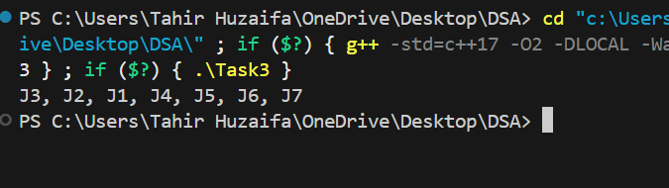
Task4:
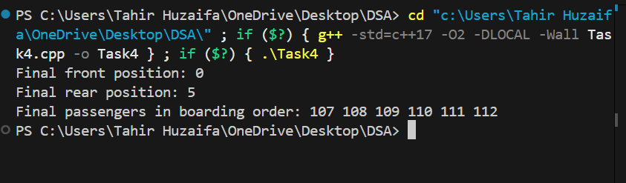

Task5:
