31. project Pasword generaor
in this project we do not need to modify html and css afterward so you can use direct code from git.
in the script.js we will create first random function and an object with key and value of the name of functions see the pic and code.
1. random funtion

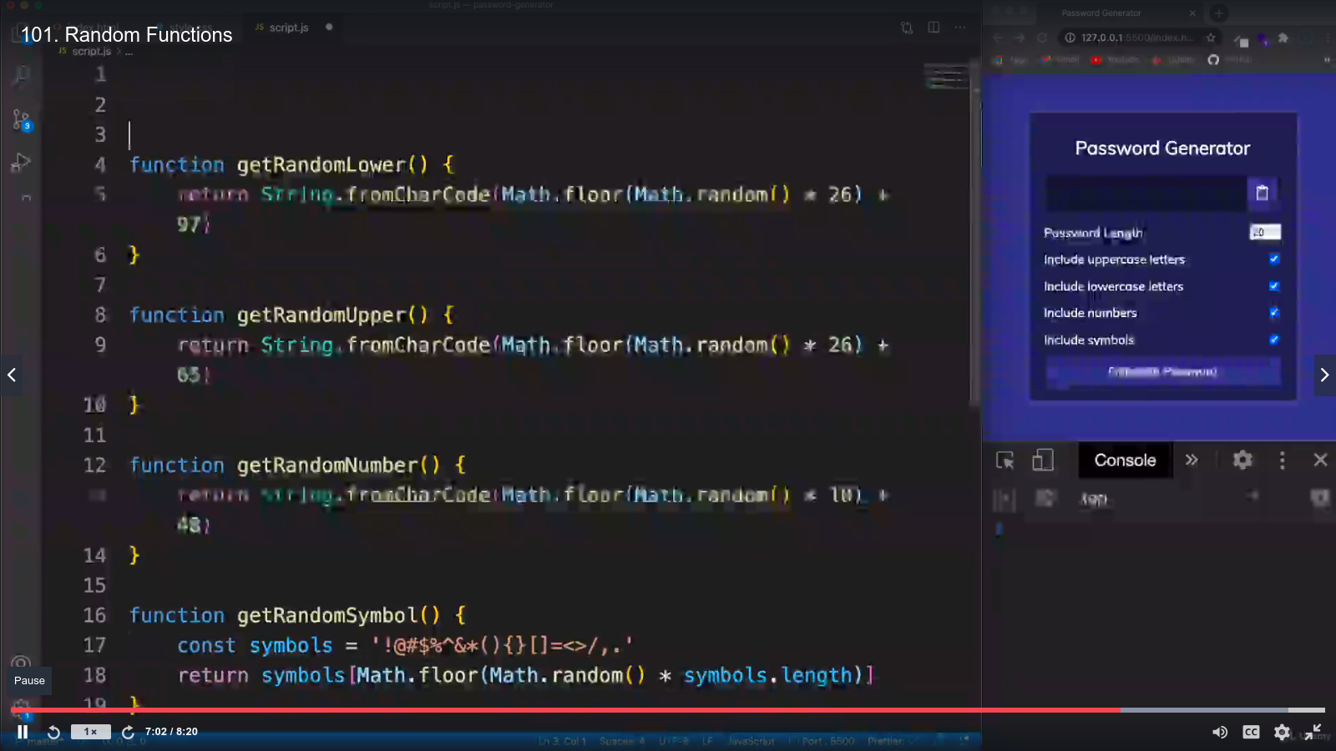
now we will bring all const in the file

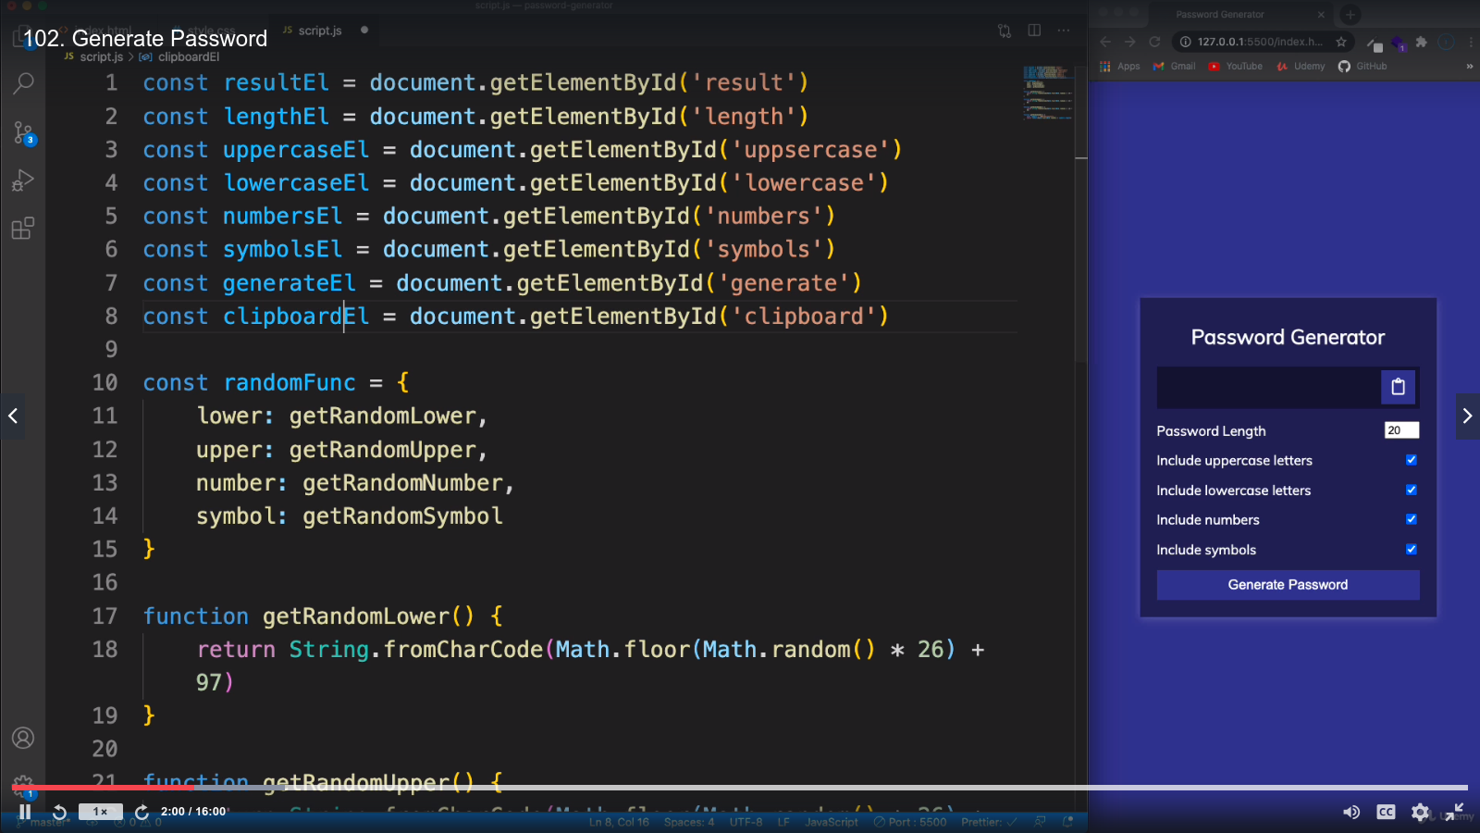
lets write a function to get value and checked( true or false )
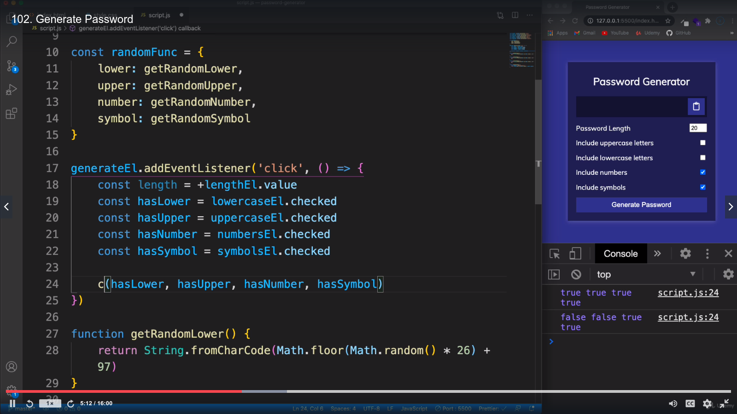
now the generatePassword function will give us number which are checked

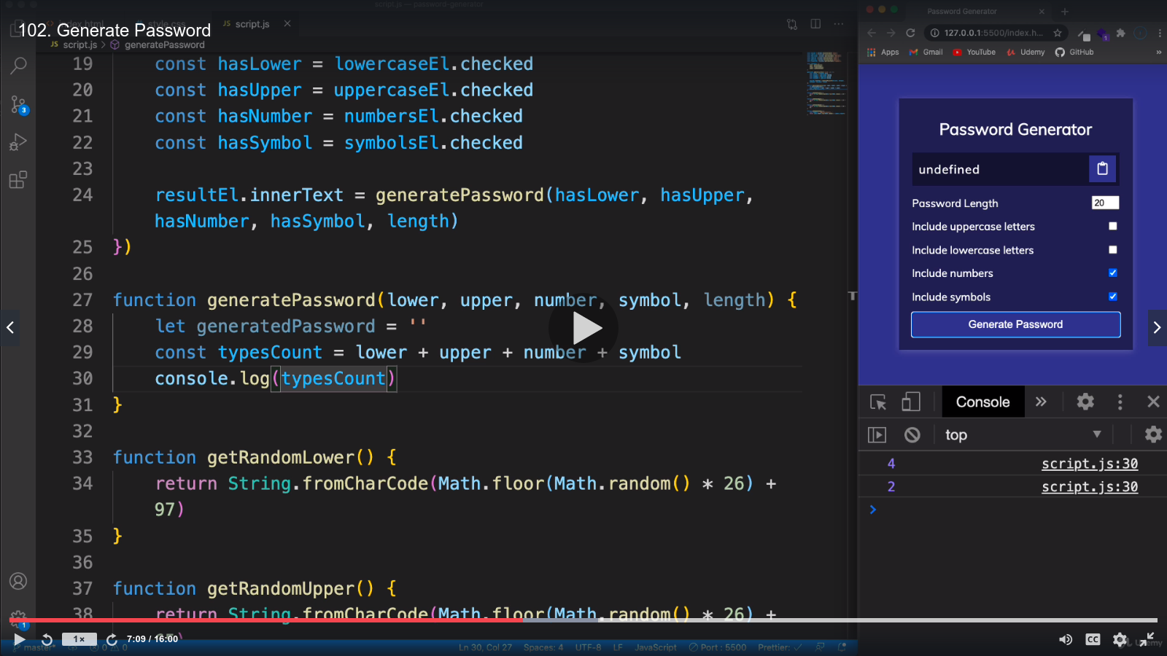
The type array is the array of objects and will filter it so that will not show the false one and only show the true values

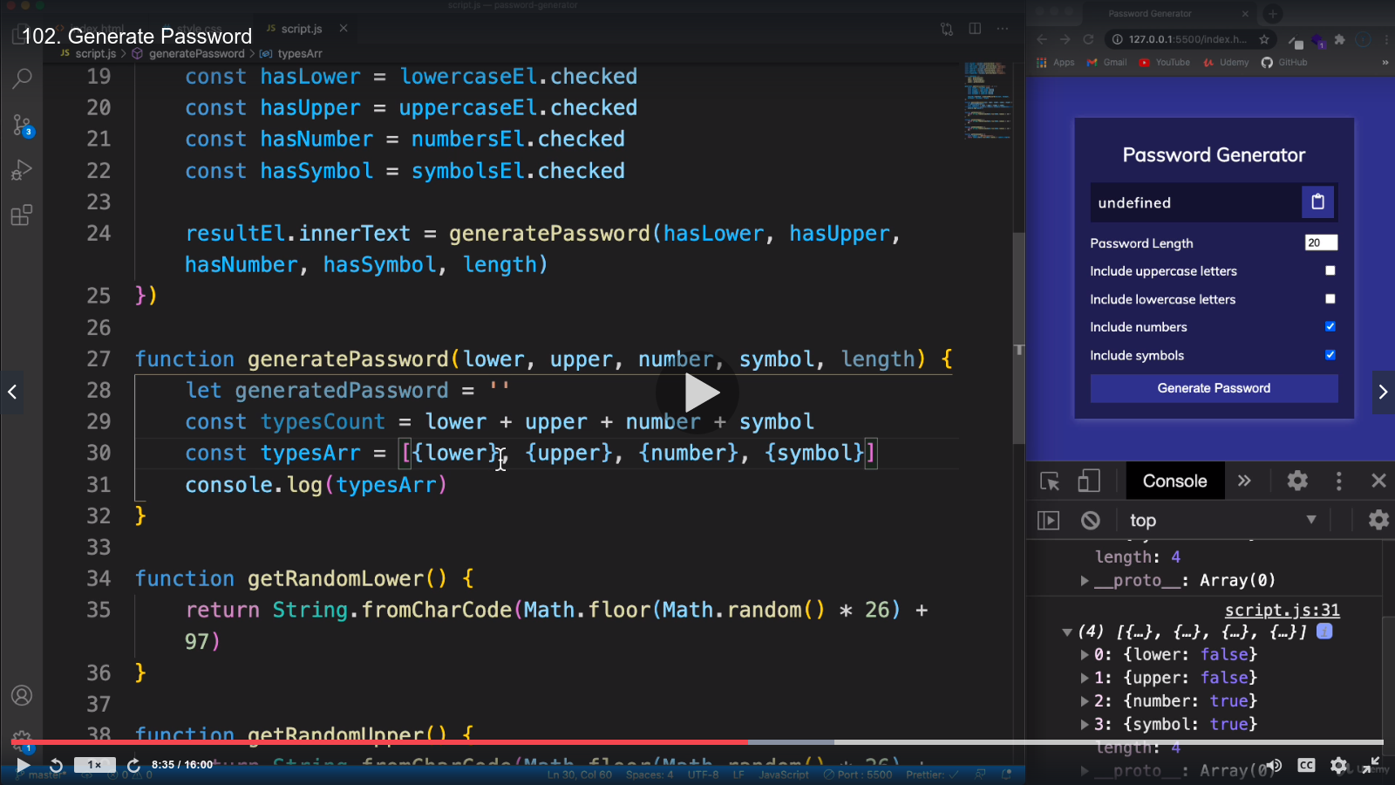
listen from 12minute again ...

