Forms
in order to prevent default behaviour we use e.preventDefault()
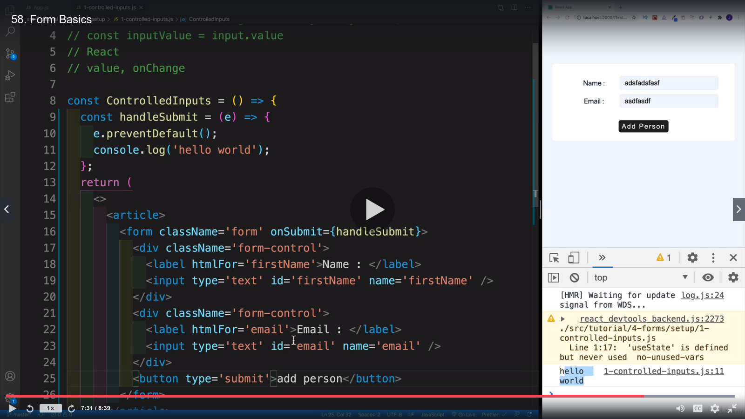

Now most important in order to use form imput value in React we introduce useState values as shown below. OnChange method will take the value covert to state value

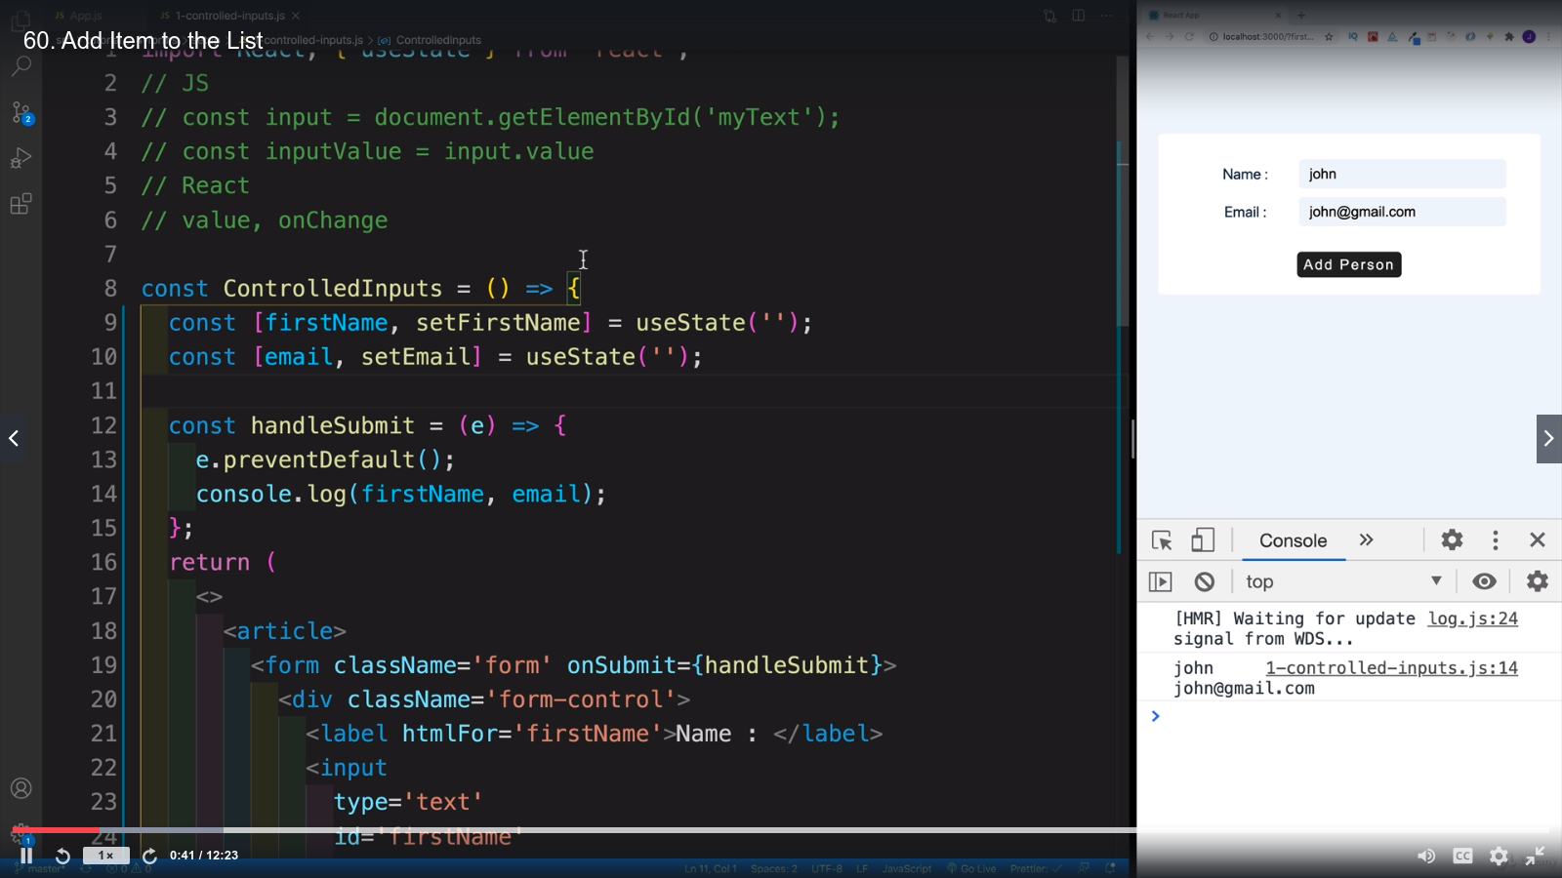

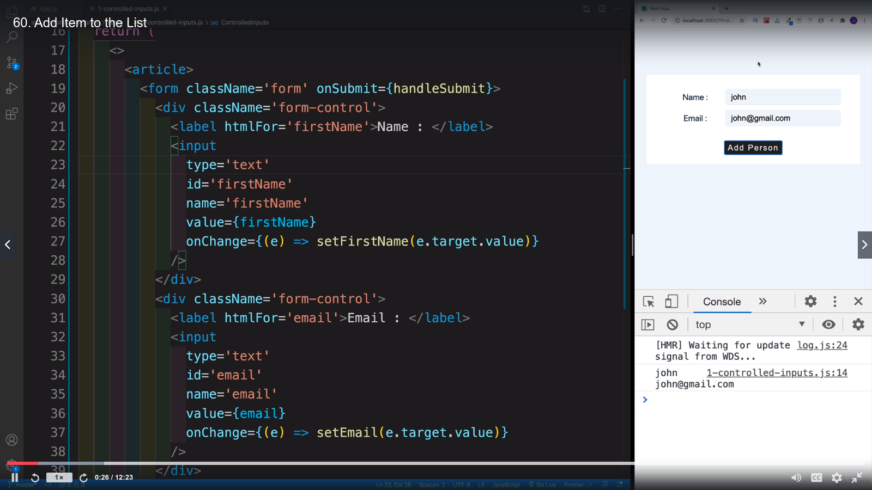

Lecture 60 Add item to the List

remember if the key value matches then use only one time see code line 16

