Pakar jagung

Konsultasi

info

Selamat datang

basis

about

admin

help

home

Basis Pengetahuan



Halaman tentang

Home

|  |
| --- |
| Pertanyaan v |
| v |
| v |
| v |

Halaman Bantuan

home

Cek hasil

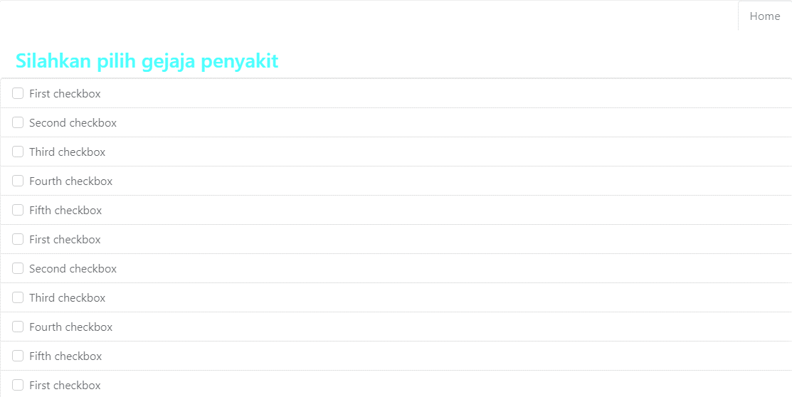

Kosultasi lagi

home

Halaman hasil

login

password

Masukkan email

Pakar Jagung

Dashboard

keluar

Data aturan

Data gejala

Data penyakit

Dashboard

|  |  |  |  |
| --- | --- | --- | --- |
|  |  |  |  |
|  |  |  |  |
|  |  |  |  |
|  |  |  |  |

Pakar Jagung

keluar

Data aturan

Data gejala

Data penyakit

Dashboard

|  |  |  |  |
| --- | --- | --- | --- |
|  |  |  |  |
|  |  |  |  |
|  |  |  |  |
|  |  |  |  |

Tabel Penyakit

Pakar Jagung

keluar

Data aturan

Data gejala

Data penyakit

Dashboard

|  |  |  |  |
| --- | --- | --- | --- |
|  |  |  |  |
|  |  |  |  |
|  |  |  |  |
|  |  |  |  |

Tabel Gejala

Pakar Jagung

keluar

Data aturan

Data gejala

Data penyakit

Dashboard

|  |  |  |  |
| --- | --- | --- | --- |
|  |  |  |  |
|  |  |  |  |
|  |  |  |  |
|  |  |  |  |

Table aturan