Department of Computer and Software Engineering – ITU
SE101T: Programming Fundamentals

Course Instructor: Usama Bin Shakeel | Dated: 28/11/2024
Teaching Assistant: Sadia, Zain & Ryan | Semester: Fall 2024
Session: 2024-2028 | Batch: BSSE2024

Assignment 14. Java

Name | Roll number | Obtained Marks/35

Checked on: ____________________________

Signature: ___________________________

Submission:
• Email instructor or TA if there are any questions. You cannot look at others’ solutions or use others’ solutions, however, you can discuss it with each other. Plagiarism will be dealt with according to the course policy.
• Submission after due time will not be accepted.

In this assignment you have to do following tasks:

Task 1: Ensure that you have installed all three softwares in your personal computer (Github, Cygwin & CLion). Now, accept the assignment posted in classroom (e.g Google, LMS etc) and after accepting, clone the repository to your computer. Make sure you have logged into the github app with your account.

Task 2: Open Cygwin app, Move to your code directory with following command “cd <path_of_folder>”
<path_of_folder> can be automatically populated by dragging the folder and dropping it to the cygwin window.
Run the code through Cygwin, use command “make run”, to get the output of the code

Task 3: Solve the given problems, write code using CLion or any other IDE.
Task 4: Keep your code in the respective git cloned folder.
Task 5: Commit and Push the changes through the Github App
Task 5: Write the code in separate files (as instructed). Ensure that file names are in lowercase (e,g main.cpp).

Task 6: Run ‘make run’ to run C++ code
Task 7: Run ‘make test’ to test the C++ code

Submission:
• Email instructor or TA if there are any questions. You cannot look at others’ solutions or use others’ solutions, however, you can discuss it with each other. Plagiarism will be dealt with according to the course policy.
• Submission after due time will not be accepted.

Theory and Background:
Java is a powerful, high-level, object-oriented, and platform-independent programming language. It is widely used for building a variety of applications, from desktop to mobile and web applications. Known for its "Write Once, Run Anywhere" principle, Java programs can run on any platform with a Java Virtual Machine (JVM). It is beginner-friendly, yet robust enough for advanced applications.
In this assignment, you will learn:
- Understand the basics of declaring variables and displaying output using System.out.println().
- Take user input using the Scanner class and perform basic arithmetic calculations.
- Learn how to use conditional statements to make decisions in your programs.
- Explore for and while loops to handle repetitive tasks efficiently.
- Understand the concept of arrays to store multiple values and perform operations like summation.
Use the following online interpreter for this lab:
https://www.programiz.com/java-programming/online-compiler/

Note:
Attach All the screenshots of code and outputs for respective tasks in the box below:

In this assignment you have to do following tasks:

Task 1:
In Java, variables are created by specifying the type and name, and then initializing them. Use System.out.println() to print messages.
In this task, create two variables: one for your name (String) and another for your roll number (int). Print both variables.
Code:
class Main {
public static void main(String[] args) {
String myName="Um-e-Aiman";//taking name as string data type
int myRollnumber=24063;//taking rollnumber as int data type
System.out.println("Task # 1");
System.out.println("Name: "+myName);//this will print name
System.out.println("Roll number: "+myRollnumber);//this will print roll number

}
}
Output:
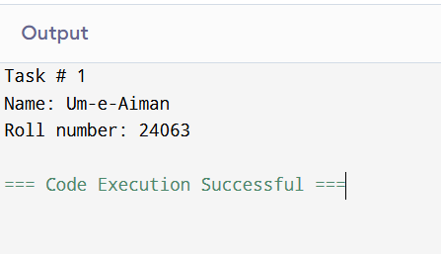

Task 2
User Input and Arithmetic Operations
In Java, you can take user input using the Scanner class. Use it to take two floating-point numbers as input from the user and perform addition, subtraction, multiplication, and division. Print the results of each operation.
Code:
import java.util.Scanner;

public class Main {
public static void main(String[] args) {
Scanner gettinginput = new Scanner(System.in); // use scanner to take input
//get the first number and second number as a float
System.out.print("Enter the first number: ");
float Firstnum = gettinginput.nextFloat();
System.out.print("Enter the second number: ");
float secondnum = gettinginput.nextFloat();

// now Perform basic operations on them:
System.out.println("Addition of two numbers: " + (Firstnum + secondnum));//addition operation
System.out.println("Subtraction of two nummber: " + (Firstnum - secondnum));//subtraction operation
System.out.println("Multiplication of two numbers: " + (Firstnum * secondnum));//multiplication
//check if second number is zero or not
if (secondnum != 0) {
System.out.println("Division of two numbers: " + (Firstnum / secondnum));//division
}
else {
System.out.println("Division impossible as i give infinity value or undefined value");
}
gettinginput.close(); // Close the scanner
}
}
Output:
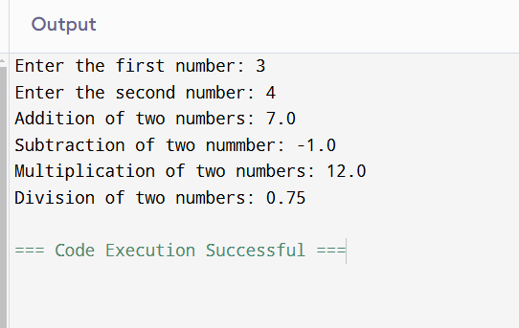

Task 3
Determine Even or Odd
Using conditional statements in Java (if-else), take an integer as input from the user and check if it is even or odd. Print the result.
Code:
import java.util.Scanner;

public class Main {
public static void main(String[] args) {
//use scanner to get input
Scanner input = new Scanner(System.in);
//tkaing number as a input from user
System.out.print("Enter an integer: ");
int nummber = input.nextInt(); // Read the integer from the user
// Check if the number is even or odd
if (nummber % 2 == 0) {
System.out.println(nummber + " is even number.");
//number is divisible by 2
}
else
{
System.out.println(nummber + " is odd number.");
// Number is not divisible by 2
}
}
}
Output:
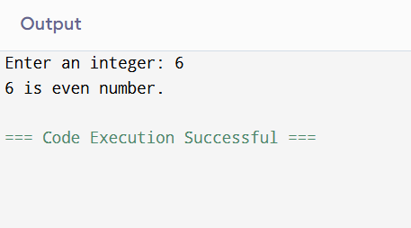

Task 4
Using Loops to Print Numbers
Loops in Java (for and while) work similarly to other programming languages. In this task, use a for loop to print numbers from 1 to 10.

Code:
import java.util.Scanner;

public class Main {
public static void main(String[] args) {
for(int i=1;i<=10;i++){//using for loop to print numbers from 1 to 10
System.out.println(i);//this will print number
}

}
}
Output:
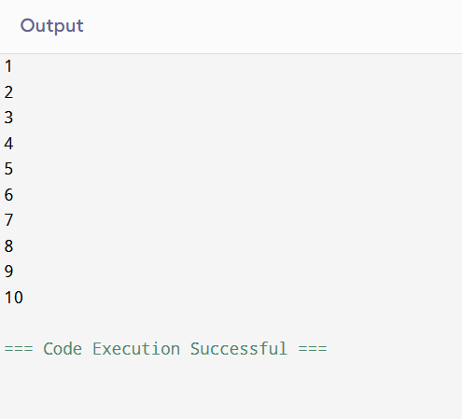

Task 5
Working with Arrays
Create an integer array of size 5. Populate it with values and calculate the sum of the elements. Use a for loop to iterate through the array. Print the sum.
Code:
import java.util.Scanner;

public class Main {
public static void main(String[] args) {
//using scanner for input
Scanner Innput = new Scanner(System.in);
// array of size 5
int[] elements = new int[5];
System.out.println("Enter 5 integers for array:");
//using for loop
for (int i = 0; i < 5; i++) {
elements[i] = Innput.nextInt();//taking input
}
int sum = 0;//intialize sum equal to 0
for (int i = 0; i < 5; i++) {
sum += elements[i];//add elements of array
}
System.out.println("sum of elements of array is : " + sum);//this will print sum of elements of array

}
}
Output:
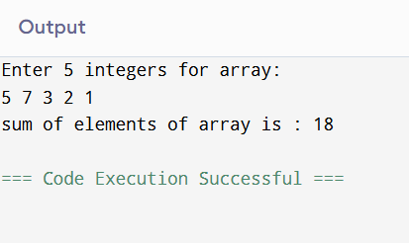

Assessment Rubric for Assignment

Performance metric | CLO | Able to complete the task over 80% (4-5) | Able to complete the task 50-80% (2-3) | Able to complete the task below 50% (0-1) | Marks
- Realization of experiment | 3 | Executes without errors excellent user prompts, good use of symbols, spacing in output. The testing has been completed. | Executes without errors, user prompts are understandable, minimum use of symbols or spacing in output. Some testing has been completed. | Does not execute due to syntax errors, runtime errors, user prompts are misleading or non- existent. No testing has been completed.
- Conducting experiment | 2 | Able to make changes and answer all questions. | Partially able to make changes and few incorrect answers. | Unable to make changes and answer all questions.
- Computer use | 4 | Document submission timely. | Document submission late. | Document submission not done.
- Teamwork | 4 | Actively engages and cooperates with other group member(s) in an effective manner. | Cooperates with other group member(s) in a reasonable manner but conduct can be improved. | Distracts or discourages other group members from conducting the experiment
- Laboratory safety and disciplinary rules | 2 | Code comments are added and do help the reader to understand the code. | Code comments are added and do not help the reader to understand the code. | Code comments are not added.
- Data collection | 2 | Excellent use of white space, creatively organized work, excellent use of variables and constants, correct identifiers for constants, No line-wrap. | Includes name, and assignment, white space makes the program fairly easy to read. Title, organized work, good use of variables. | Poor use of white space (indentation, blank lines) making code hard to read, disorganized and messy.
- Data analysis | 3 | Solution is efficient, easy to understand, and maintain. | A logical solution that is easy to follow but it is not the most efficient. | A difficult and inefficient solution.
Total (out of 35):

