Department of Computer and Software Engineering – ITU
SE101T: Programming Fundamentals

Course Instructor: Usama Bin Shakeel | Dated: 29/11/2024
Teaching Assistant: Sadia, Zain & Ryan | Semester: Fall 2024
Session: 2024-2028 | Batch: BSSE2024

Assignment 15. C++ Problem-Solving

Name | Roll number | Obtained Marks/35

Checked on: ____________________________

Signature: ___________________________

Submission:
• Email instructor or TA if there are any questions. You cannot look at others’ solutions or use others’ solutions, however, you can discuss it with each other. Plagiarism will be dealt with according to the course policy.
• Submission after due time will not be accepted.

In this assignment you have to do following tasks:

Task 1: Ensure that you have installed all three softwares in your personal computer (Github, Cygwin & CLion). Now, accept the assignment posted in classroom (e.g Google, LMS etc) and after accepting, clone the repository to your computer. Make sure you have logged into the github app with your account.

Task 2: Open Cygwin app, Move to your code directory with following command “cd <path_of_folder>”
<path_of_folder> can be automatically populated by dragging the folder and dropping it to the cygwin window.
Run the code through Cygwin, use command “make run”, to get the output of the code

Task 3: Solve the given problems, write code using CLion or any other IDE.
Task 4: Keep your code in the respective git cloned folder.
Task 5: Commit and Push the changes through the Github App
Task 5: Write the code in separate files (as instructed). Ensure that file names are in lowercase (e,g main.cpp).

Task 6: Run ‘make run’ to run C++ code
Task 7: Run ‘make test’ to test the C++ code

Submission:
• Email instructor or TA if there are any questions. You cannot look at others’ solutions or use others’ solutions, however, you can discuss it with each other. Plagiarism will be dealt with according to the course policy.
• Submission after due time will not be accepted.

Theory and Background:

You have been given two text files, “marks.txt” and “grades.txt”. Marks have randomly generated data against each of your class fellow.
“marks.txt” contain following information
- T_Quizzes : Total number of quizzes that particular student have attempted
- Each_Quiz : Followed by marks obtained in each quiz that was attempted
- RollNo : Roll number of a student in form of a single word
- Name: Name of the student in form of multiple words
“grades.txt” contain following information Grade :
- The Grade
- Lower : Lower bound of the grade, this number is included itself in the range
- Upper : Upper bound of the grade, this number is excluded itself in the range

Terms Understanding:
Given following data : 30,40,10,20,20,50

Mean = (30+40+10+20+20+50)/6 = 170/6 = 28.33
Median is the middle value or mean of two middle values if total number of terms are even • First we sort the list
10,20,20,30,40,50
Median is average of 3rd and 4th term in this case = (20+30)/2 = 25
Mod is the most frequent occurring element , so in our given data above it is 20

In this assignment you have to do following tasks:

Task 1:
Read all data from both CSV files using dynamic structures.

Task 2
Find Mean and Mod for each student, based on quiz marks, (Mod of quiz marks and Mean of quiz marks)

Task 3
Find Median for each student, based on quiz marks, (Median of quiz marks)

Task 4
Grade each student based on Mean value of quiz marks (Slabs should be taken from grades.txt 4ile)

Task 5
Create a file performance_report.txt that includes each student’s:
- Roll number
- Name
- Mean, Median, Mode
- Assigned grade
Ensure each student's data is on a separate line.

Task 6
List the details of students whose Mean quiz marks are below the overall class Mean. Save this data to a file called below_average_students.txt.

Task 7
Check for students who have attempted fewer than the total quizzes specified. Save the details of these students to a file called incomplete_records.txt.

Task 8
Write a program that prints the insurance fee to pay for a pet according to
the following rules:
- A dog that has been neutered costs $50.
- A dog that has not been neutered costs $80.
- A cat that has been neutered costs $40.
- A cat that has not been neutered costs $60.
- A bird or reptile costs nothing.
- Any other animal generates an error message.

The program should prompt the user for the appropriate information, using
a code to determine the kind of animal (i.e. D or d represents a dog, C or c represents a
cat, B or b represents a bird, R or r represents a reptile, and anything else represents
some other kind of animal). After printing the insurance fee, the program should ask the
user if (s)he wants to insure another animal.

Task 9
Write a program that produces a bar chart showing the population growth of Pakistan, at
20 years intervals during the past 100 yrs. The program should read in population
figures (rounded to the nearest 1000 people) for 1900, 1920, 1940, 1960, 1980, 2000.
For each year it should display the date and bar consisting of one asterisk for each
1000 people. It should display like this: Plattsburgh Population Growth (each*represents
1000 people)

Sample Output:
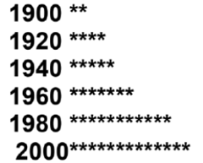
The following is the population:
- 2157(1900)
- 4289(1920)
- 5317(1940)
- 7215(1960)
- 10789(1980)
- 12984(2000).

Task 10
Write a program that input for students’ final grades in a given class (the grades are integer values in the range 1-9) after each time the program prompts "Do you want enter more Grade Y/N:" until user press N. The program then displays the class grade average, the highest grade, and how many students in the class failed the course (a grade less than 4 is a failing grade). An example running session looks as follow
Sample Output:
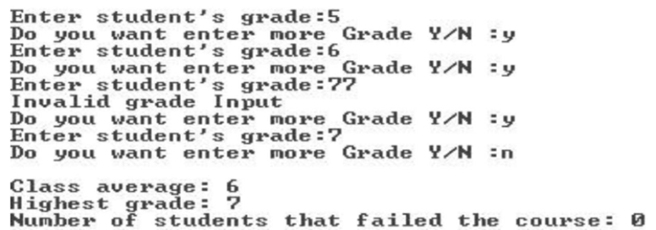

Task 11
Assume yourself as a part of the control unit of Windows Live hotmail. Your job is to determine the password length of the user-entered passwords.
A password
- Is said to be short if it contains less than 6 characters.
- Is perfect if its length is greater than 6. (Max. length is 20 characters.)
You are to design a function that takes a parameter string (By Reference) and determines its length according to the above-mentioned criteria.

Assessment Rubric for Assignment

Performance metric | CLO | Able to complete the task over 80% (4-5) | Able to complete the task 50-80% (2-3) | Able to complete the task below 50% (0-1) | Marks
- Realization of experiment | 3 | Executes without errors excellent user prompts, good use of symbols, spacing in output. The testing has been completed. | Executes without errors, user prompts are understandable, minimum use of symbols or spacing in output. Some testing has been completed. | Does not execute due to syntax errors, runtime errors, user prompts are misleading or non- existent. No testing has been completed.
- Conducting experiment | 2 | Able to make changes and answer all questions. | Partially able to make changes and few incorrect answers. | Unable to make changes and answer all questions.
- Computer use | 4 | Document submission timely. | Document submission late. | Document submission not done.
- Teamwork | 4 | Actively engages and cooperates with other group member(s) in an effective manner. | Cooperates with other group member(s) in a reasonable manner but conduct can be improved. | Distracts or discourages other group members from conducting the experiment
- Laboratory safety and disciplinary rules | 2 | Code comments are added and do help the reader to understand the code. | Code comments are added and do not help the reader to understand the code. | Code comments are not added.
- Data collection | 2 | Excellent use of white space, creatively organized work, excellent use of variables and constants, correct identifiers for constants, No line-wrap. | Includes name, and assignment, white space makes the program fairly easy to read. Title, organized work, good use of variables. | Poor use of white space (indentation, blank lines) making code hard to read, disorganized and messy.
- Data analysis | 3 | Solution is efficient, easy to understand, and maintain. | A logical solution that is easy to follow but it is not the most efficient. | A difficult and inefficient solution.
Total (out of 35):

