Department of Computer and Software Engineering – ITU
SE101T: Programming Fundamentals

Course Instructor: Usama Bin Shakeel | Dated:
Teaching Assistant: Zain, Sadia & Ryan | Semester: Fall 2024
Session: 2024-2028 | Batch: BSSE2024

Assignment 2. Flowcharts, Pseudocode and Algorithm

Name | Roll number | Obtained Marks/100
UM E Aiman Rafiq | BSSE-24063

Checked on: ____________________________

Signature: ___________________________

Submission:
• Email instructor or TA if there are any questions. You cannot look at others’ solutions or use others’ solutions, however, you can discuss it with each other. Plagiarism will be dealt with according to the course policy.
• Submission after due time will not be accepted.

In this assignment you have to do following tasks:

Task 1: Ensure that you have installed all three softwares in your personal computer (Github, Cygwin & CLion). Now, accept the assignment posted in classroom (e.g Google, LMS etc) and after accepting, clone the repository to your computer. Make sure you have logged into the github app with your account.

Task 2: Open Cygwin app, Move to your code directory with following command “cd <path_of_folder>”
<path_of_folder> can be automatically populated by dragging the folder and dropping it to the cygwin window.
Run the code through Cygwin, use command “make run”, to get the output of the code

Task 3: Solve the given problems, write code using CLion or any other IDE.
Task 4: Keep your code in the respective git cloned folder.
Task 5: Commit and Push the changes through the Github App
Task 5: Write the code in separate files (as instructed). Ensure that file names are in lowercase (e,g main.cpp).

Task 6: Run ‘make run’ to run C++ code
Task 7: Run ‘make test’ to test the C++ code

For Flowcharts you can use draw.io, export and add images for flow charts along with algorithms and pseudocode in Microsoft word.
Submission:
• Email instructor or TA if there are any questions. You cannot look at others’ solutions or use others’ solutions, however, you can discuss it with each other. Plagiarism will be dealt with according to the course policy.
• Submission after due time will not be accepted.

In this assignment you have to do following tasks:

Write down the algorithm, pseudocode and draw flowcharts for the following:

Task 1: Determine if a given year is a leap year or not. A year is a leap year if it is divisible by 4 but not divisible by 100 unless it is also divisible by 400.
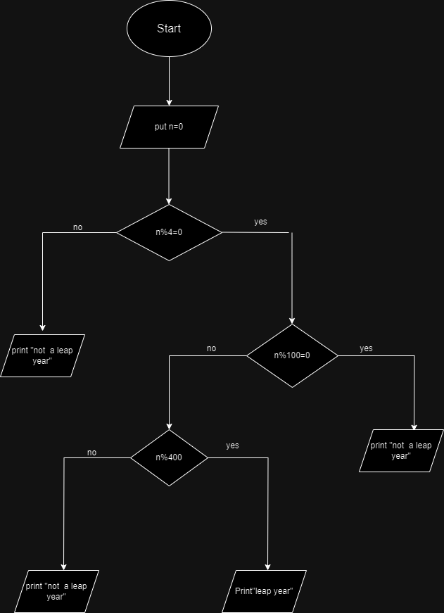 Algorithm:
Step 1:start
Step 2:entre the number
Step 3:Check number is divisible by 4 or not
Step 4:if number is divisible by 4 then check number is divsible by 100 or not
Step 5:if number is not divisible by 100 then check number is divisible by 400 or not
Step 6:if number is divible by 400 .Then the given number is a Leap year
Step 7:End the process

Pseudocode:
Start
Any number n
If(n%4);
n is leap year then
if (n is not % by 100)
n is leap year then
if (n % 400)
n is leap year;
print
leap year
End

Task 2: Repeatedly ask the user to enter a number until the user enters -1. Calculate sum of all numbers entered by user and store it in ‘Sum’. If the user enters -1, print the sum and terminate the program.
e.g. User enters the number in following order:
4 0 5 2 9 -1
Then program should print 17 (since Sum=20)
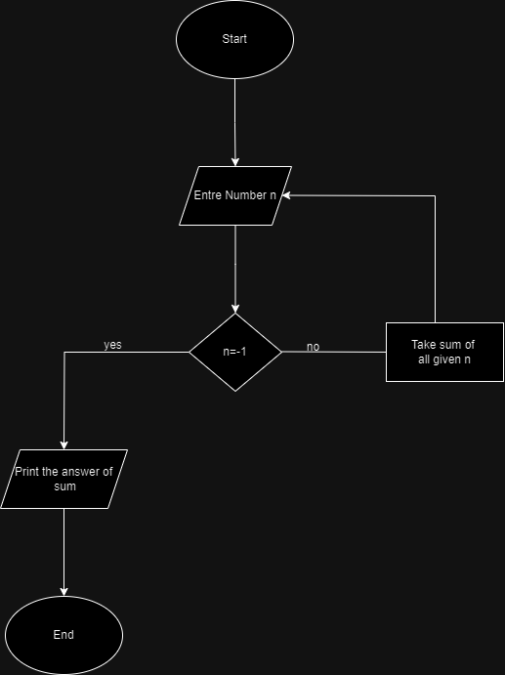
Algorithm:
Step1:start
Step 2:Entre any number n
Step 3:continue to put the value until user put value -1
Step 4: when n=-1 thenTake Sum of all the value
Step 5:print the ans of sum
Step 6:End

Pseudocode:
Start
Any number n
If ( n !=-1);
sum all n
until n ==-1;
print
total sum
End

Task 3: Calculate the factorial of a number n. The factorial of a number n is the product of all positive integers less than or equal to n.
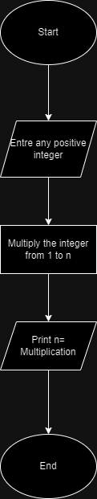
Algorithm:
Step 1:start
Step 2:Entre a positive integer n
Step 3:Multiply the number from 1 to n
Step 4:print the Ans of multiplication
Step 5:End
Pseudocode:
Start
Enter positive integer n
then
for factorial
multiply 1 to n
print
“ answer”
End

Task 4: A program that exchanges the value of two variables: x and y. The output must be: the value of variable y will become the value of variable x, and vice versa.
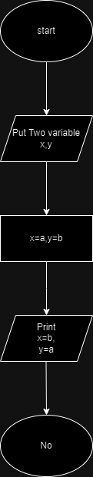
Algorithm:
Step 1:start
Step 2:put two variable x and y
Step 3:where the x=a & y=b
Step 4:exchanges the value of x and y
Step 5:print x=b and y=a
Step 6:End
Pseudocode:
Start
If ( x=a,y=b):
print y=a,x=b
End

Task 5: A number is given as input, check if it is a palindrome. A palindrome is a number that reads the same forwards and backwards, such as 121 or 12321. 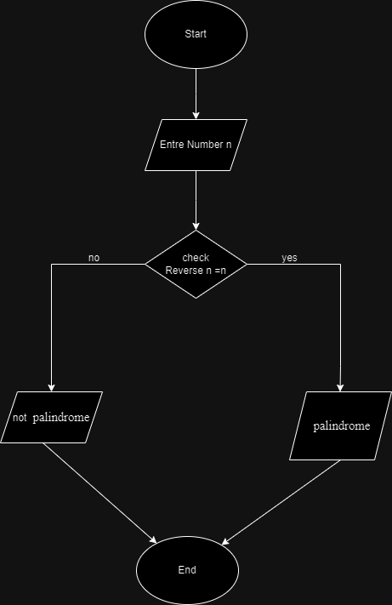

Algorithm:
Step 1:start
Step 2:entre any number n
Step 3:check its reverse
Step 4:if n becomes equal to inverse of n then it palindrome
Step 5:if n is not equal to its reverse then it is not palindrome
Step 6:End

Pseudocode:
Start
Any number n
Take reverse
If (reverse==n):
print “palindrome”
else :
print “not palindrome”

Assessment Rubric for Assignment

Performance metric | CLO | Able to complete the task over 80% (4-5) | Able to complete the task 50-80% (2-3) | Able to complete the task below 50% (0-1) | Marks
- Realization of experiment | 3 | Executes without errors excellent user prompts, good use of symbols, spacing in output. The testing has been completed. | Executes without errors, user prompts are understandable, minimum use of symbols or spacing in output. Some testing has been completed. | Does not execute due to syntax errors, runtime errors, user prompts are misleading or non- existent. No testing has been completed.
- Conducting experiment | 2 | Able to make changes and answer all questions. | Partially able to make changes and few incorrect answers. | Unable to make changes and answer all questions.
- Computer use | 4 | Document submission timely. | Document submission late. | Document submission not done.
- Teamwork | 4 | Actively engages and cooperates with other group member(s) in an effective manner. | Cooperates with other group member(s) in a reasonable manner but conduct can be improved. | Distracts or discourages other group members from conducting the experiment
- Laboratory safety and disciplinary rules | 2 | Code comments are added and do help the reader to understand the code. | Code comments are added and do not help the reader to understand the code. | Code comments are not added.
- Data collection | 2 | Excellent use of white space, creatively organized work, excellent use of variables and constants, correct identifiers for constants, No line-wrap. | Includes name, and assignment, white space makes the program fairly easy to read. Title, organized work, good use of variables. | Poor use of white space (indentation, blank lines) making code hard to read, disorganized and messy.
- Data analysis | 3 | Solution is efficient, easy to understand, and maintain. | A logical solution that is easy to follow but it is not the most efficient. | A difficult and inefficient solution.
Total (out of 35):

