Department of Computer and Software Engineering – ITU
SE101T: Programming Fundamentals

Course Instructor: Usama Bin Shakeel | Dated:
Teaching Assistant: Sadia, Zain & Ryan | Semester: Fall 2024
Session: 2024-2028 | Batch: BSSE2024

Assignment 4. Implementation of While() and For() Loop in C++

Name | Roll number | Obtained Marks/35

Checked on: ____________________________

Signature: ___________________________

Submission:
• Email instructor or TA if there are any questions. You cannot look at others’ solutions or use others’ solutions, however, you can discuss it with each other. Plagiarism will be dealt with according to the course policy.
• Submission after due time will not be accepted.

In this assignment you have to do following tasks:

Task 1: Ensure that you have installed all three softwares in your personal computer (Github, Cygwin & CLion). Now, accept the assignment posted in classroom (e.g Google, LMS etc) and after accepting, clone the repository to your computer. Make sure you have logged into the github app with your account.

Task 2: Open Cygwin app, Move to your code directory with following command “cd <path_of_folder>”
<path_of_folder> can be automatically populated by dragging the folder and dropping it to the cygwin window.
Run the code through Cygwin, use command “make run”, to get the output of the code

Task 3: Solve the given problems, write code using CLion or any other IDE.
Task 4: Keep your code in the respective git cloned folder.
Task 5: Commit and Push the changes through the Github App
Task 5: Write the code in separate files (as instructed). Ensure that file names are in lowercase (e,g main.cpp).

Task 6: Run ‘make run’ to run C++ code
Task 7: Run ‘make test’ to test the C++ code

Submission:
• Email instructor or TA if there are any questions. You cannot look at others’ solutions or use others’ solutions, however, you can discuss it with each other. Plagiarism will be dealt with according to the course policy.
• Submission after due time will not be accepted.

In this assignment you have to do following tasks:

Task 1:
Write a function named printSquare that prints a solid square pattern using stars (*) based on user input. The function should take a single integer as input, representing the side length of the square. The program should ensure that the output forms a perfect square with an equal number of stars on each side.
Example:
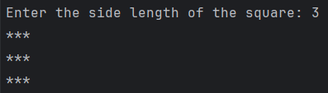

- Your function will look like this:
void printSquare(int n){
// your code here
}

Task 2:
Write a function named printHollowSquare that prints a hollow square pattern using stars (*) based on user input. The function should take a single integer as input, representing the side length of the square. The program should print stars only on the border of the square, leaving the inside part hollow.
- Your function will look like this:
void printHollowSquare(int n){
// your code here
}
Example:
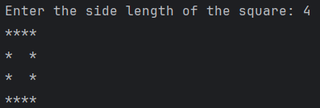

Task 3:
Write a function named printInvertedTriangle that prints an inverted right-angled triangle pattern using stars(*) based on user input. The function should take a single integer as input, representing the number of rows in the triangle. The program should ensure that the output forms a right-angled triangle with decreasing rows of * from top to bottom.

Example:
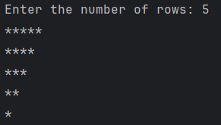
- Your function will look like this:
void printInvertedTriangle(int n){
// your code here
}

Task 4:
Write a function named printPyramid that prints a pyramid pattern using stars (*) based on user input. The function should take a single integer as input, representing the number of rows in the pyramid. The program should ensure that the output forms a symmetrical pyramid, with each row centered and increasing in the number of stars.
Example:
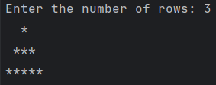

- Your function will look like this:
void printPyramid(int n){
// your code here
}

Task 5:
Write a function named printHollowPyramid that prints a hollow pyramid pattern using stars (*) based on user input. The function should take a single integer as input, representing the number of rows in the pyramid. The program should ensure that the output forms a hollow pyramid, with stars forming the borders of the pyramid and spaces inside. Each row should be centered with respect to the number of rows.
Example:
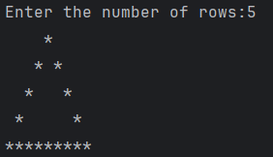
- Your function will look like this:
void printHollowDiamond(int n){
// your code here
}

Task 6:
Write a function named printPattern that prints a specific pattern of stars (*) using loops based on the user input. Your program should use the minimum number of cout statements and employ loops effectively to achieve the desired output.
Example Output:
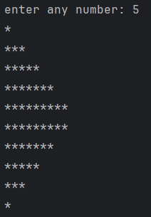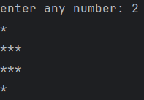
- Your function will look like this:
void printPattern(){
//your code here
}

Task 7:
Write a function printHollowDiamond that takes an odd integer n as input and prints the hollow diamond pattern using # operator. If the user enters an even number, the program should display an error message and ask the user to enter an odd number until a valid odd number is provided.

Example:
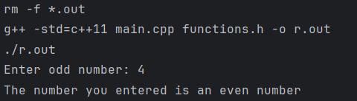
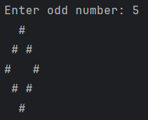
● Your function will look like this:
void printHollowDiamond(int n){
//your code here
}

Task 8:
Write a function OddNumberSum that prompts the user to input two integers: firstNum and secondNum, where firstNum must be less than secondNum. Ensure that the program checks for this condition and prompts the user to re-enter the values if the condition is not met. Return the sum of all the odd numbers between firstNum and secondNum.
The program should ensure that all user inputs are properly validated, and the output is clear and formatted correctly.

Example:
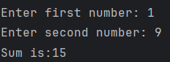
As the odd numbers between 1 and 9 are: 3, 5, 7 and their sum is 15.

Your function definition might look like this:
int OddNumberSum(int firstNum, int secondNum) {
// Your code here
}

Task 9:
Write a function multiply that takes two positive integers as parameters and returns their product without using * operator.
- Your function will look like this:
int multiply(int a, int b){
//your code here
}

Task 10:
Write a function named ‘findLCM’ that takes four positive integers as input from the user and calculates their Least Common Multiple (LCM). The function should ensure that each number entered is positive. If the user enters a negative number or zero, the program should prompt them to re-enter the number until a valid positive number is provided. Once all four valid inputs are received, the function should return the LCM of these numbers. Additionally, write code in ‘main()’ to call this function and print the LCM.
● If the inputs are 2, 3, 4, and 5, the LCM should be 60.
● Your function will look like this:
int findLCM(int a, int b, int c, int d){
//your code here
}

Assessment Rubric for Assignment

Performance metric | CLO | Able to complete the task over 80% (4-5) | Able to complete the task 50-80% (2-3) | Able to complete the task below 50% (0-1) | Marks
- Realization of experiment | 3 | Executes without errors excellent user prompts, good use of symbols, spacing in output. The testing has been completed. | Executes without errors, user prompts are understandable, minimum use of symbols or spacing in output. Some testing has been completed. | Does not execute due to syntax errors, runtime errors, user prompts are misleading or non- existent. No testing has been completed.
- Conducting experiment | 2 | Able to make changes and answer all questions. | Partially able to make changes and few incorrect answers. | Unable to make changes and answer all questions.
- Computer use | 4 | Document submission timely. | Document submission late. | Document submission not done.
- Teamwork | 4 | Actively engages and cooperates with other group member(s) in an effective manner. | Cooperates with other group member(s) in a reasonable manner but conduct can be improved. | Distracts or discourages other group members from conducting the experiment
- Laboratory safety and disciplinary rules | 2 | Code comments are added and do help the reader to understand the code. | Code comments are added and do not help the reader to understand the code. | Code comments are not added.
- Data collection | 2 | Excellent use of white space, creatively organized work, excellent use of variables and constants, correct identifiers for constants, No line-wrap. | Includes name, and assignment, white space makes the program fairly easy to read. Title, organized work, good use of variables. | Poor use of white space (indentation, blank lines) making code hard to read, disorganized and messy.
- Data analysis | 3 | Solution is efficient, easy to understand, and maintain. | A logical solution that is easy to follow but it is not the most efficient. | A difficult and inefficient solution.
Total (out of 35):

