Software Engineering Department-ITU
SE101L: Programming Fundamentals Lab
Course Instructor: Usama Bin Shakeel | Dated: 12-11-2024
Teaching Assistant: Sadia & Ryan | Semester: Fall 2024
Lab Engineer: Zain Ul Abidin | Batch: BSSE2024

Lab 11: JSON file handling

Name | Roll number | Obtained Marks/35

Checked on: ____________________________

Signature: ___________________________

11.1 Objective
The goal of this handout is to learn how to arrays in C++.

Equipment and Component
Component Description | Value | Quantity
Computer | Available in lab | 1

11.3 Conduct of Lab
- Students are required to perform this experiment individually.
- In case the lab experiment is not understood, the students are advised to seek help from the course instructor, lab engineers, assigned teaching assistants (TA) and lab attendants.

11.4 Theory and Background
In C++, JSON file handling and template functions are valuable tools for creating flexible and efficient data management solutions. JSON (JavaScript Object Notation) is a popular, lightweight format for storing and exchanging data, making it ideal for structured data management across various applications. By using JSON in C++ with libraries like `<nlohmann/json>`, we can easily parse, read, and write JSON data, allowing for persistent and well-organized storage that’s accessible across program executions. This is especially useful for handling complex datasets, configuration settings, and data logs.

In this lab, you'll explore JSON file handling alongside template functions to streamline data processing and build flexible, reusable functions for efficient data manipulation and storage.

Lab Tasks

Task 1
You are provided with a task1.json file. In this lab you will read and save the result in task1.txt file. In case of any issues, seek help from lab 1 repository.

Task 2
In this task, you will use the same task1.json file. In this task you will program a menu that lets users display, add, edit, delete, and save student entries in the file as task2.txt
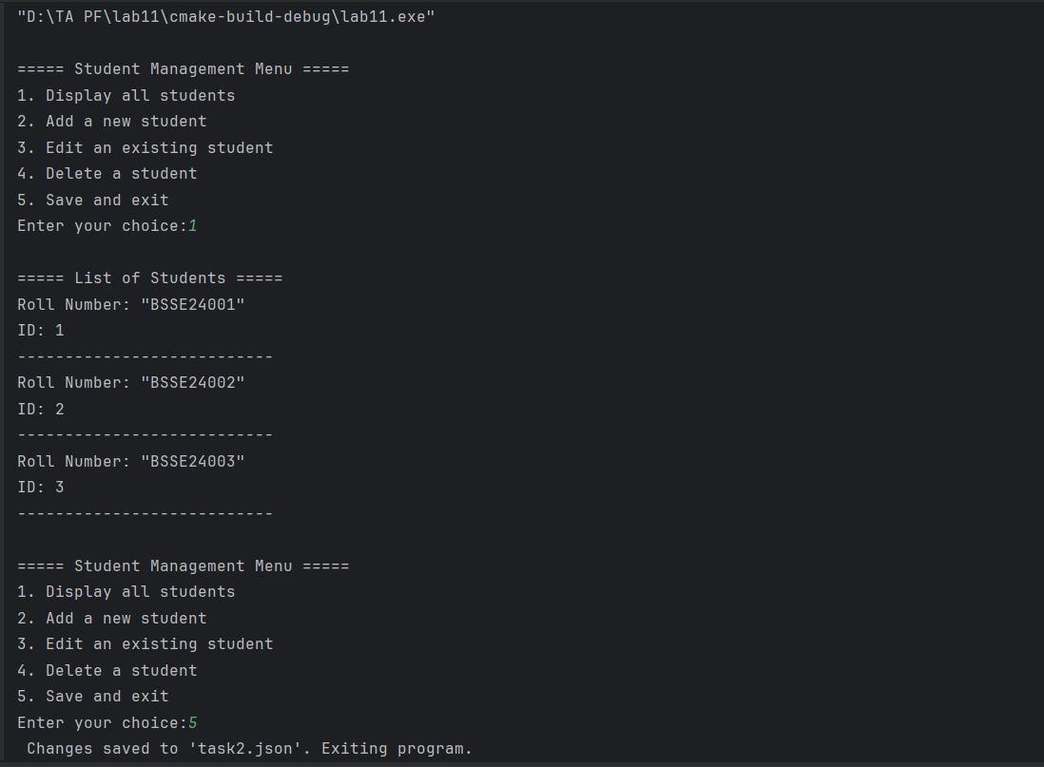

Task 3
In Lahore, air quality and weather conditions have become increasingly important due to the rising pollution levels, especially during winter when smog and haze become severe. In this problem, you will create a weather monitoring system that reads data from a JSON file containing air quality index (AQI), temperature, humidity, smog levels, and other weather parameters for different areas of Lahore. Your program should analyze this data, filter out areas with high pollution, and generate a report that provides insights on air quality, temperature, and smog levels.
Input JSON Structure (lahore_weather_data.json)
Each entry in the dataset contains:
- area_id: Unique identifier for the location
- location: Name of the location (e.g., area of Lahore)
- aqi: Air Quality Index (scale of 0-500, higher is worse)
- temperature: Temperature in Celsius (°C)
- humidity: Humidity percentage (0-100%)
- smog_level: Smog level in percentage (0-100%, where 100% represents heavy smog)
- timestamp: Date and time when the data was recorded
Json Data format in task3.json:
{ "area_id": "A001", "location": "Gulberg", "aqi": 150, "temperature": 22.5, "humidity": 65, "smog_level": 80, "timestamp": "2024-11-12 08:00:00" },

Data format to be saved in task3.txt
Weather Report for Lahore (2024-11-12 08:00:00):
Location: Gulberg
AQI: 150 (Unhealthy for Sensitive Groups)
Temperature: 22.5°C
Humidity: 65%
Smog Level: 80%
Timestamp: 2024-11-12 08:00:00

Lab Manual:
Take screenshots of your Cygwin/ WSL Terminal window and your GitHub App window using a snipping tool application and paste it in the box in your word file(.docx) named lab1.docx in your cloned folder. Now save and rename that file with your roll#_lab#.docx (e.g.BSSE24000_lab11.docx).
Task 6
Commit the changes through GitHub App
Task 7
Push the code to the repository.

