Software Engineering Department-ITU
SE101L: Programming Fundamentals Lab
Course Instructor: Usama Bin Shakeel | Dated: 25-11-2024
Teaching Assistant: Sadia & Ryan | Semester: Fall 2024
Lab Engineer: Zain Ul Abidin | Batch: BSSE2024

Lab 13. Programming fundamentals (Python)

Name | Roll number | Obtained Marks/35

Checked on: ____________________________

Signature: ___________________________

Objective
The goal of this handout to familiarize students with basic Python syntax and concepts, including variables, data types, loops, decision-making, and functions.

Equipment and Component
Component Description | Value | Quantity
Computer | Available in lab | 1

Conduct of Lab
- Students are required to perform this experiment individually.
- In case the lab experiment is not understood, the students are advised to seek help from the course instructor, lab engineers, assigned teaching assistants (TA) and lab attendants.

Theory and Background
Python is a versatile, high-level, and interpreted programming language. It is known for its simplicity and readability, making it an excellent choice for beginners. Python supports multiple programming paradigms, including procedural, object-oriented, and functional programming.
In this lab, you will learn:
- How to print messages and use variables.
- Perform arithmetic operations.
- Implement decision-making using if-else.
- Use loops for repeated tasks.
- Work with lists and calculate sums.
- Create and use functions.
Use the following online interpreter for this lab:
https://www.programiz.com/python-programming/online-compiler/

Lab Tasks

Task 1
Printing and Variables
Similar to C++, we make variables in python and print them with print("Your message here")
In this task, you will make a variable for your name and one for your roll number and print both variables.
https://www.geeksforgeeks.org/python-variables/
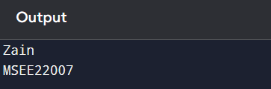

Code:
name="Aiman" #string data type
roll_number="BSSE-24063" #string data type
print(name) #it will print name
print(roll_number) #it will print roll number

Output:
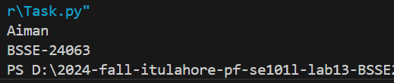

Task 2
Inputs from user is an essential part in programming, in python we use input() function to take input from user.
https://www.geeksforgeeks.org/python-input-function/
In this task you will take two inputs(floats) from user and perform sum, subtraction, multiplication and division operation on the user input.
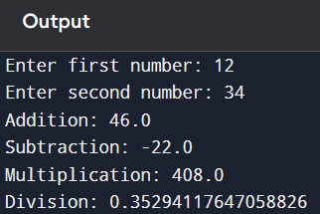
Code:
a=float(input("Entre first number ")) #taking first number as float
b=float(input("Entre second number "))#taking second number as float
addition=a+b #adding both a and b and storing them in variable addition
subtraction=a-b#subtracting both a and b and storing them in variable subtraction
multipliaction=a*b#multiplying both a and b and storing them in variable multiplication
division=a/b#dividing both a and b and storing them in variable division
print("addition={}".format(addition)) #print addition
print("subtraction={}".format(subtraction))#print sbtraction
print("multipliaction={}".format(multipliaction))#print multipliaction
print("division={}".format(division))#print division

Output:
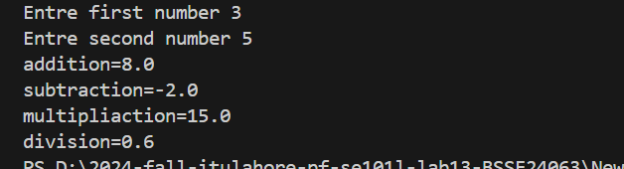

Task 3
In this task, you will take input from user and determine, whether the number is even or odd one.
https://www.geeksforgeeks.org/python-if-else/
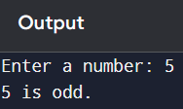
Code:
Num=int(input("Entre the number:")) #taking input from user as integer
if(Num%2==0): #condition to check number is divisble by 2 or not
print("Even")
else:#if not divisible then print odd
print("odd")

Output:
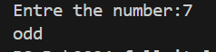

Task 4
Similar to loops in C++, in this task you will use either for or while loop to print numbers from 1 to 10
https://www.geeksforgeeks.org/loops-in-python/
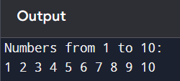
Code:
n=10 #loop end at n
for i in range(1, n+1): #range start from 1 and end at 10
print(i,end=" ") #use end=" " to print all number at one line horizontally

Output:
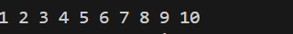

Task 5
In this task, you will use an integer array and calculate its sum:
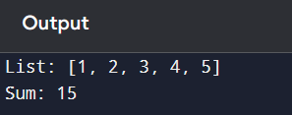
https://www.geeksforgeeks.org/python-lists/
Code:
List = [1,2,3,4,5] #array
sum = 0 #intialize sum equal to zero
for S in List:
sum = sum + S #loop iterate and sum each element in a array
print("The sum of the numbers is:", sum) #print sum of all elements

Output:
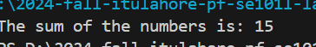

Task 6
Commit the changes through GitHub App
Task 7
Push the code to the repository.

Assessment Rubric for Lab

Performance metric | CLO | Able to complete the task over 80% (4-5) | Able to complete the task 50-80% (2-3) | Able to complete the task below 50% (0-1) | Marks
- Realization of experiment | 1 | Executes without errors excellent user prompts, good use of symbols, spacing in output. The testing has been completed. | Executes without errors, user prompts are understandable,minimum use of symbols or spacing in output. Some testing has been completed. | Does not execute due to syntax errors, runtime errors, user prompts are misleading or non- existent. No testing has been completed.
2. Conducting experiment | 1 | Able to make changes and answer all questions. | Partially able to make changes and few incorrect answers. | Unable to make changes and answer all questions.
3. Computer use | 2 | Document submission timely. | Document submission late. | Document submission not done.
4. Teamwork | 3 | Actively engages and cooperates with other group member(s) in an effective manner. | Cooperates with other group member(s) in a reasonable manner but conduct can be improved. | Distracts or discourages other group members from conducting the experiment
5. Laboratory safety and disciplinary rules | 3 | Code comments are added and do help the reader to understand the code. | Code comments are added and do not help the reader to understand the code. | Code comments are not added.
6. Data collection | 3 | Excellent use of white space, creatively organized work, excellent use of variables and constants, correct identifiers for constants, No line-wrap. | Includes name, and assignment, white space makes the program fairly easy to read. Title, organized work, good use of variables. | Poor use of white space (indentation, blank lines) making code hard to read, disorganized and messy.
7. Data analysis | 4 | Solution is efficient, easy to understand, and maintain. | A logical solution that is easy to follow but it is not the most efficient. | A difficult and inefficient solution.
Total (out of 35):

