Software Engineering Department-ITU
SE101L: Programming Fundamentals Lab

Course Instructor: Usama Bin Shakeel | Dated: 27-08-2024
Teaching Assistant: Sadia & Ryan | Semester: Fall 2024
Lab Engineer: Zain Ul Abidin | Batch: BSSE2024

Lab 2. Flowcharts & Algorithm

Name | Roll number | Obtained Marks/35
Um-E-Aiman Rafiq | BSSE24063

Checked on: ____________________________

Signature: ___________________________

Objective
The goal of this handout is to learn how we can use draw.io to create flowcharts.

Equipment and Component
Component Description | Value | Quantity
Computer | Available in lab | 1

Conduct of Lab
- Students are required to perform this experiment individually.
- In case the lab experiment is not understood, the students are advised to seek help from the course instructor, lab engineers, assigned teaching assistants (TA) and lab attendants.

Theory and Background
Draw.io is free online diagram software for making flowcharts, process diagrams, org charts, UML, ER and network diagrams.
GitHub is a web-based platform used for version control. Git simplifies the process of working with other people and makes it easy to collaborate on projects. GitHub Desktop is an application that enables you to interact with GitHub using a GUI instead of the command line or a web browser. You can push to, pull from, and clone remote repositories with GitHub Desktop.
Cygwin is a Unix-like environment and command-line interface for Microsoft Windows. Cygwin's purpose is expressed in its motto: "Get that Linux feeling – on Windows".
A word problem in math’s is a math’s question written as one sentence or more that requires children to apply their math’s knowledge to a 'real-life' scenario.
The C++ program is written using a specific template structure. Which includes documentation, link section, definition section, global declaration section, function declaration section, main function.

Lab Tasks

Task 1
Create a flowchart using draw.io and algorithm using microsoft word to determine if a given number is even or odd.
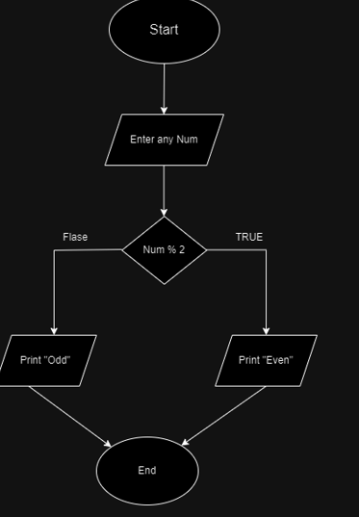

Algorithm:
Start
Declare variables
If
Num%2
Print “even”
If
Num is not % 2
Print “odd”.
Stop.
Task 2
Design a flowchart using draw.io and algorithm to find the maximum of three given numbers.

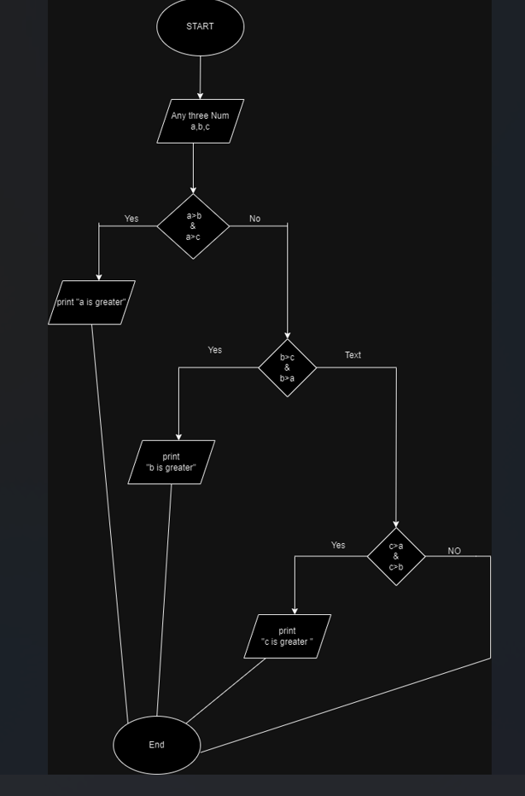
Algorithm
Start the process
Entre any three Number a,b,c
If a>b & a>c
Then a is greatest
If b>a & b>c
Then b is greatesr
If c>a & c>b
Then c is greatest
End the process

Task 3
Create a flowchart using draw.io and algorithm to verify if the entered password is correct. If the password matches a predefined correct password, print "Access Allowed." Otherwise, print "Access Not Allowed."
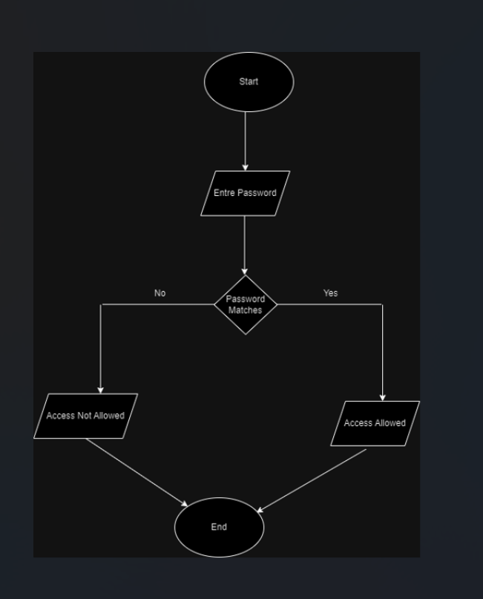
Algorithm:
Start the process
Entre password
if password matches pre-defined password
“Access Allowed”
If password deosn’t matches pre-defined password
“Access not Allowed”

Task 4
The government has imposed a tax on salary based on the following brackets:
- 7% tax on the salary above 60,000.
- 5% tax on the salary between 40,000 and 60,000.
- 3% tax on the portion of the salary up to 40,000.

Make a flowchart for the algorithm using draw.io to print the take home salary [total salary - tax].
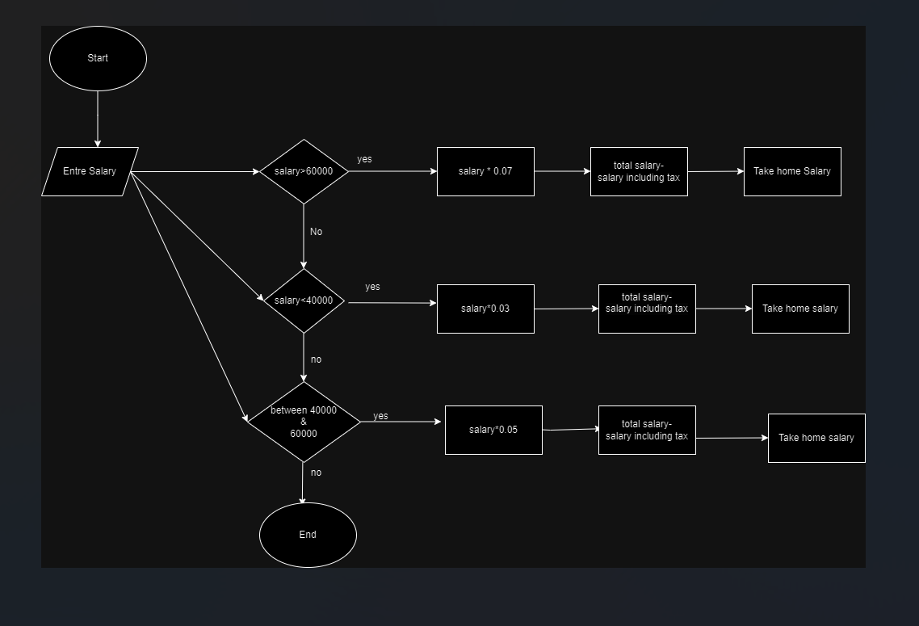
A
Algorithm:
Start the process
Entre salary
If salary >60,000
Tax is 0.07
Multiply tax with salary
Then subtract tax including salaary from total salary
Then
Print “take home salary”
If salary <40,000
Tax is 0.03
Multiply tax with salary
Then subtract tax including salaary from total salary
Then
Print “take home salary”
If salary between 40,000& 60,000
then
Tax is 0.05
Multiply tax with salary
Then subtract tax including salaary from total salary
Then
Print “take home salary”.

Lab Manual:
Take screenshots of your Draw.io window using a snipping tool application and paste it in the box in your word file(.docx) named lab1.docx in your cloned folder. Now save and rename that file with your roll#_lab#.docx (e.g.BSSE24000_lab1.docx).

Task 6
Commit the changes through GitHub App

Task 7
Push the code to the repository.

