Software Engineering Department-ITU
SE101L: Programming Fundamentals Lab
Course Instructor: Usama Bin Shakeel | Dated: 10-09-2024
Teaching Assistant: Sadia & Ryan | Semester: Fall 2024
Lab Engineer: Zain Ul Abidin | Batch: BSSE2024

Lab 4. Loops

Name | Roll number | Obtained Marks/35
Um-e-Aiman | Bsse-24063

Checked on: ____________________________

Signature: ___________________________

Objective
The goal of this handout is to learn how loops are used in C++ for basic operations.

Equipment and Component
Component Description | Value | Quantity
Computer | Available in lab | 1

Conduct of Lab
- Students are required to perform this experiment individually.
- In case the lab experiment is not understood, the students are advised to seek help from the course instructor, lab engineers, assigned teaching assistants (TA) and lab attendants.

Theory and Background
Loops are fundamental constructs in programming that allow you to execute a block of code repeatedly based on a condition. The for loop in C++ is structured to provide a concise way of iterating over a range of values. It is composed of three main parts:
- Initialization: This is where you set up a loop control variable. This part executes only once at the beginning of the loop.
- Condition: This is a boolean expression that is evaluated before each iteration. If the condition is true, the loop continues to execute. If it is false, the loop terminates.
- Iteration Expression: This part updates the loop control variable after each iteration. It typically involves incrementing or decrementing the loop control variable.

The general syntax of a for loop is as follows:
for (initialization; condition; iteration)
{
// Loop body
}

Lab Tasks

Task 1
Write a C++ program that asks the user a for loop to print the numbers 1 through user entered number, each on a new line.
Expected output:
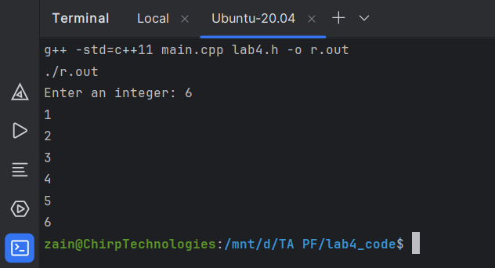
Task 2
Write a C++ program that takes an integer input from the user and calculates the sum of all numbers from 1 up to the input number.
Expected output:
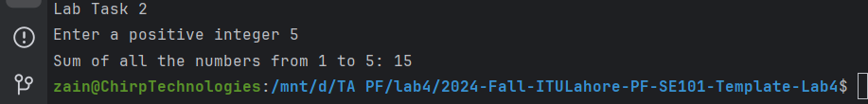

Task 3
Define a function to calculate and print the multiples of a given value up to 10 times that value.
Instructions:
- Define a function named printMultiples that takes an integer as its parameter.
- In this function, use a for loop to calculate and print the multiples of the given integer from 1 up to 10 times the integer.
- Call this function from the main function, passing the user-entered value as an argument.
Expected output:
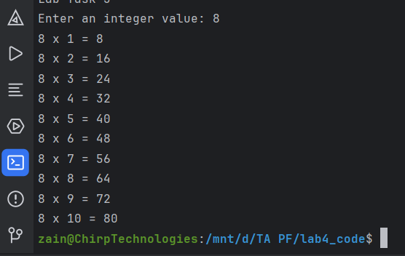

Task 4
Write a C++ program that prints a right-angled triangle of numbers. The triangle should contain numbers that increase from 1 up to the row number in each row.
Instructions:
- Prompt the user to enter the height of the triangle (an integer).
- Use nested for loops to print the triangle pattern, where:
  - The first row contains only the number 1.
  - The second row contains the numbers 1 2.
  - The third row contains the numbers 1 2 3, and so on.
- The triangle should have as many rows as the number entered by the user.
Expected output:
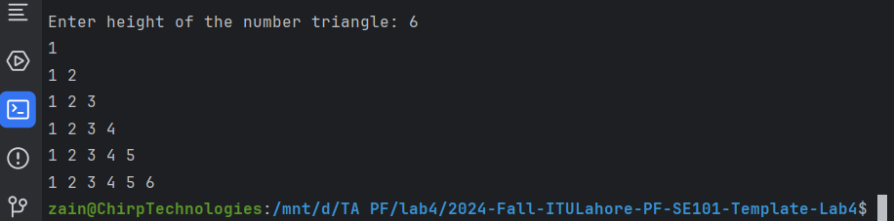

Lab Manual:
Take screenshots of your Cygwin/ WSL Terminal window and your GitHub App window using a snipping tool application and paste it in the box in your word file(.docx) named lab1.docx in your cloned folder. Now save and rename that file with your roll#_lab#.docx (e.g.BSSE24000_lab4.docx).

Task 6
Commit the changes through GitHub App

Task 7
Push the code to the repository.

