Software Engineering Department-ITU
SE101L: Programming Fundamentals Lab
Course Instructor: Usama Bin Shakeel | Dated: 17-09-2024
Teaching Assistant: Sadia & Ryan | Semester: Fall 2024
Lab Engineer: Zain Ul Abidin | Batch: BSSE2024

Lab 5. Nested loops

Name | Roll number | Obtained Marks/35

Checked on: ____________________________

Signature: ___________________________

Objective
The goal of this handout is to learn how loops are used in C++ for basic operations.

Equipment and Component
Component Description | Value | Quantity
Computer | Available in lab | 1

Conduct of Lab
- Students are required to perform this experiment individually.
- In case the lab experiment is not understood, the students are advised to seek help from the course instructor, lab engineers, assigned teaching assistants (TA) and lab attendants.

Theory and Background
Nested loops in programming are loops placed within the body of another loop, allowing for more complex iteration patterns and operations. The outer loop controls the overall iteration process, while the inner loop executes its block of code multiple times for each single iteration of the outer loop. This structure is particularly useful when dealing with multi-dimensional data, such as matrices or grids, where each element of a dimension must be processed in conjunction with elements from other dimensions.

Lab Tasks

Task 1
Write a C++ program that generates and prints a square grid of asterisks (*) using nested for loops.
Expected output:
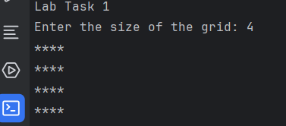

Task 2
Write a C++ program that generates and prints a checkerboard pattern using nested for loops.
Use X and O for the pattern
Expected output:
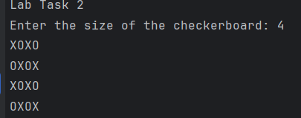

Task 3
Write a C++ program that generates and prints a grid of numbers using nested do-while loops.
Instructions:
- Create a C++ program that prompts the user to enter the number of rows and columns for the grid (e.g., 3 rows and 4 columns).
- Use nested do-while loops to print a grid where each cell contains a number. Each number in the grid should be the product of its row and column indices.
Output:
Row 1: The values are calculated as 1 * 1, 1 * 2, 1 * 3, 1 * 4 which results in 1, 2, 3, 4.
Row 2: The values are 2 * 1, 2 * 2, 2 * 3, 2 * 4 which results in 2, 4, 6, 8.
Row 3: The values are 3 * 1, 3 * 2, 3 * 3, 3 * 4 which results in 3, 6, 9, 12.

Expected output:
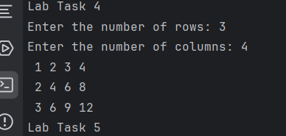

Task 4
Write a C++ program that repeatedly prompts the user to enter a positive integer for the size of a multiplication table until the user provides a valid input. Once a valid size is entered, generate and display the multiplication table.
Instructions:
- Use do while loop to validate the user input to generate the user input for positive integer for the table.

Expected output:
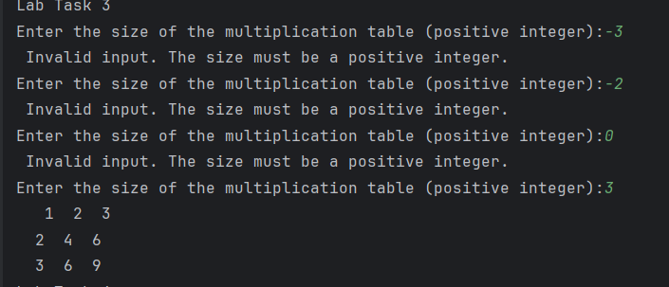

Task 5
Write a C++ program that generates and prints a number pyramid using nested while loops.
Expected output:
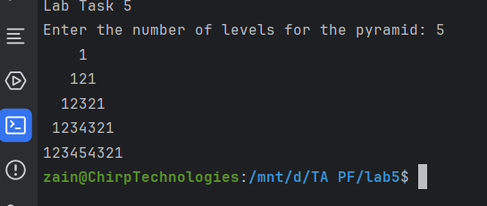

Lab Manual:
Take screenshots of your Cygwin/ WSL Terminal window and your GitHub App window using a snipping tool application and paste it in the box in your word file(.docx) named lab1.docx in your cloned folder. Now save and rename that file with your roll#_lab#.docx (e.g.BSSE24000_lab4.docx).

Task 6
Commit the changes through GitHub App

Task 7
Push the code to the repository.

