Software Engineering Department-ITU
SE101L: Programming Fundamentals Lab
Course Instructor: Usama Bin Shakeel | Dated: 24-09-2024
Teaching Assistant: Sadia & Ryan | Semester: Fall 2024
Lab Engineer: Zain Ul Abidin | Batch: BSSE2024

Lab 6. Nested loops

Name | Roll number | Obtained Marks/35

Checked on: ____________________________

Signature: ___________________________

Objective
The goal of this handout is to learn how to use recursion

Equipment and Component
Component Description | Value | Quantity
Computer | Available in lab | 1

Conduct of Lab
- Students are required to perform this experiment individually.
- In case the lab experiment is not understood, the students are advised to seek help from the course instructor, lab engineers, assigned teaching assistants (TA) and lab attendants.

Theory and Background
Recursion in programming is a technique where a function calls itself in order to solve a problem by breaking it down into smaller, more manageable sub-problems. Each recursive call works on a smaller instance of the original problem until a base case is reached, which stops the recursion and allows the results to be combined as the function returns through the call stack. In C++, recursion is commonly used in tasks such as navigating tree structures, implementing divide-and-conquer algorithms, or performing operations like factorials and Fibonacci sequences. It provides an elegant solution for problems that can be defined in terms of smaller instances of themselves.

Lab Tasks

Task 1
Write a C++ program that generates and prints a square grid of asterisks (*) using recursion
Expected output:
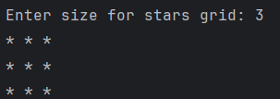

Task 2
Write a C++ program that generates and prints a checkerboard pattern using recusion.
Use X and O for the pattern
Expected output:
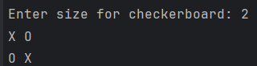

Task 3
Write a C++ program that generates and prints a grid of numbers using recursion.
Instructions:
- Create a C++ program that prompts the user to enter the number of rows and columns for the grid (e.g., 3 rows and 4 columns).
- Use recursion to print a grid where each cell contains a number. Each number in the grid should be the product of its row and column indices.
- You will write two recursive functions:
- One function to print each row.
- Another function to handle printing all the rows.
- The base case for row printing will be when all columns for that row have been printed, and the base case for the grid printing will be when all rows have been printed.
Expected output:
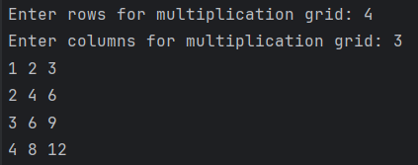

Task 4
Write a C++ program that generates and prints a number pyramid using recursion.
Expected output:
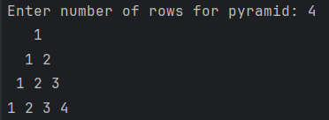

Lab Manual:
Take screenshots of your Cygwin/ WSL Terminal window and your GitHub App window using a snipping tool application and paste it in the box in your word file(.docx) named lab1.docx in your cloned folder. Now save and rename that file with your roll#_lab#.docx (e.g.BSSE24000_lab6.docx).

Task 6
Commit the changes through GitHub App

Task 7
Push the code to the repository.

