Software Engineering Department-ITU
SE101L: Programming Fundamentals Lab
Course Instructor: Usama Bin Shakeel | Dated: 22-10-2024
Teaching Assistant: Sadia & Ryan | Semester: Fall 2024
Lab Engineer: Zain Ul Abidin | Batch: BSSE2024

Lab 8. Structs

Name | Roll number | Obtained Marks/35

Checked on: ____________________________

Signature: ___________________________

Objective
The goal of this handout is to learn how to arrays in C++.

Equipment and Component
Component Description | Value | Quantity
Computer | Available in lab | 1

Conduct of Lab
- Students are required to perform this experiment individually.
- In case the lab experiment is not understood, the students are advised to seek help from the course instructor, lab engineers, assigned teaching assistants (TA) and lab attendants.

Theory and Background
In C++, a struct (short for structure) is a user-defined data type that allows grouping together different variables under a single name. These variables, also called members or fields, can be of different types. A struct is similar to a class in C++, but by default, all members of a struct are public (accessible from outside the struct),

Lab Tasks

Task 1
Create a simple C++ program that uses a struct to store student details (Name, Roll No, GPA). Implement a menu using a switch-case that allows the user to:
- Add student details.
- Display student details.
- Exit the program.

Task 2
Write a C++ program that uses a struct to store information of books in inventory. Implement a menu using a switch-case that allows the user to:
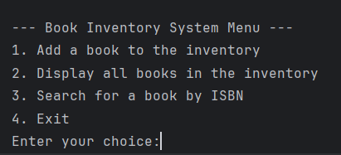

Task 3
Write a C++ program that implements a banking system using a struct for bank account details and a switch-case menu to support various operations like opening an account, depositing, withdrawing, and transferring money:

Expected output:
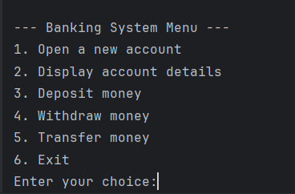

Lab Manual:
Take screenshots of your Cygwin/ WSL Terminal window and your GitHub App window using a snipping tool application and paste it in the box in your word file(.docx) named lab1.docx in your cloned folder. Now save and rename that file with your roll#_lab#.docx (e.g.BSSE24000_lab6.docx).
Task 6
Commit the changes through GitHub App
Task 7
Push the code to the repository.

