Software Engineering Department-ITU
SE101L: Programming Fundamentals Lab
Course Instructor: Usama Bin Shakeel | Dated: 29-10-2024
Teaching Assistant: Sadia & Ryan | Semester: Fall 2024
Lab Engineer: Zain Ul Abidin | Batch: BSSE2024

Lab 9. Structs and Filing

Name | Roll number | Obtained Marks/35

Checked on: ____________________________

Signature: ___________________________

Objective
The goal of this handout is to learn how to arrays in C++.

Equipment and Component
Component Description | Value | Quantity
Computer | Available in lab | 1

Conduct of Lab
- Students are required to perform this experiment individually.
- In case the lab experiment is not understood, the students are advised to seek help from the course instructor, lab engineers, assigned teaching assistants (TA) and lab attendants.

Theory and Background
In this lab, students explore the use of `struct`, Dynamic Memory Allocation (DMA), and file handling in C++ to manage data efficiently. The `struct` keyword allows for grouping related variables, forming a structured record, such as student information. With DMA, memory is allocated at runtime, enhancing flexibility in handling variable-sized data like names. File handling enables persistent data storage, allowing records to be saved and retrieved across program executions. This lab demonstrates how these concepts work together to create dynamic and persistent data management systems.

Lab Tasks

Task 1
Create a file in your project “XXXX.txt” and save your name in the first line and in the second row save your roll number. In the third line add “This is my own work, and I have not violated academic integrity policy”. Read from file and print on console.
Expected output:
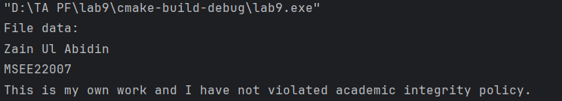

Task 2
Write a C++ program that uses struct, fstream, and string to manage student records. The program should allow the user to:
- Add a Student: Prompt the user to enter the student’s name, age, and GPA, and save this information in a file called "students.txt".
- Display All Students: Read all student records from "students.txt" and display them.
Expected Outcome:
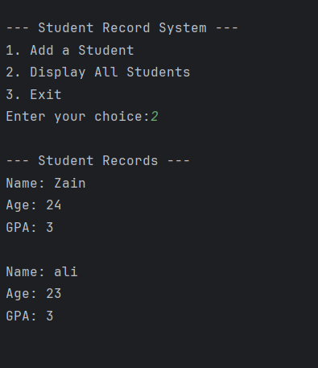

Task 3
Implement a dynamic memory allocation and file handling system to manage movie ticket bookings.
- Create a Movie struct with members as movieID, movieName, seatsAvailable
- Create a Booking struct with member movieID, movieName, seatsBooked
- Dynamically store the input data
- Write to file – to save input of movies into movie.txt
- Write booking – to save booking in booking.txt
- Read from files – to display movies and bookings

Expected output:
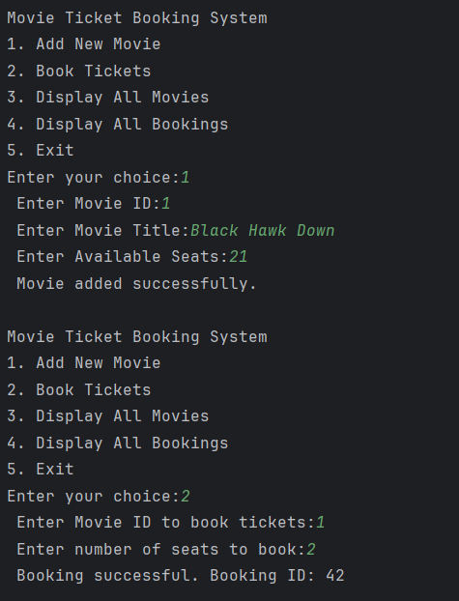
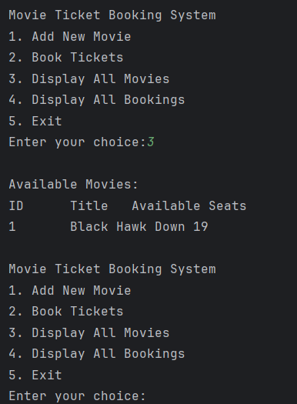

Lab Manual:
Take screenshots of your Cygwin/ WSL Terminal window and your GitHub App window using a snipping tool application and paste it in the box in your word file(.docx) named lab1.docx in your cloned folder. Now save and rename that file with your roll#_lab#.docx (e.g.BSSE24000_lab6.docx).

Task 6
Commit the changes through GitHub App

Task 7
Push the code to the repository.

